Additional file 1. Supplementary information
Article title: Cold-Water Immersion for Post-Exercise Recovery: An Overlap-Aware Umbrella Review
Journal: Sports Medicine – Open
Authors: Weibao Liang1†*, Xiaoge Ma2†, Guanping Sun3, Chuannan Liu4, Xujie Yan5
1Faculty of Health Sciences and Sports, Macao Polytechnic University, Macao SAR, China
2School of Physical Education and Leisure, Guangdong Ocean University, Zhanjiang, China
3Department of Physical Education, Kunsan National University, Gunsan-si, South Korea
4School of Physical Education and Health, Zunyi Medical University, Zunyi, China
5School of Physical Education and Sports Science, Hengyang Normal University, Hengyang, China
†Weibao Liang and Xiaoge Ma contributed equally to this work.
Correspondence: Weibao Liang, Email: 2017020800@m.scnu.edu.cn

Contents
Table S1 Search strategy
Table S2 Full characteristics of included reviews
Table S3 Population, protocol, and comparator characteristics
Table S4 Full AMSTAR 2 appraisal
Table S5 Overall and outcome-specific corrected covered area
Table S6 Corrected covered area sensitivity analyses
Table S7 Representative source-verified SMD/Hedges g estimates
Table S8 Review-level parameter evidence
Table S9 Comparator-stratified estimates from Moore et al. (2023)
Table S10 Source-verified review-level MD/WMD estimates
Figure S1 Pairwise Jaccard overlap heatmap
Figure S2 Outcome-specific corrected covered area
Figure S3 Primary-study inclusion multiplicity
Figure S4 Functional source-review SMD estimates
Figure S5 Biochemical and inflammatory source-review SMD estimates
Figure S6 Comparator-stratified Moore et al. (2023) estimates
Figure S7 Source-review MD/WMD estimates

Table S1. Search strategy
Database | Search strategy
PubMed | ("Cold Temperature"[Mesh] OR "Immersion"[Mesh] OR "cold water immersion"[Title/Abstract] OR "cold-water immersion"[Title/Abstract] OR "CWI"[Title/Abstract] OR "cold bath*"[Title/Abstract] OR "cold water bath*"[Title/Abstract] OR "ice bath*"[Title/Abstract] OR "water immersion"[Title/Abstract] OR "cryotherapy"[Title/Abstract])  AND  ("Recovery of Function"[Mesh] OR "Muscle, Skeletal"[Mesh] OR "Muscle Soreness"[Title/Abstract] OR "delayed onset muscle soreness"[Title/Abstract] OR "DOMS"[Title/Abstract] OR "fatigue"[Title/Abstract] OR "perceived fatigue"[Title/Abstract] OR "recovery"[Title/Abstract] OR "jump performance"[Title/Abstract] OR "sprint performance"[Title/Abstract] OR "strength"[Title/Abstract] OR "power"[Title/Abstract] OR "creatine kinase"[Title/Abstract] OR "CK"[Title/Abstract] OR "C-reactive protein"[Title/Abstract] OR "CRP"[Title/Abstract] OR "interleukin-6"[Title/Abstract] OR "IL-6"[Title/Abstract] OR "lactate"[Title/Abstract] OR "heart rate variability"[Title/Abstract] OR "HRV"[Title/Abstract])  AND  ("systematic review"[Publication Type] OR "meta-analysis"[Publication Type] OR "systematic review"[Title/Abstract] OR "meta-analysis"[Title/Abstract] OR "meta analysis"[Title/Abstract])
Web of Science | TS=("cold water immersion" OR "cold-water immersion" OR CWI OR "cold bath*" OR "cold water bath*" OR "ice bath*" OR "water immersion" OR cryotherapy)  AND  TS=("muscle soreness" OR "delayed onset muscle soreness" OR DOMS OR fatigue OR recovery OR "perceived fatigue" OR "jump performance" OR "sprint performance" OR strength OR power OR "creatine kinase" OR CK OR "C-reactive protein" OR CRP OR "interleukin-6" OR "IL-6" OR lactate OR "heart rate variability" OR HRV)  AND  TS=("systematic review" OR "meta-analysis" OR "meta analysis")
SPORTDiscus | (TI ("cold water immersion" OR "cold-water immersion" OR CWI OR "cold bath*" OR "cold water bath*" OR "ice bath*" OR cryotherapy OR "water immersion")  OR  AB ("cold water immersion" OR "cold-water immersion" OR CWI OR "cold bath*" OR "cold water bath*" OR "ice bath*" OR cryotherapy OR "water immersion"))  AND  (TI ("muscle soreness" OR "delayed onset muscle soreness" OR DOMS OR fatigue OR recovery OR "perceived fatigue" OR "jump performance" OR "sprint performance" OR strength OR power OR "creatine kinase" OR CK OR CRP OR "interleukin-6" OR "IL-6" OR lactate OR "heart rate variability" OR HRV)  OR  AB ("muscle soreness" OR "delayed onset muscle soreness" OR DOMS OR fatigue OR recovery OR "perceived fatigue" OR "jump performance" OR "sprint performance" OR strength OR power OR "creatine kinase" OR CK OR CRP OR "interleukin-6" OR "IL-6" OR lactate OR "heart rate variability" OR HRV))  AND  (TI ("systematic review" OR "meta-analysis" OR "meta analysis")  OR  AB ("systematic review" OR "meta-analysis" OR "meta analysis"))
Cochrane Library | #1 ("cold water immersion" OR "cold-water immersion" OR CWI OR "cold bath*" OR "cold water bath*" OR "ice bath*" OR cryotherapy OR "water immersion"):ti,ab,kw  #2 ("muscle soreness" OR "delayed onset muscle soreness" OR DOMS OR fatigue OR recovery OR "perceived fatigue" OR "jump performance" OR "sprint performance" OR strength OR power OR "creatine kinase" OR CK OR "C-reactive protein" OR CRP OR "interleukin-6" OR "IL-6" OR lactate OR "heart rate variability" OR HRV):ti,ab,kw  #3 ("systematic review" OR "meta-analysis" OR "meta analysis"):ti,ab,kw  #4 #1 AND #2 AND #3
Embase | 1. exp cold water immersion/ or exp cryotherapy/ or exp immersion/  2. ("cold water immersion" or "cold-water immersion" or CWI or "cold bath*" or "cold water bath*" or "ice bath*" or cryotherapy or "water immersion").ti,ab.  3. 1 or 2  4. exp muscle soreness/ or exp fatigue/ or exp recovery/ or exp muscle strength/ or exp athletic performance/ or exp creatine kinase/ or exp c reactive protein/ or exp interleukin 6/ or exp lactic acid/ or exp heart rate variability/  5. ("muscle soreness" or "delayed onset muscle soreness" or DOMS or fatigue or recovery or "perceived fatigue" or "jump performance" or "sprint performance" or strength or power or "creatine kinase" or CK or "C-reactive protein" or CRP or "interleukin-6" or "IL-6" or lactate or "heart rate variability" or HRV).ti,ab.  6. 4 or 5  7. ("systematic review" or "meta-analysis" or "meta analysis").ti,ab.  8. 3 and 6 and 7
Scopus | TITLE-ABS-KEY (  ("cold water immersion" OR "cold-water immersion" OR CWI OR "cold bath*" OR "cold water bath*" OR "ice bath*" OR cryotherapy OR "water immersion")  AND  ("muscle soreness" OR "delayed onset muscle soreness" OR DOMS OR fatigue OR recovery OR "perceived fatigue" OR "jump performance" OR "sprint performance" OR strength OR power OR "creatine kinase" OR CK OR "C-reactive protein" OR CRP OR "interleukin-6" OR "IL-6" OR lactate OR "heart rate variability" OR HRV)  AND  ("systematic review" OR "meta-analysis" OR "meta analysis")  )
Database-specific strategies used from inception to 30 January 2026. No language restrictions were applied. Abbreviations: AB, abstract field; CK, creatine kinase; CRP, C-reactive protein; CWI, cold-water immersion; DOMS, delayed onset muscle soreness; HRV, heart rate variability; IL-6, interleukin-6; MeSH, Medical Subject Headings; TI, title field; TS, topic field.

Table S2. Full characteristics of included reviews
Review | Design | Primary studies | Quantitative studies | Sample | Population/training level | Age | Sex | Exercise context | Comparator scope | Main outcomes | RoB tool | Contribution
Batista et al., 2023 | Systematic review with meta-analysis | 44 | NR | NR | Adults including young athletes, amateurs, non-athletes and physically active participants; Mixed: athlete to non-athlete | NR at review level | NR at review level | Resistance and endurance exercise; multiple exercise-induced soreness models | Passive or placebo/seated control | Muscle soreness (immediate and delayed) | PEDro scale; GRADE used for certainty | MD/WMD
Chen et al., 2024 | Network meta-analysis | 57 | 57 | 1220 | Healthy individuals, including athletes and non-athletes; Mixed | Study samples approximately 18–37 years | Mixed; predominantly male in several trials | Resistance exercise, HIIT and ball-game/EIMD models | Control plus multiple hydrotherapy/cryotherapy modalities | CK, DOMS and jump ability | Cochrane risk-of-bias tool (v5.1.0) | SMD (NMA relative effects)
Choo et al., 2022 | Systematic review with meta-analysis | 68 | Varies by outcome/time | 1064 | Healthy physically active adults; Recreationally active through elite athletes | Eligibility ≥18 years | Crossover: 402 male/25 female; parallel control: 258 male/17 female; parallel CWI: 298 male/19 female; sex unreported in two parallel studies (n=26) | Endurance, sprint, resistance and sport-specific strenuous exercise | Passive rest, active recovery, thermoneutral immersion and other control conditions | Performance, CK, CRP, IL-6, DOMS, perceived fatigue/recovery and lactate | Cochrane risk-of-bias tool | SMD
Galvez-Rodriguez et al., 2025 | Systematic review without meta-analysis | 12 | 0 | 240 | Elite or amateur athletes and physically active adults; Physically active to elite | Review-reported mean approximately 23.38 years; individual samples varied | Mixed, with many male-only cohorts | Cycling, team sports, swimming, HIIT and resistance models | Passive recovery, active recovery and thermoneutral/warm-water conditions | HRV/autonomic recovery | Cochrane risk-of-bias tool | Narrative only
Higgins et al., 2017 | Systematic review with meta-analysis | 23 | Varies by outcome/time | 606 | Well-trained, elite and professional team-sport athletes; Well-trained to professional/elite | NR as a single review-level value | 506 men, 47 women, sex not reported for 53 participants | Competition, training and simulated team-sport stressors | Primarily seated/passive rest; some studies included other recovery groups but CWI-vs-control was extracted | CMJ, best sprint, accumulated sprint, DOMS, fatigue and CK | Modified Delphi scale and Jadad scale | SMD
Leeder et al., 2012 | Systematic review with fixed-effect meta-analysis | 14 | 14 | 239 | Untrained healthy adults through elite athletes; Untrained to elite | 23.2 ± 3.5 years | 182 men and 57 women | Eccentric and high-intensity exercise | Passive control | DOMS, muscle power, strength and CK | Cochrane Collaboration guidance | Hedges g (SMD)
Liu and Ma, 2026 | Systematic review with meta-analysis | 13 | 13 | 214 | Healthy and physically active participants; Mixed physically active/athletic | 20–47.2 years | Mixed; predominantly male | Acute strenuous exercise | Body cryotherapy | DOMS and jump performance | Cochrane risk-of-bias tool (v5.1.0) | MD and SMD
Ma et al., 2025 | Systematic review with meta-analysis | 24 | Varies by outcome | 475 | Healthy adults, athletes and non-athletes; Athlete and non-athlete subgroups explicitly reported | Approximately 13–50 years across included studies | Mixed, predominantly male | Multiple exercise-induced fatigue/damage models | Passive control; no direct CWI-vs-combined-therapy comparison | CK, CMJ, DOMS and CRP | Cochrane risk-of-bias tool (RoB 1) | SMD and temperature-subgroup MD
Machado et al., 2016 | Systematic review with meta-analysis | 9 | 9 | 169 | Physically active individuals and athletes; Untrained/physically active to athlete | NR as a single value | 141 men and 28 women | Eccentric and high-intensity exercise | Passive recovery | Muscle soreness—immediate and delayed | PEDro scale | Weighted mean difference (MD), not SMD
Moore et al., 2022 | Systematic review with meta-analysis and meta-regression | 52 | Varies by outcome/time | NR | Adults involved in sport or deemed physically active; Mixed physically active/athletic; predominantly male samples | >18 years eligibility | Mixed, predominantly male | Eccentric exercise and high-intensity exercise analyzed separately | Passive recovery | CK, DOMS, power, strength, perceived recovery, endurance and flexibility | SIGN RCT checklist | SMD and meta-regression coefficients
Moore et al., 2023 | Systematic review with meta-analysis and meta-regression | 39 | 28 | NR | Adults involved in sport or deemed physically active; Mixed physically active/athletic | >18 years eligibility | Mixed, predominantly male | Acute strenuous exercise | Active recovery, contrast water therapy, warm-water immersion, air cryotherapy, massage and other modalities | DOMS, power, strength, perceived recovery, flexibility and CK | SIGN RCT checklist | SMD; comparator-stratified meta-analysis
Veen et al., 2026 | Systematic review with meta-analysis | 10 | 10 | 210 | Competitive trained male and female soccer players aged 15–45 years; Trained/competitive soccer players | Eligibility 15–45 years | 201 male and 9 female; only one study included women | Soccer matches and simulated soccer-specific protocols | Passive rest/control | MVC, CMJ, 20-m sprint, CK and DOMS at 24–72 h | PEDro scale; studies scoring <5 excluded from meta-analysis | SMD with 95% prediction intervals
Wang et al., 2025 | Network meta-analysis | 55 | 55 | 1139 | Healthy individuals; Mixed physically active/athletic | Approximately 14–47 years | Mixed, predominantly male | Acute exercise-induced muscle damage | Control/passive recovery and indirect network comparisons | DOMS, jump and CK | Cochrane risk-of-bias tool | SMD NMA node effects
Xiao et al., 2023 | Systematic review with meta-analysis | 20 | Varies by outcome | 357 | Healthy participants; Mixed healthy/physically active/athletic | Commonly young adults, approximately 19–31 years | Mixed; predominantly male | High-intensity exercise, matches, running, cycling and eccentric protocols | Mostly passive control; one active cycling control noted | CMJ, DOMS, RPE, CK, lactate, CRP and IL-6 | Cochrane risk-of-bias tool | SMD and MD
Source-reported review counts are shown. For CCA, duplicate reports within a review were collapsed to publication-family units. Abbreviations: CK, creatine kinase; CMJ, countermovement jump; CRP, C-reactive protein; CWI, cold-water immersion; DOMS, delayed onset muscle soreness; EIMD, exercise-induced muscle damage; GRADE, Grading of Recommendations Assessment, Development and Evaluation; HIIT, high-intensity interval training; HRV, heart rate variability; IL-6, interleukin-6; MD, mean difference; MVC, maximal voluntary contraction; NMA, network meta-analysis; NR, not reported; PEDro, Physiotherapy Evidence Database; RCT, randomized controlled trial; RoB, risk of bias; RPE, rating of perceived exertion; SIGN, Scottish Intercollegiate Guidelines Network; SMD, standardized mean difference; WMD, weighted mean difference.

Table S3. Population, protocol, and comparator characteristics
Review | Population | Training level | Exercise context | Temperature | Duration | Depth | Timing | Frequency | Comparator categories | Comparator homogeneity | Evidence level
Batista et al., 2023 | Adults including young athletes, amateurs, non-athletes and physically active participants | Mixed: athlete to non-athlete | Resistance and endurance exercise; multiple exercise-induced soreness models | ≤15°C; subgroups 5–9°C and 10–15°C | ≤10, 11–15, and 16–20 min; continuous/intermittent | Often not consistently reported | Post-exercise | Usually single bout; mixed/unclear at review level | Passive or placebo/seated control | Mostly passive/placebo control | Review-level mixed ranges unless explicitly dose-stratified
Chen et al., 2024 | Healthy individuals, including athletes and non-athletes | Mixed | Resistance exercise, HIIT and ball-game/EIMD models | Approximately 5–15°C | Mixed/unclear | Often not consistently reported | Post-exercise | Usually single bout; mixed/unclear at review level | Control plus multiple hydrotherapy/cryotherapy modalities | Heterogeneous network comparators | Review-level mixed ranges unless explicitly dose-stratified
Choo et al., 2022 | Healthy physically active adults | Recreationally active through elite athletes | Endurance, sprint, resistance and sport-specific strenuous exercise | ≤15°C; review-reported mean 12.3°C | Mixed; review-reported mean approximately 12 min | Often not consistently reported | Post-exercise | Usually single bout; mixed/unclear at review level | Passive rest, active recovery, thermoneutral immersion and other control conditions | Heterogeneous: passive, active and thermoneutral controls | Review-level mixed ranges unless explicitly dose-stratified
Galvez-Rodriguez et al., 2025 | Elite or amateur athletes and physically active adults | Physically active to elite | Cycling, team sports, swimming, HIIT and resistance models | 9–15°C among studies with favorable HRV patterns | 5–15 min | Anterior superior iliac spine to neck in the authors’ descriptive proposal | Post-exercise | Usually single bout; mixed/unclear at review level | Passive recovery, active recovery and thermoneutral/warm-water conditions | Heterogeneous; narrative only | Review-level mixed ranges unless explicitly dose-stratified
Higgins et al., 2017 | Well-trained, elite and professional team-sport athletes | Well-trained to professional/elite | Competition, training and simulated team-sport stressors | 5–15°C; most studies 10–12°C | 5–15 min; intermittent and continuous | Often not consistently reported | Post-exercise | Usually single bout; mixed/unclear at review level | Primarily seated/passive rest; some studies included other recovery groups but CWI-vs-control was extracted | CWI-vs-control extracted; review also evaluated CWT | Review-level mixed ranges unless explicitly dose-stratified
Leeder et al., 2012 | Untrained healthy adults through elite athletes | Untrained to elite | Eccentric and high-intensity exercise | 5–15°C | 5–24 min | Often not consistently reported | Within 1 h post-exercise | Usually single bout; mixed/unclear at review level | Passive control | Passive control | Review-level mixed ranges unless explicitly dose-stratified
Liu and Ma, 2026 | Healthy and physically active participants | Mixed physically active/athletic | Acute strenuous exercise | 8–15°C | 3–10 min | Often not consistently reported | Post-exercise | Usually single bout; mixed/unclear at review level | Body cryotherapy | Body cryotherapy comparator only | Review-level mixed ranges unless explicitly dose-stratified
Ma et al., 2025 | Healthy adults, athletes and non-athletes | Athlete and non-athlete subgroups explicitly reported | Multiple exercise-induced fatigue/damage models | Approximately 5–15°C; CRP subgroup <10°C vs >10°C | 1–20 min | Often not consistently reported | Post-exercise | Usually single bout; mixed/unclear at review level | Passive control; no direct CWI-vs-combined-therapy comparison | Passive control; CWI-alone and CWI+other are separate intervention classes | Review-level mixed ranges unless explicitly dose-stratified
Machado et al., 2016 | Physically active individuals and athletes | Untrained/physically active to athlete | Eccentric and high-intensity exercise | 5–10°C vs 11–15°C | Short (5–10 min), medium (11–15 min), longer (16–20 min) | Often not consistently reported | Post-exercise | Usually single bout; mixed/unclear at review level | Passive recovery | Passive recovery | Review-level mixed ranges unless explicitly dose-stratified
Moore et al., 2022 | Adults involved in sport or deemed physically active | Mixed physically active/athletic; predominantly male samples | Eccentric exercise and high-intensity exercise analyzed separately | Continuous moderator; mixed study-level range | Continuous moderator; mixed study-level range | Often not consistently reported | Post-exercise | Usually single bout; mixed/unclear at review level | Passive recovery | Passive recovery | Review-level mixed ranges unless explicitly dose-stratified
Moore et al., 2023 | Adults involved in sport or deemed physically active | Mixed physically active/athletic | Acute strenuous exercise | Continuous moderator; mixed study-level range | Continuous moderator; mixed study-level range | Often not consistently reported | Post-exercise | Usually single bout; mixed/unclear at review level | Active recovery, contrast water therapy, warm-water immersion, air cryotherapy, massage and other modalities | Highly heterogeneous; comparator-stratified extraction required | Review-level mixed ranges unless explicitly dose-stratified
Veen et al., 2026 | Competitive trained male and female soccer players aged 15–45 years | Trained/competitive soccer players | Soccer matches and simulated soccer-specific protocols | 8–15°C | 5–15 min, including one 5×1-min intermittent protocol | Varied/not consistently summarized | Immediately post-match or simulated soccer protocol | Single post-match application | Passive rest/control | Passive rest/control | Review-level mixed ranges unless explicitly dose-stratified
Wang et al., 2025 | Healthy individuals | Mixed physically active/athletic | Acute exercise-induced muscle damage | Low 5–10°C; moderate 11–15°C; high 16–20°C | Short <10 min; medium 10–15 min; long >15 min | Often not consistently reported | Post-exercise | Usually single bout; mixed/unclear at review level | Control/passive recovery and indirect network comparisons | Control plus indirect network comparisons | NMA dose-node evidence; not independent replications
Xiao et al., 2023 | Healthy participants | Mixed healthy/physically active/athletic | High-intensity exercise, matches, running, cycling and eccentric protocols | ≤15°C; subgroup <10°C vs ≥10°C | 5–20 min | Often not consistently reported | Post-exercise | Usually single bout; mixed/unclear at review level | Mostly passive control; one active cycling control noted | Mostly passive; at least one active cycling control | Review-level mixed ranges unless explicitly dose-stratified
Protocol coding is review-level and may reflect mixed ranges rather than fixed trial-level doses. Abbreviations: CRP, C-reactive protein; CWI, cold-water immersion; CWT, contrast water therapy; EIMD, exercise-induced muscle damage; HIIT, high-intensity interval training; HRV, heart rate variability; NMA, network meta-analysis.

Table S4. Full AMSTAR 2 appraisal
Review | Q1 | Q2 | Q3 | Q4 | Q5 | Q6 | Q7 | Q8 | Q9 | Q10 | Q11 | Q12 | Q13 | Q14 | Q15 | Q16 | Overall | Critical flaws | Rationale
Batista et al., 2023 | Y | Y | Y | PY | Y | Y | N | Y | PY | N | Y | N | Y | Y | Y | Y | Low | Q7 | Prospective PROSPERO registration and duplicate processes reported; no excluded-study list; PEDro only partially covers all AMSTAR 2 RoB domains; the impact of RoB on pooled estimates was not analyzed (item 12); publication bias and GRADE were considered.
Chen et al., 2024 | Y | Y | Y | PY | Y | Y | N | Y | Y | N | Y | N | N | Y | Y | Y | Critically low | Q7; Q13 | Registered NMA with broad search and appropriate NMA methods, but no excluded-study list and risk of bias was not adequately integrated into interpretation.
Choo et al., 2022 | Y | N | Y | PY | Y | Y | N | Y | Y | N | Y | Y | Y | Y | N | Y | Critically low | Q2; Q7; Q15 | No prospective protocol identified, no excluded-study list, and no adequate publication-bias investigation despite many pooled analyses.
Galvez-Rodriguez et al., 2025 | Y | PY | Y | PY | Y | Y | N | Y | Y | N | NA | NA | Y | Y | NA | Y | Low | Q7 | Narrative systematic review with duplicate processes and Cochrane RoB; INPLASY identifier is reported but prospective timing/details are not fully documented; no excluded-study list. Meta-analysis items not applicable.
Higgins et al., 2017 | Y | N | Y | PY | Y | N | N | Y | PY | N | Y | N | Y | Y | N | Y | Critically low | Q2; Q7; Q15 | No prospective protocol or excluded-study list; extraction duplication was not clearly reported; modified Delphi/Jadad only partially addresses contemporary RoB domains. Funnel-plot inspection was stated in the Methods, but no results or discussion of its likely impact were reported (item 15).
Leeder et al., 2012 | Y | N | Y | PY | N | N | N | Y | PY | N | Y | N | Y | Y | N | Y | Critically low | Q2; Q7; Q15 | Older review without prospective protocol, duplicate processes, excluded-study list or publication-bias assessment; study descriptions and meta-analytic methods were otherwise clear.
Liu and Ma, 2026 | Y | N | Y | PY | Y | Y | N | Y | Y | N | Y | N | N | Y | Y | Y | Critically low | Q2; Q7; Q13 | No prospective protocol or excluded-study list; RoB was assessed but not adequately incorporated into interpretation; funnel plots were reported.
Ma et al., 2025 | Y | Y | Y | PY | Y | Y | N | Y | Y | N | Y | N | N | Y | N | Y | Critically low | Q7; Q13; Q15 | Prospectively registered and duplicate processes reported, but no excluded-study list; formal publication-bias assessment was not undertaken, the impact of RoB on pooled estimates was not analyzed (item 12), and RoB integration into conclusions was limited.
Machado et al., 2016 | Y | Y | Y | PY | Y | Y | N | Y | PY | N | Y | N | Y | Y | N | Y | Critically low | Q7; Q15 | Prospectively registered, but no excluded-study list or publication-bias assessment. The absence of critical reporting elements resulted in critically low overall confidence under AMSTAR 2.
Moore et al., 2022 | Y | Y | Y | PY | Y | Y | N | Y | PY | N | Y | Y | Y | Y | N | Y | Critically low | Q7; Q15 | Prospective OSF registration, duplicate processes, GRADE and robust meta-regression; no excluded-study list or publication-bias investigation. Two critical weaknesses (items 7 and 15) resulted in critically low overall confidence.
Moore et al., 2023 | Y | Y | Y | PY | Y | Y | N | Y | PY | N | Y | Y | Y | Y | N | Y | Critically low | Q7; Q15 | Prospective OSF registration and comparator-stratified analyses, but no excluded-study list or publication-bias investigation. Two critical weaknesses (items 7 and 15) resulted in critically low overall confidence.
Veen et al., 2026 | Y | Y | Y | PY | Y | Y | N | Y | PY | N | Y | Y | Y | Y | N | Y | Critically low | Q7; Q15 | Prospectively registered; extraction and PEDro appraisal were duplicate; meta-analysis was restricted to studies with PEDro scores of 5 or higher; prediction intervals and robustness checks were reported. No excluded-study list; publication bias was described only as assessed qualitatively, without graphical or statistical testing or discussion of its likely impact (item 15). Two critical weaknesses resulted in critically low overall confidence.
Wang et al., 2025 | Y | Y | Y | PY | Y | Y | N | Y | Y | N | Y | N | N | Y | Y | Y | Critically low | Q7; Q13 | Registered NMA with appropriate network methods and funnel plots, but no excluded-study list and limited integration of primary-study RoB into conclusions.
Xiao et al., 2023 | Y | N | Y | N | Y | Y | N | Y | Y | N | Y | N | N | Y | N | Y | Critically low | Q2; Q4; Q7; Q13; Q15 | No prospective protocol; restrictive/incomplete database search; no excluded-study list; risk of bias not adequately incorporated into interpretation. Funnel-plot assessment was stated in the Methods, but no results or discussion of its likely impact were reported (item 15).
AMSTAR 2, A MeaSurement Tool to Assess Systematic Reviews 2; GRADE, Grading of Recommendations Assessment, Development and Evaluation; INPLASY, International Platform of Registered Systematic Review and Meta-analysis Protocols; N, no; NA, not applicable; NMA, network meta-analysis; OSF, Open Science Framework; PEDro, Physiotherapy Evidence Database; PROSPERO, International Prospective Register of Systematic Review and Meta-analysis Protocols; PY, partial yes; Q1–Q16, AMSTAR 2 items 1–16; RoB, risk of bias; Y, yes. Two reviews were rated low and 12 critically low. Items 2, 4, 7, 9, 11, 13, and 15 were treated as critical domains; a partial yes rating is available only for items 2, 4, 7, 8, and 9.

Table S5. Overall and outcome-specific corrected covered area
Analysis | Outcome/cluster | Reviews | c | r | N | Redundant | CCA (%) | Overlap level | Decision
Overall | All included primary studies | R01; R02; R03; R04; R05; R06; R07; R08; R09; R10; R11; R12; R13; R14 | 14 | 165 | 437 | 272 | 12.68 | High | Do not conduct second-order pooling; use structured overlap-aware evidence synthesis.
Outcome-specific | DOMS | R01; R02; R03; R05; R06; R07; R08; R09; R10; R11; R12; R13; R14 | 13 | 107 | 300 | 193 | 15.03 | Very high | Do not conduct second-order pooling; use structured overlap-aware evidence synthesis.
Outcome-specific | Perceived Fatigue | R03; R05; R14 | 3 | 16 | 18 | 2 | 6.25 | Moderate | Do not conduct second-order pooling; use structured overlap-aware evidence synthesis.
Outcome-specific | Perceived Recovery | R03; R10; R11 | 3 | 13 | 19 | 6 | 23.08 | Very high | Do not conduct second-order pooling; use structured overlap-aware evidence synthesis.
Outcome-specific | Jump Performance | R02; R03; R05; R07; R08; R12; R13; R14 | 8 | 61 | 134 | 73 | 17.10 | Very high | Do not conduct second-order pooling; use structured overlap-aware evidence synthesis.
Outcome-specific | Sprint Performance | R03; R05; R12 | 3 | 28 | 36 | 8 | 14.29 | High | Do not conduct second-order pooling; use structured overlap-aware evidence synthesis.
Outcome-specific | Strength | R03; R06; R10; R11; R12 | 5 | 42 | 75 | 33 | 19.64 | Very high | Do not conduct second-order pooling; use structured overlap-aware evidence synthesis.
Outcome-specific | Power | R06; R10; R11 | 3 | 39 | 56 | 17 | 21.79 | Very high | Do not conduct second-order pooling; use structured overlap-aware evidence synthesis.
Outcome-specific | CK | R02; R03; R05; R06; R08; R10; R11; R12; R13; R14 | 10 | 67 | 168 | 101 | 16.75 | Very high | Do not conduct second-order pooling; use structured overlap-aware evidence synthesis.
Outcome-specific | CRP | R03; R08; R14 | 3 | 18 | 27 | 9 | 25.00 | Very high | Do not conduct second-order pooling; use structured overlap-aware evidence synthesis.
Outcome-specific | IL-6 | R03; R14 | 2 | 8 | 8 | 0 | 0.00 | Slight | Do not conduct second-order pooling; use structured overlap-aware evidence synthesis.
Outcome-specific | Lactate | R03; R14 | 2 | 13 | 15 | 2 | 15.38 | Very high | Do not conduct second-order pooling; use structured overlap-aware evidence synthesis.
Outcome-specific | HRV/Autonomic Recovery | R04 | 1 | 12 | 12 | 0 | Not calculable | Not calculable (single review) | Report descriptively.
CCA = (N − r) / [r(c − 1)]. CCA is not estimable when one review contributes. Abbreviations: CCA, corrected covered area; c, number of reviews; N, study-review inclusion cells; r, unique primary-study families. R01–R14, review identifiers: R01, Batista et al. (2023); R02, Chen et al. (2024); R03, Choo et al. (2022); R04, Galvez-Rodriguez et al. (2025); R05, Higgins et al. (2017); R06, Leeder et al. (2012); R07, Liu and Ma (2026); R08, Ma et al. (2025); R09, Machado et al. (2016); R10, Moore et al. (2022); R11, Moore et al. (2023); R12, Veen et al. (2026); R13, Wang et al. (2025); R14, Xiao et al. (2023).

Table S6. Corrected covered area sensitivity analyses
Type | Scenario | Omitted review | c | r | N | CCA (%) | Level | Difference (pp) | Interpretation
Scenario | Analysis excluding Veen et al. (2026) | R12: Veen et al. (2026) | 13 | 162 | 427 | 13.63 | High | 0.95 | Assesses the influence of excluding the Veen review.
Scenario | Primary 14-review analysis |  | 14 | 165 | 437 | 12.68 | High | 0.00 | Primary analysis.
Leave-one-review-out | Exclude R01 | R01: Batista et al. (2023) | 13 | 158 | 393 | 12.39 | High | -0.29 | Overlap classification remained high.
Leave-one-review-out | Exclude R02 | R02: Chen et al. (2024) | 13 | 158 | 380 | 11.71 | High | -0.97 | Overlap classification remained high.
Leave-one-review-out | Exclude R03 | R03: Choo et al. (2022) | 13 | 150 | 370 | 12.22 | High | -0.46 | Overlap classification remained high.
Leave-one-review-out | Exclude R04 | R04: Galvez-Rodriguez et al. (2025) | 13 | 157 | 425 | 14.23 | High | 1.54 | Overlap classification remained high.
Leave-one-review-out | Exclude R05 | R05: Higgins et al. (2017) | 13 | 158 | 414 | 13.50 | High | 0.82 | Overlap classification remained high.
Leave-one-review-out | Exclude R06 | R06: Leeder et al. (2012) | 13 | 163 | 423 | 13.29 | High | 0.61 | Overlap classification remained high.
Leave-one-review-out | Exclude R07 | R07: Liu and Ma (2026) | 13 | 165 | 424 | 13.08 | High | 0.40 | Overlap classification remained high.
Leave-one-review-out | Exclude R08 | R08: Ma et al. (2025) | 13 | 162 | 413 | 12.91 | High | 0.23 | Overlap classification remained high.
Leave-one-review-out | Exclude R09 | R09: Machado et al. (2016) | 13 | 165 | 428 | 13.28 | High | 0.60 | Overlap classification remained high.
Leave-one-review-out | Exclude R10 | R10: Moore et al. (2022) | 13 | 165 | 385 | 11.11 | High | -1.57 | Overlap classification remained high.
Leave-one-review-out | Exclude R11 | R11: Moore et al. (2023) | 13 | 160 | 398 | 12.40 | High | -0.28 | Overlap classification remained high.
Leave-one-review-out | Exclude R12 | R12: Veen et al. (2026) | 13 | 162 | 427 | 13.63 | High | 0.95 | Overlap classification remained high.
Leave-one-review-out | Exclude R13 | R13: Wang et al. (2025) | 13 | 157 | 384 | 12.05 | High | -0.63 | Overlap classification remained high.
Leave-one-review-out | Exclude R14 | R14: Xiao et al. (2023) | 13 | 164 | 417 | 12.86 | High | 0.18 | Overlap classification remained high.
Outcome-level sensitivity | DOMS, excluding Veen et al. (2026) | R12: Veen et al. (2026) | 12→13 | 107→107 | 296→300 | 16.06→15.03 | See primary result | 1.03 | Exclusion scenario minus primary analysis.
Outcome-level sensitivity | Jump performance, excluding Veen et al. (2026) | R12: Veen et al. (2026) | 7→8 | 60→61 | 126→134 | 18.33→17.10 | See primary result | 1.24 | Exclusion scenario minus primary analysis.
Outcome-level sensitivity | Sprint performance, excluding Veen et al. (2026) | R12: Veen et al. (2026) | 2→3 | 23→28 | 28→36 | 21.74→14.29 | See primary result | 7.45 | Exclusion scenario minus primary analysis.
Outcome-level sensitivity | Strength, excluding Veen et al. (2026) | R12: Veen et al. (2026) | 4→5 | 40→42 | 71→75 | 25.83→19.64 | See primary result | 6.19 | Exclusion scenario minus primary analysis.
Outcome-level sensitivity | CK, excluding Veen et al. (2026) | R12: Veen et al. (2026) | 9→10 | 65→67 | 161→168 | 18.46→16.75 | See primary result | 1.71 | Exclusion scenario minus primary analysis.
Abbreviations: CCA, corrected covered area; c, number of contributing reviews; N, study-review inclusion cells; pp, percentage points; r, unique primary-study families.

Table S7. Representative source-verified SMD/Hedges g estimates
Review | Outcome | Source time | Mapped window | Comparator | Metric | Effect | 95% CI | P | I² | 95% PI | Analysis | Subgroup
Chen et al., 2024 | DOMS | Overall | Overall | Network control | SMD | -0.64 | -0.94 to -0.35 | <0.05 | NR |  | Primary pooled estimate
Chen et al., 2024 | Jump Performance | Overall | Overall | Network control | SMD | -0.37 | -0.61 to -0.13 | <0.05 | NR |  | Primary pooled estimate
Chen et al., 2024 | CK | Overall | Overall | Network control | SMD | -0.37 | -0.59 to -0.15 | <0.05 | NR |  | Primary pooled estimate
Choo et al., 2022 | DOMS | <1 h | 0 h | Mixed control | SMD | -0.67 | -0.97 to -0.38 | <0.01 | 66 |  | Primary pooled estimate
Choo et al., 2022 | DOMS | 1–6 h | 6 h | Mixed control | SMD | -0.35 | -0.65 to -0.05 | 0.02 | 40 |  | Primary pooled estimate
Choo et al., 2022 | DOMS | 24 h | 24 h | Mixed control | SMD | -0.48 | -0.77 to -0.18 | <0.01 | 67 |  | Primary pooled estimate
Choo et al., 2022 | DOMS | 48 h | 48 h | Mixed control | SMD | -0.49 | -0.81 to -0.17 | <0.01 | 57 |  | Primary pooled estimate
Choo et al., 2022 | DOMS | 72 h | 72 h | Mixed control | SMD | -0.48 | -0.84 to -0.12 | <0.01 | 42 |  | Primary pooled estimate
Choo et al., 2022 | DOMS | ≥96 h | 96 h+ | Mixed control | SMD | -0.2 | -0.7 to 0.3 | 0.43 | 48 |  | Primary pooled estimate
Choo et al., 2022 | Perceived Fatigue | <1 h | 0 h | Mixed control | SMD | -0.63 | -1.03 to -0.23 | <0.01 | 0 |  | Primary pooled estimate
Choo et al., 2022 | Perceived Fatigue | 1–6 h | 6 h | Mixed control | SMD | -0.53 | -1.07 to 0.0 | 0.05 | 29 |  | Primary pooled estimate
Choo et al., 2022 | Perceived Fatigue | 24 h | 24 h | Mixed control | SMD | -0.63 | -1.46 to 0.2 | 0.13 | 76 |  | Primary pooled estimate
Choo et al., 2022 | Perceived Fatigue | 48 h | 48 h | Mixed control | SMD | -0.36 | -1.06 to 0.35 | 0.32 | 11 |  | Primary pooled estimate
Choo et al., 2022 | Jump Performance | <1 h | 0 h | Mixed control | SMD | 0.17 | -0.07 to 0.42 | 0.16 | 7 |  | Primary pooled estimate
Choo et al., 2022 | Jump Performance | 1–6 h | 6 h | Mixed control | SMD | 0.48 | 0.02 to 0.94 | 0.04 | 48 |  | Primary pooled estimate
Choo et al., 2022 | Jump Performance | 24 h | 24 h | Mixed control | SMD | -0.22 | -0.41 to -0.03 | 0.02 | 44 |  | Primary pooled estimate
Choo et al., 2022 | Jump Performance | 48 h | 48 h | Mixed control | SMD | -0.34 | -0.75 to 0.06 | 0.10 | 66 |  | Primary pooled estimate
Choo et al., 2022 | Jump Performance | 72 h | 72 h | Mixed control | SMD | -0.49 | -1.08 to 0.09 | 0.10 | 64 |  | Primary pooled estimate
Choo et al., 2022 | Jump Performance | ≥96 h | 96 h+ | Mixed control | SMD | -1.34 | -2.16 to -0.52 | <0.01 | NR |  | Primary pooled estimate
Choo et al., 2022 | Strength | <1 h | 0 h | Mixed control | SMD | -0.1 | -0.42 to 0.22 | 0.53 | 40 |  | Primary pooled estimate
Choo et al., 2022 | Strength | 1–6 h | 6 h | Mixed control | SMD | -0.06 | -0.66 to 0.53 | 0.83 | 68 |  | Primary pooled estimate
Choo et al., 2022 | Strength | 24 h | 24 h | Mixed control | SMD | -0.27 | -0.47 to -0.07 | <0.01 | 18 |  | Primary pooled estimate
Choo et al., 2022 | Strength | 48 h | 48 h | Mixed control | SMD | -0.35 | -0.72 to 0.02 | 0.06 | 58 |  | Primary pooled estimate
Choo et al., 2022 | Strength | 72 h | 72 h | Mixed control | SMD | -0.08 | -0.33 to 0.18 | 0.54 | 0 |  | Primary pooled estimate
Choo et al., 2022 | Strength | ≥96 h | 96 h+ | Mixed control | SMD | 0.13 | -0.18 to 0.44 | 0.40 | 0 |  | Primary pooled estimate
Choo et al., 2022 | CK | <1 h | 0 h | Mixed control | SMD | -0.27 | -0.58 to 0.05 | 0.10 | 23 |  | Primary pooled estimate
Choo et al., 2022 | CK | 1–6 h | 6 h | Mixed control | SMD | 0.11 | -0.22 to 0.44 | 0.51 | 0 |  | Primary pooled estimate
Choo et al., 2022 | CK | 24 h | 24 h | Mixed control | SMD | -0.38 | -0.66 to -0.1 | <0.01 | 60 |  | Primary pooled estimate
Choo et al., 2022 | CK | 48 h | 48 h | Mixed control | SMD | -0.36 | -0.58 to -0.14 | <0.01 | 11 |  | Primary pooled estimate
Choo et al., 2022 | CK | 72 h | 72 h | Mixed control | SMD | -0.27 | -0.54 to -0.01 | 0.04 | 2 |  | Primary pooled estimate
Choo et al., 2022 | CK | ≥96 h | 96 h+ | Mixed control | SMD | -0.11 | -0.44 to 0.22 | 0.52 | 0 |  | Primary pooled estimate
Choo et al., 2022 | CRP | <1 h | 0 h | Mixed control | SMD | 0.05 | -0.79 to 0.88 | 0.91 | 75 |  | Primary pooled estimate
Choo et al., 2022 | CRP | 1–6 h | 6 h | Mixed control | SMD | -0.17 | -0.64 to 0.29 | 0.47 | 0 |  | Primary pooled estimate
Choo et al., 2022 | CRP | 24 h | 24 h | Mixed control | SMD | -0.09 | -0.64 to 0.46 | 0.76 | 71 |  | Primary pooled estimate
Choo et al., 2022 | CRP | 48 h | 48 h | Mixed control | SMD | 0.05 | -0.41 to 0.51 | 0.83 | 15 |  | Primary pooled estimate
Choo et al., 2022 | CRP | 72 h | 72 h | Mixed control | SMD | 0.11 | -0.53 to 0.75 | 0.73 | 0 |  | Primary pooled estimate
Choo et al., 2022 | IL-6 | <1 h | 0 h | Mixed control | SMD | -2.07 | -7.16 to 3.02 | 0.43 | 91 |  | Primary pooled estimate
Choo et al., 2022 | IL-6 | 1–6 h | 6 h | Mixed control | SMD | -1.74 | -4.64 to 1.17 | 0.24 | 88 |  | Primary pooled estimate
Choo et al., 2022 | IL-6 | 24 h | 24 h | Mixed control | SMD | -0.31 | -0.76 to 0.14 | 0.17 | 0 |  | Primary pooled estimate
Choo et al., 2022 | IL-6 | 48 h | 48 h | Mixed control | SMD | 0.47 | -0.07 to 1.0 | 0.09 | 8 |  | Primary pooled estimate
Choo et al., 2022 | IL-6 | 72 h | 72 h | Mixed control | SMD | 0.0 | -0.91 to 0.91 | 1.00 | 0 |  | Primary pooled estimate
Choo et al., 2022 | Lactate | <1 h | 0 h | Mixed control | SMD | 0.2 | -0.32 to 0.72 | 0.45 | 70 |  | Primary pooled estimate
Higgins et al., 2017 | DOMS | within 1 h | 0 h | Passive/control | SMD | -0.364 | -0.92 to 0.192 | 0.20 | NR |  | Primary pooled estimate
Higgins et al., 2017 | DOMS | 24 h | 24 h | Passive/control | SMD | -0.922 | -1.936 to 0.092 | 0.08 | NR |  | Primary pooled estimate
Higgins et al., 2017 | DOMS | 48 h | 48 h | Passive/control | SMD | -1.19 | -4.011 to 1.632 | 0.41 | NR |  | Primary pooled estimate
Higgins et al., 2017 | DOMS | 72 h | 72 h | Passive/control | SMD | -0.717 | -1.555 to 0.121 | 0.09 | NR |  | Primary pooled estimate
Higgins et al., 2017 | Perceived Fatigue | 24 h | 24 h | Passive/control | SMD | -0.174 | -0.611 to 0.264 | 0.44 | NR |  | Primary pooled estimate
Higgins et al., 2017 | Perceived Fatigue | 48 h | 48 h | Passive/control | SMD | -0.377 | -1.063 to 0.309 | 0.28 | NR |  | Primary pooled estimate
Higgins et al., 2017 | Perceived Fatigue | 72 h | 72 h | Passive/control | SMD | -0.74 | -1.418 to -0.061 | 0.03 | NR |  | Primary pooled estimate
Higgins et al., 2017 | Perceived Fatigue | >90 h | 96 h+ | Passive/control | SMD | -0.591 | -1.422 to 0.24 | 0.16 | NR |  | Primary pooled estimate
Higgins et al., 2017 | Jump Performance | within 1 h | 0 h | Passive/control | SMD | -0.156 | -0.514 to 0.202 | 0.39 | NR |  | Primary pooled estimate
Higgins et al., 2017 | Jump Performance | 24 h | 24 h | Passive/control | SMD | -0.287 | -0.578 to 0.004 | 0.05 | NR |  | Primary pooled estimate
Higgins et al., 2017 | Jump Performance | 48 h | 48 h | Passive/control | SMD | -0.104 | -0.451 to 0.244 | 0.56 | NR |  | Primary pooled estimate
Higgins et al., 2017 | Jump Performance | 72 h | 72 h | Passive/control | SMD | -0.297 | -0.954 to 0.36 | 0.38 | NR |  | Primary pooled estimate
Higgins et al., 2017 | Best Sprint Performance | within 1 h | 0 h | Passive/control | SMD | -0.417 | -0.873 to 0.039 | 0.07 | NR |  | Primary pooled estimate
Higgins et al., 2017 | Best Sprint Performance | 24 h | 24 h | Passive/control | SMD | -0.373 | -0.801 to 0.056 | 0.02 | NR |  | Primary pooled estimate
Higgins et al., 2017 | Best Sprint Performance | 48 h | 48 h | Passive/control | SMD | -0.455 | -1.068 to 0.159 | 0.15 | NR |  | Primary pooled estimate
Higgins et al., 2017 | Best Sprint Performance | >90 h | 96 h+ | Passive/control | SMD | -0.249 | -0.591 to 0.093 | 0.15 | NR |  | Primary pooled estimate
Higgins et al., 2017 | CK | 24 h | 24 h | Passive/control | SMD | -0.325 | -0.658 to 0.009 | 0.06 | NR |  | Primary pooled estimate
Leeder et al., 2012 | DOMS | Overall | Overall | Passive/control | SMD | -0.525 | -0.668 to -0.383 | <0.001 | 55.6 |  | Overall pooled estimate
Leeder et al., 2012 | Power | Overall | Overall | Passive/control | SMD | -0.597 | -0.935 to -0.26 | <0.001 | 70.0 |  | Overall pooled estimate
Leeder et al., 2012 | Strength | Overall | Overall | Passive/control | SMD | -0.134 | -0.309 to 0.041 | 0.133 | 0 |  | Overall pooled estimate
Leeder et al., 2012 | CK | Overall | Overall | Passive/control | SMD | -0.221 | -0.41 to -0.032 | 0.022 | 21.6 |  | Overall pooled estimate
Liu and Ma, 2026 | Jump Performance | Overall | Overall | Body cryotherapy | SMD | 0.39 | -0.18 to 0.96 | 0.18 | 72 |  | Primary pooled estimate
Ma et al., 2025 | CK | Overall | Overall | Passive/control | SMD | -0.01 | -0.27 to 0.24 | 0.92 | 11 |  | Primary pooled estimate
Ma et al., 2025 | CMJ | Overall | Overall | Passive/control | SMD | -0.22 | -0.57 to 0.13 | 0.22 | 15 |  | Primary pooled estimate
Ma et al., 2025 | DOMS | Overall | Overall | Passive/control | SMD | -0.37 | -0.65 to -0.1 | 0.007 | 12 |  | Sensitivity-defined final pooled estimate
Ma et al., 2025 | CRP | Overall | Overall | Passive/control | SMD | -0.07 | -0.71 to 0.58 | 0.83 | NR |  | Primary pooled estimate
Veen et al., 2026 | MVC | 24 h | 24 h | Passive/control | SMD | -1.22 | -1.97 to -0.48 | 0.001 | 62.17 | −4.28 to 1.83 | Primary pooled estimate | Trained soccer players
Veen et al., 2026 | MVC | 48 h | 48 h | Passive/control | SMD | -1.1 | -2.21 to 0.02 | 0.05 | 83.12 | −6.15 to 2.96 | Primary pooled estimate | Trained soccer players
Veen et al., 2026 | MVC | 72 h | 72 h | Passive/control | SMD | -0.65 | -1.26 to -0.04 | 0.04 | 0 |  | Primary pooled estimate | Trained soccer players
Veen et al., 2026 | MVC | Overall | Overall | Passive/control | SMD | -1.02 | -1.5 to -0.55 | 0.001 | 64.01 | −2.53 to 0.48 | Primary pooled estimate | Trained soccer players
Veen et al., 2026 | CMJ | Overall | Overall | Passive/control | SMD | -0.38 | -0.64 to -0.12 | <0.01 | 37.73 | −1.15 to 0.39 | Primary pooled estimate | Trained soccer players
Veen et al., 2026 | 20-m Sprint | 24 h | 24 h | Passive/control | SMD | -0.44 | -1.75 to 0.87 | 0.51 | 92.82 | -5.13 to 4.25 | Primary pooled estimate | Trained soccer players
Veen et al., 2026 | 20-m Sprint | 48 h | 48 h | Passive/control | SMD | -0.67 | -1.78 to 0.44 | 0.24 | 90.53 | -4.6 to 3.26 | Primary pooled estimate | Trained soccer players
Veen et al., 2026 | 20-m Sprint | 72 h | 72 h | Passive/control | SMD | -0.86 | -5.14 to 3.42 | 0.69 | 96.71 |  | Primary pooled estimate | Trained soccer players
Veen et al., 2026 | 20-m Sprint | Overall | Overall | Passive/control | SMD | -0.59 | -1.41 to 0.23 | 0.16 | 91.97 | -4.14 to 2.95 | Primary pooled estimate | Trained soccer players
Veen et al., 2026 | CK | 24 h | 24 h | Passive/control | SMD | -0.86 | -1.68 to -0.04 | 0.04 | 83.74 | -3.66 to 1.94 | Primary pooled estimate | Trained soccer players
Veen et al., 2026 | CK | 48 h | 48 h | Passive/control | SMD | -0.69 | -1.21 to -0.17 | 0.01 | 56.16 | -2.22 to 0.84 | Primary pooled estimate | Trained soccer players
Veen et al., 2026 | CK | 72 h | 72 h | Passive/control | SMD | -0.82 | -1.44 to -0.2 | 0.01 | 0 |  | Primary pooled estimate | Trained soccer players
Veen et al., 2026 | CK | Overall | Overall | Passive/control | SMD | -0.77 | -1.17 to -0.37 | <0.01 | 68.82 | -2.23 to 0.69 | Primary pooled estimate | Trained soccer players
Veen et al., 2026 | DOMS | 24 h | 24 h | Passive/control | SMD | -1.71 | -2.98 to -0.43 | 0.01 | 83.14 | -7.5 to 4.09 | Primary pooled estimate | Trained soccer players
Veen et al., 2026 | DOMS | 48 h | 48 h | Passive/control | SMD | -0.41 | -1.77 to 0.95 | 0.56 | 88.19 | -6.74 to 5.95 | Primary pooled estimate | Trained soccer players
Veen et al., 2026 | DOMS | 72 h | 72 h | Passive/control | SMD | -1.02 | -2.01 to -0.03 | 0.04 | NR |  | Primary pooled estimate | Trained soccer players
Veen et al., 2026 | DOMS | Overall | Overall | Passive/control | SMD | -1.04 | -1.91 to -0.17 | 0.02 | 85.89 | -4.12 to 2.03 | Primary pooled estimate | Trained soccer players
Xiao et al., 2023 | DOMS | 0 h | 0 h | Mostly passive control | SMD | -0.59 | -0.9 to -0.28 | <0.05 | 1 |  | Primary fixed/random model as reported
Xiao et al., 2023 | DOMS | 24 h | 24 h | Mostly passive control | SMD | -0.34 | -0.65 to -0.04 | <0.05 | 67 |  | Fixed-effect (not the source-selected model)
Xiao et al., 2023 | DOMS | 24 h | 24 h | Mostly passive control | SMD | -0.5 | -1.05 to 0.04 | >0.05 | NR |  | Random-effects (source-selected model)
Xiao et al., 2023 | DOMS | 48 h | 48 h | Mostly passive control | SMD | -0.25 | -0.58 to 0.07 | >0.05 | 66 |  | Fixed-effect (not the source-selected model)
Xiao et al., 2023 | DOMS | 48 h | 48 h | Mostly passive control | SMD | -0.41 | -0.98 to 0.71 | >0.05 | NR |  | Random-effects (source-selected model)
Xiao et al., 2023 | Perceived Fatigue | 0 h | 0 h | Mostly passive control | SMD | -0.57 | -0.86 to -0.28 | <0.05 | 20 |  | Primary pooled estimate
Xiao et al., 2023 | Perceived Fatigue | 24 h | 24 h | Mostly passive control | SMD | -0.2 | -0.53 to 0.13 | >0.05 | 0 |  | Primary pooled estimate
Xiao et al., 2023 | Perceived Fatigue | 48 h | 48 h | Mostly passive control | SMD | 0.09 | -0.3 to 0.48 | >0.05 | 0 |  | Primary pooled estimate
Xiao et al., 2023 | Lactate | 0 h | 0 h | Mostly passive control | SMD | 0.05 | -0.37 to 0.47 | >0.05 | 58 |  | Fixed-effect (not the source-selected model)
Xiao et al., 2023 | Lactate | 0 h | 0 h | Mostly passive control | SMD | -0.01 | -0.67 to 0.64 | >0.05 | NR |  | Random-effects (source-selected model)
Xiao et al., 2023 | Lactate | 24 h | 24 h | Mostly passive control | SMD | -0.61 | -1.08 to -0.13 | <0.05 | 0 |  | Primary pooled estimate
Xiao et al., 2023 | Lactate | 48 h | 48 h | Mostly passive control | SMD | -0.82 | -1.56 to -0.08 | <0.05 | 28 |  | Primary pooled estimate
The complete source-verified SMD dataset is supplied as Additional file 2. Negative values favor CWI; estimates were not pooled at umbrella level. For Xiao et al., the random-effects estimates are those selected by the source review because of heterogeneity, and the corresponding fixed-effect estimates are shown for transparency. P values and CIs are reproduced as reported; where they were inconsistent (e.g., Higgins et al. best sprint at 24 h), interpretation followed the CI. The Xiao et al. 48-h DOMS random-effects interval (−0.98 to 0.71) and the Veen et al. 48-h MVC prediction interval are reproduced as reported in the source reviews; their asymmetry around the point estimates suggests typographical errors in the sources, but interpretation is unchanged because both intervals cross zero. CI, confidence interval; CK, creatine kinase; CMJ, countermovement jump; CRP, C-reactive protein; CWI, cold-water immersion; DOMS, delayed onset muscle soreness; I², heterogeneity statistic; IL-6, interleukin-6; MVC, maximal voluntary contraction; NR, not reported; P, P value; PI, prediction interval; SMD, standardized mean difference.

Table S8. Review-level parameter evidence
Review | Outcome | Time | Domain | Category | Metric | Effect | 95% CI | P | Comparator | Interpretation
Ma et al., 2025 | CRP | Overall | Temperature | <10°C | MD | 0.36 | -0.07 to 0.79 | 0.10 | CWI alone vs passive control | No clear difference
Ma et al., 2025 | CRP | Overall | Temperature | >10°C | MD | -0.18 | -0.3 to -0.07 | 0.002 | CWI alone vs passive control | Favors CWI
Machado et al., 2016 | DOMS | Immediate | Temperature | 5–10°C | MD | 0.144 | -1.299 to 1.526 | 0.875 | CWI vs passive recovery | No clear difference
Machado et al., 2016 | DOMS | Immediate | Temperature | 11–15°C | MD | 0.273 | 0.107 to 0.44 | 0.001 | CWI vs passive recovery | Favors CWI
Machado et al., 2016 | DOMS | Delayed (24–48 h) | Temperature | 5–10°C | MD | 0.057 | -1.483 to 1.598 | 0.942 | CWI vs passive recovery | No clear difference
Machado et al., 2016 | DOMS | Delayed (24–48 h) | Temperature | 11–15°C | MD | 0.317 | 0.102 to 0.532 | 0.004 | CWI vs passive recovery | Favors CWI
Machado et al., 2016 | DOMS | Immediate | Duration | Short immersion | MD | 0.646 | -0.36 to 1.652 | 0.208 | CWI vs passive recovery | No clear difference
Machado et al., 2016 | DOMS | Immediate | Duration | Medium (11–15 min) | MD | 0.227 | 0.139 to 0.314 | <0.001 | CWI vs passive recovery | Favors CWI
Machado et al., 2016 | DOMS | Immediate | Duration | Longer immersion | MD | -1.3 | -2.927 to 0.327 | 0.117 | CWI vs passive recovery | No clear difference
Machado et al., 2016 | DOMS | Delayed (24–48 h) | Duration | Short immersion | MD | 0.728 | -0.561 to 2.017 | 0.268 | CWI vs passive recovery | No clear difference
Machado et al., 2016 | DOMS | Delayed (24–48 h) | Duration | Medium (11–15 min) | MD | 0.317 | 0.102 to 0.532 | 0.004 | CWI vs passive recovery | Favors CWI
Machado et al., 2016 | DOMS | Delayed (24–48 h) | Duration | Longer immersion | MD | -2.2 | -4.169 to -0.231 | 0.029 | CWI vs passive recovery | Favors comparator
Batista et al., 2023 | DOMS | Immediate | Temperature | 5–9°C | MD | 0.99 | 0.38 to 1.6 | 0.001 | CWI vs passive/placebo control | Favors CWI
Batista et al., 2023 | DOMS | Immediate | Temperature | 10–15°C | MD | 1.0 | 0.44 to 1.56 | <0.001 | CWI vs passive/placebo control | Favors CWI
Batista et al., 2023 | DOMS | Delayed (24–48 h) | Temperature | 5–9°C | MD | 0.68 | 0.09 to 1.26 | 0.02 | CWI vs passive/placebo control | Favors CWI
Batista et al., 2023 | DOMS | Delayed (24–48 h) | Temperature | 10–15°C | MD | 1.22 | 0.61 to 1.83 | <0.001 | CWI vs passive/placebo control | Favors CWI
Batista et al., 2023 | DOMS | Immediate | Duration | ≤10 min | MD | 0.8 | 0.18 to 1.41 | 0.01 | CWI vs passive/placebo control | Favors CWI
Batista et al., 2023 | DOMS | Immediate | Duration | 11–15 min | MD | 1.58 | 0.7 to 2.45 | <0.001 | CWI vs passive/placebo control | Favors CWI
Batista et al., 2023 | DOMS | Immediate | Duration | 16–20 min | MD | 0.69 | -0.06 to 1.43 | 0.07 | CWI vs passive/placebo control | No clear difference
Batista et al., 2023 | DOMS | Delayed (24–48 h) | Duration | ≤10 min | MD | 1.25 | 0.51 to 1.99 | <0.001 | CWI vs passive/placebo control | Favors CWI
Batista et al., 2023 | DOMS | Delayed (24–48 h) | Duration | 11–15 min | MD | 1.02 | 0.08 to 1.96 | 0.03 | CWI vs passive/placebo control | Favors CWI
Batista et al., 2023 | DOMS | Delayed (24–48 h) | Duration | 16–20 min | MD | 0.75 | -0.16 to 1.65 | 0.11 | CWI vs passive/placebo control | No clear difference
Batista et al., 2023 | DOMS | Immediate | Application format | Intermittent | MD | 1.47 | 0.66 to 2.28 | <0.001 | CWI vs passive/placebo control | Favors CWI
Batista et al., 2023 | DOMS | Immediate | Application format | Continuous | MD | 0.92 | 0.35 to 1.48 | 0.001 | CWI vs passive/placebo control | Favors CWI
Batista et al., 2023 | DOMS | Delayed (24–48 h) | Application format | Intermittent | MD | 1.85 | 0.44 to 3.26 | 0.01 | CWI vs passive/placebo control | Favors CWI
Batista et al., 2023 | DOMS | Delayed (24–48 h) | Application format | Continuous | MD | 0.86 | 0.27 to 1.46 | 0.004 | CWI vs passive/placebo control | Favors CWI
Batista et al., 2023 | DOMS | Immediate | Exercise context | Resistance exercise | MD | 0.63 | -0.68 to 1.94 | 0.34 | CWI vs passive/placebo control | No clear difference
Batista et al., 2023 | DOMS | Immediate | Exercise context | Endurance exercise | MD | 1.08 | 0.57 to 1.58 | <0.001 | CWI vs passive/placebo control | Favors CWI
Batista et al., 2023 | DOMS | Delayed (24–48 h) | Exercise context | Resistance exercise | MD | 1.4 | 0.45 to 2.34 | 0.004 | CWI vs passive/placebo control | Favors CWI
Batista et al., 2023 | DOMS | Delayed (24–48 h) | Exercise context | Endurance exercise | MD | 0.97 | 0.3 to 1.64 | 0.005 | CWI vs passive/placebo control | Favors CWI
Moore et al., 2022 | CK | 24 h | Meta-regression | +1 min duration | Beta/change in SMD | -0.28 | -0.47 to -0.09 | 0.004 | CWI vs passive recovery after high-intensity exercise | Longer/warmer exposure was associated with a smaller CWI benefit in the reported model; exploratory and potentially confounded.
Moore et al., 2022 | CK | 48 h | Meta-regression | +1 min duration | Beta/change in SMD | -0.51 | -0.77 to -0.25 | <0.001 | CWI vs passive recovery after high-intensity exercise | Longer/warmer exposure was associated with a smaller CWI benefit in the reported model; exploratory and potentially confounded.
Moore et al., 2022 | CK | 48 h | Meta-regression | +1°C temperature | Beta/change in SMD | -0.51 | -0.77 to -0.25 | <0.001 | CWI vs passive recovery after high-intensity exercise | Longer/warmer exposure was associated with a smaller CWI benefit in the reported model; exploratory and potentially confounded.
Moore et al., 2023 | Power | 24 h | Meta-regression | +1 min duration | Beta/change in SMD | -0.07 | -0.12 to -0.01 | 0.01 | CWI vs active recovery | Each additional minute was associated with a smaller CWI advantage in this comparator-specific model.
Moore et al., 2023 | Power | 24 h | Meta-regression | +1°C temperature | Beta/change in SMD | -0.06 | -0.1 to -0.01 | 0.007 | CWI vs active recovery | Each additional degree was associated with a smaller CWI advantage in this comparator-specific model.
Wang et al., 2025 | DOMS | Within 48 h | Temperature | 10–15 min, 5–10°C | SMD | -1.12 | -1.78 to -0.47 | 0.01 | Dose node vs control | Favors CWI
Wang et al., 2025 | DOMS | Within 48 h | Temperature | 10–15 min, 11–15°C | SMD | -1.45 | -2.13 to -0.77 | <0.01 | Dose node vs control | Favors CWI
Wang et al., 2025 | DOMS | Within 48 h | Temperature | >15 min, 5–10°C | SMD | -0.95 | -2.01 to 0.1 | NR | Dose node vs control | No clear difference
Wang et al., 2025 | DOMS | Within 48 h | Temperature | 10–15 min, 16–20°C | SMD | -1.0 | -2.81 to 0.82 | NR | Dose node vs control | No clear difference
Wang et al., 2025 | DOMS | Within 48 h | Temperature | >15 min, 16–20°C | SMD | 1.51 | -0.35 to 3.38 | NR | Dose node vs control | No clear difference
Wang et al., 2025 | Jump Performance | Within 48 h | Temperature | 10–15 min, 5–10°C | SMD | 0.48 | 0.2 to 0.77 | 0.01 | Dose node vs control | Favors CWI
Wang et al., 2025 | Jump Performance | Within 48 h | Temperature | 10–15 min, 11–15°C | SMD | 0.42 | 0.15 to 0.7 | 0.02 | Dose node vs control | Favors CWI
Wang et al., 2025 | Jump Performance | Within 48 h | Temperature | >15 min, 5–10°C | SMD | 0.48 | -0.09 to 1.06 | NR | Dose node vs control | No clear difference
Wang et al., 2025 | Jump Performance | Within 48 h | Temperature | 10–15 min, 16–20°C | SMD | 0.11 | -0.66 to 0.88 | NR | Dose node vs control | No clear difference
Wang et al., 2025 | Jump Performance | Within 48 h | Temperature | >15 min, 16–20°C | SMD | 0.39 | -0.38 to 1.17 | NR | Dose node vs control | No clear difference
Wang et al., 2025 | CK | Within 48 h | Temperature | 10–15 min, 5–10°C | SMD | -0.9 | -1.46 to -0.34 | 0.02 | Dose node vs control | Favors CWI
Wang et al., 2025 | CK | Within 48 h | Temperature | 10–15 min, 11–15°C | SMD | -0.85 | -1.36 to -0.35 | 0.01 | Dose node vs control | Favors CWI
Wang et al., 2025 | CK | Within 48 h | Temperature | >15 min, 5–10°C | SMD | -0.29 | -1.06 to 0.48 | NR | Dose node vs control | No clear difference
Wang et al., 2025 | CK | Within 48 h | Temperature | <10 min, 5–10°C | SMD | -0.68 | -2.68 to 1.33 | NR | Dose node vs control | No clear difference
Galvez-Rodriguez et al., 2025 | HRV/autonomic recovery | Acute post-exercise | Narrative protocol cluster | 9–15°C for 5–15 min | Narrative only |  | NA |  | Passive/active/thermoneutral comparators | Studies with favorable HRV findings clustered in this range.
Parameter findings are descriptive subgroup, meta-regression, or network-node results and do not establish an optimal dose. Effect estimates in this table are presented in the direction and metric reported by each source review. Signs and units are not directly comparable across rows; interpretation should follow the “Interpretation” column. These parameter results were not combined quantitatively. Abbreviations: CI, confidence interval; CK, creatine kinase; CRP, C-reactive protein; CWI, cold-water immersion; DOMS, delayed onset muscle soreness; HRV, heart rate variability; MD, mean difference; NA, not applicable; NR, not reported; SMD, standardized mean difference.

Table S9. Comparator-stratified estimates from Moore et al. (2023)
Outcome | Comparator | Time | Mapped | SMD | 95% CI | P | I² | Interpretation
DOMS | Active recovery | 1 h | 0 h | -0.35 | -0.6 to -0.09 | 0.01 | 0 | Favors CWI
DOMS | Active recovery | 24 h | 24 h | -0.1 | -0.45 to 0.25 | 0.56 | 0 | No clear difference
DOMS | Active recovery | 48 h | 48 h | -0.06 | -0.5 to 0.37 | 0.78 | 16.7 | No clear difference
Power | Active recovery | 24 h | 24 h | -0.1 | -0.29 to 0.09 | 0.32 | 58.8 | No clear difference
Power | Active recovery | 48 h | 48 h | 0.07 | -0.05 to 0.19 | 0.25 | 0 | No clear difference
Perceived Recovery | Active recovery | 24 h | 24 h | -0.13 | -0.44 to 0.19 | 0.43 | 0 | No clear difference
DOMS | Contrast water therapy | 1 h | 0 h | -0.05 | -0.36 to 0.27 | 0.78 | 50.8 | No clear difference
DOMS | Contrast water therapy | 24 h | 24 h | -0.55 | -1.22 to 0.12 | 0.11 | 77.3 | No clear difference
DOMS | Contrast water therapy | 48 h | 48 h | -0.54 | -0.97 to -0.11 | 0.01 | 53.7 | Favors CWI
Power | Contrast water therapy | 1 h | 0 h | -1.13 | -3.34 to 1.09 | 0.32 | 84 | No clear difference
Power | Contrast water therapy | 24 h | 24 h | -1.01 | -2.62 to 0.59 | 0.22 | 73.5 | No clear difference
Power | Contrast water therapy | 48 h | 48 h | -0.89 | -2.35 to 0.56 | 0.23 | 70.8 | No clear difference
Flexibility | Contrast water therapy | 1 h | 0 h | -1.02 | -3.0 to 0.95 | 0.31 | 90.0 | No clear difference
Flexibility | Contrast water therapy | 24 h | 24 h | -2.56 | -7.9 to 2.78 | 0.35 | 96.2 | No clear difference
Flexibility | Contrast water therapy | 48 h | 48 h | -2.14 | -6.05 to 1.78 | 0.28 | 92.9 | No clear difference
DOMS | Warm-water immersion | 1 h | 0 h | -0.03 | -0.57 to 0.51 | 0.90 | 0 | No clear difference
DOMS | Warm-water immersion | 24 h | 24 h | -1.0 | -2.34 to 0.33 | 0.14 | 81.3 | No clear difference
DOMS | Warm-water immersion | 48 h | 48 h | -0.93 | -2.08 to 0.23 | 0.12 | 63.6 | No clear difference
Power | Warm-water immersion | 24 h | 24 h | 0.31 | -0.23 to 0.85 | 0.26 | 75.7 | No clear difference
Power | Warm-water immersion | 48 h | 48 h | -0.08 | -0.64 to 0.48 | 0.78 | 68.2 | No clear difference
Strength | Warm-water immersion | 1 h | 0 h | 0.31 | -1.22 to 1.85 | 0.69 | 84.1 | No clear difference
Strength | Warm-water immersion | 24 h | 24 h | -0.3 | -1.2 to 0.61 | 0.52 | 75.8 | No clear difference
Strength | Warm-water immersion | 48 h | 48 h | -0.18 | -0.77 to 0.42 | 0.56 | 0 | No clear difference
CK | Warm-water immersion | 1 h | 0 h | -0.23 | -1.32 to 0.86 | 0.68 | 77.3 | No clear difference
DOMS | Air cryotherapy | 24 h | 24 h | -0.11 | -0.56 to 0.33 | 0.62 | 47.4 | No clear difference
DOMS | Air cryotherapy | 48 h | 48 h | 0.03 | -0.35 to 0.4 | 0.88 | 21.9 | No clear difference
DOMS | Air cryotherapy | 72 h | 72 h | 0.51 | -0.08 to 1.11 | 0.09 | 55.6 | No clear difference
Power | Air cryotherapy | 1 h | 0 h | 0.7 | 0.08 to 1.32 | 0.03 | 0 | Favors comparator
Power | Air cryotherapy | 24 h | 24 h | 0.09 | -0.25 to 0.43 | 0.60 | 0.7 | No clear difference
Power | Air cryotherapy | 48 h | 48 h | 0.18 | -0.13 to 0.49 | 0.25 | 2.4 | No clear difference
Power | Air cryotherapy | 72 h | 72 h | 0.05 | -0.49 to 0.58 | 0.86 | 53.5 | No clear difference
Strength | Air cryotherapy | 1 h | 0 h | 2.6 | -1.8 to 7.0 | 0.25 | 95.1 | No clear difference
Strength | Air cryotherapy | 24 h | 24 h | 1.58 | -1.49 to 4.65 | 0.31 | 89.3 | No clear difference
Strength | Air cryotherapy | 48 h | 48 h | 1.32 | -0.95 to 3.59 | 0.25 | 89.3 | No clear difference
Power | Massage | 24 h | 24 h | -0.16 | -0.39 to 0.07 | 0.18 | 0 | No clear difference
Comparator strata from the same review are dependent and are presented for context only. Abbreviations: CI, confidence interval; CK, creatine kinase; CWI, cold-water immersion; DOMS, delayed onset muscle soreness; I², heterogeneity statistic; SMD, standardized mean difference.

Table S10. Source-verified review-level MD/WMD estimates
Review | Outcome | Time | Mapped | Comparator | Metric | Effect | 95% CI | P | I² | Analysis
Liu and Ma, 2026 | DOMS | 24 h | 24 h | Body cryotherapy | MD | -1.07 | -1.43 to -0.7 | <0.00001 | 0 | Primary pooled estimate
Liu and Ma, 2026 | DOMS | 48 h | 48 h | Body cryotherapy | MD | -0.47 | -0.98 to 0.04 | 0.07 | 4 | Primary pooled estimate
Liu and Ma, 2026 | DOMS | Overall | Overall | Body cryotherapy | MD | -0.86 | -1.16 to -0.57 | <0.00001 | 0 | Primary pooled estimate
Machado et al., 2016 | DOMS | Immediate | 0 h | Passive/control | MD | -0.29 | -0.543 to -0.037 | 0.025 | NR | Overall pooled estimate
Machado et al., 2016 | DOMS | Delayed (24–48 h) | 24–48 h | Passive/control | MD | -0.315 | -0.581 to -0.048 | 0.021 | NR | Overall pooled estimate
Batista et al., 2023 | DOMS | Immediate | 0 h | Passive/control | MD | -1.0 | -1.43 to -0.58 | <0.001 | NR | Overall pooled estimate
Batista et al., 2023 | DOMS | Delayed (24–48 h) | 24–48 h | Passive/control | MD | -1.05 | -1.55 to -0.55 | <0.001 | NR | Overall pooled estimate
Xiao et al., 2023 | CMJ | 0 h | 0 h | Mostly passive control | MD | 2.71 | 0.39 to 5.03 | <0.05 | 14 | Primary fixed-effect result
Xiao et al., 2023 | CMJ | 24 h | 24 h | Mostly passive control | MD | -4.77 | -7.42 to -2.12 | <0.05 | 86 | Fixed-effect (not the source-selected model)
Xiao et al., 2023 | CMJ | 24 h | 24 h | Mostly passive control | MD | -5.72 | -13.27 to 1.83 | >0.05 | NR | Random-effects (source-selected model)
Xiao et al., 2023 | CMJ | 48 h | 48 h | Mostly passive control | MD | 1.6 | -1.79 to 4.98 | >0.05 | 0 | Primary pooled estimate
Xiao et al., 2023 | CK | 0 h | 0 h | Mostly passive control | MD | -2.63 | -36.72 to 31.47 | >0.05 | 0 | Primary pooled estimate
Xiao et al., 2023 | CK | 24 h | 24 h | Mostly passive control | MD | -86.04 | -153.88 to -18.21 | <0.05 | 0 | Primary pooled estimate
Xiao et al., 2023 | CK | 48 h | 48 h | Mostly passive control | MD | -5.44 | -62.93 to 52.04 | >0.05 | 0 | Primary pooled estimate
Xiao et al., 2023 | CRP | 0 h | 0 h | Mostly passive control | MD | -0.01 | -0.06 to 0.04 | >0.05 | 0 | Primary pooled estimate
Xiao et al., 2023 | CRP | 24 h | 24 h | Mostly passive control | MD | 0.06 | -0.45 to 0.57 | >0.05 | 0 | Primary pooled estimate
Values remain in source units; negative values favor CWI after direction harmonization. The complete MD/WMD dataset is Additional file 3. For Xiao et al. CMJ at 24 h, the random-effects estimate was the model selected by the source review because of heterogeneity. The source text labels that estimate SMD, whereas the preceding forest plot reports MD; this source inconsistency is retained transparently in the dataset note. CI, confidence interval; CK, creatine kinase; CMJ, countermovement jump; CRP, C-reactive protein; CWI, cold-water immersion; DOMS, delayed onset muscle soreness; I², heterogeneity statistic; MD, mean difference; NR, not reported; P, P value; WMD, weighted mean difference.

Figure S1. Pairwise Jaccard overlap heatmap.

Pairwise Jaccard coefficients based on the publication-family study-review matrix. R01–R14, review identifiers (Additional file 4).

Figure S2. Outcome-specific corrected covered area.
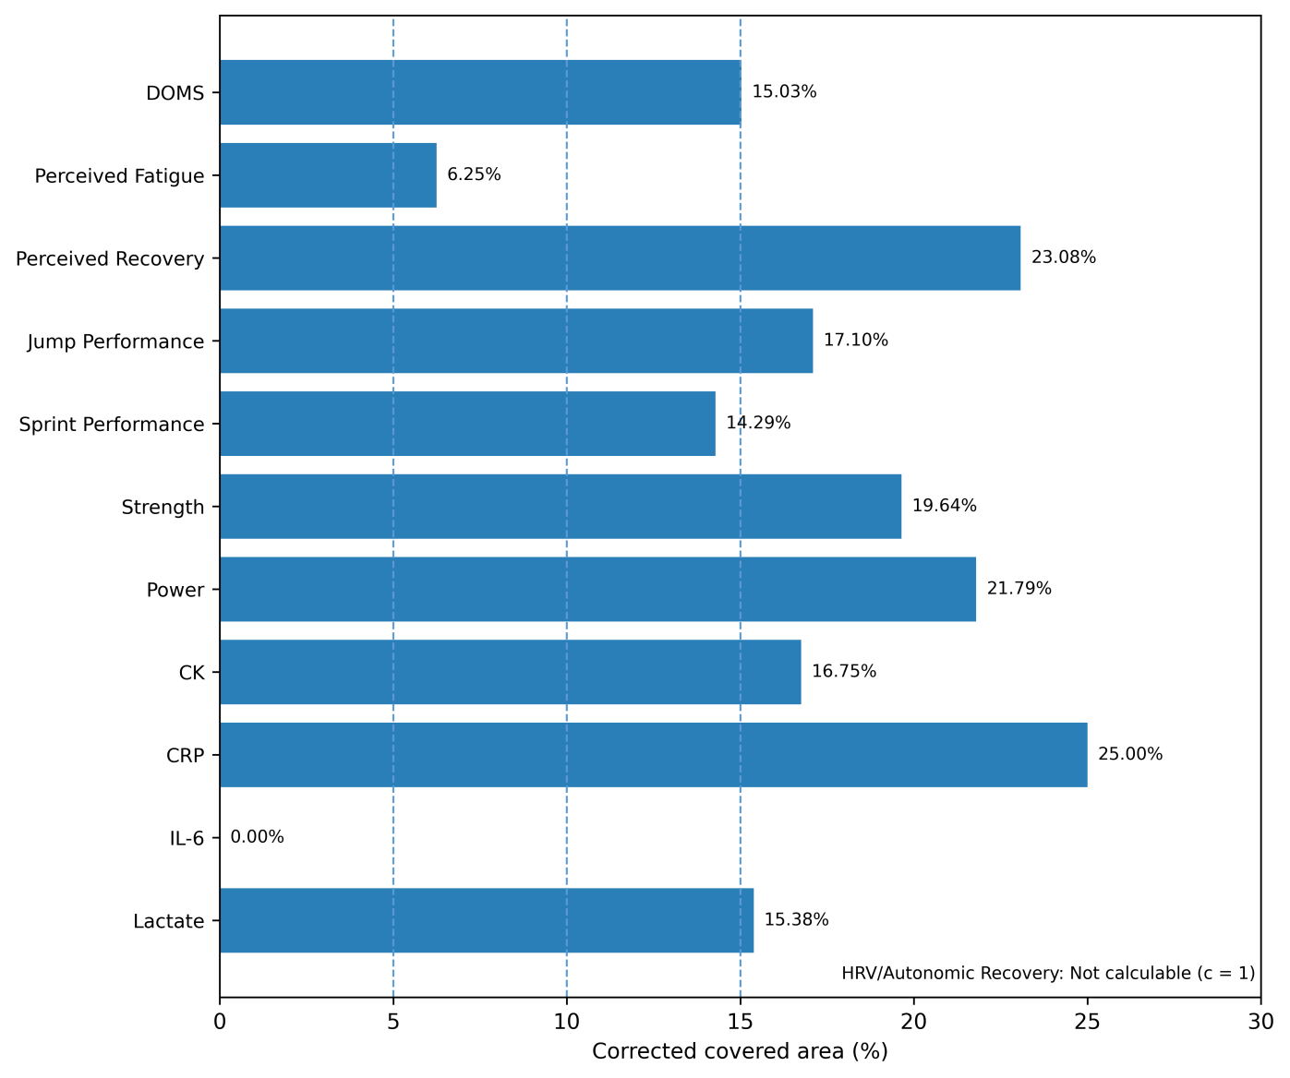
CCA is shown for outcomes represented by at least two reviews, counting the primary-study families that each review included in its analysis of the outcome. Vertical reference lines indicate the conventional 5%, 10%, and 15% thresholds. c, number of contributing reviews; CCA, corrected covered area; CK, creatine kinase; CRP, C-reactive protein; DOMS, delayed onset muscle soreness; HRV, heart rate variability; IL-6, interleukin-6.

Figure S3. Primary-study inclusion multiplicity.
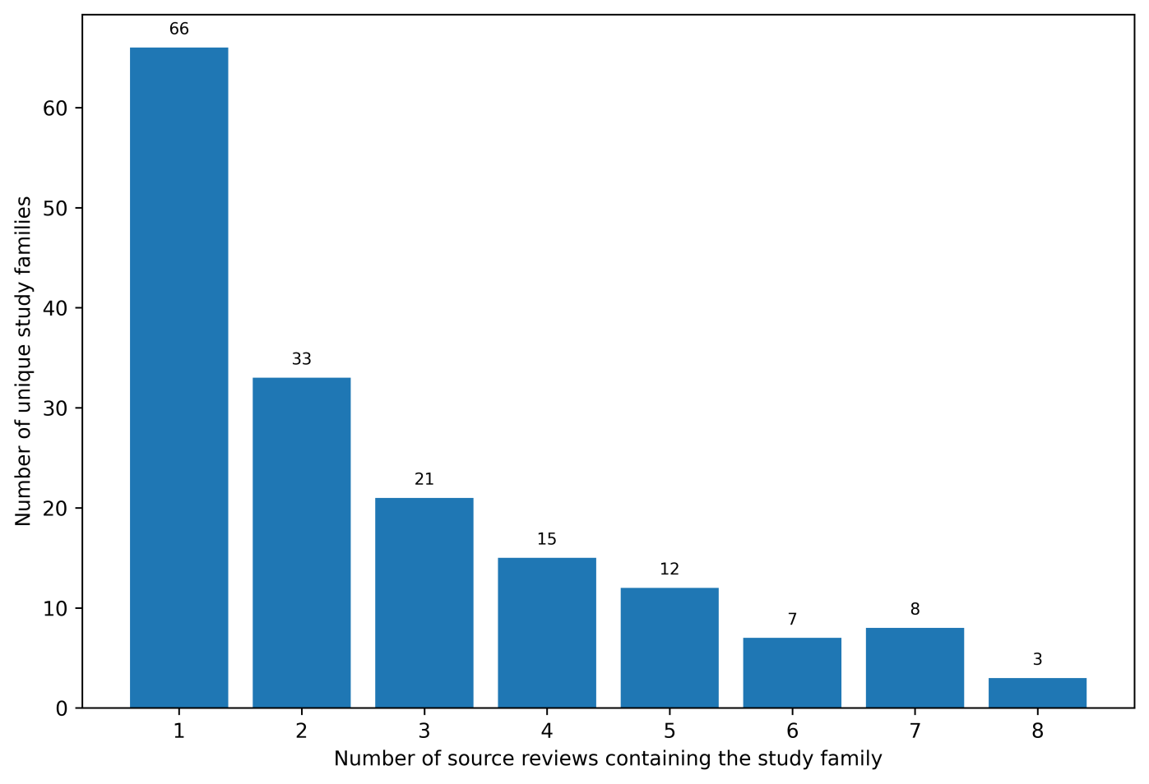
Number of unique primary-study families according to the number of reviews in which each family appeared.

Figure S4. Functional source-review SMD estimates.
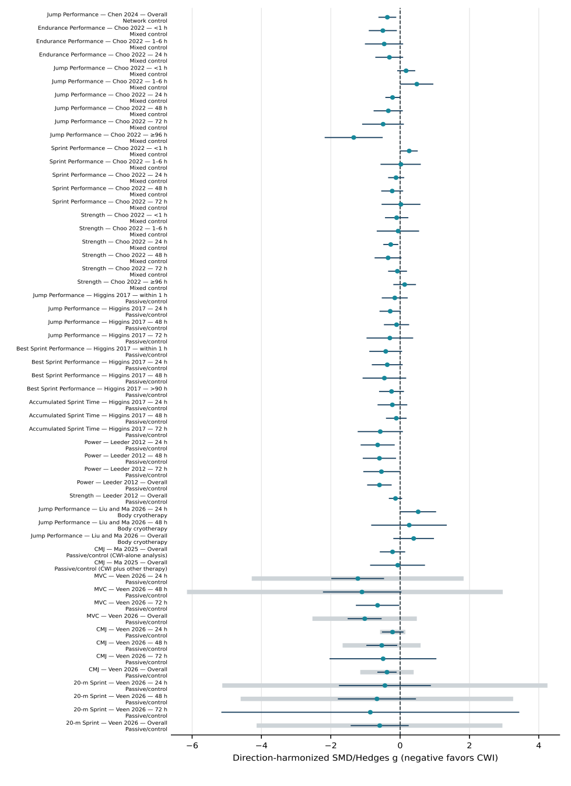
Direction-harmonized estimates and 95% CIs are shown; pale thick lines indicate direction-harmonized 95% prediction intervals where reported. Negative values favor CWI; no umbrella-level pooled estimate is shown. For Ma et al., both analyses used passive control as the comparator; the second concerns CWI combined with other therapy. CI, confidence interval; CMJ, countermovement jump; CWI, cold-water immersion; MVC, maximal voluntary contraction; SMD, standardized mean difference.

Figure S5. Biochemical and inflammatory source-review SMD estimates.
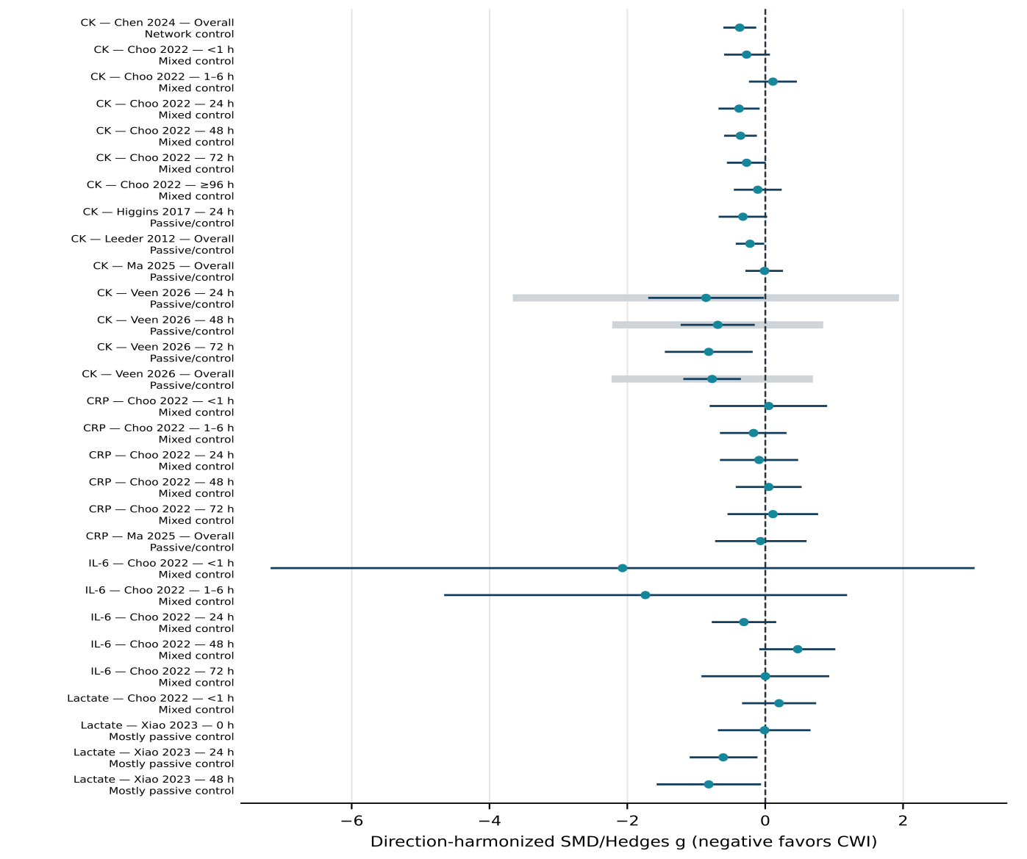
Direction-harmonized estimates and 95% CIs. Negative values favor CWI; no umbrella-level pooled estimate is shown. Pale thick lines indicate direction-harmonized 95% prediction intervals where reported. For Xiao et al. lactate at 0 h, the random-effects estimate selected by the source review is shown. CI, confidence interval; CK, creatine kinase; CRP, C-reactive protein; CWI, cold-water immersion; IL-6, interleukin-6; SMD, standardized mean difference.

Figure S6. Comparator-stratified Moore et al. (2023) estimates.
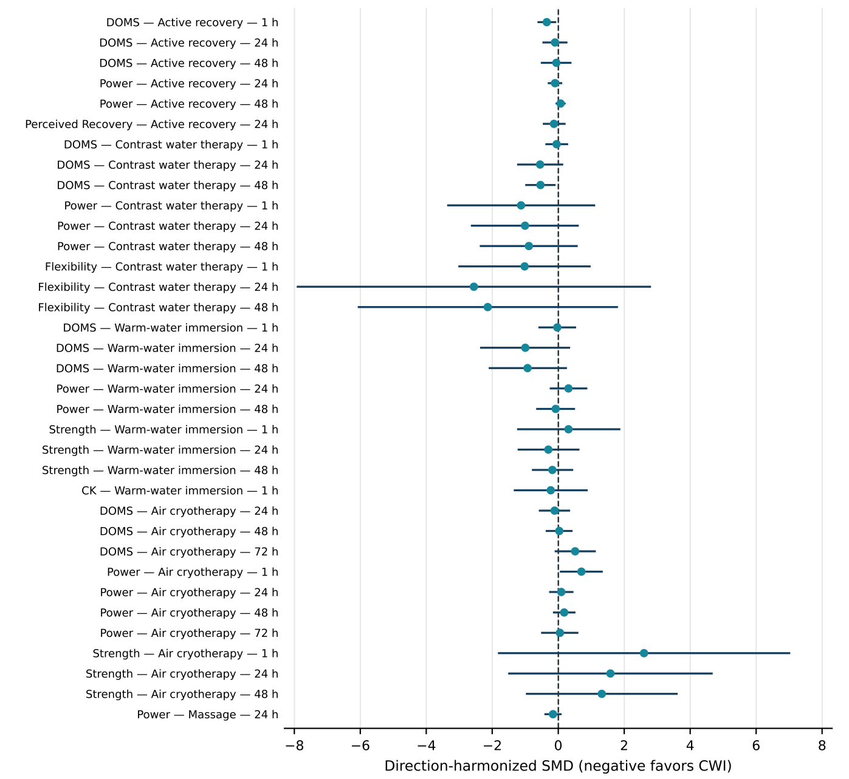
Source-review estimates by comparator and recovery time. Strata are dependent and are not pooled. Points and lines show direction-harmonized SMDs and 95% CIs; negative values favor CWI. CI, confidence interval; CK, creatine kinase; CWI, cold-water immersion; DOMS, delayed onset muscle soreness; SMD, standardized mean difference.

Figure S7. Source-review MD/WMD estimates.
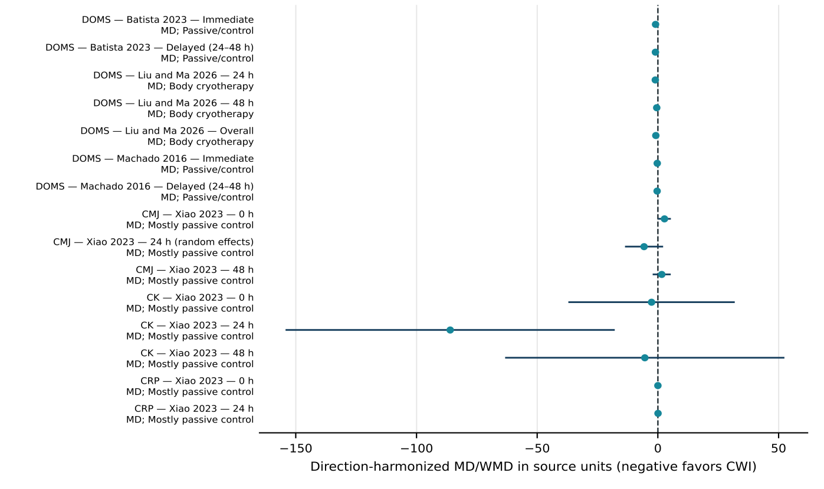
Direction-harmonized metric-specific estimates are retained in source units. Negative values favor CWI. Axis positions are interpretable only within the same outcome and metric; cross-outcome positions are not quantitatively comparable. For Xiao et al. CMJ at 24 h, the random-effects estimate selected by the source review is shown; the source text labels it SMD although the preceding forest plot reports MD. CK, creatine kinase; CMJ, countermovement jump; CRP, C-reactive protein; CWI, cold-water immersion; DOMS, delayed onset muscle soreness; MD, mean difference; WMD, weighted mean difference.

