APPENDIX

APPENDIX A: SAMPLE OF HOUSEHOLD AND FIRM QUESTIONNAIRE

KWAME NKRUMAH UNIVERSITY OF SCIENCE AND TECHNOLOGY
DEPARTMENT OF ECONOMICS
TOPIC: CONSUMER PREFERENCE AND WILLINGNESS TO PAY FOR ALTERNATIVE SOURCE OF ENERGY: A DISCRETE CHOICE EXPERIMENT.
May 2022
Dear Sir/Madam
QUESTIONNAIRES FOR ENERGY CONSUMERS (HOUSEHOLDS)
This questionnaire is intended for households with access to electricity. The researcher is seeking to investigate households’ preferences and willingness to pay for an alternative power source during power outages. Later in this survey, you will come across several choice sets with different options. You are required to select your most preferred option considering the various electricity service attributes (Purchase price, Service provider, Service Quality). The researcher would appreciate it if you could participate in this study by responding to the questions below as best you can. This is a strictly academic exercise, and all information provided will be treated with utmost confidentiality and anonymity.
Thank you.
Angela Boakye Afriyie

MODULE A: BACKGROUND INFORMATION
Q1. Gender of the Household head.  [ ] Male [ ] Female | Q2. Age of the Household head.  __________ years.
Q3. Location / Place of residence.  __________________________ | Q4. What is the size of your household?  _________________________
Q5. Housing Status  [ ] Owning  [ ] Renting  [ ] Rent- Free | Q6. Marital Status  [ ] Married  [ ] Single  [ ] Divorced
Q7. Highest education qualification  [ ] Diploma [ ] Bachelors  [ ] Master [ ] [ ] Doctorate | Q8. Kindly state your primary occupation  _________________________
Q9. Monthly income level
[ ] GHS 1250 – GHS 1999 [ ] GHS 6000 – GHS 6999
[ ] GHS 2000- GHS 2999 [ ] Above GHS 7000
[ ] GHS 3000 - GHS 3999
[ ] GHS 4000- GHS 4999
[ ] GHS 5000 – GHS 5999

MODULE B: ENERGY-RELATED QUESTIONS
Q1. What is your Household’s current source of electricity?  [ ] National Grid Connection  [ ] Local Mini Grid  [ ] Private Generator  [ ] Solar Home System  [ ] Other (Specify) _______________ | Q2. Meter Ownership  [ ] Separate Meter  [ ] Shared Meter
Q3. What is your average monthly electricity bill?  GHS ____________________ | Q4. What is your alternative source of power during power outages?  Kindly tick all that applies  [ ] Power Generators [ ] Solar PV panels  [ ] Biomass [ ] Rechargeable electric lamp  [ ] Solar lamp [ ] Torch/ Battery lamp  [ ] Candles [ ] None
Q5. How much do you spend on your alternative source of power? (Monthly)  GHS ______________ | Q6. Do you know what renewable / green energy sources are?  [ ] Yes [ ] No
Q7. Which of these renewable/green sources of energy are you familiar with?  [ ] Solar energy [ ] Biomass  [ ] Wind energy [ ] Hydro | Q8. Are you concerned about environmental pollution, global warming or climate change?  [ ] Yes [ ] No
Q9. Do you know of any renewable/green energy company in Ghana?  [ ] Yes [ ] No | Q10. Is there enough information to convince you to buy green/renewable energy?  [ ] Yes [ ] No

Q11. In your opinion, how can households be motivated toward green/ renewable energy

MODULE C: CHOICE SETS (BLUE CHOICE CARD)
Note to Enumerators: Kindly explain in detail the product attribute to respondents.
Instruction: For each choice set (1-8), kindly tick [ √] your preferred option based on different combinations of the attributes. Please note that there is no right or wrong answer; I would like to know your preference.
Before we commence, I would like to talk about a challenge that has been identified in previous studies of similar nature. Most people act differently in situations where they have to really pay for a good or service than in situations where they do not make payments. That is, they say something but do something differently. For example, some people state high prices which under normal real-world situation they will not buy an item at that price. Among others, the reason accounting for this is that in real situations people take into account their household budget. It could also possibly be that people are unable to clearly picture what product they are being offered for them to make the decisions. Please, do you understand what I am talking about? Now, we want you to behave in the same way that you would really do in making such decisions and paying to participate in the program, taking cognizance of what you really want and the alternatives presented. It is also important to take into account other constraints that I have not highlighted in this situation. Please, try to put yourself in a realistic situation and act as you would in a real-world situation.

Choice Task 1
Energy Source | Power Generators | Biomass | Solar PV panels | None
Purchase Price | GHS 775 | GHS 475 | GHS 625
Service Quality |   High service quality |   Moderate service quality |   Low service quality
Service Provider | Foreign Firm | Domestic Firm | Foreign Firm
Preferred Option | [ ] | [ ] | [ ] | [ ]
Choice Task 2
Energy Source | Biomass | Power Generators | Solar PV panels | None
Purchase Price | GHS 775 | GHS 625 | GHS 475
Service Quality | High service quality | Low service quality | Moderate service quality
Service Provider | Domestic Firm | Foreign Firm | Foreign Firm
Preferred Option | [ ] | [ ] | [ ] | [ ]
Choice Task 3
Energy Source | Biomass | Solar PV panels | Power Generators | None
Purchase Price | GHS 775 | GHS 625 | GHS 475
Service Quality | Moderate service quality | Low service quality | High service quality
Service Provider | Domestic Firm | Foreign Firm | Foreign Firm
Preferred Option | [ ] | [ ] | [ ] | [ ]
Choice Task 4
Energy Source | Power Generators | Biomass | Solar PV panels | None
Purchase Price | GHS 625 | GHS 775 | GHS 475
Service Quality | High service quality | Low service quality | Moderate service quality
Service Provider | Domestic Firm | Foreign Firm | Foreign Firm
Preferred Option | [ ] | [ ] | [ ] | [ ]
Choice Task 5
Energy Source | Power Generators | Solar PV panels | Biomass | None
Purchase Price | GHS 775 | GHS 475 | GHS 625
Service Quality | High service quality | Moderate service quality | Low service quality
Service Provider | Foreign Firm | Foreign Firm | Domestic Firm
Preferred Option | [ ] | [ ] | [ ] | [ ]
Choice Task 6
Energy Source | Power Generators | Biomass | Solar PV panels | None
Purchase Price | GHS 475 | GHS 775 | GHS 625
Service Quality | High service quality | Low service quality | Moderate service quality
Service Provider | Foreign Firm | Foreign Firm | Domestic Firm
Preferred Option | [ ] | [ ] | [ ] | [ ]
Choice Task 7
Energy Source | Power Generators | Solar PV panels | Biomass | None
Purchase Price | GHS 475 | GHS 775 | GHS 625
Service Quality | Low service quality | High service quality | Moderate service quality
Service Provider | Foreign Firm | Domestic Firm | Domestic Firm
Preferred Option | [ ] | [ ] | [ ] | [ ]
Choice Task 8
Energy Source | Biomass | Solar PV panels | Power Generators | None
Purchase Price | GHS 775 | GHS 475 | GHS 625
Service Quality | High service quality | Low service quality | Moderate service quality
Service Provider | Foreign Firm | Foreign Firm | Domestic Firm
Preferred Option | [ ] | [ ] | [ ] | [ ]

Thank you.

VISUAL ILLUSTRATIONS
For Field Officers
(Show this to participant when you are explaining the experiment and let this guide their responses)

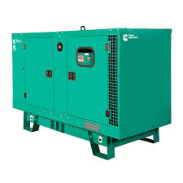
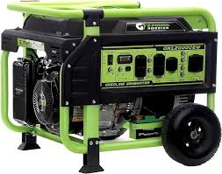
EXAMPLES OF A POWER GENERATOR
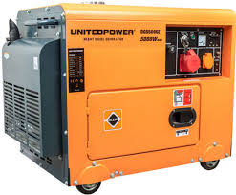
Purchase Price: GHS 625 Purchase Price: GHS 475 Purchase Price: GHS 775
Power Generator with high service quality
A power generator with premium quality service is a high-performance machine that reliably produces electricity, backed by excellent customer support. It offers dependable operation, durability, and efficiency, ensuring that users have a consistent power supply. Additionally, it comes with strong after-sales service, including easy access to maintenance, technical support, and warranty coverage, ensuring long-term satisfaction and peace of mind for the users.
Power Generator with moderate service quality
A power generator with moderate quality service is a reliable machine that produces electricity fairly well but may have some limitations in performance or features. A generator that runs reliably but might be a bit noisier or less fuel-efficient than top models. Customer support responds within a few days, providing adequate help. Maintenance and repairs are available but might require longer waiting times.
Power Generator with low service quality
A power generator with low service quality may still produce electricity but often has more frequent performance issues or less durability. Customer support is minimal or poor, with long wait times, limited maintenance options, and inadequate technical assistance, making it harder to resolve problems and maintain the generator's functionality over time. Maintenance services are limited, with long delays and poor-quality repairs.

EXAMPLES OF SOLAR PANEL SYSTEM
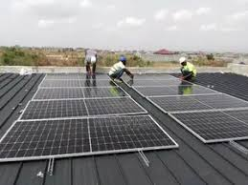
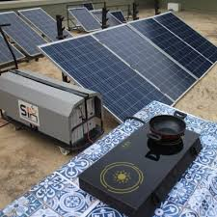
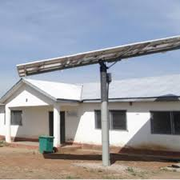
Purchase Price: GHS 475 Purchase Price: GHS 625 Purchase Price: GHS 775

Solar pv panel with high service quality
The solar panels are high-quality and generate electricity efficiently, even in less-than-ideal conditions. The company offers prompt, friendly, and knowledgeable customer service, ready to help with any questions or issues. Regular maintenance checks are scheduled to ensure optimal performance, and any repairs needed are carried out quickly and effectively. Professional installation is done correctly the first time, with clear instructions on how to use and monitor the system. Users have access to detailed manuals and can call or chat online with technical support for quick assistance.

Solar pv panel with moderate service quality
The solar panels work well and generate electricity efficiently, but may not perform optimally in all conditions. The company offers helpful customer service, but response times may vary and support may not always be as thorough. Regular maintenance is provided, but it might take longer to schedule and complete repairs. The system is installed properly, though the process may not be as smooth or as well-explained as with high service quality. Users have access to manuals and online resources, but getting in touch with technical support can be a bit slow.

Solar pv panel with low service quality
The solar panels may work but often have issues and may not be very efficient, especially in less-than-ideal conditions. The company’s customer service is hard to reach, slow to respond, and often unhelpful. Maintenance services are infrequent and slow; repairs take a long time to be completed and may not be thorough. The system is installed poorly, with potential issues like incorrect wiring, and installers provide little to no explanation or follow-up.

EXAMPLES OF A BIOMASS ENERGY
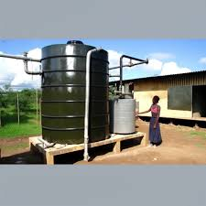
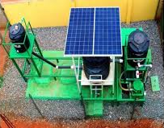
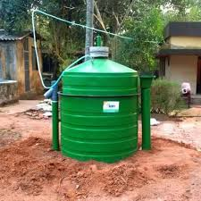

Purchase Price: GHS 425 Purchase Price: GHS 625 Purchase Price: GHS 775

Biomass energy with high service quality
Biomass energy with high service quality involves generating electricity or heat from organic materials like wood, crop waste, or animal manure, and ensuring the whole process is efficient and reliable. The biomass power plant runs smoothly and produces energy consistently without frequent breakdowns. The company provides excellent customer support, answering questions quickly and offering helpful solutions. Maintenance services are prompt and effective, ensuring the plant remains in good working condition. There are clear instructions and easy access to spare parts and technical help, so any issues are resolved quickly and efficiently.
Biomass energy with moderate service quality
The biomass power plant generally runs well, but may have occasional issues or need more frequent maintenance. Customer support is available and helpful, but it might take a few days to get a response or assistance. Local technicians can fix issues, but it might take a week or so to get parts and complete repairs. Maintenance services are good but not always fast; you might have to wait a bit longer for repairs or parts.
Biomass energy with low service quality
The system uses wood chips to heat homes in a rural area. It often malfunctions, leaving homes without reliable heat. Residents rarely get timely help from the service team, and issues are often unresolved. Scheduled maintenance is infrequent, and emergency repairs are slow, taking weeks to address. Manuals and resources are limited or hard to understand, making it tough to troubleshoot problems.

