Synergistic Decarbonization: The Role of Grid Cleanliness and New Energy Vehicle Adoption in China’s Transport-Energy Transition
Lu Weifengª , Liang Shuo^{b} , Wang Xiaolong^{c,*}
^{a,b,c}School of Economics and Management, Bozhou University, Bozhou, China

Supporting Information (SI)

Table S1 Assumptions of Basic Parameters
LCA components | Setup for this study |  | Data sources and key assumptions
System boundaries | From "cradle to grave," including:  Raw material acquisition: metal, material production.  Vehicle manufacturing: parts production, vehicle assembly.  Use phase: energy consumption of vehicle operation (electricity/gasoline).  Recycling stage: Credits for emission reduction brought about by material recycling. |  | Follow the ISO 14040/14044 standard. Emissions from infrastructure (such as charging pile manufacturing) and vehicle maintenance are ignored as they have a relatively small impact on the comparison results
Functional unit | Life cycle carbon dioxide equivalent emissions per km travelled by the vehicle |  | This unit was chosen to directly compare the efficiency of vehicles with different powertrains, in line with the literature
Key Assumptions
Battery chemistry |  | Lithium iron phosphate (LFP) batteries | Based on the research on mainstream BEV models in the market in 2021 (such as BYD Qin EV). Data mainly from the GREET model.
Lifetime mileage |  | 150,000 km | Refer to the relevant guidelines and industry research in China's Regulations on Maintenance, Better and Return Liability of Household Automobile Products, assuming that all models are the same.
Charging loss |  | 5% | The charging efficiency is 95%, which is commonly used in the field of electric vehicle charging default
Scrap recovery path |  | 90% of steel, cast iron, aluminum, and copper are recycled | The recovery rate refers to the study of Hao et al. (2017). The recycling process only considers the energy consumption and emissions of metal material regeneration.

Table S2 Mass proportion of main automobile parts
form | components | ICEV | PHEV | BEV
power system | engine | 10.1 | 8.8 | 0
power system | transmission | 8.4
power system | Power storage battery |  | 10 | 21.8
power system | fuel battery
power system | lead-acid battery | 1.3 | 0.4
power system | electrical machinery |  | 2.7 | 2.1
power system | electric control gear |  | 0.6 | 0.6
power system | main retarder |  |  | 2.1
Other components | bodywork | 42 | 42 | 41.8
Other components | base | 36.3 | 33.8 | 29.8
Other components | fluid | 1.9 | 1.7 | 1.8
Note: The data source can be found in the references (CSAE，2020; Qiao et al., 2017a; Burnham et al., 2013a; Yang et al., 2021）

Table S3 Proportion of other parts and materials by mass (unit: %)
material | transmission | gearbox | generator | bodywork | base | electrical machinery | electric control gear | main retarder | fluid
steel | 30 | 5 | 36.1 | 68.7 | 82.3 | 31.5 | 5 | 60.6
aluminum | 30 | 47 | 36.1 | 0.8 | 1 | 39.5 | 47.5 | 20
cast iron | 30 |  |  |  | 6.3
copper |  | 8.2 | 27.3 | 1.9 | 2.3 | 15.8 | 8.3 | 19
rubber | 5 | 3.7 |  | 0.51 | 4.2 |  | 3.8
plastic | 5 | 23.8 |  | 17.4 | 3.3 |  | 23 | 0.2
neodymium iron boron |  |  |  |  |  | 13.2
organic matter |  | 12.3
glass |  |  |  | 6.62
lube oil |  |  |  |  |  |  |  |  | 14.5
brake fluid |  |  |  |  |  |  |  |  | 2.8
cooling liquid |  |  |  |  |  |  |  |  | 32.2
Wiper fluid |  |  |  |  |  |  |  |  | 8.4
adhesive |  |  |  |  |  |  |  |  | 42.1
other |  |  | 0.5 | 4.07 | 0.6 |  | 12.4 | 0.2
Note: The component data of the vehicles comes from the GREET2 2017 model (Greenhouse Gas Emissions, Regulated Emissions and Energy Use in Transportation) (http://greet.es.anl.gov/)

Table S4 Mass Proportion of Automotive Engine and Battery Materials (Unit: %)
Lithium iron phosphate battery | Proportion | lead-acid battery | Proportion | engine | Proportion
active material | 22.4 | lead | 69 | aluminum | 35.7
lithium (Li) | 15.2 | sulphuric acid | 7.9 | steel | 42
aluminum | 20.3 | polypropylene | 6.1 | cast iron | 12.3
Kynoar | 12.1 | glass fibre | 2.1 | copper | 1
copper | 12.4 | lead | 14.1 | rubber | 4.5
bath solution | 18.3 | other | 0.8 | plastic | 4.5
other | 6.2
Note: The component data of the vehicles comes from the GREET2 2017 model (Greenhouse Gas Emissions, Regulated Emissions and Energy Use in Transportation) (http://greet.es.anl.gov/)

Table S5 Energy consumption of spare parts manufacturing (unit: MJ/kg)
components | electric energy | heat energy
Lithium iron phosphate battery | 27 | 8.8
lead-acid battery | 2.72
Nickel-hydrogen battery | 5.48 | 3.64
engine | 23.6
transmission | 17.97 | 10.7
bodywork | 3.43
base | 1.39 | 0.43
electrical machinery | 5.28 | 1.9
electric control gear | 1.38
main retarder | 18 | 10.07
Note: Energy consumption during vehicle assembly (Burnham et al., 2013b; Sullivan et al., 2010)

Table S6 Energy consumption of metal recycling（Hao et al., 2017）
energy | steel products | Aluminum | cast iron | copper product
Gasoline (kg) |  | 0.0000485
Diesel oil (kg) |  | 0.0000308
Natural gas (m³) | 0.0066 | 0.047
Coal (kg) |  |  | 0.313
Electricity (kWh) | 1.176 | 0.2211 | 0.622 | 2.65

Table S7 Carbon Emissions at Different Life Cycle Stages (Unit: kg CO₂e/kg)
 | ICEV | PHEV | BEV
Raw material acquisition | 5165.31 | 5677.471 | 8215.483
Manufacturing assembly | 2597.676 | 2841.468 | 3482.591
Use stage | 27383.4 | 15118.46 | 10972.89
End-of-life and recycling | -3463.98 | -3367.26 | -3331.42
Total life cycle emissions | 31682.41 | 20270.14 | 19339.55

Table S8 Proportion of carbon emissions in use stage (unit: %)
Vehicle type | Total life cycle emissions | Use stage
ICEV | 0.86 | 0.14
PHEV | 0.74 | 0.26
BEV | 0.57 | 0.43

Table S9 Benchmark Regression Results
 | lnCO2 |  | PCO2
VARIABLES | (1) | (2) | (3) | (4)
PER | -0.253** | -0.358*** | -7.111** | -8.090**
 | (-2.31) | (-2.91) | (-2.32) | (-2.36)
lnAVGDP |  | -0.123 |  | 1.256
 |  | (-0.76) |  | (0.34)
lnAVGDP2 |  | 0.059 |  | 0.929
 |  | (1.68) |  | (0.80)
lnENV |  | 0.017 |  | -0.081
 |  | (1.26) |  | (-0.25)
lnPCAR |  | 0.167 |  | 1.389
 |  | (1.62) |  | (0.58)
lnWAY |  | -0.030** |  | -0.467
 |  | (-2.38) |  | (-1.15)
lnCOMO |  | 0.004 |  | -0.112
 |  | (0.32) |  | (-0.38)
ECS |  | 0.375* |  | 10.688**
 |  | (1.94) |  | (2.32)
PRICE |  | 0.006* |  | 0.082
 |  | (1.98) |  | (1.60)
lnPOP |  | 0.095 |  | -3.713
 |  | (0.32) |  | (-0.53)
Constant | 19.387*** | 16.941*** | 8.174*** | 17.390
 | (2,399.98) | (7.05) | (47.56) | (0.29)
Observations | 210 | 210 | 210 | 210
R-squared | 0.758 | 0.811 | 0.448 | 0.564
Number of provinces | 30 | 30 | 30 | 30
City FE | Yes | Yes | Yes | Yes
Year FE | Yes | Yes | Yes | Yes
Note: *, **, and *** represent significance at the 10%, 5%, and 1% levels, respectively.

Table S10 Other robustness test results
 | Control the industrial  sector |  | Control of enterprise departments |  | Exclude some  samples
VARIABLES | lnCO2 | PCO2 | lnCO2 | PCO2 | lnCO2 | PCO2
PER | -0.267** | -4.509 | -0.253** | -3.762* | -0.393** | -0.828**
 | (-2.22) | (-1.51) | (-2.63) | (-1.73) | (-2.54) | (-2.22)
lnNET |  |  | -0.004 | -0.209
 |  |  | (-0.32) | (-1.05)
lnFIRM |  |  | 0.184** | 7.831***
 |  |  | (2.05) | (2.82)
IND | -0.050 | -1.950*
 | (-1.55) | (-1.85)
Constant | 17.016*** | 20.347 | 17.130*** | 25.328 | 17.008*** | 24.015
 | (7.17) | (0.35) | (7.53) | (0.49) | (6.40) | (0.38)
Observations | 210 | 210 | 209 | 209 | 175 | 175
R-squared | 0.814 | 0.590 | 0.821 | 0.650 | 0.800 | 0.585
Number of provinces | 30 | 30 | 30 | 30 | 25 | 25
City FE | Yes | Yes | Yes | Yes | Yes | Yes
Year FE | Yes | Yes | Yes | Yes | Yes | Yes
Note: *, **, and *** represent significance at the 10%, 5%, and 1% levels, respectively. In the benchmark regression model, this study incorporates control variables for economic activities in non-transportation sectors to address potential omitted variable bias. First, at the industry level, the influence of industrial activity is captured by including the share of secondary industry value-added in GDP (IND). At the firm level, enterprise operating conditions are controlled by introducing the logarithms of private enterprise profits (NET) and private enterprise value-added (FIRM), respectively. By accounting for these key confounding factors that may simultaneously influence both the adoption of new energy vehicles (NEVs) and regional carbon emission levels, the model enables a more precise estimation of the net effect of NEVs on emissions. Furthermore, to strengthen the robustness assessment, a stringent sample exclusion test is conducted by removing observations from representative "industrial powerhouses"—Beijing, Shanghai, Shandong, Jiangsu, and Guangdong. The rationale is that if the observed emission reductions are primarily driven by strong industrial decarbonization trends in these regions, the estimated coefficients would be expected to diminish substantially or lose statistical significance upon their removal. As shown in the table above, even after controlling for industry- and firm-level variables and excluding data from major industrial provinces/cities, the coefficients on the core explanatory variables remain statistically significant, reinforcing the robustness of the main findings.

Table S11 The endogeneity analysis based on the instrumental variable method
 | LnCO2 |  | PCO2
VARIABLES | First | Second | First | Second
IV | 0.022*** |  | 0.022***
 | (9.96) |  | (9.96)
PER |  | -0.327** |  | -5.971*
 |  | (-2.26) |  | (-1.82)
Control variables | Yes | Yes | Yes | Yes
Observations | 210 | 210 | 210 | 210
Number of provinces | 30 | 30 | 30 | 30
F value | 99.198 |  | 99.2
Cragg-Donald Wald F statistic |  | 50.618 |  | 50.62
Note: *, **, and *** represent significance at the 10%, 5%, and 1% levels, respectively, The Stock-Yogo weak ID test critical value is 16.38 at the 10 % level. To address potential endogeneity concerns, this study adopts the instrumental variable (IV) approach for appropriate control. In selecting the instrumental variable, provincial-level foreign direct investment (FDI) is employed as the IV. The validity of this instrument is justified through two key aspects: First, FDI exerts a significant influence on the development scale of the NEV industry via mechanisms such as technology spillovers and industrial chain optimization, and demonstrates a strong correlation with NEV sales volume. Consequently, this variable satisfies the relevance condition required of instrumental variables. Second, FDI primarily affects carbon emission levels indirectly through technological pathways, with no direct link to the error term associated with NEV sales volume, fulfilling the exogeneity requirement of instrumental variables. Regarding the methodological approach, this study employed two-stage least squares (2SLS) regression to conduct robustness checks on the benchmark regression results. The relevant regression results are presented in Table S11, in the first stage of the regression, the coefficients of the IV are all significantly positive at the 1% significance level, and the Cragg-Donald Wald F statistics all exceed the standard of the 10% critical value, effectively eliminating the problem of weak instrumental variables, indicating that the selected instrumental variables have good validity. After estimation using the 2SLS, the coefficients of the policy variables are all negative and pass the 5% and 10% significance test, indicating that the core research conclusion remains valid after considering the endogeneity problem. However, although the IV is correlated with the endogenous variable, the condition that it strictly satisfies the exclusion restriction may be difficult to hold completely. Therefore, the IV estimation results are placed in the appendix for reference.

Table S12 The policy of new energy vehicles promotion
Policy type | Definition and Description | Main Implementation Method | Policy Objectives
Purchase Subsidy | The government directly provides financial subsidies to reduce the initial cost for consumers to purchase new energy vehicles. The document explicitly lists it as a core incentive measure. | Joint subsidies from central and local finances (such as the policy in 2013), with subsidy amounts linked to the vehicle's range and a gradual tapering mechanism (transitioning to market mechanisms after 2021). | Lower the threshold for car purchases and accelerate the penetration of the private market.
Right of Way Priority | Granting traffic privileges to new energy vehicles, such as dedicated lanes and exemption from traffic restrictions. | Establish dedicated lanes for NEVs in urban core areas; exempt them from traffic restrictions and license plate restrictions; and grant them priority passage rights, such as sharing bus lanes. | Enhance the convenience of NEV usage and increase user stickiness.
Charging Infrastructure Support | Government-led construction of charging piles, battery swap stations and other infrastructure. | Subsidies for public charging station construction; mandatory requirements for community and workplace facilities; promotion of battery standardization and battery swap networks. | Reduce usage costs and enhance the practicality of NEVs.
Non-incentive Policies | Non-incentive Policies: Non-fiscal incentives, such as government priority procurement or administrative directives. | Mandatory proportion of electrification for government and state-owned enterprise fleets; priority procurement of NEVs in public transportation; exemption from license plate auction fees | Reduce usage costs and enhance the practicality of NEVs.

Table S13 Results of heterogeneity treatment effects
 | Group-Time DID |  | Imputation DID
VARIABLES | LnCO2 | PCO2 | lnCO2 | PCO2
Policy | -0.033** | -0.36** | -0.047* | -0.45
 | (-1.95) | (-2.24) | (-1.77) | (-1.46)
Controls | Yes | Yes | Yes | Yes
Province FE | Yes | Yes | Yes | Yes
Year FE | Yes | Yes | Yes | Yes
N | 330 | 330 | 770 | 770
Note: *, **, and *** represent significance at the 10%, 5%, and 1% levels, respectively. First, following the Group-Time DID approach proposed by Sun and Abraham (2021), this method mitigates the weighting bias inherent in traditional DID under heterogeneous treatment effects by decomposing the treatment effect along two dimensions: “policy entry cohort” and “relative policy time”. Second, we adopt the Imputation DID estimator developed by Borusyak et al. (2024), which constructs counterfactual trajectories for each treated unit in the absence of intervention, thereby further reducing estimation bias arising from staggered treatment timing. Table 12 presents the regression results from both methods. The findings indicate that, with the exception of column (4) in Table 11, the policy's inhibitory effect on carbon emissions is consistently negative and statistically significant across all specifications. This consistency in magnitude, direction, and significance strongly confirms the robustness of the baseline estimates. Therefore, the evidence demonstrates that the new energy vehicle promotion policy not only yields a statistically significant reduction in carbon emissions but also maintains its validity under multiple approaches for addressing heterogeneous treatment effects.

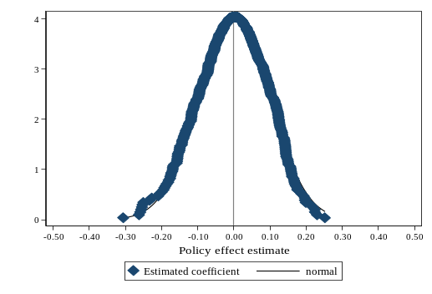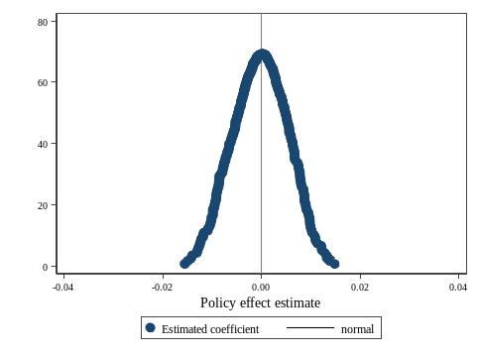
(a) (b)
Fig. S1. Placebo Test
Note: (a) The explained variable is the logarithm of carbon emissions, (b) The explained variable is the per capita carbon emissions. Based on the research sample, this study randomly generates a list of provinces designated as promoting new energy vehicles, constructs a placebo treatment variable (Policy), and conducts 1,000 replications of the regression on the per capita carbon emission index using the specification in Equation (1). The figure above displays the distribution of the estimated regression coefficients and their corresponding p-values. The results show that the coefficients from the random assignments are tightly clustered around zero and approximate a normal distribution. The actual coefficient from the baseline regression is represented by the red dashed vertical line on the left, which lies far outside the central mass of the placebo distribution and exhibits minimal overlap with the simulated estimates. This confirms that in the absence of a genuine policy effect, the estimated impacts are statistically indistinguishable from zero—consistent with the expectations of a placebo test. Consequently, the policy effect identified in the main analysis is unlikely to arise from spurious correlations or random noise, reinforcing the robustness of the regression results.

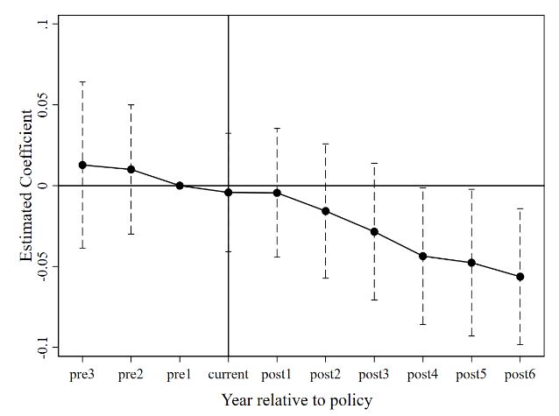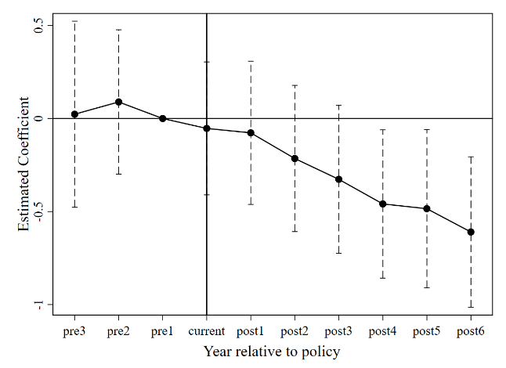
(a) (b)
Fig. S2. The results of the parallelism trend test
Note: (a) The explained variable is the logarithm of carbon emissions, (b) The explained variable is the per capita carbon emissions. The parallel trend test was conducted using the Group-Time DIDs method proposed by Sun and Abraham (2021). The figure above displays the event study estimation results based on this approach. The estimated treatment effects in all periods prior to policy implementation are not statistically significant and cluster closely around zero, with all corresponding confidence intervals containing zero. This indicates that the outcome trends of the treatment and control groups followed a common trajectory before the intervention, satisfying the parallel trends assumption. Following policy implementation, deviations emerge in some post-treatment periods; however, these reflect dynamic treatment effects rather than violations of identification assumptions. The horizontal axis “Year relative to policy” shows years relative to policy implementation: -3 to -1 indicate 3, 2, and 1 years before implementation; 0 is the implementation year; and 1-6 denote the first through sixth years after. The vertical axis displays standardized changes in carbon emissions. The dashed line indicates the 95% confidence interval.

Reference
Borusyak, K., Jaravel, X., & Spiess, J. (2024). Revisiting event-study designs: robust and efficient estimation. Review of Economic Studies, 91(6), 3253-3285.
China Society of Automotive Engineers. (2020). Energy Saving and New Energy Vehicle Technology Roadmap 2.0.
Hao, H., Mu, Z., Jiang, S., Liu, Z., & Zhao, F. (2017). GHG emissions from the production of lithium-ion batteries for electric vehicles in China. Sustainability, 9(4), 504.
Qiao, Q., Zhao, F., Liu, Z., Jiang, S., & Hao, H. (2017). Cradle-to-gate greenhouse gas emissions of battery electric and internal combustion engine vehicles in China. Applied energy, 204, 1399-1411.
Sullivan, J. L., Burnham, A., & Wang, M. (2010). Energy-consumption and carbon-emission analysis of vehicle and component manufacturing (No. ANL/ESD/10-6). Argonne National Lab.(ANL), Argonne, IL (United States).
Sullivan, J. L., Burnham, A., & Wang, M. Q. (2013). Model for the part manufacturing and vehicle assembly component of the vehicle life cycle inventory. Journal of industrial ecology, 17(1), 143-153.
Sun, L., & Abraham, S. (2021). Estimating dynamic treatment effects in event studies with heterogeneous treatment effects. Journal of Econometrics, 225(2), 175-199.
Yang, L., Yu, B., Yang, B., Chen, H., Malima, G., & Wei, Y. M. (2021). Life cycle environmental assessment of electric and internal combustion engine vehicles in China. Journal of Cleaner Production, 285, 124899.

