Dietary inclusion of fibrous corn silages reduces gastric mucosa damage in fattening heavy pigs

Spanghero M., Braidot M.*, Orioles, M., Sarnataro C., Pividori I., Romanzin A.

Department of Agricultural, Food, Environmental and Animal Sciences, University of Udine, Via Sondrio, 2/A, 33100 Udine, Italy

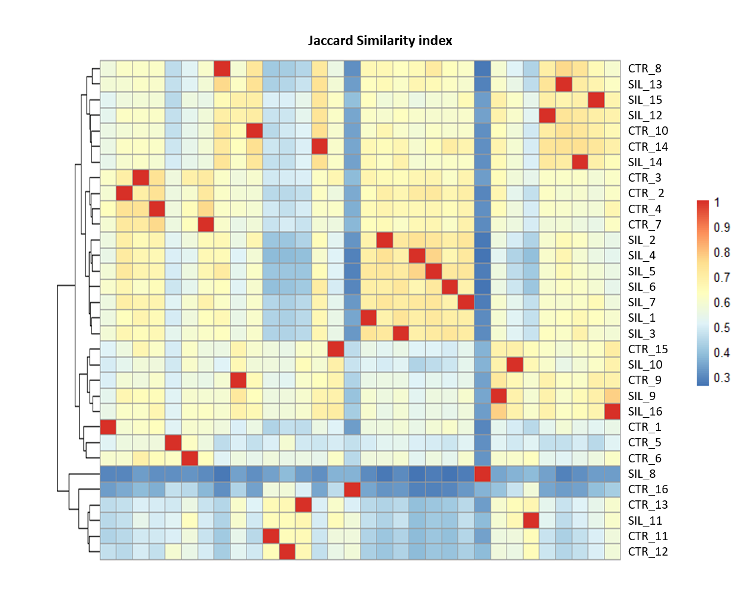
Supplementary material
Figure S2. The Jaccard similarity index (beta diversity) calculated for samples of gut microbiota collected from subjects fed with the control diet (CTR) or the silage diet (SIL). A score equal to 1 represents 100% similarity between samples.

