Appendix 1. Variable dictionary

 | Variable name | Description | Variable type | Values / Units
 | Client ID | Unique identifier for each respondent | Categorical (nominal) | Alphanumeric code
Sociodemographic characteristics | Gender | Self-identified gender | Categorical (nominal) | Male / Female / Other
Sociodemographic characteristics | Age | Respondent’s age | Quantitative (continuous) | Years
Sociodemographic characteristics | Other diploma | Additional degrees or certifications obtained | Categorical (nominal) | National specialization / European certificate / Other (multiple responses possible)
Sociodemographic characteristics | Status | Current employment type | Categorical (nominal) | Private practitioner / Employee
Sociodemographic characteristics | Company size | Size of the employing organization | Ordinal | <5 employees / 5–10 employees / 10–50 employees / >50 employees
Sociodemographic characteristics | Vets’ proportions | Proportion of veterinarians in the organization | Quantitative (continuous) | Percentage (0 to 100%)
Sociodemographic characteristics | Years of exp. | Years of experience working in swine production | Categorical (nominal) | <5 years / 5–10 years / >10 years
Sociodemographic characteristics | Contract | Employment status | Categorical (nominal) | Full-time / Part-time
Sociodemographic characteristics | Swine proportion | Share of work activities dedicated to pig consulting | Quantitative (continuous) | Percentage (0 to 100%)
Sociodemographic characteristics | Country | Country in which the respondent mostly works | Categorical (nominal) | One of 30 listed European countries (e.g., France, Germany, Spain, etc.)
Professional interactions & exchanges | Meeting frequencies | Do you usually work in a team within your organization? | Categorical (ordinal) | Never (0) – Very often (4)
Professional interactions & exchanges | Teamwork | Teamwork for Implementation of diagnosis / Techno-economic analysis / Herd monitoring / Lab result interpretation | Categorical (ordinal, ranked) | From 1 to 4 (ordered)
Professional interactions & exchanges | Laboratories exchanges | Frequency of interaction with each peer type | Categorical (ordinal) | Rarely (1) – Very often (4)
Professional interactions & exchanges | Vets’ exchanges | Frequency of interaction with each peer type | Categorical (ordinal) | Rarely (1) – Very often (4)
Professional interactions & exchanges | Technicians’ exchanges | Frequency of interaction with each peer type | Categorical (ordinal) | Rarely (1) – Very often (4)
Professional interactions & exchanges | Authorities’ exchanges | Frequency of interaction with each peer type | Categorical (ordinal) | Rarely (1) – Very often (4)
Professional interactions & exchanges | Continuing education | Frequency of involvement in evidence-based activities (reading publications, attending congresses/seminars, trainings) | Numerical (percentage) | 0 to 100% of working time
Professional interactions & exchanges | Performance monitoring | Technical and economic performance indicators monitoring | Categorical (nominal) | Yes / No / It depends
Evidence-Based Veterinary Medicine | Knowledge | Had you heard of Evidence-Based Medicine (EBM) before we contacted you? | Categorical (binary) | Yes / No
Evidence-Based Veterinary Medicine | Usefulness | Do you find this approach useful in supporting decision-making? | Categorical (nominal) | Yes / No / It depends
Evidence-Based Veterinary Medicine | Barriers | Do you have any reluctance or barriers to using the EBM approach? | Categorical (binary) | Yes / No
Evidence-Based Veterinary Medicine | Development in practice | In your opinion, is the EBM approach sufficiently developed in daily practice? | Ordinal (Likert) | 1 = Strongly disagree /  2 = Somewhat disagree /  3 = Somewhat agree / 4 = Strongly agree
PRRSV management and practices | Prevalence | Estimated prevalence of PRRSV in the respondent’s country | Quantitative (continuous) | Percentage (0 to 100%)
PRRSV management and practices | Genotype | PRRSV genotypes encountered | Categorical (nominal) | Type I / Type II / Both / None
PRRSV management and practices | Sampling | Who primarily performs the biological samplings | Categorical (nominal) | Farmer / Myself / Technician / Other
PRRSV management and practices | Lab access | Easy access to diagnostic laboratory facilities | Categorical (binary) | Yes / No
PRRSV management and practices | Partial sequencing | Access to partial sequencing (e.g., ORF5 and/or ORF7) | Categorical (nominal) | Yes / No / Don’t know
PRRSV management and practices | Whole genome sequencing | Access to full genome sequencing | Categorical (nominal) | Yes / No / Don’t know
PRRSV management and practices | PRRSV cases | Frequency of PRRSV clinical cases encountered in practice | Ordinal (Likert) | 0 = Never /  1 = Rarely /  2 = Occasionally  (<6 cases/year) /  3 = Often  (≥1 case/month) /  4 = Very often
PRRSV management and practices | Diagnostic procedure | Presence of predefined diagnostic procedures | Categorical (binary) | Yes / No
PRRSV management and practices | Company consensus for diagnostic | Basis of diagnostic procedures | Categorical (binary) | Yes / No
PRRSV management and practices | Regulatory recommendations for diagnostic | Basis of diagnostic procedures | Categorical (binary) | Yes / No
PRRSV management and practices | Professional consensus for diagnostic | Basis of diagnostic procedures | Categorical (binary) | Yes / No
PRRSV management and practices | Sow diagnostic tools | Sufficiency of resources to diagnose in sows | Categorical (binary) | Yes / No
PRRSV management and practices | Piglets’ diagnostic tools | Sufficiency of resources to diagnose in post-weaning/fattening pigs | Categorical (binary) | Yes / No
PRRSV management and practices | MLV1 access | Access to PRRS vaccines | Categorical (binary) | Yes / No
PRRSV management and practices | MLV2 access | Access to PRRS vaccines | Categorical (binary) | Yes / No
PRRSV management and practices | Inactivated vaccine access | Access to PRRS vaccines | Categorical (binary) | Yes / No
PRRSV management and practices | Autogenous vaccine access | Access to PRRS vaccines | Categorical (binary) | Yes / No
PRRSV management and practices | Vaccine regulations | Whether vaccination is subject to regulation | Categorical (binary) | Yes / No
PRRSV management and practices | Live vaccine for sows? | Recommendation to use inactivated vaccine alone in sows | Categorical (nominal) | Yes / No / No opinion
PRRSV management and practices | MLV for sows? | Recommendation to use live vaccine alone in sows | Categorical (nominal) | Yes / No / No opinion
PRRSV management and practices | Both combine for sows? | Recommendation to use both types in combination | Categorical (nominal) | Yes / No / No opinion
PRRSV management and practices | Effective live vaccine for sows? | Perceived efficacy of inactivated vaccine alone in sows | Categorical (ordinal) | 1 = Not effective at all to 4 = Very effective
PRRSV management and practices | Effective MLV for sows? | Perceived efficacy of live vaccine alone in sows | Categorical (ordinal) | 1 = Not effective at all to 4 = Very effective
PRRSV management and practices | Effective both for sows? | Perceived efficacy of combined vaccination in sows | Categorical (ordinal) | 1 = Not effective at all to 4 = Very effective
PRRSV management and practices | Live vaccine for piglets? | Recommendation to use inactivated vaccine alone in post-weaning/fattening pigs | Categorical (nominal) | Yes / No / No opinion
PRRSV management and practices | MLV for piglets? | Recommendation to use live vaccine alone in post-weaning/fattening pigs | Categorical (nominal) | Yes / No / No opinion
PRRSV management and practices | Both combine for piglets? | Recommendation to use both types in combination | Categorical (nominal) | Yes / No / No opinion
PRRSV management and practices | Effective live vaccine for piglets? | Perceived efficacy of inactivated vaccine alone in post-weaning/fattening pigs | Categorical (ordinal) | 1 = Not effective at all to 4 = Very effective
PRRSV management and practices | Effective MLV for piglets? | Perceived efficacy of live vaccine alone in post-weaning/fattening pigs | Categorical (ordinal) | 1 = Not effective at all to 4 = Very effective
PRRSV management and practices | Effective both for piglets? | Perceived efficacy of combined vaccination in post-weaning/fattening pigs | Categorical (ordinal) | 1 = Not effective at all to 4 = Very effective
PRRSV management and practices | Vaccine combination | Combined use of multiple live modified vaccines in a single farm | Categorical (binary) | Yes / No
PRRSV stabilization programs | Stabilization program | Have you ever implemented stabilization programs? | Categorical (binary) | Yes / No
PRRSV stabilization programs | %succes | Estimated success rate of stabilization programs in the last two years (%) | Quantitative (continuous) | 0 to 100%
PRRSV stabilization programs | Lack of tools | Technical tools (apps, calculators, etc.) were missing to obtain 100% of success | Categorical (binary) | Yes / No
PRRSV stabilization programs | Lack of farmer cooperation | Farmer cooperation was missing to obtain 100% of success | Categorical (binary) | Yes / No
PRRSV stabilization programs | Lack of evidence | Scientific arguments or evidence were missing to obtain 100% of success | Categorical (binary) | Yes / No

Appendix 2. Illustration of the three sociodemographic profiles of the swine veterinarians
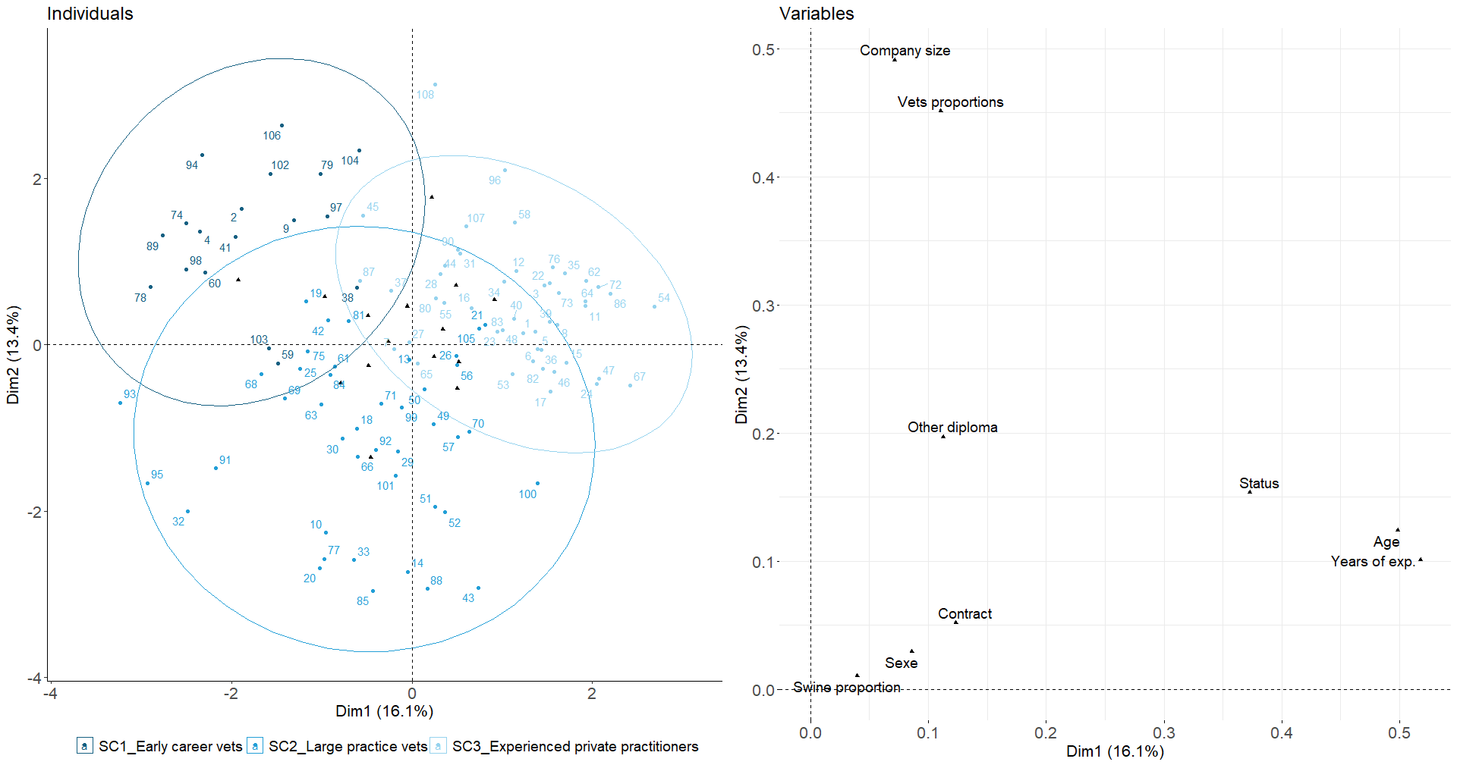
Legend: FAMD biplot illustrating the distribution of individuals and the contribution of categorical and continuous variables. The individuals are represented as points, while categorical variables are displayed as vectors. The plot shows the relationships between the first and second principal components, with continuous variables shown on the axes and categorical variables color-coded for clarity. The variance explained by each component is also indicated in the inset.

Appendix 3. Illustration of the three profiles of the swine veterinarians regarding their professional exchange and interaction

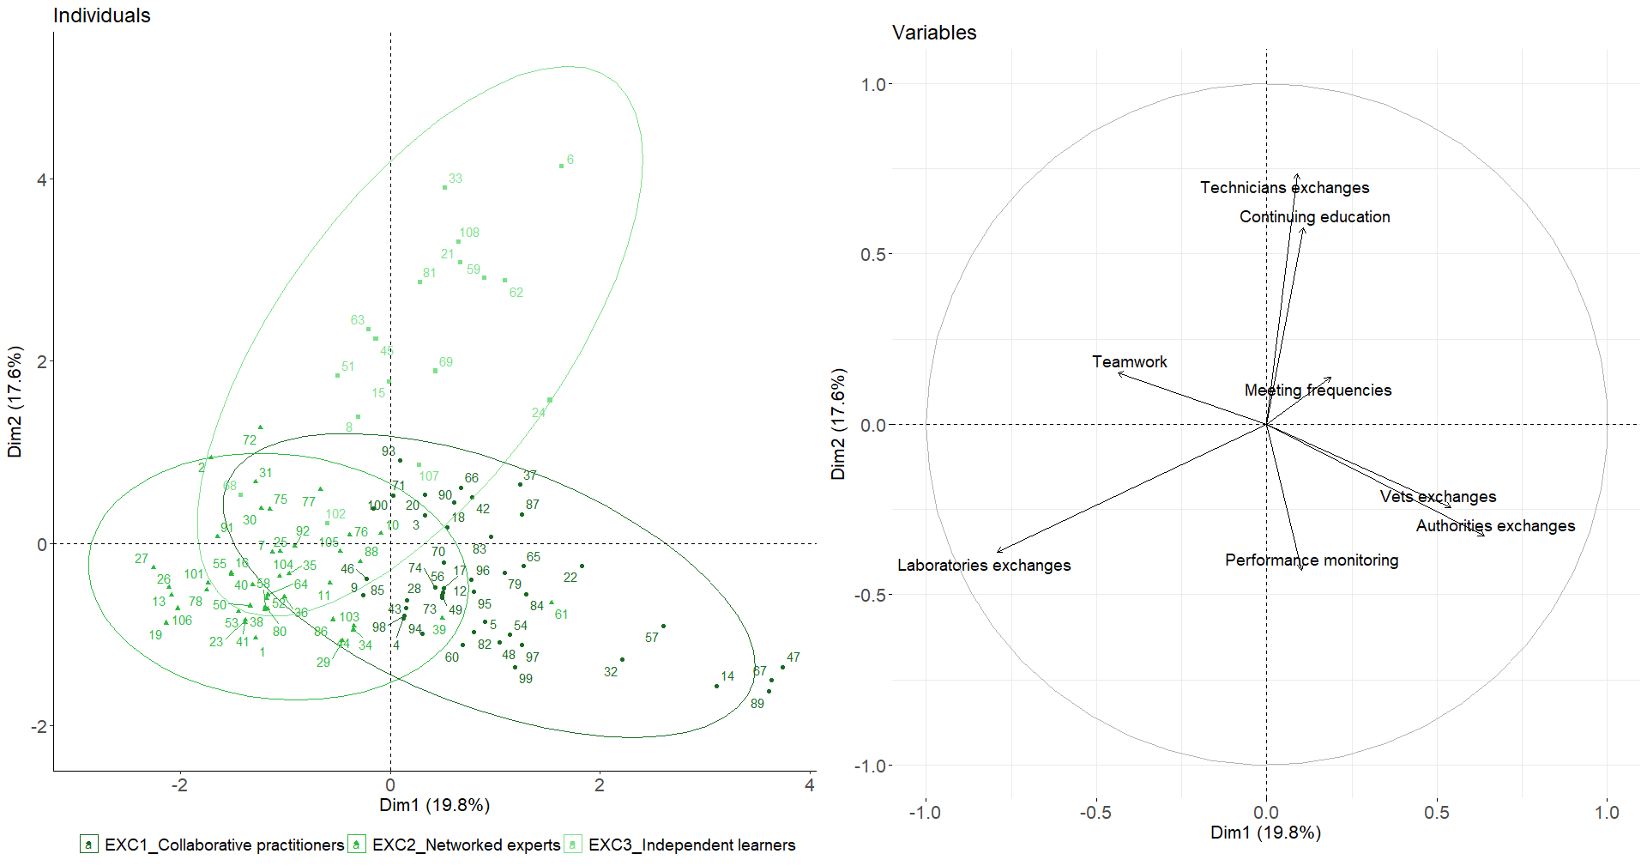
Legend: PCA biplot illustrating the distribution of individuals and the contribution of categorical and continuous variables. The individuals are represented as points, while categorical variables are displayed as vectors. The plot shows the relationships between the first and second principal components, with continuous variables shown on the axes and categorical variables color-coded for clarity. The variance explained by each component is also indicated in the inset.

Appendix 4. Illustration of the three profiles of the swine veterinarians regarding EBVM

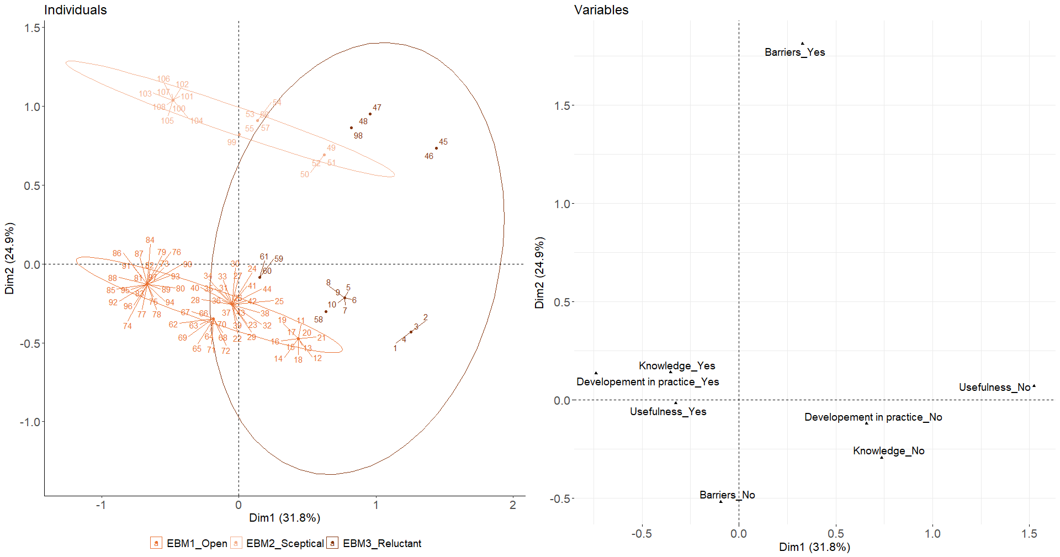

Legend: MCA biplot illustrating the distribution of individuals and the contribution of categorical and continuous variables. The individuals are represented as points, while categorical variables are displayed as vectors. The plot shows the relationships between the first and second principal components, with continuous variables shown on the axes and categorical variables color-coded for clarity. The variance explained by each component is also indicated in the inset.

Appendix 5. Illustration of the three profiles of the swine veterinarians regarding PRRSV

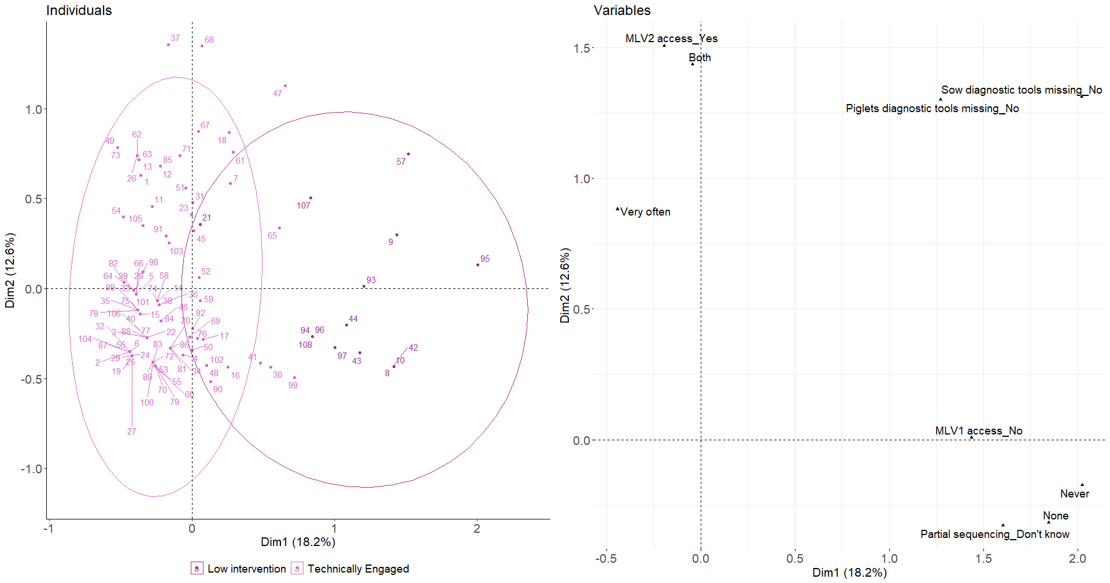
Legend: MCA biplot illustrating the distribution of individuals and the contribution of categorical and continuous variables. The individuals are represented as points, while categorical variables are displayed as vectors. The plot shows the relationships between the first and second principal components, with continuous variables shown on the axes and categorical variables color-coded for clarity. The variance explained by each component is also indicated in the inset.

Appendix 6. Illustration of the three profiles of the swine veterinarians regarding their PRRSV stabilisation programs’ experiences

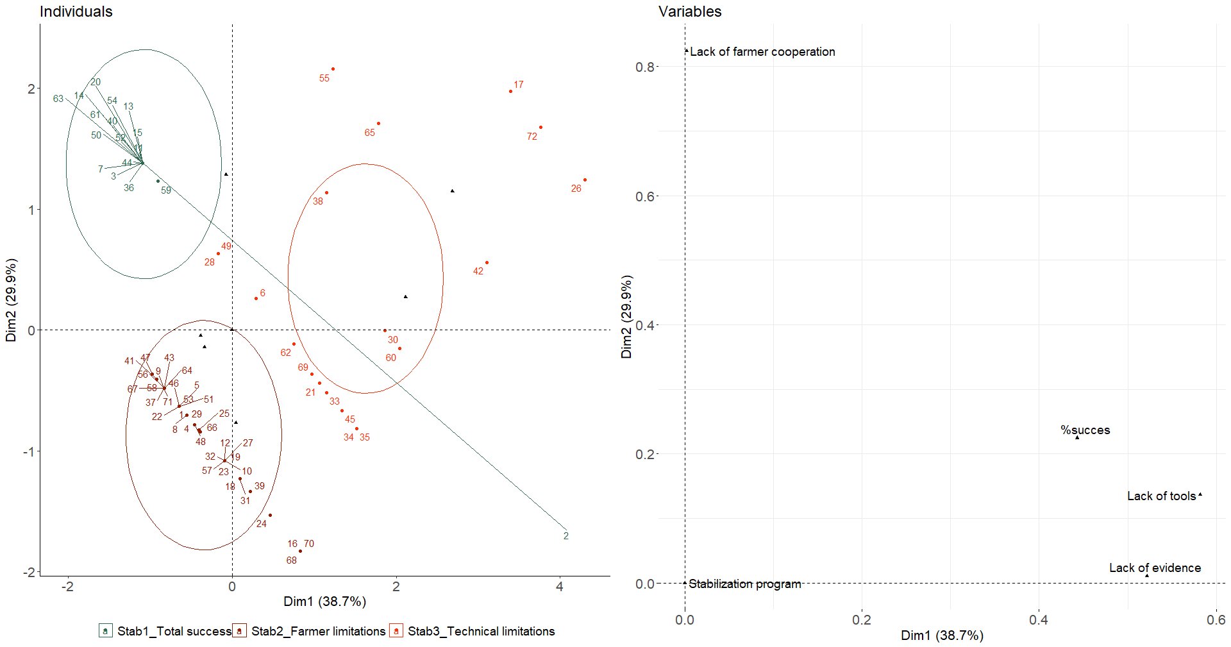
Legend: FAMD biplot illustrating the distribution of individuals and the contribution of categorical and continuous variables. The individuals are represented as points, while categorical variables are displayed as vectors. The plot shows the relationships between the first and second principal components, with continuous variables shown on the axes and categorical variables color-coded for clarity. The variance explained by each component is also indicated in the inset.

