Supplementary Table 1. Annual and regional distribution of Korean PRRSV-2 ORF5 sequences included in this study (2018–2024). Sequences were obtained from clinical samples submitted to the Jeonbuk National University Veterinary Diagnostic Center (JBNU-VDC), Kyungpook National University (KNU), and from GenBank (NCBI). To minimize redundancy, a total of 1305 sequences were subsampled using CD-HIT at a 99.9% similarity threshold. Numbers represent the counts of non-redundant sequences per year and geographic region: GG (Gyeonggi), CB (Chungbuk), CN (Chungnam), GB (Gyeongbuk), GN (Gyeongnam), JB (Jeonbuk), JN (Jeonnam), GW (Gangwon), JJ (Jeju), and Unknown (region not available). The merged dataset, covering all major swine-producing regions of Korea, was used to generate the final non-redundant panel of 907 ORF5 sequences.
JBNU-VDC | Region | 2018 | 2019 | 2020 | 2021 | 2022 | 2023 | 2024 | Sum
JBNU-VDC | GG | 0 | 2 | 0 | 16 | 26 | 20 | 40 | 104
JBNU-VDC | CB | 1 | 0 | 0 | 4 | 9 | 2 | 5 | 21
JBNU-VDC | CN | 0 | 0 | 0 | 11 | 21 | 14 | 33 | 79
JBNU-VDC | GB | 1 | 0 | 0 | 4 | 3 | 8 | 10 | 26
JBNU-VDC | GN | 1 | 84 | 1 | 33 | 30 | 25 | 116 | 290
JBNU-VDC | JB | 1 | 0 | 0 | 9 | 8 | 9 | 29 | 56
JBNU-VDC | JN | 2 | 0 | 0 | 6 | 13 | 5 | 23 | 49
JBNU-VDC | GW | 0 | 0 | 0 | 0 | 0 | 0 | 0 | 0
JBNU-VDC | JJ | 0 | 0 | 0 | 0 | 0 | 0 | 0 | 0
JBNU-VDC | Unknown | 60 | 17 | 0 | 0 | 0 | 0 | 0 | 77
JBNU-VDC | Sum | 66 | 103 | 1 | 83 | 110 | 83 | 256 | 702
KNU | Region | 2018 | 2019 | 2020 | 2021 | 2022 | 2023 | 2024 | Sum
KNU | GG | 3 | 17 | 33 | 8 | 0 | 0 | 0 | 61
KNU | CB | 0 | 4 | 9 | 1 | 0 | 0 | 0 | 14
KNU | CN | 0 | 11 | 8 | 0 | 0 | 0 | 0 | 19
KNU | GB | 4 | 15 | 11 | 5 | 0 | 0 | 0 | 35
KNU | GN | 1 | 6 | 14 | 6 | 0 | 0 | 0 | 27
KNU | JB | 0 | 6 | 4 | 0 | 0 | 0 | 0 | 10
KNU | JN | 0 | 4 | 5 | 1 | 0 | 0 | 0 | 10
KNU | GW | 3 | 2 | 3 | 1 | 0 | 0 | 0 | 9
KNU | JJ | 0 | 6 | 6 | 2 | 0 | 0 | 0 | 14
KNU | Unknown | 0 | 0 | 0 | 0 | 0 | 0 | 0 | 0
KNU | Sum | 11 | 71 | 93 | 24 | 0 | 0 | 0 | 199
NCBI | Region | 2018 | 2019 | 2020 | 2021 | 2022 | 2023 | 2024 | Sum
NCBI | GG | 0 | 0 | 0 | 0 | 0 | 0 | 0 | 0
NCBI | CB | 0 | 0 | 0 | 0 | 0 | 0 | 0 | 0
NCBI | CN | 0 | 0 | 0 | 0 | 0 | 0 | 0 | 0
NCBI | GB | 0 | 0 | 0 | 0 | 0 | 0 | 0 | 0
NCBI | GN | 0 | 0 | 0 | 0 | 0 | 0 | 0 | 0
NCBI | JB | 0 | 0 | 0 | 0 | 0 | 0 | 0 | 0
NCBI | JN | 0 | 0 | 0 | 0 | 0 | 0 | 0 | 0
NCBI | GW | 0 | 0 | 0 | 0 | 0 | 0 | 0 | 0
NCBI | JJ | 0 | 0 | 0 | 0 | 0 | 0 | 0 | 0
NCBI | Unknown | 3 | 0 | 2 | 0 | 1 | 0 | 0 | 6
NCBI | Sum | 3 | 0 | 2 | 0 | 1 | 0 | 0 | 6
Merged  (JBNU-VDC  +  KNU  +  NCBI) | Region | 2018 | 2019 | 2020 | 2021 | 2022 | 2023 | 2024 | Sum
Merged  (JBNU-VDC  +  KNU  +  NCBI) | GG | 3 | 19 | 33 | 24 | 26 | 20 | 40 | 165
Merged  (JBNU-VDC  +  KNU  +  NCBI) | CB | 1 | 4 | 9 | 5 | 9 | 2 | 5 | 35
Merged  (JBNU-VDC  +  KNU  +  NCBI) | CN | 0 | 11 | 8 | 11 | 21 | 14 | 33 | 98
Merged  (JBNU-VDC  +  KNU  +  NCBI) | GB | 5 | 15 | 11 | 9 | 3 | 8 | 10 | 61
Merged  (JBNU-VDC  +  KNU  +  NCBI) | GN | 2 | 90 | 15 | 39 | 30 | 25 | 116 | 317
Merged  (JBNU-VDC  +  KNU  +  NCBI) | JB | 1 | 6 | 4 | 9 | 8 | 9 | 29 | 66
Merged  (JBNU-VDC  +  KNU  +  NCBI) | JN | 2 | 4 | 5 | 7 | 13 | 5 | 23 | 59
Merged  (JBNU-VDC  +  KNU  +  NCBI) | GW | 3 | 2 | 3 | 1 | 0 | 0 | 0 | 9
Merged  (JBNU-VDC  +  KNU  +  NCBI) | JJ | 0 | 6 | 6 | 2 | 0 | 0 | 0 | 14
Merged  (JBNU-VDC  +  KNU  +  NCBI) | Unknown | 63 | 17 | 2 | 0 | 1 | 0 | 0 | 83
Merged  (JBNU-VDC  +  KNU  +  NCBI) | Sum | 80 | 174 | 96 | 107 | 111 | 83 | 256 | 907

Supplementary Table 2. Average pairwise nucleotide differences (%) among PRRSV-2 ORF5 sequences classified into 12 lineages, including 11 previously defined lineages (Yim-Im et al., 2023) and the proposed lineage L12 (formerly LKB).
Lineage | L1 | L2 | L3 | L4 | L5 | L6 | L7 | L8 | L9 | L10 | L11 | L12 (LKB)
L1 | 14.49
L2 | 18.77 | 11.14
L3 | 20.15 | 19.94 | 14.06
L4 | 16.70 | 15.13 | 16.96 | 9.72
L5 | 17.82 | 13.77 | 18.25 | 12.85 | 4.82
L6 | 18.86 | 17.30 | 20.73 | 15.45 | 13.39 | 5.78
L7 | 16.72 | 14.19 | 16.79 | 10.75 | 10.59 | 13.25 | 0.36
L8 | 18.42 | 16.23 | 18.68 | 14.10 | 13.43 | 14.85 | 11.45 | 10.53
L9 | 18.38 | 16.14 | 18.87 | 13.79 | 13.47 | 14.00 | 10.44 | 12.62 | 10.56
L10 | 17.60 | 14.88 | 18.09 | 13.14 | 12.94 | 15.82 | 10.29 | 13.29 | 12.94 | 4.52
L11 | 18.27 | 16.65 | 18.65 | 15.39 | 15.15 | 17.07 | 15.01 | 16.85 | 16.13 | 15.70 | 12.37
L12 (LKB) | 19.85 | 18.58 | 19.64 | 17.00 | 15.63 | 18.41 | 15.83 | 17.44 | 17.85 | 17.25 | 18.48 | 11.61

Supplementary Table 3. Pairwise nucleotide and amino acid similarities of ORF5 sequences among NADC34 (MF326985), the first Korean NADC34-like isolate JBNU-22-N01 (OP970983, 2022), the Farm A outbreak strain JBNU-23-N05 (PV459697, 2023), and field isolates from Farm B (PV425837, 2023) and Farm C (PV425849, 2024). Values are presented as nucleotide % identity / amino acid % identity.
Nucleotide / amino acid similarity | NADC34 | JBNU-22-N01 | JBNU-23-N05 | JBNU-VDC-2023-001 | JBNU-VDC-2024-001
MF326985_NADC34|2014
OP970983_JBNU-22-N01|2022 | 96.6% / 97.5%
(Farm A) PV459697_JBNU-23-N05|2023 | 95.9% / 95.4% | 98.3% / 98.0%
(Farm B) PV425837_JBNU-VDC-2023-001|2023 | 96.2% / 97.0% | 98.1% / 99.0% | 97.1% / 97.0%
(Farm C) PV425849_JBNU-VDC-2024-001|2024 | 95.5% / 96.4% | 97.6% / 99.0% | 96.9% / 98.0% | 98.8% / 98.0%

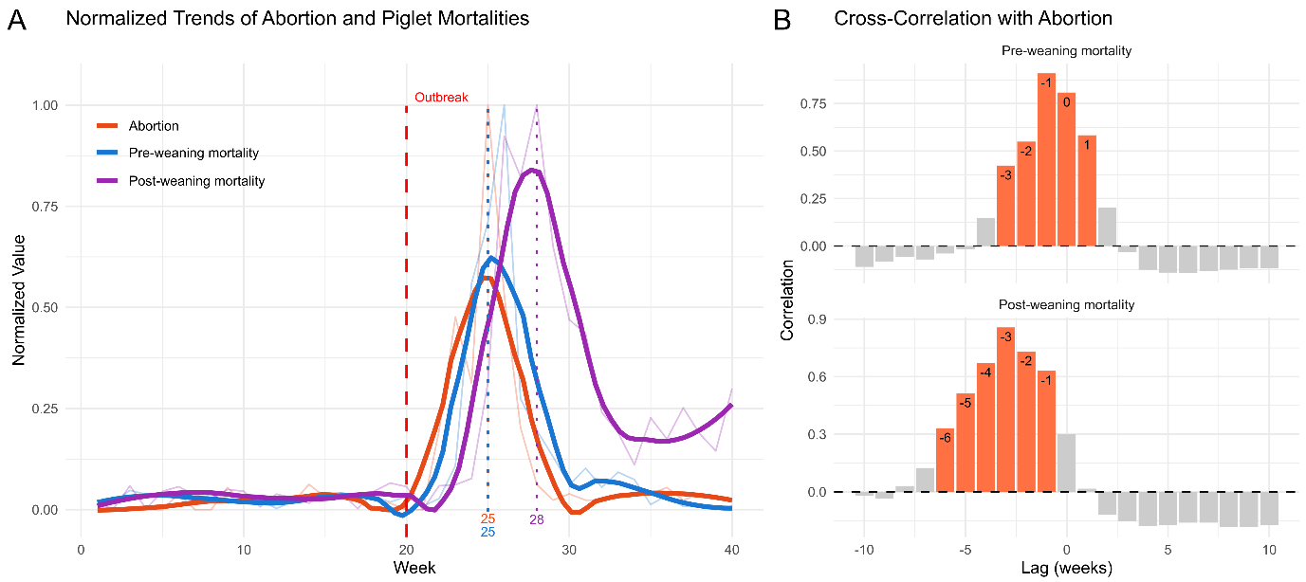

Supplementary Figure 1. Temporal relationship between abortion and piglet mortalities following NADC34-like PRRSV outbreak.
(A) Weekly normalized trends of abortion, pre-weaning mortality, and post-weaning mortality over a 40-week observation period from a 3,000-sow farm that experienced an NADC34-like PRRSV outbreak in week 20 (red dashed line). Colored dotted lines indicate the peak week for each smoothed metric. (B) Cross-correlation analysis between abortion and pre-/post-weaning mortalities. Bars represent correlation coefficients at each time lag (weeks), with orange indicating statistically significant correlations (|r| > 0.31, p < 0.05). The results suggest that pre-weaning mortality followed the abortion peak with minimal delay, while post-weaning mortality showed a lag of 3 weeks, consistent with a delayed impact on piglets born from affected sows.

