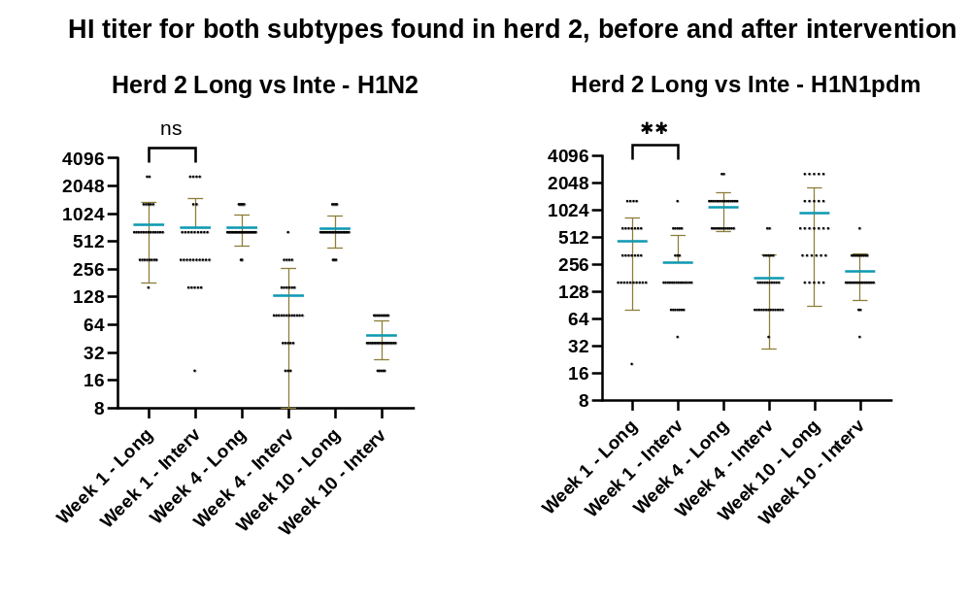
HI titer for both subtypes found in Herd 2 before and after intervention. Long indicates the first study in Herd 2 and Interv indicates the intervention study. Each point represents the titer of an individual pig. The brown lines indicate error bars, and the blue horizontal line indicates the mean titer.

