Supplementary Figure 2: Patterns of metaphylactic treatment most frequently used by pig veterinarians for each antimicrobial classes
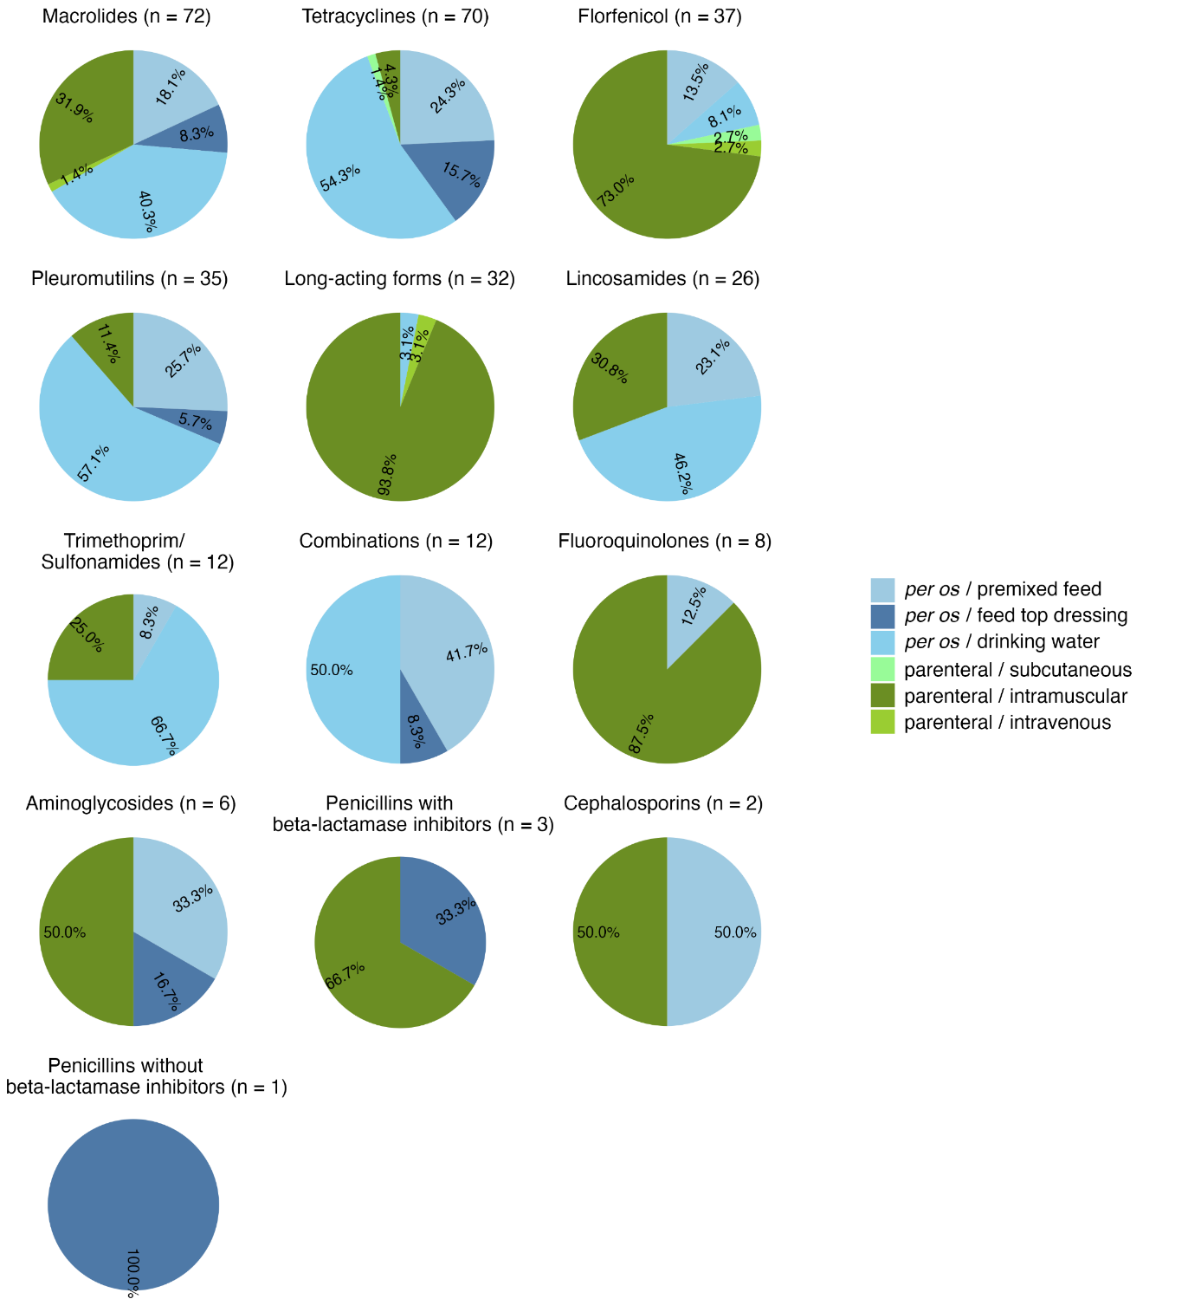

Legend: This figure represents the answers to the multiple-choice question: “what is the most frequent pattern for metaphylactic treatment that you apply in your practice?”. The respondents had to tick the corresponding boxes (antimicrobial and administration route); they could answer for each family. The percentages are calculated on the numbers of answers for each category (indicated in brackets).

