Participant Information Sheet
Student Study

Better Conversations with Primary Progressive Aphasia (BCPPA)
Pilot Study
This project has been approved by the Health Research Authority. REC reference number: 17/LO/0357
Before you accept it is important to understand:
- Who is doing the research?

- Why is the research being done?

- What will it involve?

- You can choose if you do or do not want to do the research.

- You can talk about this with family and friends.

- You can ask questions at any time.
Who is doing the research?

The research is being done from University College London.

The main researcher on this project is: Anna Volkmer

You can contact her on
07879 655 426 or
a.volkmer.15@ucl.ac.uk

The National Institute for Health Research is paying for this research

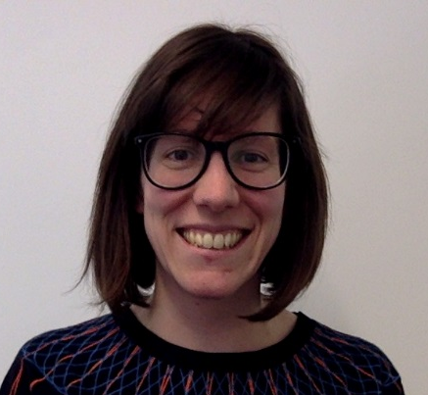

Why is the research being done?
Speech and language therapists provide therapy for people with primary progressive aphasia.

But we don’t know enough about it.
The research will help us learn more.

We are developing a therapy treatment called Better Conversations with Primary Progressive Aphasia.

The researcher will look at the results.

We want to know if it works.

We want to know if it works.

What will it involve?

We want 42 pairs to take part.

We want to compare Better Conversations with Primary Progressive Aphasia with no treatment

Half the people will have the Better Conversations with Primary Progressive Aphasia treatment for 4 weeks.

Half the people will have no treatment for 4 weeks.

If you agree to take part you will be randomly assigned to either:
- Better Conversations with Primary Progressive Aphasia
OR
- No treatment.



Better Conversations with PPA



No treatment

What will I have to do?
Week 6
Week 1
Weeks 2-5
‘

The tests:
Your speech and language therapist will test your talking, reading and writing. She will ask you how you feel about talking and the impact that PPA has on your life.
You will be video recorded 4 times having a conversation with your family member. The speech and language therapist will make 2 videos, you will make 2 videos at home. We will train you to use the video camera or iPad.

GROUP A: Better Conversations with PPA therapy treatment:
You will watch the videos with the speech and language therapist.
The speech and language therapist will help you see the good strategies, and things that are not working well.
You and your family member will practice how to make conversation easier.

GROUP B: No treatment:
You will have no speech and language therapy for 4 weeks. You will get all your other NHS care as normal.

Repeating the tests:

You will do the tests of talking, reading and writing again.
You will make 4 more videos of you talking with your family member.

Other questions?

We will collect information about you, your contact details and when you were diagnosed with PPA. We will also ask you what other languages you speak, your previous occupation and other medical conditions you might have.

The information we collect will be stored in a locked filing cabinet at UCL for 10 years.

During the study the videos will be stored in a locked computer hard drive.

After the 6 weeks of tests and treatment is finished you can go back to your normal speech and language therapy.

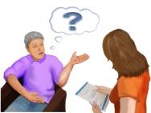



Other questions?
You can choose if you want to do the research or not.

You can talk about this with family and friends.

You can stop being in the research at any time

If you stop you do not have to give a reason…..and you will still get your normal care.

If you stop your data will still be included in the study.

We will let your doctor know that you are taking part (if you give permission).

If you tell us that you or someone else are at risk of harm we will need to speak to other people about this to keep everyone safe.

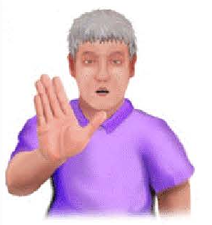
The videos will be stored in the Human Communication Audio Visual Archive (CAVA) at UCL Library for either
- As long as the Library exists. If you agree your videos will be used for future research. Future researchers will sign a contract to respect your confidentiality, rights and dignity and use the videos responsibly.

- For one year after the study ends, when they will be destroyed.
You can choose how long the videos are kept.

Other researchers and students might look at the videos to do more research.
They will be able to see your faces. They will keep the videos and the information about you safe.

+++ Years

1 year

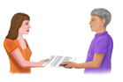

What might be difficult about taking part?
You may find it won’t help you.

You may find it tiring.

You may find it upsetting.

It will take 6 weeks of your time.

6 weeks

What might be good about taking part?
You may find it helps you.
Other people have found it:
- makes conversations easier
- improves things with their family members
- makes them feel more confident

You may enjoy taking part.

You may find it interesting.

The results may help people in the future.




If you need to make a complaint or you think you were harmed please contact:

- The main researcher,
Anna Volkmer,
Chandler House
2 Wakefield Street
London WC1N 1PF

07879 655 426

Email: a.volkmer.15@ucl.ac.uk

Or

- The project leader,
Suzanne Beeke
Chandler House
2 Wakefield Street
London WC1N 1PF

020 7679 4215

Email s.beeke@ucl.ac.uk

If you are still unhappy,
make a formal complaint by writing to the NHS Trust that is looking after you. Tell them the project number is …………………………….

You can also contact the Patient Advice and Liaison Service (PALS) in your local hospital trust. You can find your local PALS service by asking any local health provider or by looking on the NHS Choices website.

The University has insurance.

