Paramedic Pathway to Perform a Landmark Guided
Fascia Iliaca Compartment Block as part of the RAPID Trial

TASK | RATIONALE
- Confirm indication for Fascia Iliaca Compartment Block [FICB] (using hip fracture assessment checklist tool) | To ensure inclusion criteria are met
- Explain the procedure and potential side effects of an FICB to the patient and carer/next-of-kin and ensure consent is taken (verbal)  Include: - Permanent nerve damage [very rare]  - Local anaesthetic toxicity [very rare]  - Local bruising, infection and bleeding [uncommon]  - Failure of blockade [5-20%] | To ensure the patient makes informed consent about receiving FICB
- Establish monitoring using Dinamap® (non-invasive blood pressure, pulse oximetry) | To facilitate recognition of any potential adverse events
- Record patient’s vital signs and pain score before providing analgesia. If the patient has cognitive impairment and is unable to verbalise a pain score, please provide a subjective pain score, and note on the patient clinical record that you have done so. | To provide baseline observations and assess efficacy of FICB
- Confirm patent intravenous access | To facilitate treatment of any potential adverse events
- Ensure that resuscitation equipment and emergency drugs are readily available before commencing FICB | To facilitate treatment of any potential adverse outcomes
- Assist the patient into the supine position with affected leg extended as much as possible. | To provide correct position of leg for FICB
- Undertake physical examination of patient’s lower limb. Confirm pulse in foot. | To detect FICB contraindications
- Check correct side against patient’s notes and verbal confirmation if possible  ‘STOP BEFORE YOU BLOCK’ | To confirm the correct leg is to be blocked
- Place one middle finger on Anterior Superior Iliac Spine [ASIS] and the other middle finger on the symphysis pubis. Divide the line using both index fingers into three equal parts as shown  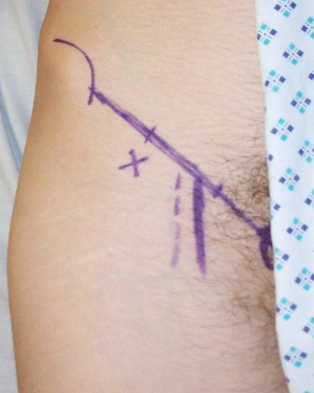 | To ensure accurate needle placement
- Mark the injection point 1cm below the lateral index finger | To facilitate block placement
- Confirm the femoral artery position is medial to the injection point (palpate femoral artery making sure it is at least 2cm medial to marked injection point)  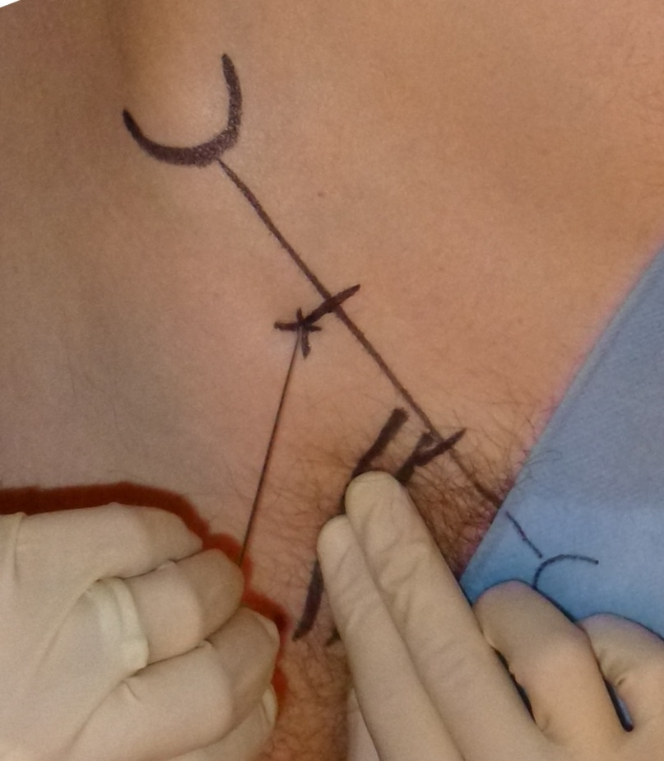 | To avoid complications
- Wash hands, prepare equipment and sterile field:  - Open dressing pack, syringes, needles, local anaesthetic etc  - Clean the skin from the ASIS to the pubic bone with provided skin preparation  - Wash hands  - Put on sterile gloves  - Draw up prilocaine 1% into 1 x 20ml and 1 x 10ml syringe and flush the extension line ensuring Bsmart pressure monitor positioned between syringe and needle. | To minimise the risk of introducing infection
- Insert the 18G block needle perpendicular to the skin at the marked point  - Do not aim needle medially | To prevent accidental damage / injection of the femoral nerve
- Advance the needle  - Advance through two distinct pops [loss of resistance felt following penetration of Fascia Lata and Fascia Iliaca]  - If pop not clear, bring needle back under skin and slightly change angle  - Once in position, the needle can be released | To ascertain correct placement of under the Fascia Iliacus muscle compartment
- Aspirate and if no blood detected:  - Slowly inject Prilocaine 1% x 20ml total aspirating every 5 mls  - There should be no resistance to the injection. The Bsmart monitor should not progress into the yellow zone; if there is, pull back cannula slightly and retry injection  Correct placement is confirmed by:  - No resistance to injection  - No appearance of subcutaneous swelling  - Onset of analgesia over 20-minutes | To reduce the risk of accidental intravenous injection and ensure correct placement of Prilocaine
- Change syringe and complete Prilocaine injection according to patient weight (total dose 30ml if >50kg body weight). Remove cannula | To prevent overdose of local anaesthetic
- Monitor and record patient observations over first 30-minutes  NB The biggest risk of local anaesthetic toxicity is during the first 20 minutes following bolus administration | Early detection of adverse effects
- Discard all sharps and used equipment, in accordance with WAST policy, in the appropriate containers i.e.  - Sharps box  - Clinical waste bin | To minimise sharps injury  To allow for the correct disposal of possible contaminated equipment
- Instruct the patient to inform the paramedic crew if they experience any tingling/numbness around the mouth, tinnitus and/or if they feel ‘strange’ | Local anaesthetic toxicity or hypersensitivity reaction may occur after Prilocaine injection
- Record the procedure on the trial documentation provided, indicating any problems or complications encountered and action taken | To ensure accurate records are maintained and adverse events can be investigated
- Advise the patient not to mobilise without the assistance of a staff member | Blockade of the motor nerves of leg may occur, limiting ability to mobilise safely
- When the patient is handed over to emergency department staff, please remind the triage nurse to take a pain score from the patient | To assess efficacy of the FICB

