Worksheet for barriers and facilitators task (caregiver group) – workshop 1

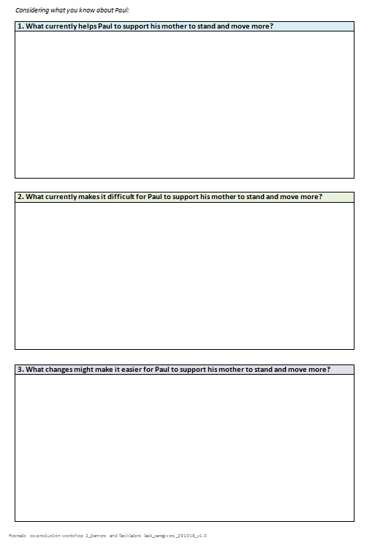

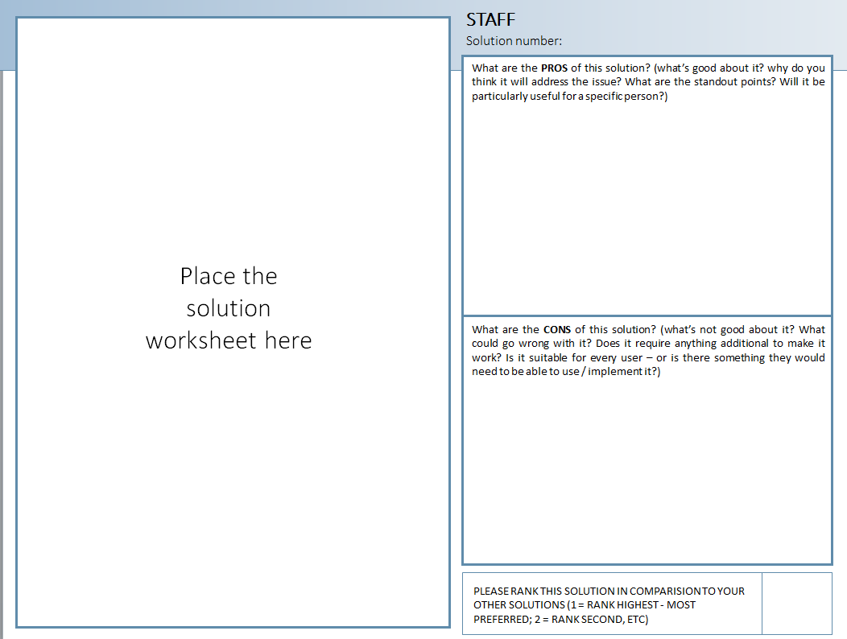
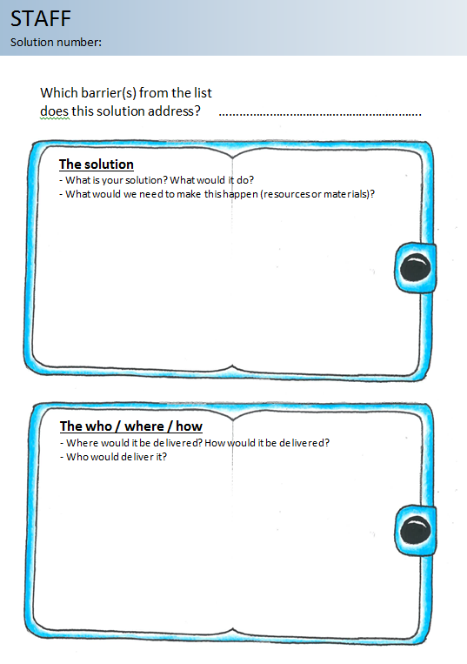
Worksheets for generating for appraising solutions activities (staff) – workshop 3

An extract from individually-completed validation activity – workshop 4

1. Education about the importance of standing and moving after stroke  Bespoke to staff, stroke survivors, and family and friends, including: |  | YES | NO
COMPONENTS
1a | Health consequences of sitting, standing and moving
1b | How to stand and move safely including relationship to falls risk
1c | Considering frequency of and suggestions for standing and moving
1d | Staff specific content about how to integrate the solution(s) into routine practice

Appraising prototype intervention material example – workshop 5
