Additional file 2

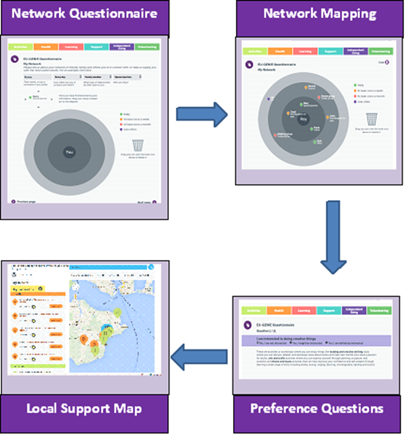
Figure 1. The stages of the GENIE intervention delivery.

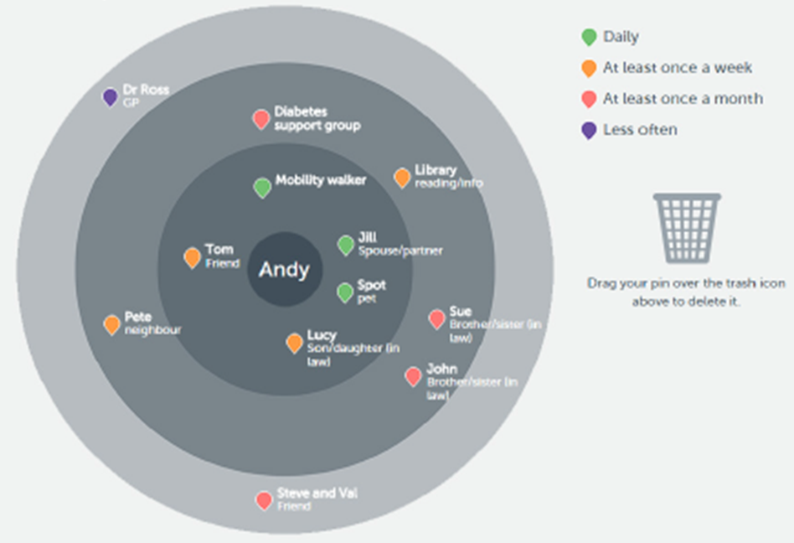
Figure 2. An example of a concentric circles diagram, which is used to facilitate the mapping of a user’s current support networks (Stages 1 and 2).

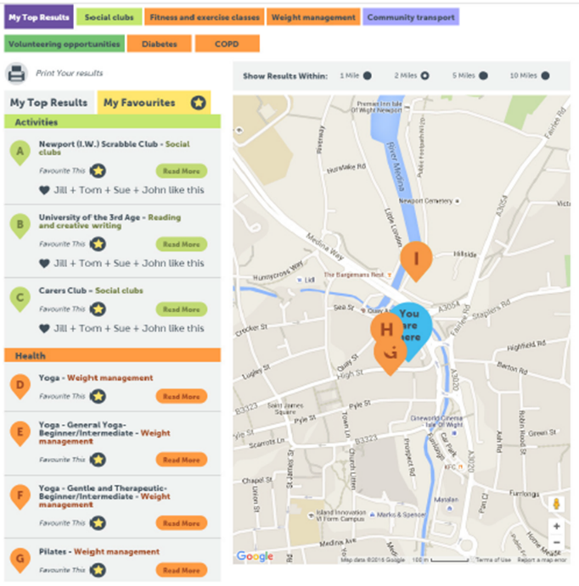
Figure 3. An example of suggestions of local resources that are presented to GENIE users, with location and further details (Stage 4).

