Participant Questionnaire

Please answer the following questions below in regards to the telehealth session. For the questions involving a scale, please rate your level of agreement with each of the items. If you do not want to answer a question, you do not have to answer.

- The instructions you received on setting up the tablet in your home for the session were effective. Circle one.

1 2 3 4 5
Completely Disagree Neutral Agree Completely
Disagree Agree

Suggestions for improvement (optional)

- Did you encounter any problems with setting up the tablet for the session? YES or NO . If YES, what problems did you encounter?

- Did you encounter any technical problems during the telehealth session? YES or NO. If YES, what problems did you encounter?

- The tablet was easy to navigate. Circle one.
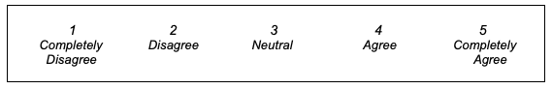

Suggestions for improvement (optional)

- Did you experience any problems with the courier service used for receiving and sending the tablet? YES or NO . If YES, please explain

- The instructions given to you by the physiotherapist were clear and easy to follow. Circle one.

Suggestions for improvement (optional)

How safe did you feel during the session on a scale of 1-5?
(1 = very safe; 5 = very unsafe)

Suggestions for improvement (optional)

- Your experience of the overall session was positive. Circle one.

Comments (optional)

- You would you use telehealth again to communicate with a physiotherapist or other healthcare professional if needed in the future. Circle one.

- What were the most positive aspects of the session? Open-ended

- What changes could be made to improve the experience and or delivery of the session? Open-ended

- Other comments

