Assessor Questionnaire

Please answer the following questions below in regards to the telehealth session. For the questions involving a scale, please rate your level of agreement with each of the items.

- The video conferencing tool was user friendly and easy to use. Circle one.
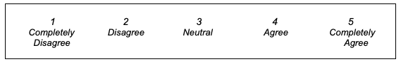

- Did you encounter any problems with the video conferencing tool? YES or NO
If YES, please explain

- You were able to adequately assess participants. Circle one.

- The standardized instructions were effective. Circle one.

- I did not have to change my instructions from the standardized version. Circle one.

- I felt the participants were safe during the telehealth session. Circle one.

- If participants encountered a problem with the assessment, I felt I was able to find a safe and/or effective solution. Circle one.

- What components of the assessment were most challenging to conduct? Open-ended

- What components of the assessment were easiest to conduct? Open-ended

- What were the most positive aspects of the telehealth session? Open-ended

- What changes could be made to improve the experience and or delivery of the telehealth session? Open-ended

- Other comments

