Study title: Feasibility study of a supported self-management intervention for aphasia (StarStep study)

You are being invited to take part in a research study

What is the research about?
 | We are doing some research.  It is about improving support for people with aphasia.  Research helps us learn.  We need to know more about how to help.

Who is doing the research?
   | The Chief Investigator is Dr Faye Wray.  The research is run from the University of Leeds.

Why are we doing the research?
 | There is a new type of therapy. The therapy is to help build confidence and ways to cope with aphasia. Speech and language therapists give this therapy.  We want to study the new therapy. We want to see how feasible it is to give at your local NHS service.  You will get the new therapy and your usual therapy.

Why me?
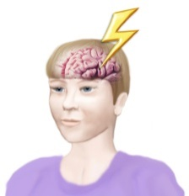 | You have aphasia after your stroke.  Aphasia can make it hard to:  - Speak  - Understand what other people say  - Read  - Write

What will I have to do?
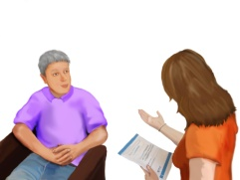 | Do an assessment  The researcher will assess your language (when you join the study). It will take 5-10 minutes.
 | Complete some questionnaires  Fill in some questionnaires about your health (when you join the study and 6 months later). It will take 30-60 minutes.  Fill in a questionnaire about the therapy after each session. It will take 5 minutes.  Tell us if you need help. We will help you.
 | Take part in observations  Your speech and language therapist will video record your therapy sessions.  Or  A researcher will watch one of your speech and language therapy sessions. This will happen if there are any problems with the video recording.  We would like to find out about how the therapy works in practice.
 | Access to your medical and care records  We would like to find out about;  - The type of stroke you had.  - How your health has been affected  The information will be anonymised so you cannot be identified.
Take part in an interview
We may contact you about this. We would like to know your views of the therapy you receive.
You can agree or refuse at this time.

What happens if we can’t meet in person due to the COVID-19 pandemic?

 | A researcher may visit you at home to:  - complete the questionnaires  - watch a therapy session  - do an interview
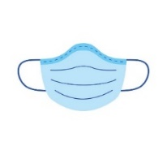 | But, We will not visit if it is not safe.  We will not visit if you do not feel comfortable.
 | We may use an on-line platform, e.g. Microsoft Teams or Skype (for questionnaires and interviews).
 | We will help you to access on-line platforms.  We will have regular breaks.

Do I have to take part?
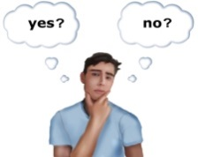 | You can decide. You don't have to.  If you don’t take part you will still get your normal help.
   | You can stop at any time.  You don't have to give a reason.  If you stop you will still get your normal help.
You can decide
- if you want to take part in the observations.
- if you want to complete the questionnaires.
- If you want to take part in the observations and complete the questionnaires

Who will see the information about me?
 | We will keep the information about you safe.  Only the researchers will see the information about you.  We will keep your information (at the Academic Unit for Ageing and Stroke Research) for 3 years.
 | But  if the researcher is worried that you or someone else is at risk of harm  we will tell someone in your local healthcare services.  We will tell your GP that you are taking part in the study.
Contact us if you would like your information removed from the study.

Contact us within 2 weeks.

After 2 weeks your information cannot be removed.


What might be good about taking part?

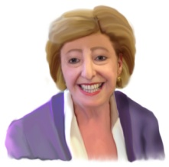 | You will help people in the future.  They will get better help.
 | You may enjoy taking part.  You may find it interesting.


What might be difficult about taking part?
 | You may find the questions in the questionnaires upsetting.  You might not like being watched or video recorded when taking part in therapy.

Is the research safe?
     | A committee decides if research can happen.  This is the Essex Research Ethics Committee (Ref: 21/EE/0115).  They say that this research can happen.  They say that it is safe.  They say that it has been planned properly.

Will I be harmed by the research?
This is very unlikely.

However, the NHS has set up a committee.

This committee will monitor the research.

The committee has different people from those who do this research.

What will happen after the research?
 | The researchers will look at the results.
 | They will learn more about supporting people with aphasia after stroke.

What will happen to the results?
 | We will send you a summary of the results.
 | We will share the results with other researchers at conferences and meetings in academic journals.
 | The results will not use your name.
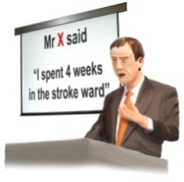 | The results may include what you said  but not who said it.

What next?
 | Do you want to take part?  You need to decide.
 | If you want to take part we will ask you to sign a consent form. Someone can help you with this.  This says that you understand the research and you agree to take part.  We may ask you to agree verbally if we meet you by videocall. We will take a sound recording of this.
 | If you decide not to take part you do not need to do anything.
   | If you want more information  Please contact the researcher: Faye Wray  Telephone 01274 38 3400 Or  Email f.d.wray@leeds.ac.uk

Claims and insurance

 | If you take part in the research  and if you think you were harmed  you may be able to claim compensation from the University of Leeds.  You may have to pay legal costs.

What if there is a problem?

 | If you want to discuss this study with someone independent contact:  Clare Skinner on: 0113 343 4897 or email: governance-ethics@leeds.ac.uk

Where could I get further support?

 | If you have concerns about the care you have had in the NHS  or you need advice about other organisations who can help you can contact:  The Patient Advice and Liaison Service (PALS). Phone 111 for details of your nearest PALS or visit https://www.nhs.uk/common-health-questions/nhs-services-and-treatments/what-is-pals-patient-advice-and-liaison-service/  Or the Stroke Association on 0303 3033 100

Thank you for taking the time to read this information.

This study is organised and run by the Academic Unit for Ageing and Stroke Research (a department of the University of Leeds) at Bradford Teaching Hospitals NHS Foundation Trust. This study is funded by The Stroke Association. The sponsor for the research is the University of Leeds. The study has been approved by East of England - Essex Research Ethics Committee (Ref: 21/EE/0115). Sources: All images in this information sheet are from: https://www.nihr.ac.uk/stroke/pcpie/enabling-people-with-aphasia-to-participate-in-research-resources-for-stroke-researchers/ [accessed 10th July 2018]

