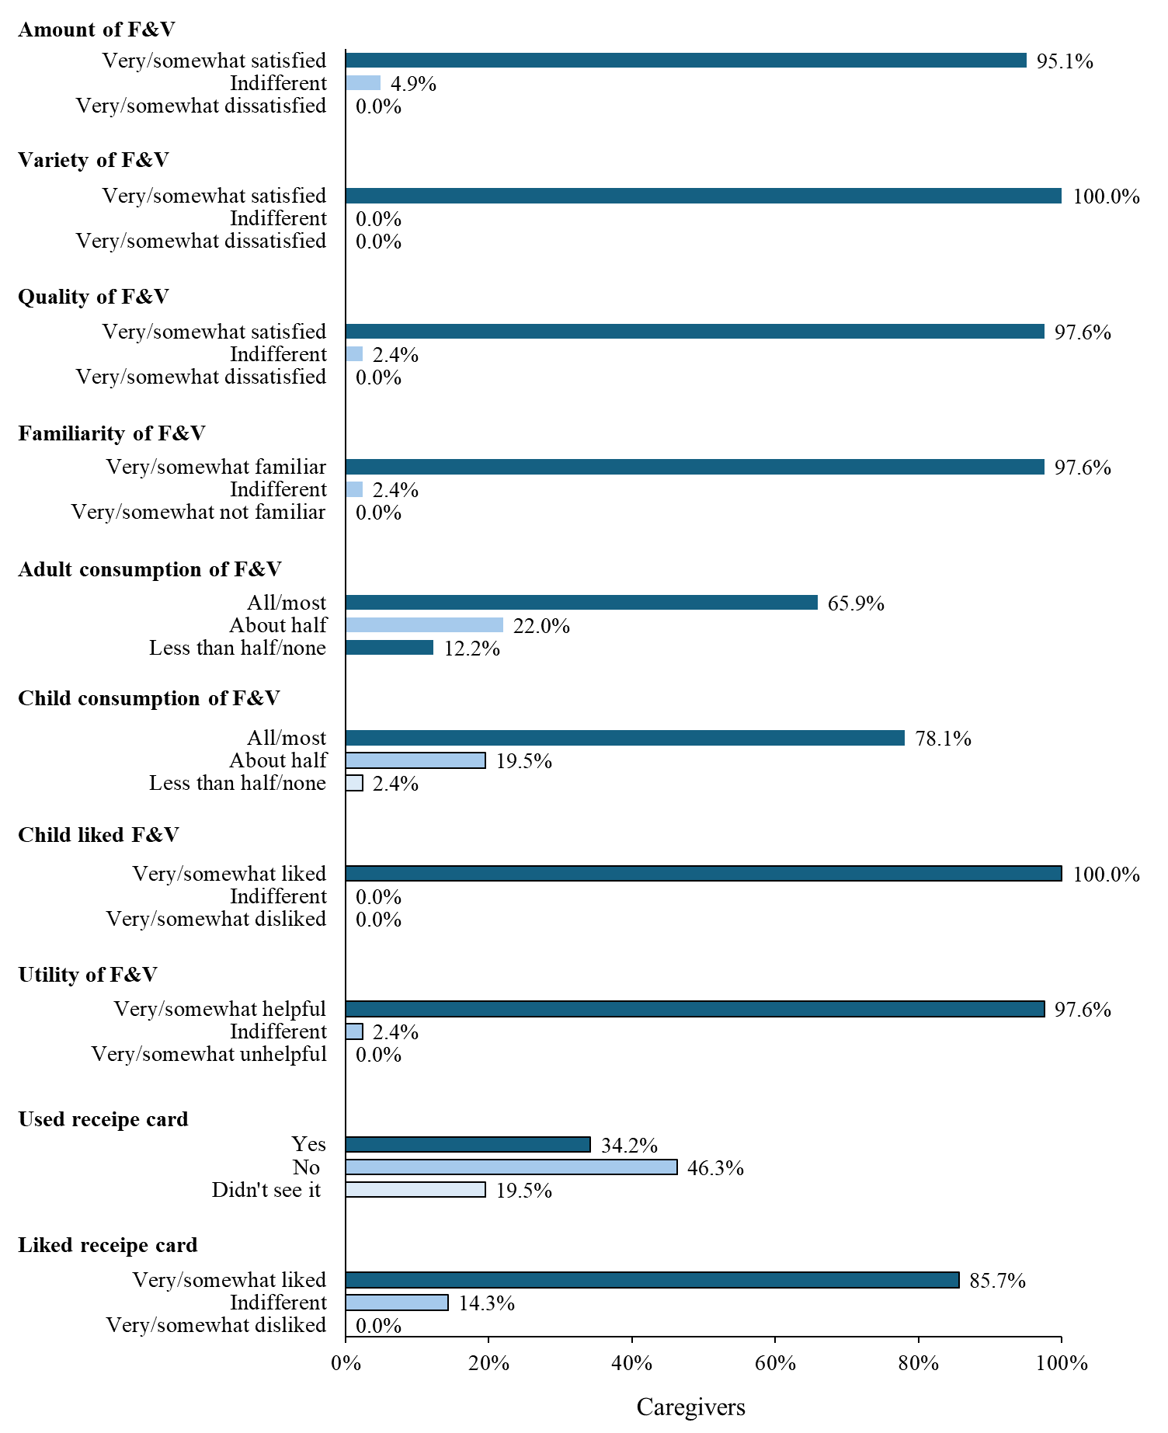
Appendix Figure 1a. Caregiver (n=41) acceptability ratings after receiving their 2nd free trial fruit and vegetable box. Surveys were administered 1 week after receiving the free box. Response options were on a 5-point Likert scale and collapsed into 3 categories as indicated above. F&V = fruit and vegetable
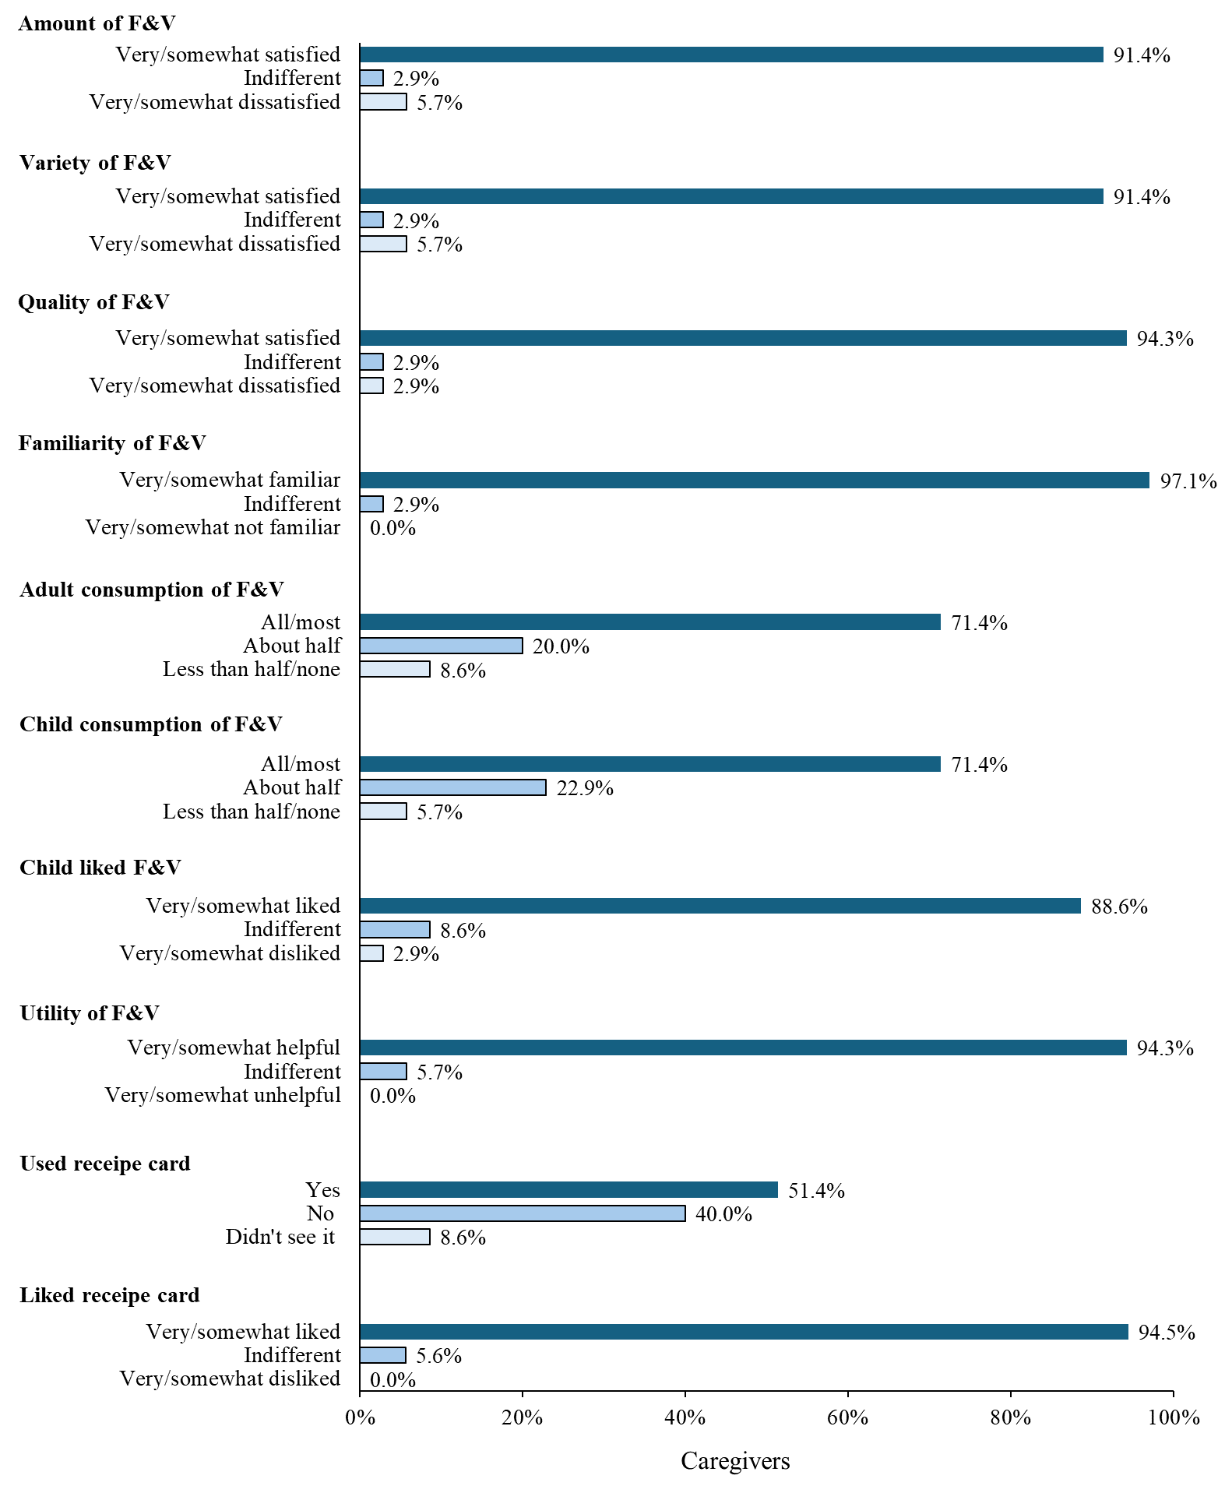
Appendix Figure 1b. Caregiver (n=35) acceptability ratings after receiving their 3rd free trial fruit and vegetable box. Surveys were administered 1 week after receiving the free box. Response options were on a 5-point Likert scale and collapsed into 3 categories as indicated above. F&V = fruit and vegetable

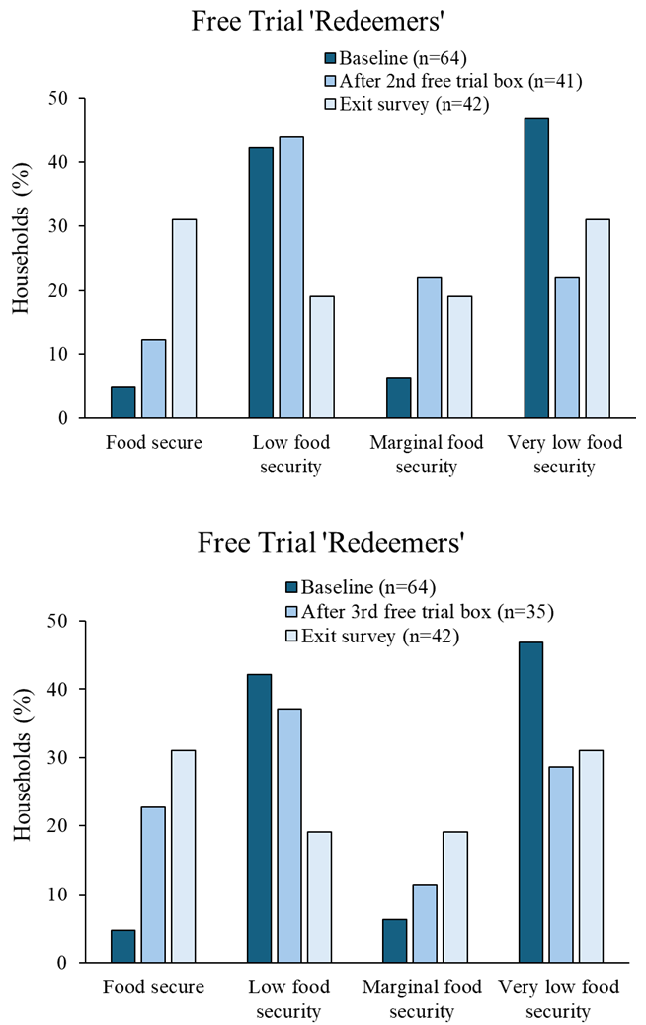
Appendix Figure 2. Patterns in household food security status for free trial ‘redeemers’ over time. Data collected at baseline, following receipt of their 2nd (top) and 3rd (bottom) free fruit and vegetable box, while the exit survey occurred 2 months after free trial vouchers were redeemed.
Appendix Table 1. Mean±standard deviation for household nutrition security, healthfulness choice, and dietary choice measures for free trial ‘redeemers’ over time.
 | Baseline (n=36) | After 2nd free trial box (n=31) | After 3rd free trial box (n=33) | Exit survey (n=42)
‘Redeemers’
Household nutrition security | 2.6±1.0 | 3.0±0.7 | 3.0±0.7 | 3.0±0.9
Household healthfulness choice | 2.0±0.9 | 2.5±0.9 | 2.6±1.0 | 2.7±1.1
Household dietary choice | 2.4±0.8 | 2.8±0.8 | 3.0±0.8 | 2.8±1.0
Note: The exit survey occurred 2 months after free trial vouchers were redeemed.

Appendix Table 2. Caregiver-report of children’s dietary intake values (mean±standard deviation) using the National Cancer Institute Dietary Screening Questionnaire for free trial ‘redeemers’ and ‘non-redeemers’ over time.
 | Baseline | After 1st free trial box | After 2nd free trial box | After 3rd free trial box | Exit surveyª
Vegetables (cup eq/day)^{b}
‘Redeemers’ | 0.9±0.3 | 0.8±0.2 | 0.9±0.3 | 0.9±0.4 | 1.0±0.4
‘Non-redeemers’ | 0.8±0.3 |  |  |  | 0.8±0.3
Fruits (cup eq/day)
‘Redeemers’ | 1.3±0.7 | 1.2±0.5 | 1.3±0.7 | 1.2±0.6 | 1.3±0.7
‘Non-redeemers’ | 1.3±0.6 |  |  |  | 1.0±0.5
Fiber intake (g/day)
‘Redeemers’ | 13.2±3.1 | 12.6±2.0 | 12.9±2.2 | 13.2±3.0 | 13.7±3.2
‘Non-redeemers’ | 12.3±2.5 |  |  |  | 12.0±1.8
Calcium (mg/day)
‘Redeemers’ | 1032.8±316.3 | 893.6±179.5 | 934.0±238.5 | 959.7±268.9 | 992.0±267.3
‘Non-redeemers’ | 959.5±194.4 |  |  |  | 921.2±187.1
Whole grains (oz eq/day)
‘Redeemers’ | 0.7±0.4 | 0.5±0.3 | 0.5±0.3 | 0.5±0.3 | 0.6±0.5
‘Non-redeemers’ | 0.5±0.2 |  |  |  | 0.5±0.3
Total added sugar (tsp eq/day)
‘Redeemers’ | 16.4±7.2 | 14.5±4.8 | 14.4±4.2 | 14.8±5.1 | 15.0±4.0
‘Non-redeemers’ | 15.1±3.7 |  |  |  | 15.4±4.6
Dairy (cup eq/day)
‘Redeemers’ | 2.4±1.1 | 2.0±0.7 | 2.1±0.8 | 2.1±0.9 | 2.2±0.9
‘Non-redeemers’ | 2.2±0.7 |  |  |  | 2.0±0.6
‘Redeemers’ used >1 free trial voucher. ‘Non-redeemers’ used 0 free trial vouchers.
Sample sizes included baseline (‘redeemers’: n=62; ‘non-redeemers’: n=27); after 1st free trial box (n=52), after 2nd free trial box (n=38), after 3rd free trial box (n=34), and exit survey (‘redeemers’: n=40; ‘non-redeemers’: n=14)
ªThe exit survey for ‘redeemers’ occurred 2 months after free trial vouchers were redeemed, while the exit survey for ‘non-redeemers’ occurred after the free trial vouchers expired.
^{b}Data for values including legumes and excluding French fries

