Table of Contents
Supplemental Table 1: Exercise Benefits and Barriers Mean (SD) at Pre-Intervention and Post-Intervention and Mean (95%CI) Difference between Time Points. 2
Supplemental Figure 1: Body Mass Index (BMI) Changes 2
Supplemental Figure 2: Systolic and Diastolic Blood Pressure Changes 3
Supplemental Figure 3: 6-Minute Walk Test Changes 3
Supplemental Figure 4: Short Physical Performance Battery Changes 4
Supplemental Figure 5: 4-Meter Walk Changes 4

Supplemental Table 1: Exercise Benefits and Barriers Mean (SD) at Pre-Intervention and Post-Intervention and Mean (95%CI) Difference between Time Points.
Exercise Benefits and Barriers Scale | Times |  | Differences Between Times* | Effect Size
 | Pre-Intervention | Post-Intervention | Post-Intervention minus Pre-Intervention | Hedges’ g  (95% CI)
Total Score | 135 (16.2) | 138.6 (18.9) | 3.6 (-2.4 to 9.6) | 0.2 (-0.6 to 1.0)
Exercise Benefit Subscale | 94 (13.0) | 94.8 (15.4) | 0.8 (-4.0 to 5.6) | 0.1 (-0.8 to 0.9)
Exercise Barriers Subscale | 29 (6.3) | 26.2 (6.5) | -2.8 (-5.8 to 0.2) | 0.4 (-0.4 to 1.3)
*Differences between times are the average of paired differences.
CI = Confidence Interval

Supplemental Figure 1: Body Mass Index (BMI) Changes
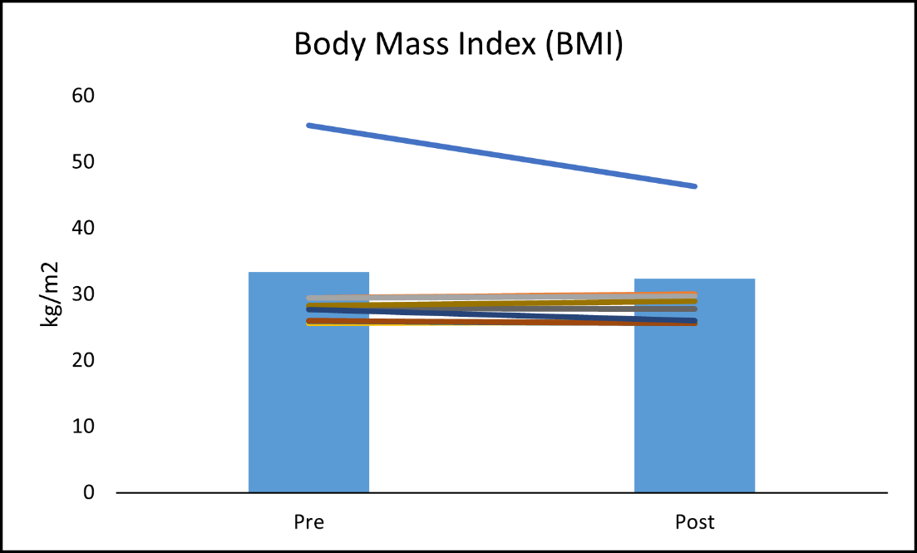

Supplemental Figure 2: Systolic and Diastolic Blood Pressure Changes
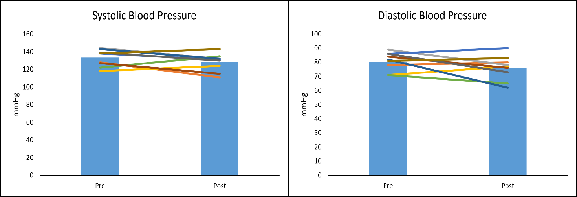

Supplemental Figure 3: 6-Minute Walk Test Changes
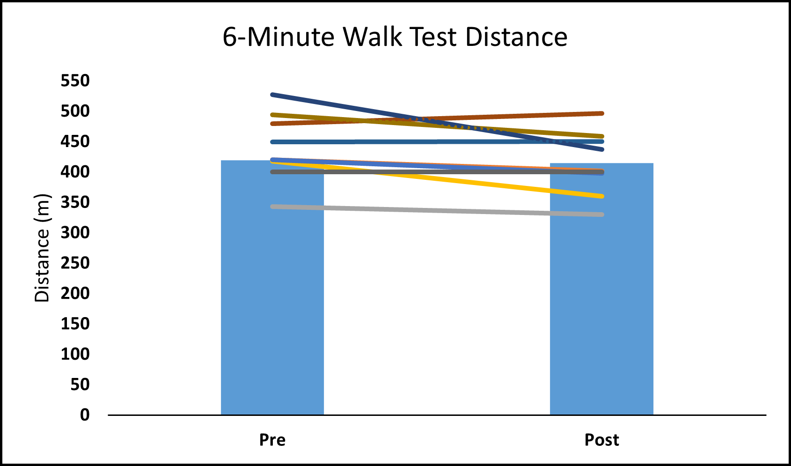

Supplemental Figure 4: Short Physical Performance Battery Changes
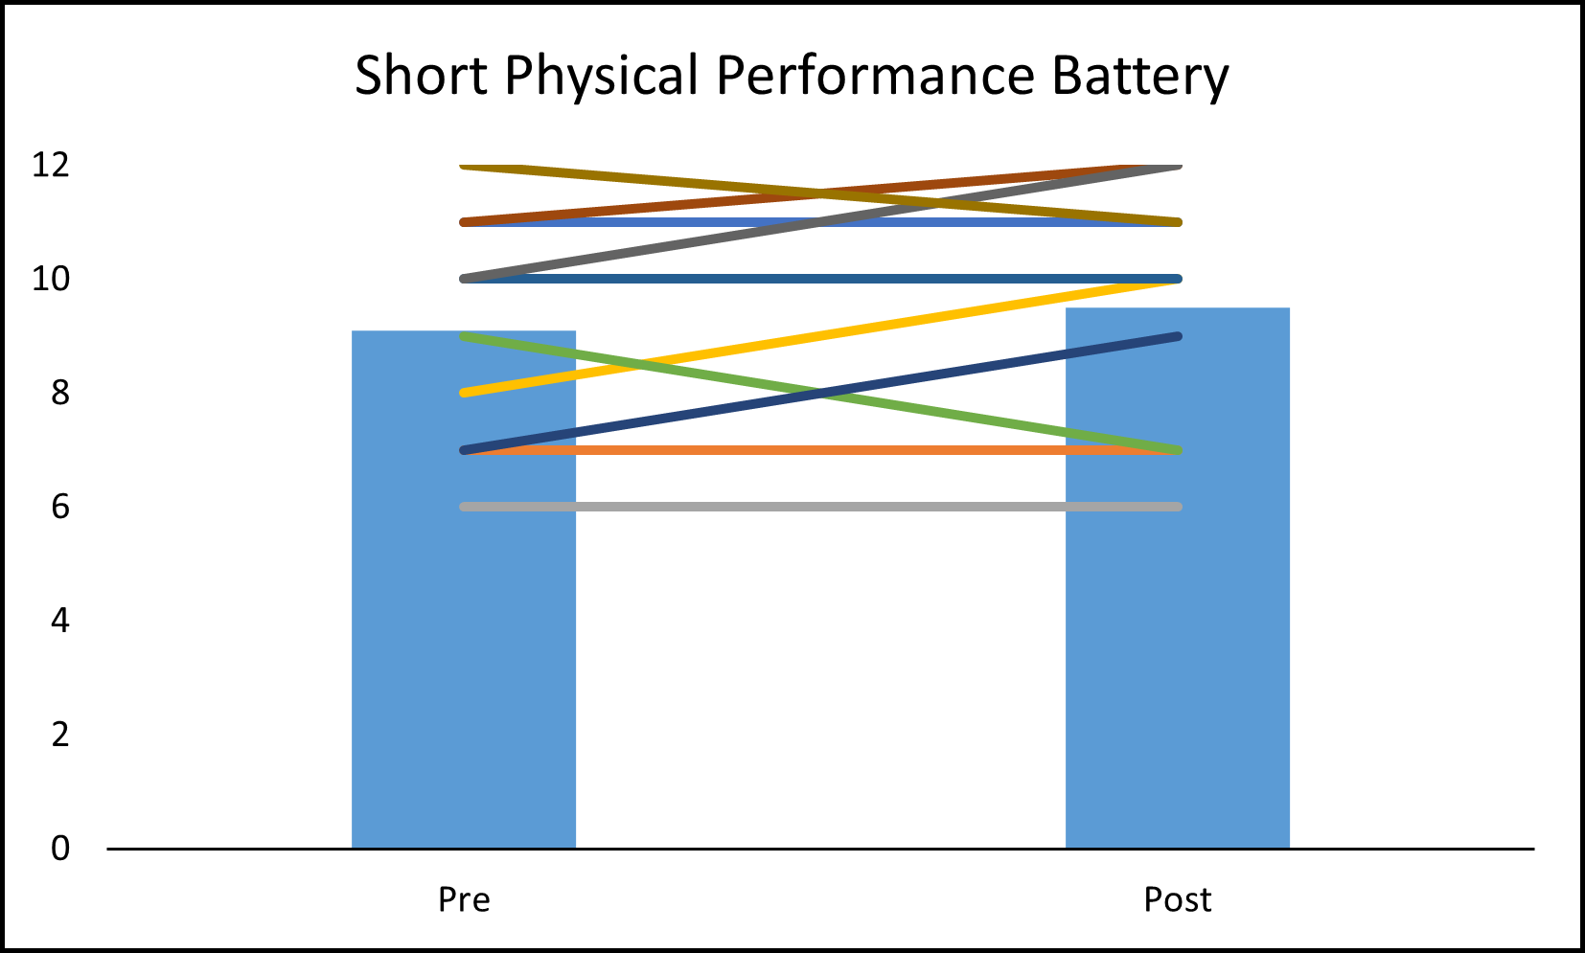

Supplemental Figure 5: 4-Meter Walk Changes
