Appendix A: Table: Individual Pre TRTP and Follow-up scores for DASS21 and PCL-5 on all 20 ‘completers’

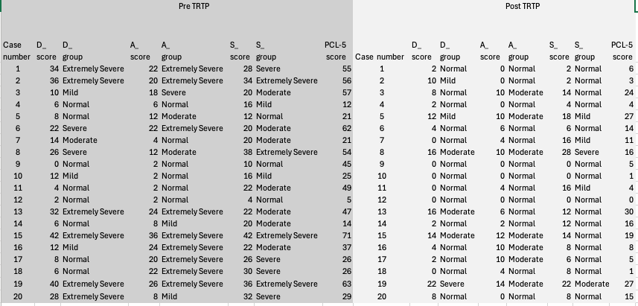

Appendix B: Graphical Representation of Data

Abnormal range depression

