Additional File E: Figures illustrating effects of intervention on outcome measures

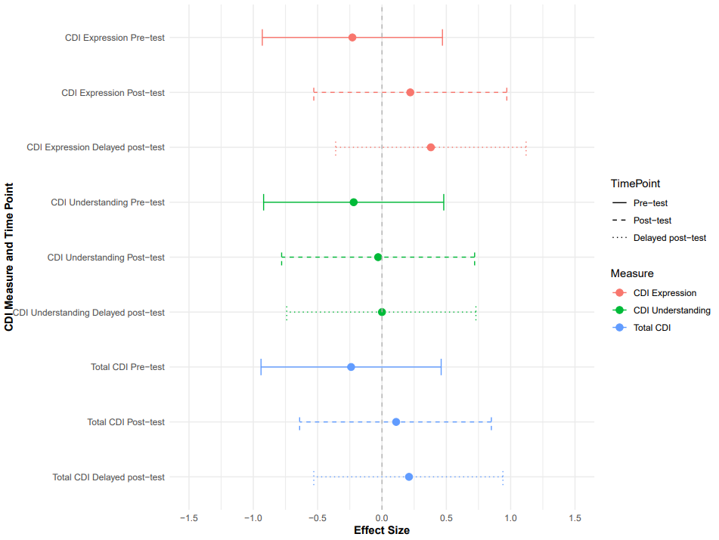
Figure E.1: Effect size (Hedges’ g) of mean raw score difference between groups at baseline, post-test, and delayed post-test on parent-completed child language measure (CDI) with 95% confidence intervals. Note. CDI = Communicative Development Inventories

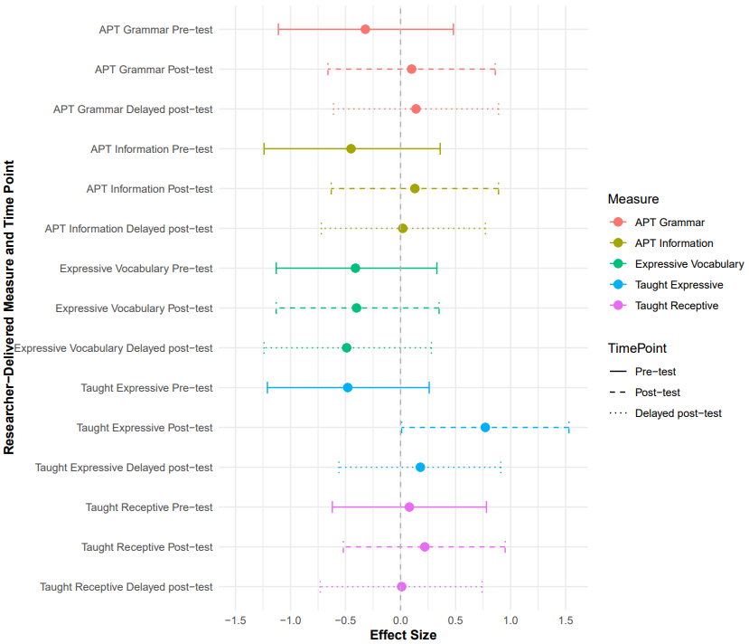
Figure E.2: Effect size (Hedges’ g) of mean raw score difference between groups at baseline, post-test, and delayed post-test on researcher-administered child language measures with 95% confidence intervals. Note. APT = Action Picture Test

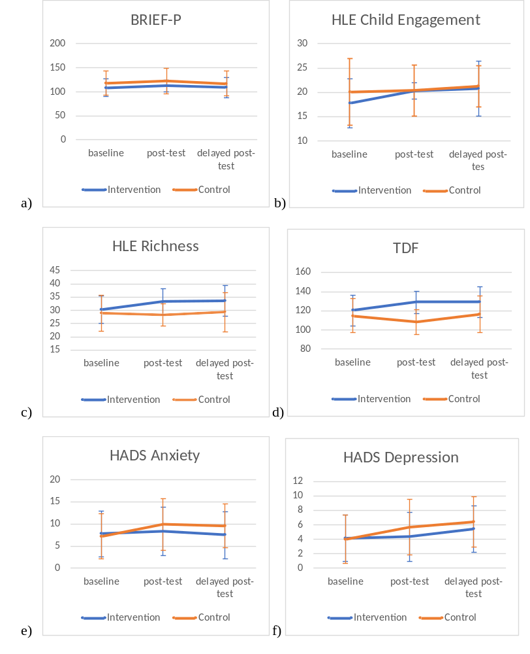

Figure E.3: Linegraphs showing the effects of the intervention at post-test and delayed post-test on a) BRIEF-P; b) HLE Child Engagement; c) HLE Richness; d) TDF; e) HADS Anxiety; f) HADS Depression and g) AC-QOL. Note. BRIEF-P = Behaviour Rating Inventory of Executive Function-Preschool Version; HLE = Home Learning Environment; TDF = Theoretical Domains Framework; AC-QOL = Adult Carer- Quality of Life; HADS = Hospital Anxiety and Depression Scale

