Additional file 2: Overview of publications listed in Pubmed on silimarin, silibinin, or milk thistle
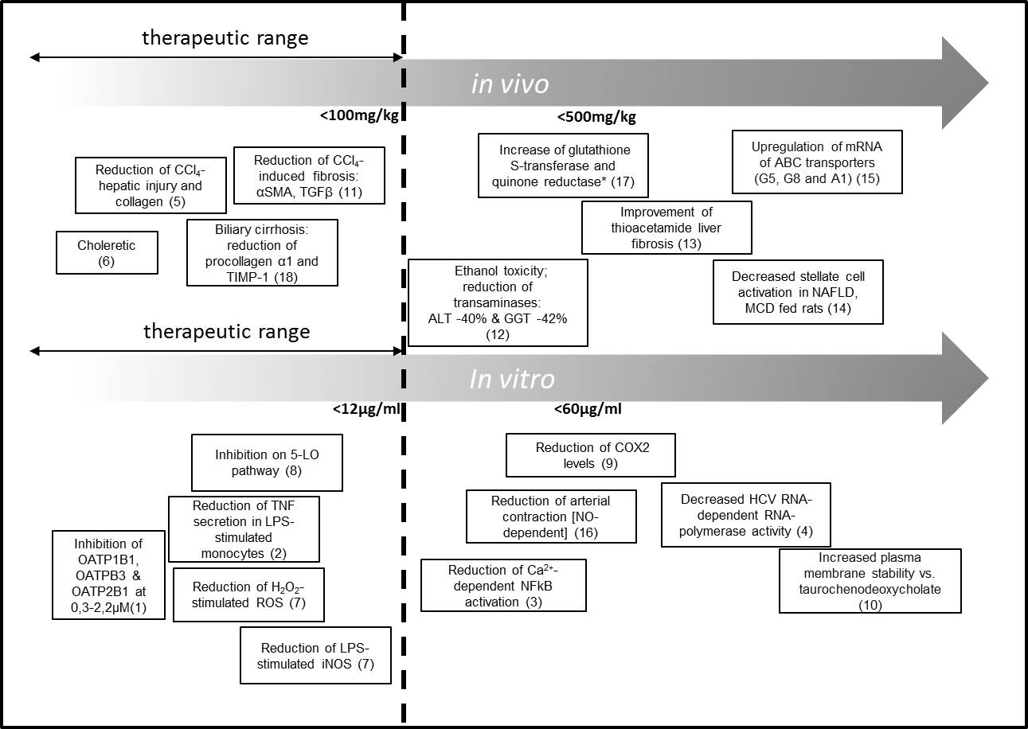
1. Kock K, Xie Y, Hawke RL, Oberlies NH, Brouwer KL. Interaction of silymarin flavonolignans with organic anion-transporting polypeptides. Drug metabolism and disposition: the biological fate of chemicals. 2013;41(5):958-65. doi:10.1124/dmd.112.048272.
2. Bannwart CF, Peracoli JC, Nakaira-Takahagi E, Peracoli MT. Inhibitory effect of silibinin on tumour necrosis factor-alpha and hydrogen peroxide production by human monocytes. Natural product research. 2010;24(18):1747-57. doi:10.1080/14786410903314492.
3. Chang JW, Kim CS, Kim SB, Park SK, Park JS, Lee SK. Proinflammatory cytokine-induced NF-kappaB activation in human mesangial cells is mediated through intracellular calcium but not ROS: effects of silymarin. Nephron Experimental nephrology. 2006;103(4):e156-65. doi:10.1159/000092906.
4. Ahmed-Belkacem A, Ahnou N, Barbotte L, Wychowski C, Pallier C, Brillet R et al. Silibinin and related compounds are direct inhibitors of hepatitis C virus RNA-dependent RNA polymerase. Gastroenterology. 2010;138(3):1112-22. doi:10.1053/j.gastro.2009.11.053.
5. Favari L, Perez-Alvarez V. Comparative effects of colchicine and silymarin on CCl4-chronic liver damage in rats. Archives of medical research. 1997;28(1):11-7.
6. Shukla B, Visen PK, Patnaik GK, Dhawan BN. Choleretic effect of picroliv, the hepatoprotective principle of Picrorhiza kurroa. Planta medica. 1991;57(1):29-33. doi:10.1055/s-2006-960010.
7. Kang JS, Jeon YJ, Kim HM, Han SH, Yang KH. Inhibition of inducible nitric-oxide synthase expression by silymarin in lipopolysaccharide-stimulated macrophages. The Journal of pharmacology and experimental therapeutics. 2002;302(1):138-44.
8. Fiebrich F, Koch H. Silymarin, an inhibitor of lipoxygenase. Experientia. 1979;35(12):1548-60.
9. Ahmadi-Ashtiani H, Allameh A, Rastegar H, Soleimani M, Barkhordari E. Inhibition of cyclooxygenase-2 and inducible nitric oxide synthase by silymarin in proliferating mesenchymal stem cells: comparison with glutathione modifiers. Journal of natural medicines. 2012;66(1):85-94. doi:10.1007/s11418-011-0554-6.
10. Basiglio CL, Sanchez Pozzi EJ, Mottino AD, Roma MG. Differential effects of silymarin and its active component silibinin on plasma membrane stability and hepatocellular lysis. Chemico-biological interactions. 2009;179(2-3):297-303. doi:10.1016/j.cbi.2008.12.008.
11. Clichici S, Olteanu D, Nagy AL, Oros A, Filip A, Mircea PA. Silymarin inhibits the progression of fibrosis in the early stages of liver injury in CCl(4)-treated rats. Journal of medicinal food. 2015;18(3):290-8. doi:10.1089/jmf.2013.0179.
12. Habib-ur-Rehman M, Mahmood T, Salim T, Afzal N, Ali N, Iqbal J et al. Affect of silymarin on serum levels of ALT and GGT in ethanol induced hepatotoxicity in albino rats. Journal of Ayub Medical College, Abbottabad : JAMC. 2009;21(4):73-5.
13. Chen IS, Chen YC, Chou CH, Chuang RF, Sheen LY, Chiu CH. Hepatoprotection of silymarin against thioacetamide-induced chronic liver fibrosis. Journal of the science of food and agriculture. 2012;92(7):1441-7. doi:10.1002/jsfa.4723.
14. Kim M, Yang SG, Kim JM, Lee JW, Kim YS, Lee JI. Silymarin suppresses hepatic stellate cell activation in a dietary rat model of non-alcoholic steatohepatitis: analysis of isolated hepatic stellate cells. International journal of molecular medicine. 2012;30(3):473-9. doi:10.3892/ijmm.2012.1029.
15. R. Vecera AZ, J. Orolin, N. Skottova, P. Anzenbacher The effect of silymarin on expression of selected ABC transporters in the rat. Veterinarni Medicina. 2011;56(2):59-62.
16. Demirci B, Demir O, Dost T, Birincioglu M. Treated effect of silymarin on vascular function of aged rats: Dependant on nitric oxide pathway. Pharmaceutical biology. 2013. doi:10.3109/13880209.2013.842597.
17. Zhao J, Agarwal R. Tissue distribution of silibinin(*), the major active constituent of silymarin, in mice and its association with enhancement of phase II enzymes: implications in cancer chemoprevention. Carcinogenesis. 1999;20(11):2101-8.
18. Jia JD, Bauer M, Cho JJ, Ruehl M, Milani S, Boigk G et al. Antifibrotic effect of silymarin in rat secondary biliary fibrosis is mediated by downregulation of procollagen alpha1(I) and TIMP-1. Journal of hepatology. 2001;35(3):392-8.

Additional figure 1: Main hepatic effects in vivo and in vitro of silymarin. Figure shows references and abbreviations for Fig. 1 of the main text.

