Additional file 1
Supporting information for - Characterisation of a novel poly(ether ether ketone)/calcium sulphate composite for bone augmentation

Erik A. B. Hughes¹ and Liam M. Grover¹*
¹ School of Chemical Engineering, University of Birmingham, Edgbaston, B15 2TT, UK
* Corresponding author - L.M.Grover@bham.ac.uk

Equations used in this work:

% volumetric shrinkage = ((V₁ – V₂) / V₁) x 100 (Equation S1)

Where,
V₁ = Volume of specimen prior to heat treatment (mm³)
V₂ = Volume of specimen after heat treatment (mm³)

ρ_{rel} = ρ_{app} / ρ_{true} (Equation S2)

Where,
ρ_{rel} = Relative density of specimen (g/cm³)
ρ_{app} = Apparent density of specimen (g/cm³)
ρ_{true} = True density of specimen (g/cm³)

Porosity = (1 - ρ_{relative}) x 100 (Equation S3)

Where,
ρ_{relative} = Relative density of specimen

σ = F / A (Equation S4)

Where,
σ_{comp} = Compressive stress (MPa)
F = Loading force (N)
A = Specimen contact area (mm²)

ε = l_{change} / l_{original} (Equation S5)

Where,
ε = Strain
l_{change} = Change in specimen height (mm)
l_{original} = Original specimen height (mm)

E_{comp} = (σ / ε) / 1000 (Equation S6)

Where,
E_{comp} = Compressive modulus (GPa)
σ = Stress (MPa)
ε = Strain

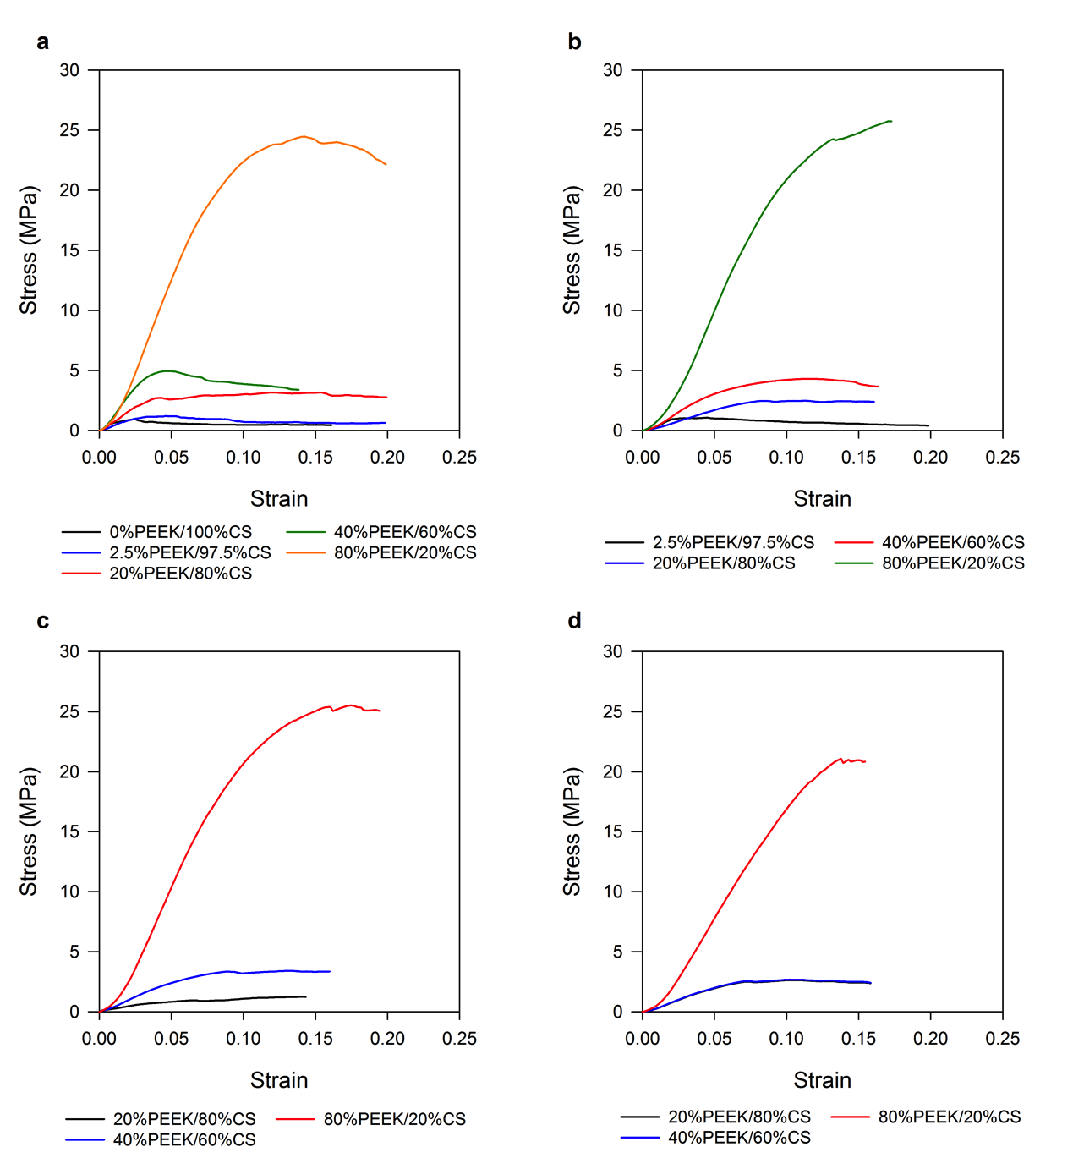
Figure S1. Averaged stress vs. strain curves for n=10 PEEK/CS specimens tested (a) after heat treatment prior to ageing (0 Days) and (b) after 7 Days, (c) 14 Days and (d) 21 Days of ageing.

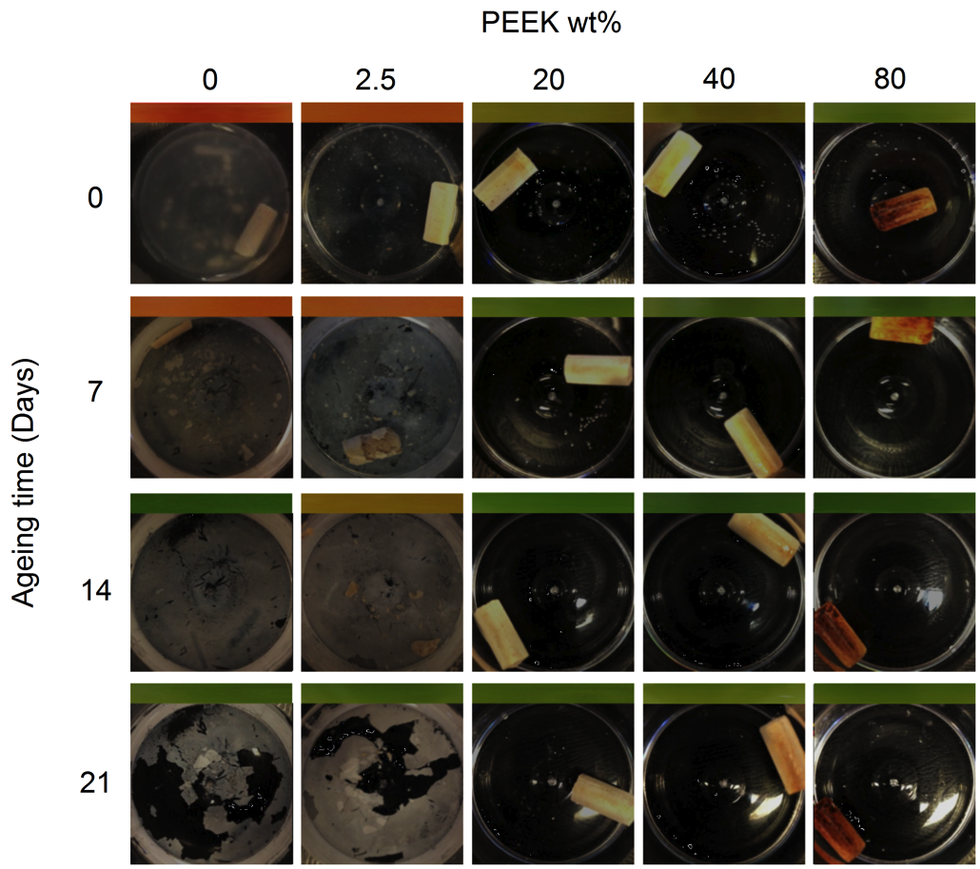
Figure S2. Top down view of PEEK/CS specimens during dynamic ageing study at 1 day, 7 days, 14 days and 21 days, bar above individual images is the colouration of an aliquot of PBS ageing media after addition of universal pH indicator before replenishment (PBS media was green) (orange = pH 5 – 5.5, yellow = pH 6 – 6.5, green = pH 7 - 7.5).

