Supplementary Information
Sequential Activation of M1 and M2 Phenotype in Macrophages by Mg Degradation from Ti-Mg Alloy for Enhanced Osteogenesis
Luxin Liang ^{a,b}, Deye Song ^{b}, Kai Wu ^{c}, Zhengxiao Ouyang ^{b}, Qianli Huang ^{a, d**},
Guanghua Lei ^{e}, Kun Zhou ^{f}, Jian Xiao ^{g, ***}, Hong Wu ^{a, *}
ª State Key Laboratory of Powder Metallurgy, Central South University, Changsha 410083, P. R. China
^{b} Department of Orthopedics, The Second Xiangya Hospital, Central South University, Changsha 410011, P. R. China
^{c} Department of Rehabilitation, Xiangya Hospital, Central South University, Changsha 410008, P. R. China
^{d} Foshan (Southern China) Institute for New Materials, Foshan 528200, P. R. China
^{e} Department of Orthopedics, Xiangya Hospital, Central South University, Changsha, 410008, P. R. China
^{f} School of Mechanical and Aerospace Engineering, Nanyang Technological University, Singapore, 639798, Singapore
^{g} Department of Pharmacy, Xiangya Hospital, Central South University, Changsha, 410008, P. R. China
^{h} National Clinical Research Center for Geriatric Disorders, Xiangya Hospital, Central South University, Changsha 410008, P. R. China

E-mail: hwucsu@csu.edu.cn (Hong Wu), hql1990@163.com (Qianli Huang), admanoas@163.com (Jian Xiao)

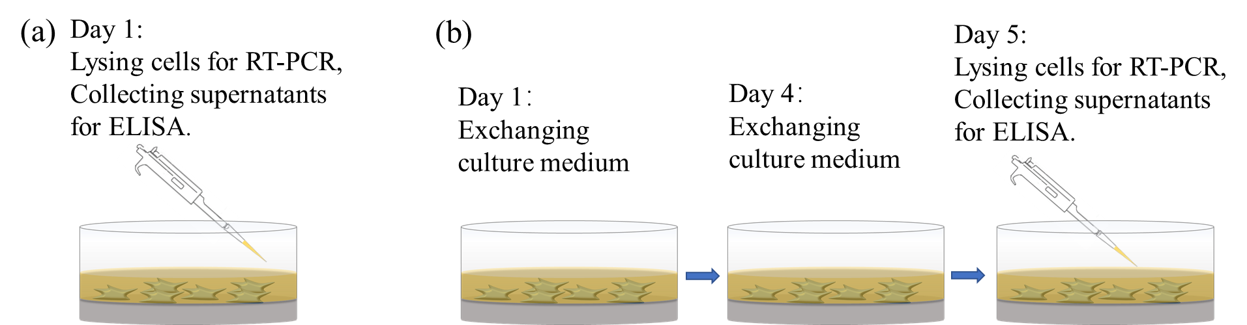
Fig. S1. The schematic showing the measured method of ELISA and RT-PCR for (a) day 1, and (b) day 5.

Table S1 The sequences of primers employed for macrophages
Gene | Primer sequences
GAPDH | Forward: 5’-TCAGCAATGCCTCCTGCAC-3’
GAPDH | Reverse: 5’-TCTGGGTGGCAGTGATGGC-3’
CD86 | Forward: 5’-CTGCTCATCATTGTATGTCAC-3’
CD86 | Reverse: 5’-ACTGCCTTCACTCTGCATTTG-3’
CD11c | Forward: 5’-ACTTCACGGCCTCTCTTCC-3’
CD11c | Reverse: 5’-CACCAGGGTCTTCAAGTCTG-3’
iNOS | Forward: 5’-CAGAAGTGCAAAGTCTCAGACAT-3’
iNOS | Reverse: 5’-GTCATCTTGTATTGTTGGGCT-3’
CCL24 | Forward: 5’-AGGCAGGGGTCATCTTCATCAC-3’
CCL24 | Reverse: 5’-GGCTGGTTTTTCTTGGCATCC-3’
IL-1β | Forward: 5’-TGGAGAGTGTGGATCCCAAG-3’
IL-1β | Reverse: 5’-GGTGCTGATGTACCAGTTGG-3’
TNF-α | Forward: 5’-CTGAACTTCGGGGTGATCGG-3’
TNF-α | Reverse: 5’-GGCTTGTCACTCGAATTTTGAGA-3’
IL-10 | Forward: 5’-TGCTATGCTGCCTGCTCTTA-3’
IL-10 | Reverse: 5’-TGTTGTCCAGCTGGTCCTTT-3’
BMP-2 | Forward: 5’-GCTCCACAAACGAGAAAAGC-3’
BMP-2 | Reverse: 5’-AGCAAGGGGAAAAGGACACT-3’
BMP-6 | Forward: 5’-TGGCAGGACTGGATCATTGC-3’
BMP-6 | Reverse: 5’-ACCAAGGTCTGTACAATGGCG-3’
OSM | Forward: 5’-ACGGTCCACTACAACACCAG-3’
OSM | Reverse: 5’-CCATCGTCCCATTCCCTGAAG-3’
α5 | Forward: 5’-CTTCTCCGTGGAGTTTTACCG-3’
α5 | Reverse: 5’-GCTGTCAAATTGAATGGTGGTG-3’
αM | Forward: 5’-CCATGACCTTCCAAGAGAATGC-3’
αM | Reverse: 5’-ACCGGCTTGTGCTGTAGTC-3’
β1 | Forward: 5’-CGTGGTTGCCGGAATTGTTC-3’
β1 | Reverse: 5’-ACCAGCTTTACGTCCATAGTTTG-3’
β2 | Forward: 5’-CAGGAATGCACCAAGTACAAAGT-3’
β2 | Reverse: 5’-GTCACAGCGCAAGGAGTCA-3’
TLR-3 | Forward: 5’-CGGGATTGGTGAGTCTGAAG-3’
TLR-3 | Reverse: 5’-CGGAAAGGTGAAGGGGAG-3’
TLR-4 | Forward: 5’-CACCTGATACTTGCTGGC-3’
TLR-4 | Reverse: 5’-TCCCCAGAGGATTGTCCTC-3’
Myd88 | Forward: 5’-AGGTAAGCAGCAGAACCAGG-3’
Myd88 | Reverse: 5’-TGTCCTAGGGGGTCATCAAGG-3’
Ticam-1 | Forward: 5’-AGATGGTTCAGCTGGGTGTC-3’
Ticam-1 | Reverse: 5’-TGGAGTCTCAAGAAGGGGTTC-3’
Ticam-2 | Forward: 5’-CTTGGCGCTGCAAACCATC-3’
Ticam-2 | Reverse: 5’-GCCTCTCAAATACAGACTCCCG-3’
TRPM6 | Forward: 5’-TGGACTTCTTTGCTGTGAAT -3’
TRPM6 | Reverse: 5’-AAGAGGTAGACAGCTTGCA-3’
TRPM7 | Forward: 5’-CTCATGGGAGGAACCTACAG-3’
TRPM7 | Reverse: 5’-CATCTTTGGTCTGTAGGGTTG-3’

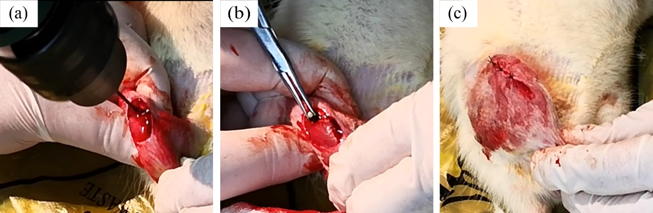
Figure. S2 Surgery procedures; (a) the defects of the femurs in longitudinal axis created by an electric drill, (b) implantation of Ti-Mg alloy in pro-dirlled defect and (c) sutured wound.

