<Supplementary Information>

Nanodiamond enhanced mechanical and biological properties of extrudable gelatin hydrogel cross-linked with tannic acid and ferrous sulphate
Amitava Bhattacharyya ^{1, 2, 3}, V. N. Karthikai Priya ³, Ji-hyun Kim ¹, Mst Rita Khatun ¹, R. Nagarajan ³, Insup Noh ^{1, 2*}
ª Department of Chemical and Biomolecular Engineering, Seoul National University of Science and Technology, Seoul 01811, Republic of Korea
^{b} Convergence Institute of Biomedical Engineering and Biomaterials, Seoul National University of Science and Technology, Seoul 01811, Republic of Korea
^{c} Functional, Innovative and Smart Textiles, PSG Institute of Advanced Studies, Coimbatore 641004, India *insup@seoultech.ac.kr

Supporting data file
Table 1. Different combination of components used for optimization.
Gelatin (g) | Tannic acid (g) in 2 ml water | FeSO₄ (g)
2 in 8 ml water | 0.05 | 0.01
2 in 8 ml water | 0.05 | 0.02
2 in 8 ml water | 0.05 | 0.03
2 in 8 ml water | 0.1 | 0.01
2 in 8 ml water | 0.1 | 0.02
2 in 8 ml water | 0.1 | 0.03
2 in 8 ml water | 0.15 | 0.01
2 in 8 ml water | 0.15 | 0.02
2 in 8 ml water | 0.15 | 0.03

Table 2. Extrusion images of different gel samples (Gel: gelatin, TA: Tannic acid, FS: Ferrous sulfate; the amount (in g) of TA and FS mentioned in the samples, 2 g gelatin used in each case)
Sample | Image
Gel/TA-0.1/FS-0.01 | 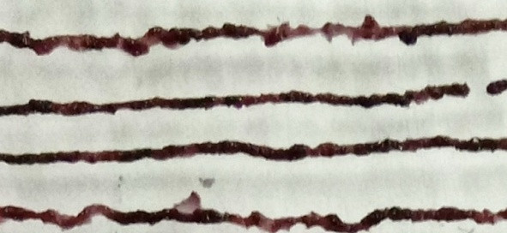
Gel/TA-0.1/FS-0.02 | 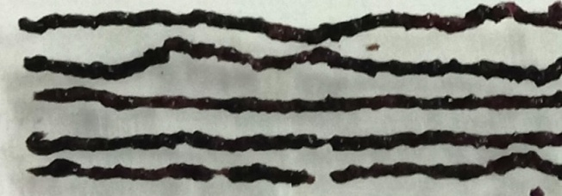
Gel/TA-0.1/FS-0.03 | 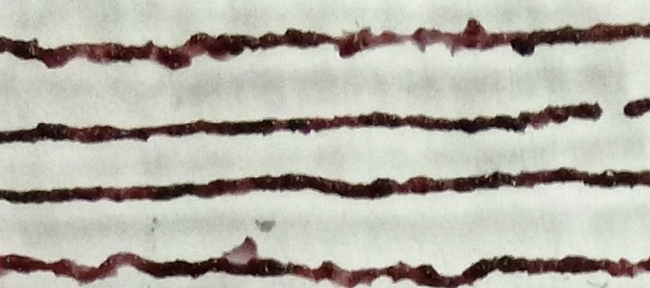
Gel/TA-0.05/FS-0.01 | 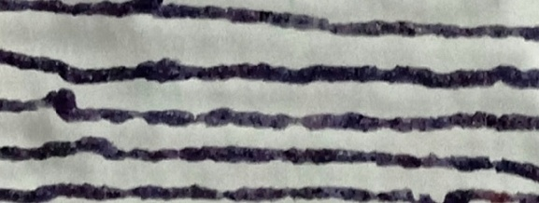
Gel/TA-0.05/FS-0.02 | 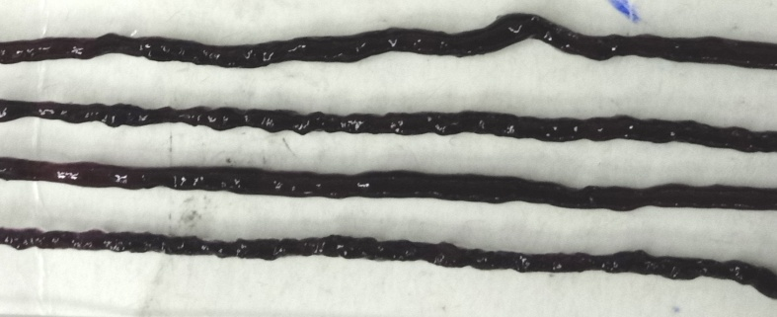
Gel/TA-0.05/FS-0.03 | 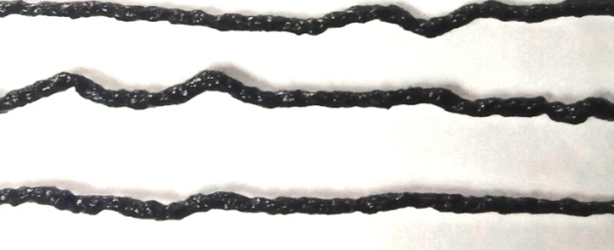
Gel/TA-0.15/FS-0.01 | 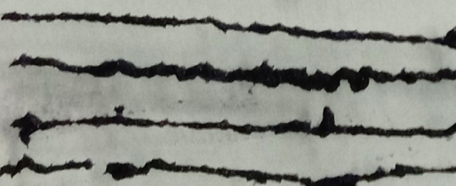

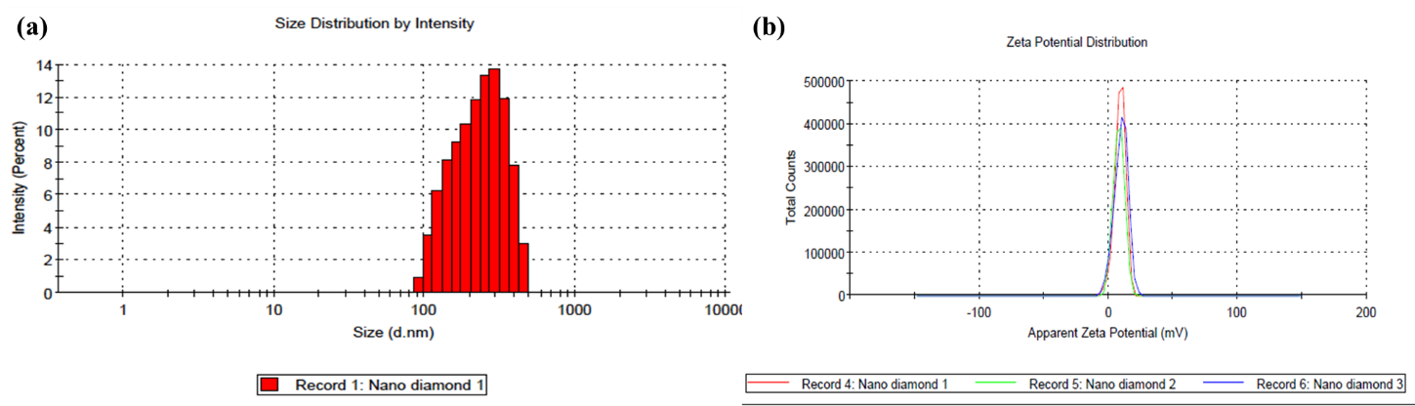
Figure 1: ND in water using dynamic light scattering (DLS) technique, (a) particle size distribution, (b) zeta protentional

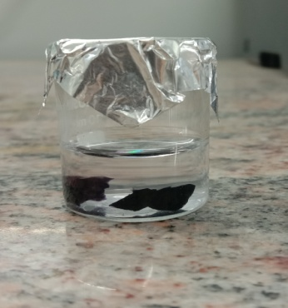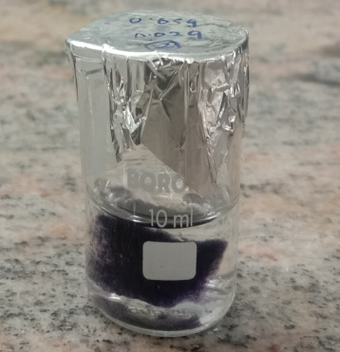
Gel-ND 3 kept for solubility Gel-ND 3 insoluble after 6 days

Figure 2: Solubility test for nanocomposite gel

