Supporting Information

Contact Osteogenesis by Biodegradable 3D-printed Poly(lactide-co-trimethylene carbonate)

Mohamad Nageeb Hassan*, Mohammed Ahmed Yassin, Ahmed Maher Eltawila, Ahmed Emad Aladawi, Samih Mohamed-Ahmed, Salwa Suliman, Sherif Kandil, and Kamal Mustafa*

Table S1: List of genes assessed in the current study.
Gene and code |  | Name |  | Role
GAPDH Hs02758991_g1 |  | Glyceraldehyde-3-phosphate dehydrogenase |  | House-keeping gene
Runx-2 Hs01047973_m1 |  | Runt-related transcription factor 2 |  | Early osteogenic marker  (for osteoblast differentiation)
ALPL  Hs01029144_m1 |  | ALP; Alkaline phosphatase, liver/bone/kidney |  | Early to intermediate osteogenic marker
COL1A2 Hs00164099_m1 |  | COL1; Collagen, type I, alpha 2 |  | Early to intermediate osteogenic marker
BMP-2 Hs00154192_m1 |  | Bone morphogenetic protein-2 |  | Early to intermediate osteogenic marker
SPP1 Hs00959010_m1 |  | Osteopontin |  | Late osteogenic marker
BGLAP Hs01587814_g1 |  | Osteocalcin; Bone gamma carboxyglutamate protein |  | Late osteogenic marker

Table S2: Printing parameters of PCL and PLATMC
Group | Pressure | Temperature ^{a)} | Printing speed | Printing Time | Feed
 | [bar] | [ºC] | [mm sec⁻¹] | [min] | [g]
PCL | 8.4 | 110 | 1.6 | 360 | 3.5
PLATMC | 8.0 | 195 | 2.0 - 5.0 | 85 | 3.0
^{a)} All polymers were pre-heated for 15 min before printing at 15-25 ºC beyond the actual recorded printing temperature.

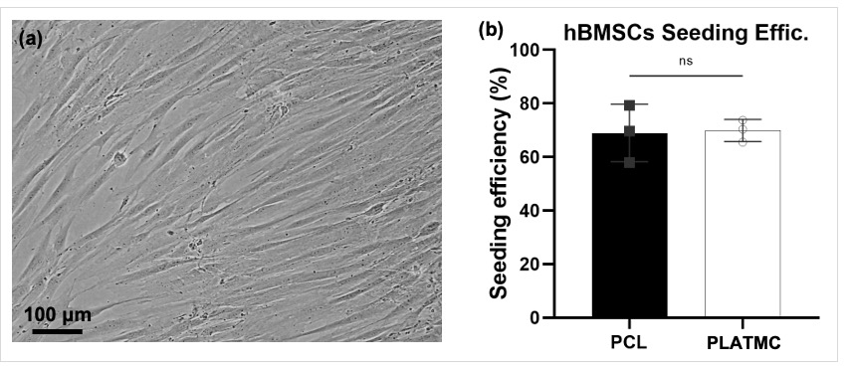
Figure S1: (a) morphology of the seeded hBMSCs at passage 4 (just before seeding) and (b) the quantification of seeding efficiency on PCL and PLATMC (b).

