Supporting Information for

Green tea catechin-grafted silk fibroin hydrogels with reactive oxygen species scavenging activity for wound healing applications

Gyeongwoo Leeª, Young-Gwang Koª, Ki Hyun Bae^{b}, Motoichi Kurisawa^{b}, Oh Kyoung Kwon^{c}, Oh Hyeong Kwon^{a,*}

ªDepartment of Polymer Science and Engineering, Kumoh National Institute of Technology, Gumi, Gyeongbuk 39177, Korea
^{b}Institute of Bioengineering and Bioimaging, 31 Biopolis Way, The Nanos, Singapore 138669, Singapore
^{c}Gastric Cancer Center, Kyungpook National University Chilgok Hospital, Daegu 41404, Korea

*Corresponding author: Professor Oh Hyeong Kwon
E-mail: ohkwon@kumoh.ac.kr
Tel: +82-54-478-7690
Fax: +82-54-478-7710

Table S1
Gel permeation chromatography (GPC) analysis of SF-WS
Sample | M_{n} (Da) | M_{w} (Da) | Polydispersity index (PDI)
SF-WS | 3,922 | 15,599 | 3.98
* Note: Weight-average molecular weight (Mw) of native SF is up to 500 kDa.³⁷

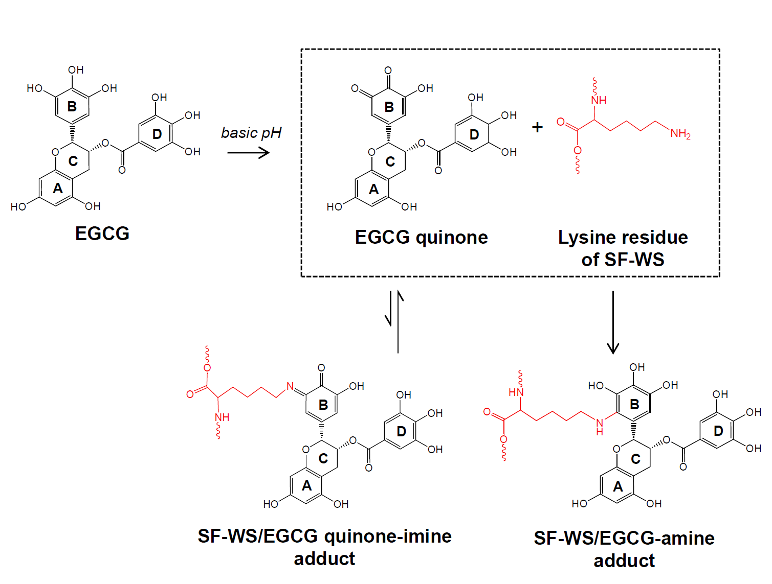
Fig. S1. The reaction mechanism for the SF-EGCG conjugates formation through autoxidation of EGCG at mild basic pH 7.4 and subsequent conjugation of EGCG quinone (ring B) with a lysine residue of SF-WS. SF-WS/EGCG-amine adduct (Michael addition) is considered the dominant final product as the minor formation of SF-WS/EGCG quinone imine adduct (Schiff base addition) is unfavorable due to rapid hydrolysis of the imine bond in aqueous solution.

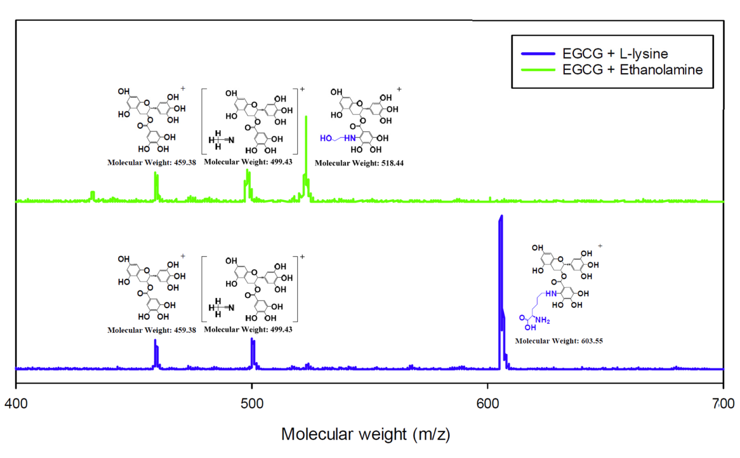
Fig. S2. Mass spectrum of EGCG-L-lysine reaction product and EGCG-ethanolamine reaction product.

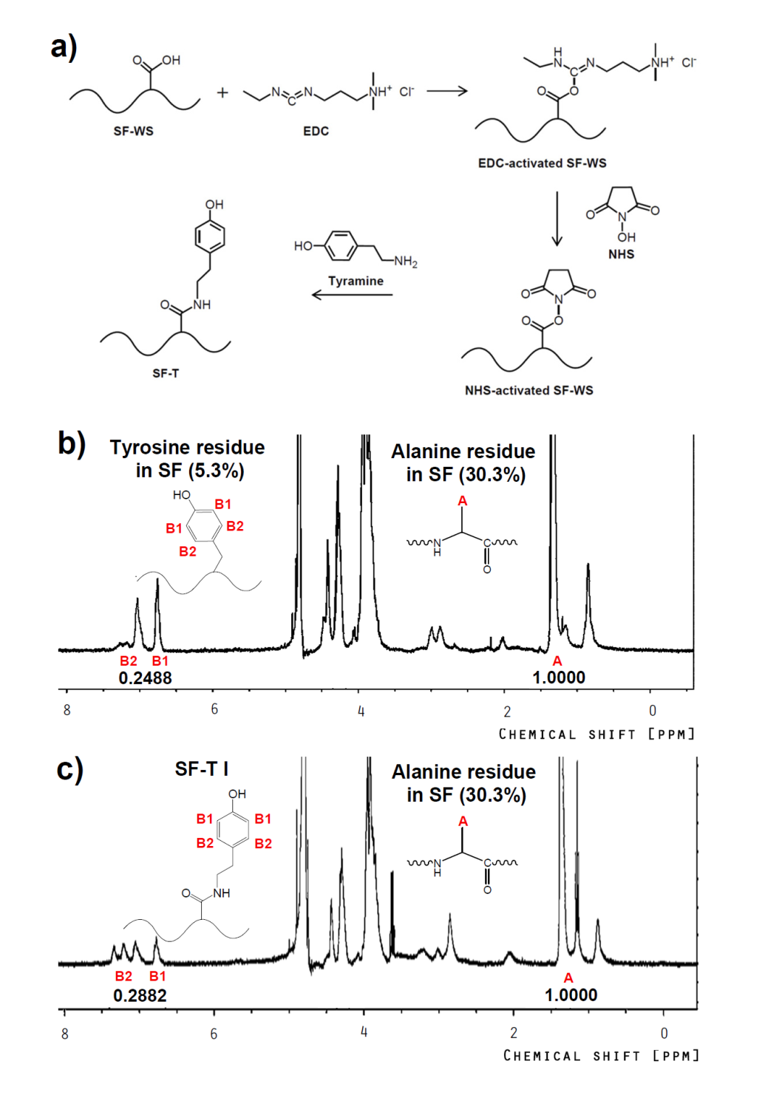
Fig. S3. (a) Synthetic scheme for SF-tyramine (SF-T) conjugate through EDC/NHS activation of carboxyl residue of SF-WS and subsequent amidation reaction with a primary amine group of tyramine. ¹H NMR spectra of (b) SF-WS and (c) SF-T (DS = 1.37). The integrated intensity of the characteristic peaks of tyrosine and tyramine moieties (6.6~7.4 ppm, B1, B2) was compared with that of the peak of alanine residues (1.3~1.5 ppm, A) to determine DS of tyramine moieties.

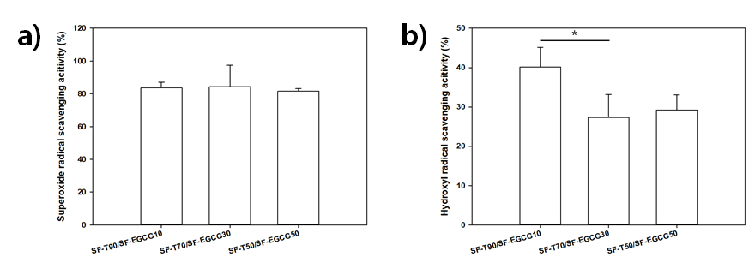
Fig. S4. (a) Superoxide anion radical (O₂•¯) and (b) hydroxyl radical (•OH) scavenging activity (n = 3) of SF-T/SF-EGCG composite hydrogels.

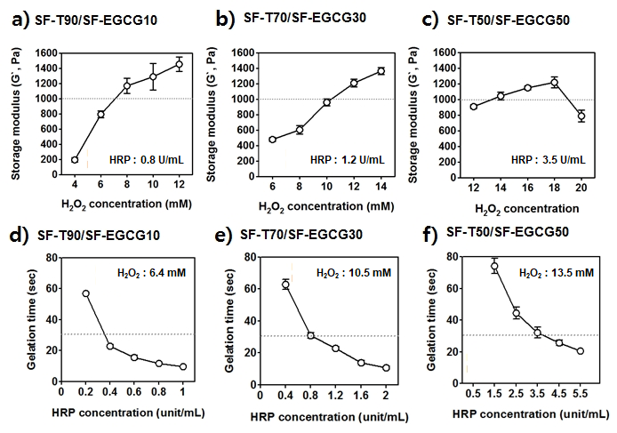
Fig. S5. Storage modulus of (a) SF-T90/SF-EGCG10, (b) SF-T70/SF-EGCG30 and (c) SF-T50/SF-EGCG50 composite hydrogels as a function of H₂O₂ concentration. The dotted line indicates the desired level of storage modulus (1,000 Pa). Gelation time of (d) SF-T90/SF-EGCG10, (e) SF-T70/SF-EGCG30 and (f) SF-T50/SF-EGCG50 composite hydrogels as a function of HRP concentration. The dotted line indicates the desired threshold for gelation time (30 sec), (Mean ± SD, n = 5).

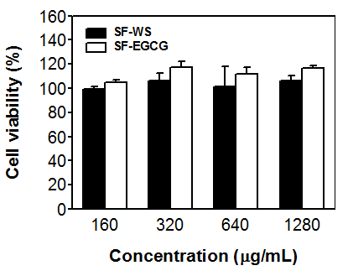
Fig. S6. Viability of NIH3T3 fibroblasts as a function of SF-WS and SF-EGCG concentrations for 24 hours (Mean ± SD, n = 4).

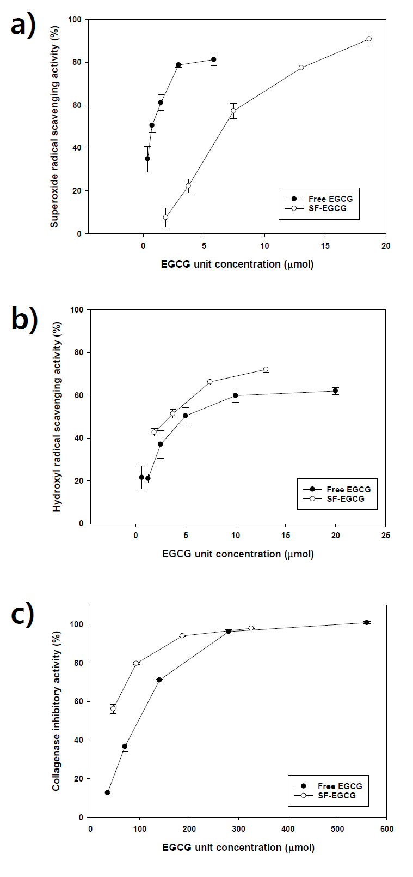
Fig. S7. (a) Superoxide anion radical (O₂•¯) and (b) hydroxyl radical (•OH) scavenging activity (n = 3) and (c) collagenase inhibitory activity (n = 3) of free EGCG and SF-EGCG as a function of concentration..

