Supplementary Information
Ginsenoside Rg3 nanoparticles with permeation enhancing based chitosan derivatives were encapsulated with doxorubicin by thermosensitive hydrogel and anti-cancer evaluation of peritumoral hydrogel injection combined with PD-L1 antibody
Hao Wu ^{c}, Guoli Wei ^{a, b, d}, Lixia Luo ^{a, b}, Lingchang Li ^{a, b}, Yibo Gao ^{a, b}, Xiaobin Tan ^{a, b}, Sen Wang ^{a, b}, Haoxiao Chang ^{c, e}, Yuxi Liu ^{c}, Yingjie Wei ^{a, b}, Jie Song ^{a, b,} *, Zhenhai Zhang ^{a, b,} *, Jiege Huo ^{a, b,}*
a Affiliated Hospital of Integrated Traditional Chinese and Western Medicine, Nanjing University of Chinese Medicine, 210023 Nanjing, China
b Jiangsu Province Academy of Traditional Chinese Medicine, 210028 Nanjing, China
c School of Material Science and Chemical Engineering, Chuzhou University, Chuzhou 239000
d Department of Oncology, Nanjing Lishui District Hospital of Traditional Chinese Medicine, Nanjing, China
e Department of Neurology, Beijing Tiantan Hospital, Capital Medical University, Beijing, China.

Supplementary Methods
In vivo Hydrogel Degradation. The thermosensitive hydrogel (PLGA-PEG-PLGA, PPP) (20%, 200 μL) was injected into the right backs of BALB/c mice. The mice were photographed and sacrificed at different time intervals. The remaining hydrogel in each mouse was firstly photographed. Skins were examined by H&E staining.

Supplementary Results
Supplementary Figure S1. Schematic procedure of the synthesis of PEP-CS.
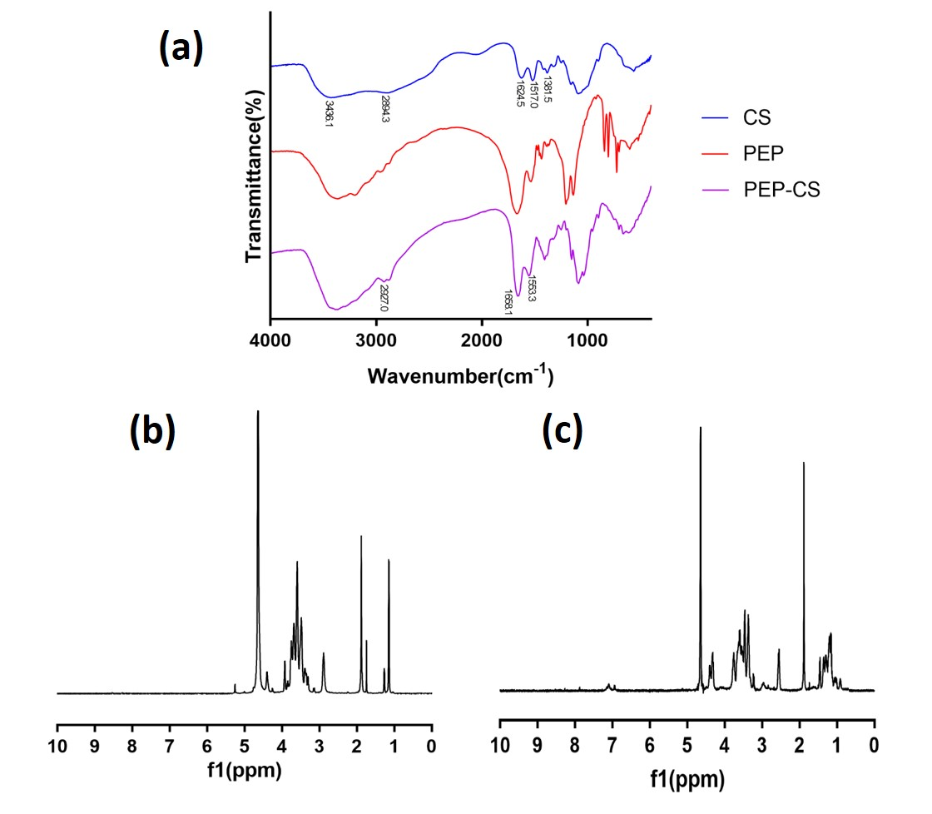
Supplementary Figure S2. The characterization of CS, Pep and Pep-CS. (a) The FT-IR of CS, Pep and Pep-CS. The ¹H NMR spectra of CS (b) and the ¹H NMR spectra of Pep-CS (c).

Supplementary Figure S3. The stability of Rg3-NPs and Rg3-PNPs (pH 7.4) at 25°C for up to 7 days.
Supplementary Figure S4. The stability of blank PPP and Rg3-PNPs+DOX@PPP (pH 7.4) at 25°C for up to 7 days.

Supplementary Figure S5 4T1 cytotoxicity study and CI value treated with different combined groups.

Supplementary Figure S6. The degradation behavior of the thermogel and the H&E-stained images of skin tissue after subcutaneous injection of thermogel.

Supplementary Figure S7. Body weight and histopathological images of the major organs, including spleen, lung, liver, heart and kidney obtained from the 4T1-bearing mice sacrificed at Day 15 (scale bar: 100 μm).
Supplementary Figure S8. Representative flow cytometry profiles and quantitation of TH1 (IFN-γ⁺CD4⁺T) cell, CTL (IFN-γ⁺CD8⁺T) cell, and Tregs (CD4⁺Foxp3⁺ T) cell populations in spleen from tumor-bearing mice. The data show mean ± SD from a representative experiment (n=3). *p < 0.05, ** p < 0.01 vs PBS.

Supplementary Table S1. Properties of different nanoparticles.
Sample | DL (%) | EE (%)
Rg3-NPs | 8.7±1.2 | 50.3±2.3
Rg3-PNPs | 9.2±1.7 | 53.6±1.8
The data are presented as means ± SD (n = 3).

Supplementary Table S2. Zeta potential of blank PPP and Rg3-PNPs+DOX@PPP
Time (day) | PPP | Rg3-PNPs+DOX@PPP
1 | -0.51±0.08 | 10.7±0.76
3 | -0.54±0.07 | 9.8±0.73
5 | -0.57±0.07 | 11.3±0.79
7 | -0.63±0.06 | 11.7±0.81

