Supplementary Materials

Surface Modifications of Titanium Dental Implants with Strontium Eucommia Ulmoides to Enhance Osseointegration and Suppress Inflammation
Rui Sun^{a, d, e, 1}, Qili Sun^{a,1}, Yansong Wang^{a,1}, Liqiu Huª, Yutong Wuª, Fenbo Maª, Jiayi Liuª, Xiangchao Pang^{a, f, *}, Bin Tang^{a,b,c,*}.
ª Department of Biomedical Engineering, Southern University of Science and Technology, Shenzhen, 518055, China
^{b} Guangdong Provincial Key Laboratory of Cell Microenvironment and Disease Research, China
^{c} Shenzhen Key Laboratory of Cell Microenvironment, China
^{d} Department of Biomedical Engineering, College of Design and Engineering, National University of Singapore, Singapore 117583, Singapore
^{e} Mechanobiology Institute (MBI), National University of Singapore, Singapore 117411, Singapore
^{f} College of Materials Science and Engineering, Central South University of Forestry and Technology, Changsha 410004, China
¹ These authors contributed equally to this study.
*Corresponding author (s)
Main corresponding author: Bin Tang, Email: tangb@sustech.edu.cn; Tel: 86-0755-88018998

Supplementary material S1

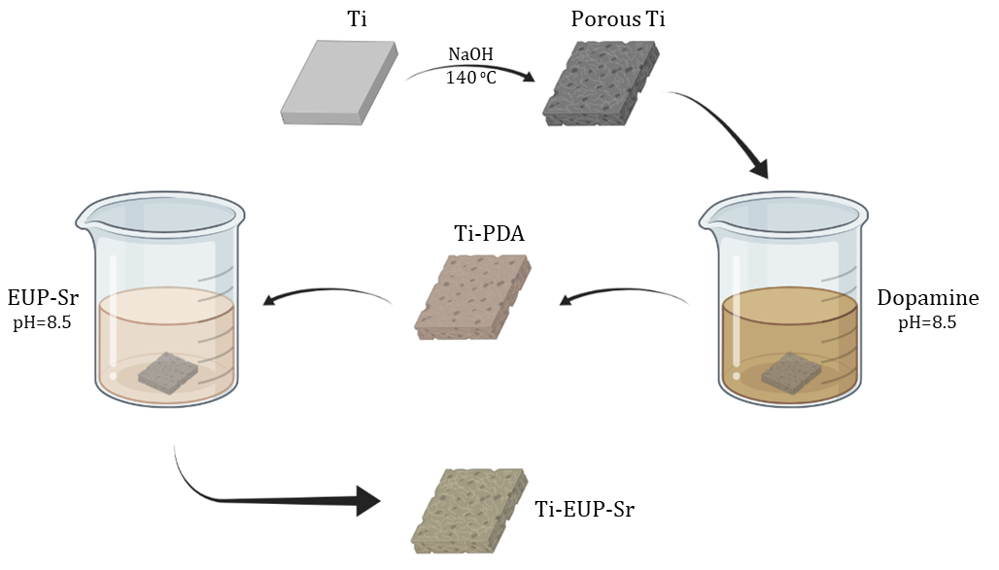
Supplemental Figure 1. Schematic illustration of implant surface modified by EUP-Sr. (Created with BioRender.com)

