Supplementary Materials

Surface Modifications of Titanium Dental Implants with Strontium Eucommia Ulmoides to Enhance Osseointegration and Suppress Inflammation
Rui Sun^{a, d, e, 1}, Qili Sun^{a,1}, Yansong Wang^{a,1}, Liqiu Huª, Yutong Wuª, Fenbo Maª, Jiayi Liuª, Xiangchao Pang^{a, f, *}, Bin Tang^{a,b,c,*}.
ª Department of Biomedical Engineering, Southern University of Science and Technology, Shenzhen, 518055, China
^{b} Guangdong Provincial Key Laboratory of Cell Microenvironment and Disease Research, China
^{c} Shenzhen Key Laboratory of Cell Microenvironment, China
^{d} Department of Biomedical Engineering, College of Design and Engineering, National University of Singapore, Singapore 117583, Singapore
^{e} Mechanobiology Institute (MBI), National University of Singapore, Singapore 117411, Singapore
^{f} College of Materials Science and Engineering, Central South University of Forestry and Technology, Changsha 410004, China
¹ These authors contributed equally to this study.
*Corresponding author (s)
Main corresponding author: Bin Tang, Email: tangb@sustech.edu.cn; Tel: 86-0755-88018998

Supplementary material S2

Mineralization assay
Sterilized Ti-EUP-Sr samples and Ti control samples were air dried and placed in a 24 well plate. Simulated body fluid (SBF) was prepared and added to the samples (1 mL/well) to mimic the in vivo electrolytes and osmolarity environment [1]. The well plate was kept on a 100 rpm shaker at 37 ºC for 14 days, where the SBF was exchanged every 3 days. The samples were subsequently rinsed by ddH₂O and kept at 37 ºC for 4 hours until fully dried. The samples were then coated with gold and observed with Hitachi Regulus SEM.
As is shown in Fig. S2, mineralized structure was more obviously and ubiquitously identified on the surface of EUP-Sr modified Ti using SEM (Hitachi Regulus). Combining our in vitro cell experiments evaluating osteogenic gene expression, we believe Ti-EUP-Sr demonstrates better inducement in bone regeneration.
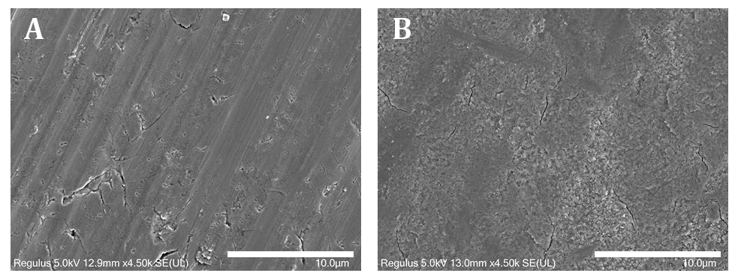
Fig. S2 EUP-Sr loaded titanium implants (B) demonstrate more effective mineralization compared to untreated Ti (A). Scale bar: 10 μm
Reference
[1] T. Kokubo, H. Kushitani, S. Sakka, T. Kitsugi, and T. Yamamuro, "Solutions able to reproduce in vivo surface-structure changes in bioactive glass-ceramic A-W," (in eng), J Biomed Mater Res, vol. 24, no. 6, pp. 721-34, Jun 1990.

