Supplemental Table 1. Summary of sensitivity and specificity values in determining the ovulatory phase relative to follicular phase for Cervical Fluid Impedance relative to an accepted form of ovulatory predictor: basal body temperature. Averaged percentages to demonstrate trends.
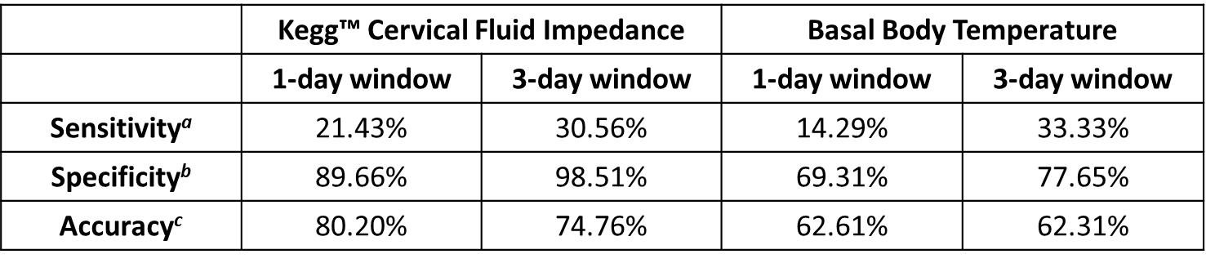
ªSensitivity (True Positive Rate) refers to the probability of a positive test, conditioned on truly being positive.
^{b}Specificity (True Negative Rate) refers to the probability of a negative test, conditioned on truly being negative.
^{c}Accuracy refers to the proportion of true results, either true positive or false negative.

