Supplementary material

Table S1. Pre and Post Overlap Weights Covariate Balance
Figure S1. Propensity scores distributional balance

Table S1. Before and After Overlap Weights Covariate Balance
Before weighting |  |  |  | After weighting
Variable | DPP4i (n=166) | Non-DPP4i (n=359) | Unadjusted absolute SMD | DPP4i  (ESS= 148) | Non-DPP4i (ESS= 259) | Adjusted Absolute SMD
Age, mean (SD) | 67.2 (12.5) | 66.4 (13.3) | 0.061 | 67.3 (12.8) | 67.3 (12.8) | <0.001
Male, (%) | 58 | 50 | 0.077 | 54 | 54 | <0.001
Weight, mean (SD) | 76.7 (15.6) | 81.0 (18.5) | 0.261 | 77.3 (16.2) | 77.4 (16.8) | <0.001
Hemoglobin A1c, mean (SD) | 8.9 (2.3) | 8.5 (2.3) | 0.160 | 8.8 (2.2) | 8.9 (2.4) | <0.001
COVID-19 WHO severity classification at baseline, % |  |  |  |  |  | <0.001
Mild to moderate | 51 | 43 | 0.079 | 49 | 49
Severe | 39 | 42 | 0.039 | 39 | 39
Critical | 11 | 15 | 0.040 | 12 | 12
Hypertension, % | 76 | 77 | 0.013 | 75 | 75 | <0.001
Dyslipidemia, % | 53 | 49 | 0.040 | 50 | 50 | <0.001
Cardiovascular diseases, % | 36 | 29 | 0.071 | 34 | 34 | <0.001
Chronic kidney disease, % | 16 | 13 | 0.029 | 16 | 16 | <0.001
Respiratory diseases, % | 11 | 12 | 0.014 | 11 | 11 | <0.001
Anemia, % | 4 | 3 | 0.008 | 3 | 3 | <0.001
ICU admission, (%) | 28 | 37 | 0.096 | 31 | 31 | <0.001
Anticoagulant use, % | 10 | 9 | 0.002 | 10 | 10 | <0.001
Steroids use, % | 10 | 9 | 0.005 | 10 | 10 | <0.001
PPI, % | 36 | 34 | 0.020 | 35 | 35 | <0.001
Antiplatelet Therapy | 39 | 31 | 0.084 | 35 | 35 | <0.001
Statin, % | 63 | 51 | 0.123 | 59 | 59 | <0.001
BB, % | 28 | 26 | 0.024 | 27 | 27 | <0.001
CCB, % | 36 | 43 | 0.066 | 36 | 26 | <0.001
Thiazide diuretics, % | 8 | 7 | 0.019 | 7 | 7 | <0.001
ACEI/ARB, % | 38 | 34 | 0.043 | 36 | 36 | <0.001
Insulin, % | 29 | 46 | 0.170 | 33 | 33 | <0.001
Metformin, % | 55 | 46 | 0.098 | 55 | 55 | <0.001
Sulfonylureas, % | 8 | 8 | 0.019 | 8 | 8 | <0.001
GLP-RA, % | 3 | 3 | 0.004 | 3 | 3 | <0.001
SGLT-2 inhibitor, % | 20 | 5 | 0.148 | 12 | 12 | <0.001
IV steroids (in-patient) , % | 49 | 60 | 0.107 | 53 | 53 | <0.001
Favipiravir (in-patient), % | 14 | 14 | 0.005 | 16 | 16 | <0.001
Tocilizumab, % | 9 | 10 | 0.009 | 9 | 9 | <0.001
Abbreviations: SD: Standard deviation. DPP-4i: Dipeptidyl peptidase-4 inhibitors; WHO: World Health Organization; COVID-19: coronavirus disease 2019; HbA1c: hemoglobin A1c; SGLT-2i: Sodium-glucose transport protein-2 inhibitor; GLP-1RA: Glucagon-like peptide-1 receptor agonist; ACEI: Angiotensin-converting enzyme inhibitors; ARBs: Angiotensin II receptor blockers. ICU: Intensive Care Unit. IV: Intravenous; ESS: Effective sample size.

Data imputation for a few missing data points was performed via transcan function from the Hmisc package. Covariate balance was achieved via the overlap weights methodology according to Li (2017) by weighting each unit proportional to its probability of assignment to the opposite group. The estimand is referred to "ATO" (average treatment effect in the overlap). SMD closer to zero are indicative of good balance. These computations were performed using the WeightIt package. Covariates balance diagnostics are assessed using the cobalt package in R.

Figure S1. Propensity scores distributional balance (pre and post the adjusted samples)
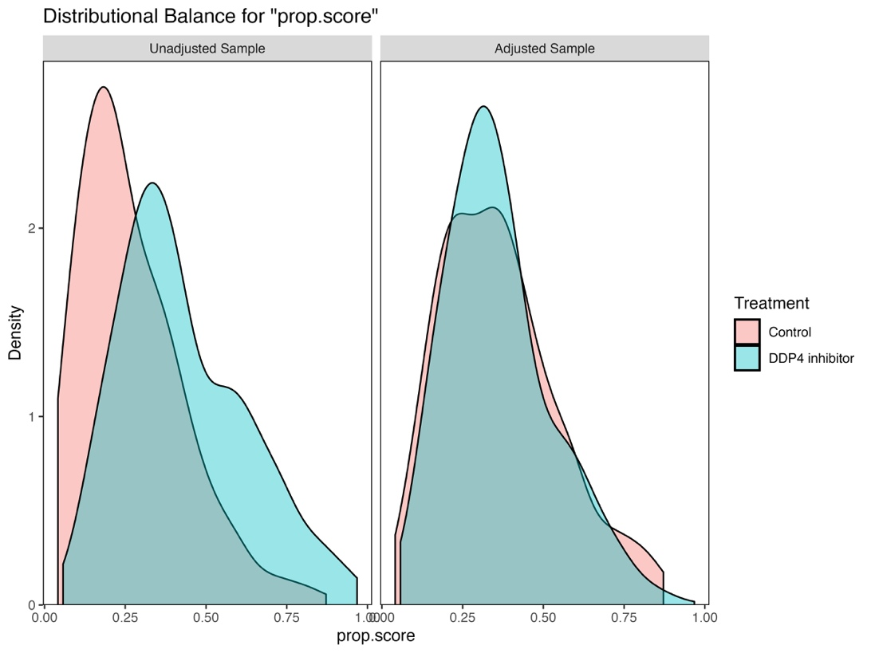
Control refers to the non-DDP4 group. Abbreviations: DPP-4i: Dipeptidyl peptidase-4 inhibitors; Prop: Propensity

