Supplementary materials

Figure S1: Consort flow of the study
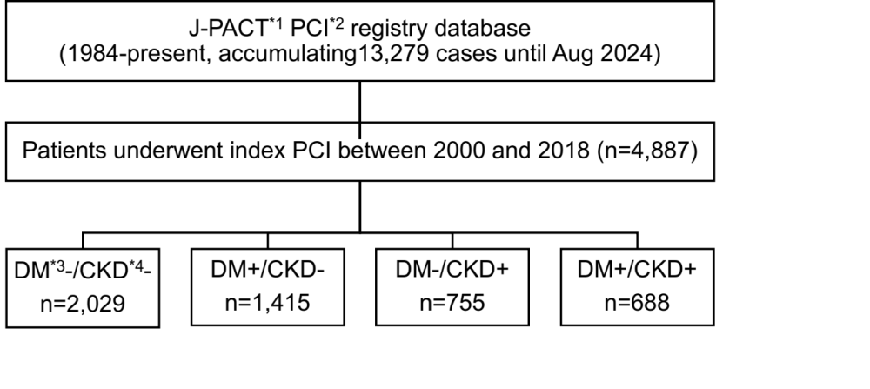
*1: J-PACT: Juntendo-Physicians Alliance for Clinical Trial, *2: PCI: Percutaneous coronary intervention, *3: DM: Diabetes mellitus, *4: CKD: Chronic kidney disease

Figure S2: Cumulative incidences of CV death in patients with and without DM (a) and CKD (b)
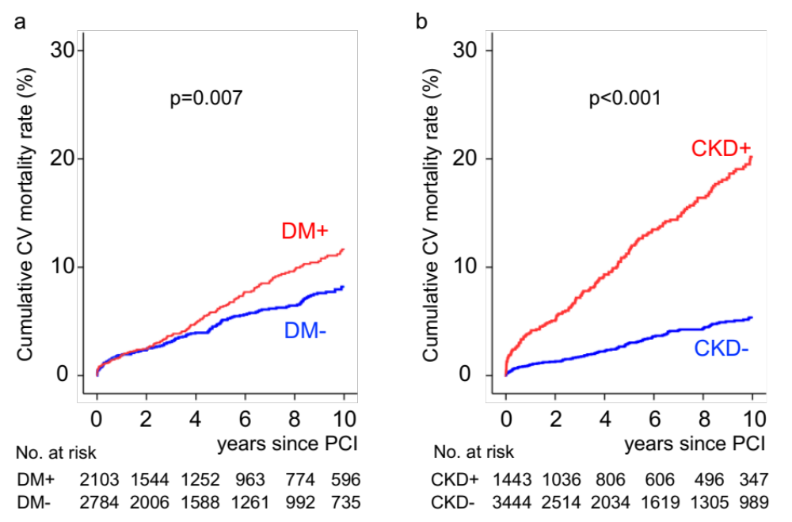
Log-rank analysis compared Kaplan-Meier curves in each analysis.

