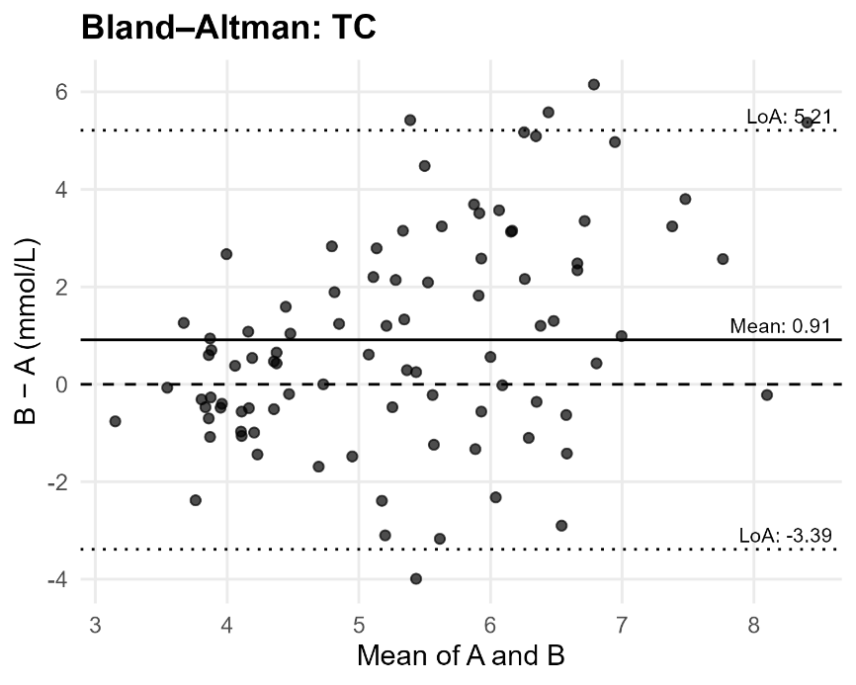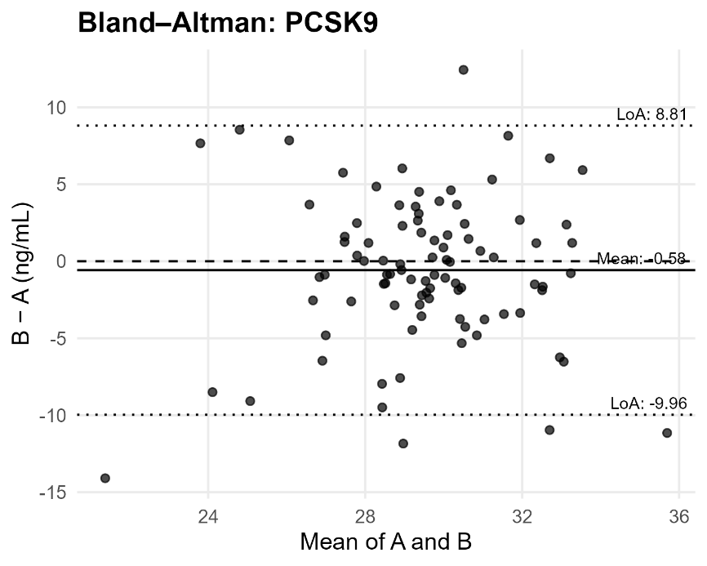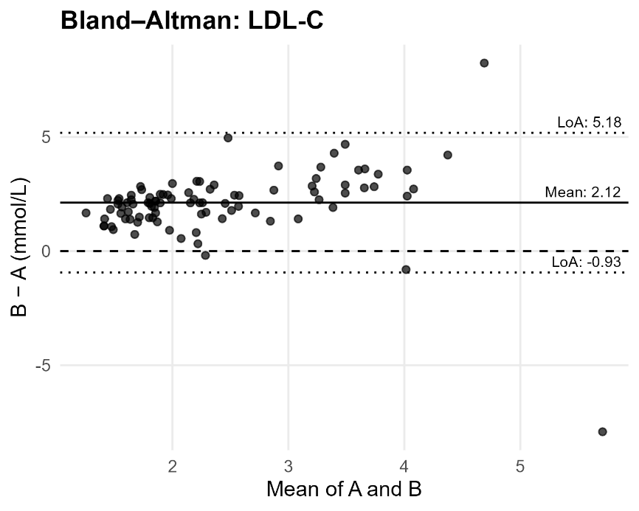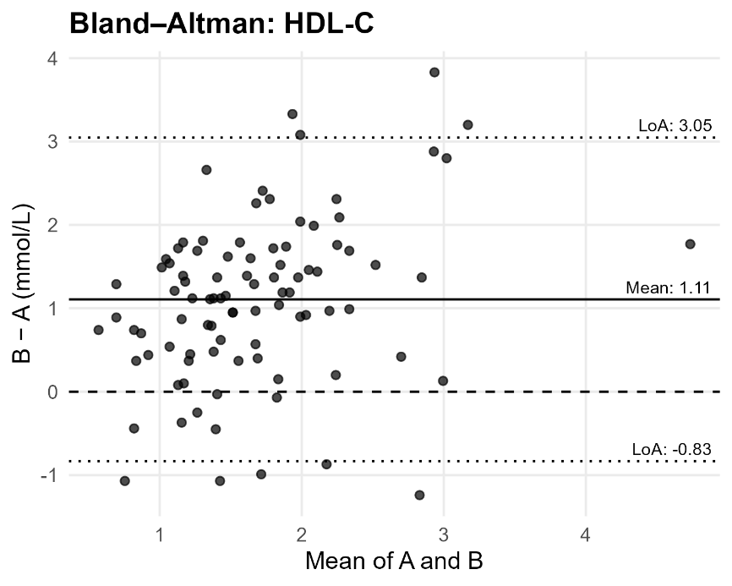
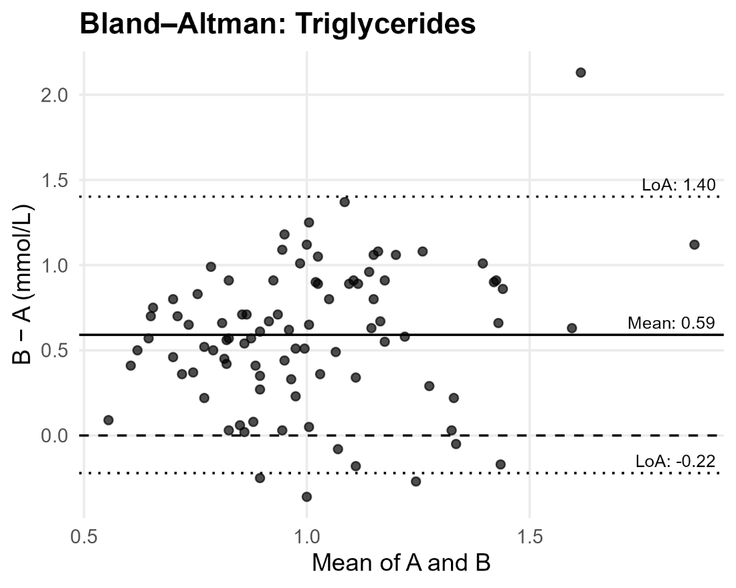
Figure S1. Bland–Altman plots: Agreement plots for each marker (T2DM–Control vs pair mean). Solid line = mean bias; dashed lines = mean ±1.96 SD (limits of agreement). Lipids show positive mean biases (higher in T2DM); PCSK9 shows no material bias.

Table S1. Unpaired sensitivity analyses: Welch t and Wilcoxon p-values for between-group comparisons treating observations as independent (sensitivity only). Inferences match the paired analysis.
marker | t_stat | t_p | wilcox_stat | wilcox_p | t_q_BH | t_p_Bonf | w_q_BH | w_p_Bonf
hdl | -9.03821 | 3.98E-16 | 1262 | 2.01E-16 | 6.63E-16 | 1.99E-15 | 3.35E-16 | 1.01E-15
ldl | -12.1231 | 3.89E-25 | 363 | 9.15E-27 | 9.74E-25 | 1.95E-24 | 4.58E-26 | 4.58E-26
pcsk9 | 1.179515 | 0.239734 | 4554 | 0.373445 | 0.239734 | 1 | 0.373445 | 1
tchol | -3.87776 | 1.55E-04 | 3120.5 | 0.0021 | 1.94E-04 | 7.75E-04 | 0.002625 | 0.010499
trig | -12.4566 | 7.52E-26 | 757 | 6.62E-22 | 3.76E-25 | 3.76E-25 | 1.66E-21 | 3.31E-21

