SUPPLEMENTAL FIGURES
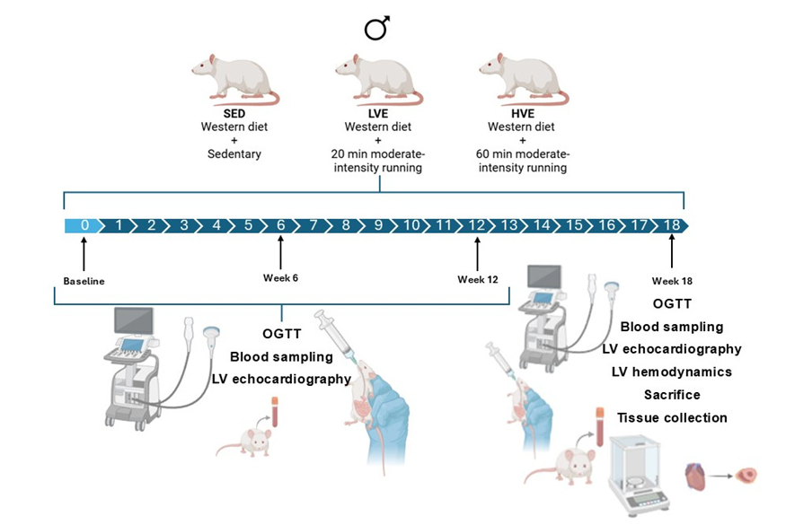
Figure S1: Representation of the study design. Male Sprague Dawley rats were fed a daily in-house high-glucose (western) diet to induce T2DM and randomly assigned to an experimental group. Rats performed five days per week LVE or HVE training, and results were compared with SED control rats to evaluate the preventive mechanisms of exercise volume training in DCM progression. T2DM, type 2 diabetes; SED, sedentary; LVE, low-volume exercise; HVE, high-volume exercise; DCM, cardiomyopathy; OGTT, oral glucose tolerance test; LV, left ventricle.

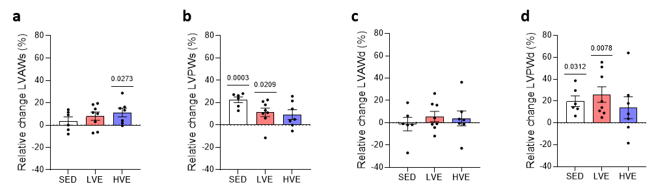
Figure S2: HVE training prevents diastolic LV hypertrophy. Conventional echocardiography in M-mode was performed to evaluate anterior and posterior wall thickness. Data represents percentage change in (a, b) systolic and (c, d) diastolic LV anterior and posterior wall thickness after 18 weeks. Data are presented as median [Q1, Q3]. Baseline value = 0. LV, left ventricular; LVAW, left ventricular anterior wall thickness; LVPWs, left ventricular posterior wall thickness.

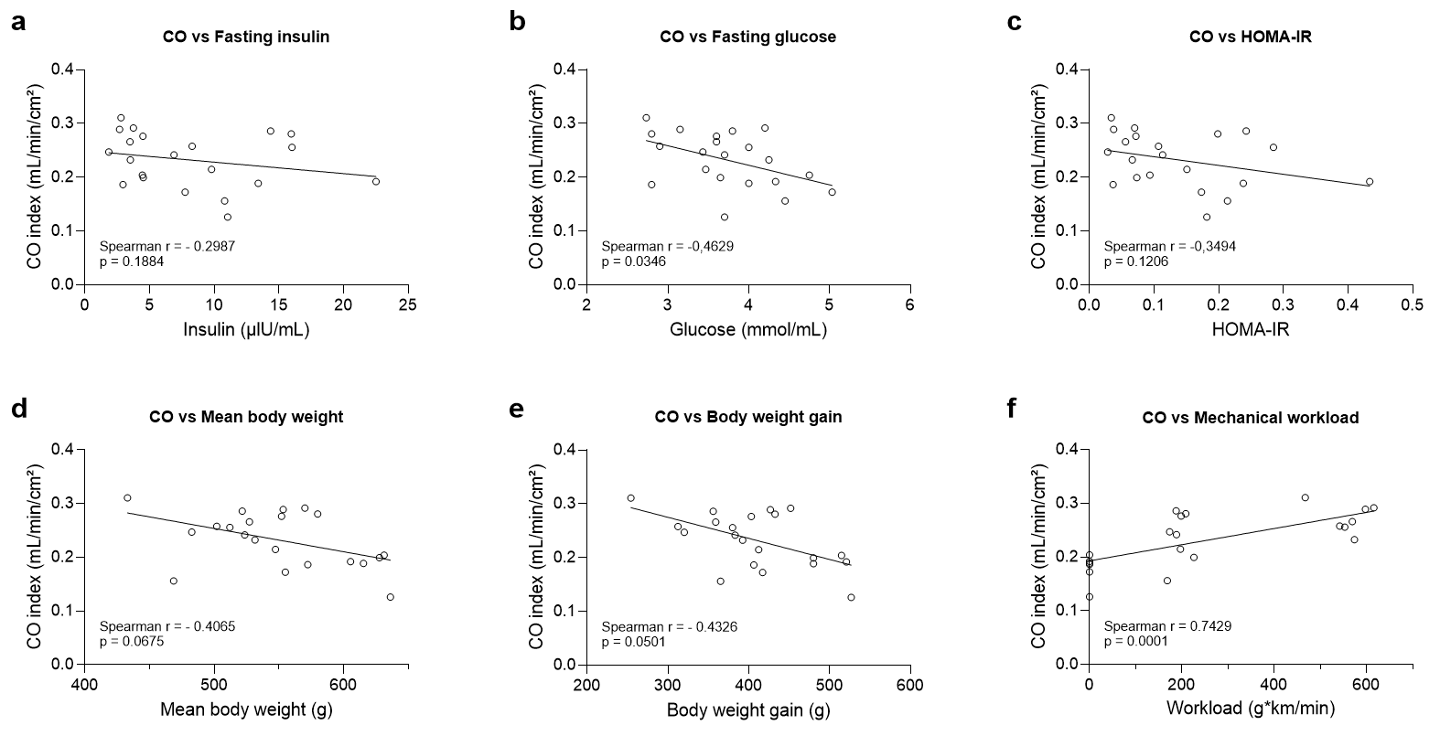
Figure S3: Correlation analysis of cardiac performance with metabolic and exercise-related parameters. (a) cardiac output index to body surface area vs fasting plasma insulin at week 18. (b) cardiac output index to body surface area vs fasting plasma insulin at week 18. (c) cardiac output index to body surface area vs. HOMA-IR index at week 18. (d) cardiac output index to body surface area vs. mean body weight. (e) cardiac output index to body surface area vs. body weight gain. (f) cardiac output index to body surface area vs. Mechanical workload per training session. Data points represent the corresponding values of each animal. CO, cardiac output index

Table S1. Multivariable linear regression analysis assessing predictors of cardiac output index

 | Model 1:  All animals |  |  | Model 2:  Exercise groups only
Predictor | β coefficient | 95% CI | p-value | β coefficient | 95% CI | p-value
Mechanical workload | -0.0001431 | 6.026e-005 to 0.0002260 | 0.0019 | 8.048e-005 | -4.349e-005 to 0.0002045 | 0.1826
HOMA-IR week 18 | -0.04392 | -0.2305 to 0.1426 | 0.6268 | -0.06648 | -0,3561 to 0.2231 | 0.6260

