Supplementary Data
Table 1. Accession numbers used in phylogenetic analyses.
 | CO1 |  | 12S |  | 18S
Taxon | Access No GenBank | Length | Access No GenBank | Length | Access No GenBank | Length
HS1- Hirudo sulukii n. sp. | KU216239 | 648 | KU216262 | 345 | KU216264 | 688
HS2- Hirudo sulukii n. sp. | KU216240 | 571 | KU216263 | 345 | KU216265 | 689
HS5- Hirudo sulukii n. sp. | KU216241 | 634 | - | - | - | -
HS6- Hirudo sulukii n. sp. | KU216242 | 648 | - | - | - | -
HS7- Hirudo sulukii n. sp. | KU216243 | 654 | - | - | - | -
HV- Hirudo verbana | - | - | KU216246 | 348 | KU216254 | 653
HV1- Hirudo verbana | - | - | KU216247 | 347 | KU216255 | 671
HV2- Hirudo verbana | - | - | KU216248 | 343 | KU216256 | 671
HV3- Hirudo verbana | KU216244 | 642 | KU216249 | 347 | KU216257 | 666
HV4- Hirudo verbana | - | - | KU216250 | 345 | KU216258 | 670
HV5- Hirudo verbana | - | - | KU216251 | 348 | KU216259 | 670
HV6- Hirudo verbana | - | - | KU216252 | 317 | KU216260 | 673
HV7- Hirudo verbana | - | - | KU216253 | 340 | KU216261 | 670
HV19- Hirudo verbana | KT692947 | 691 | - | - | - | -
HV20a- Hirudo verbana | KU216245 | 655 | - | - | - | -
Hirudo medicinalis | EF446712 | 659 | JN118994 | 508 | AY786464 | 1779
Hirudo medicinalis | EU100093 | 1282 | DQ097197 | 347 | AF116011 | 1838
Hirudo orientalis | GQ36875 | 629 | JN118988 | 505 | GQ368792 | 1765
Hirudo orientalis | JN1046480 | 659 | JN118987 | 505 | - | -
Hirudo verbena | EF446698 | 653 | JN104653 | 507 | HQ691212 | 1832
Hirudo verbena | HQ691223 | 815 | AY763160 | 496 | GQ368794 | 1733
Hirudo troctina | GQ368751 | 629 | JQ364947 | 507 | GQ368793 | 1765
Hirudo troctina | JQ364946 | 661 | AY763164 | 492 | - | -
Hirudo nipponia | GQ368749 | 652 | AY763162 | 492 | AY425468 | 1813
Hirudo nipponia | AY763153 | 654 | AY425427 | 345 | JX885694 | 980
Haemadipsa rjukjuana | KC524509 | 649 | - | - | HQ203097 | 1865
Haemadipsa rjukjuana | HQ322462 | 658 | - | - | KC524510 | 1706
Haemopis sanguisuga | AF462021 | 647 | AF099960 | 344 | AF099941 | 1,884
Haemopis sanguisuga | KP663470 | 561 | - | - | X91401 | 1,874
Haemadipsa sylvestris | HQ203175 | 1299 | AY425416 | 337 | HQ203102 | 1859
Haemadipsa zeylanica | HQ203183 | 1299 | AY763165 | 469 | HQ203104 | 1860
Hirudinaria javanica | JN412851 | 675 | - | - | JN412845 | 1858
Hirudinaria javanica | GQ368745 | 658 | - | - | GQ368787 | 1817
Hirudinaria manillensis | GQ368747 | 658 | AY425426 | 369 | JN412844 | 1809
Hirudinaria manillensis | JN412848 | 651 | GU045561 | 343 | GQ368789 | 1833
Limnatis_nilotica | AY425452 | 648 | AY425430 | 353 | AY425470 | 1901
Macrobdella decora | EU100095 | 1282 | AY425431 | 334 | AF116007 | 1855
Macrobdella decora | AF003271 | 651 | - | - | - | -

Morphological data
Characters used in this study were adapted from Borda and Siddall (2004) and Utevsky and Trontelj (2005). A matrix of 26 morphological characters is shown in Table 4, based on criteria and nomenclature summarized below:
Character 1, Muscular jaws: (0) Absent, (1) Present
Character 2, Toothed jaw: (0) Monostichodont, (1) Distichodont, (2) Astichodont, (3) With stylets
Character 3, Number of jaws: (0) Agnathous, (1) Duognathous, (2) Trignathous
Character 4, Feeding habit: (0) Macrophagous, (1) Haematophagous
Character 5, Salivary papillae: (0) Absent, (1) Present
Character 6, Number of annuli with eyespots: (0) None, (1) One, (2) Two, (3) Three, (4) Four, (5) Five
Character 7, Eyespots per annulus: (0) One pair, (1)Two or more pairs
Character 8, Vaginal tube: (0) Absent, (1) Present
Character 9, Vaginal caecum: (0) Absent, (1) Present
Character 10, Ovisac shape: (0) Tubular, (1) Spheroid
Character 11, Common oviduct: (0) Absent, (1) Present
Character 12, Male atrium extended into elongated penis and sheath: (0) Absent, (1) Present
Character 13, Penis shape: (0) Straight, (1) Recurved
Character 14, Ejaculatory ducts: (0) U-shaped, (1) Shaped
Character 15, Atria: (0) Bilobed, (1) Fused
Character 16, Copulatory glands: (0) Absent, (1) Present
Character 17, Intergonadal conducting tissue: (0) Absent, (1) Present
Character 18, Testisac arrangement: (0) Grape-like cluster profusely arranged on vasa deferentia, (1) Discretely arranged on vasa deferentia
Character 19, Testisacs per body somite: (0) One pair, (1) Two pairs, (2) Four pairs
Character 20, Cocoons: (0) Brooded, (1) Cemented, (2) Spongy and deposited on land
Character 21, Mid-body nephropores: (0) Ventromedial, (1) Ventrolateral
Character 22, Nephridia: (0) Single funnel apparatus, (1) Multiple funnels in a ciliated organ
Character 23, Friction rays on caudal sucker: (0) Absent, (1) Present
Character 24, Respiratory auricles: (0) Absent, (1) Present
Character 25, Dorsum coloration pattern: (0) one characteristic longitudinal pair of paramedian black stripes, (1) dorsal red/orange pigmented longitudal reticulum, (2) Dorsum brown olive with five longitudinal yellow stripes (3) quadrangular metameric black dots , (4) pattern absent with broad marginal orange stripes on either side (5) three longitudinal dark-brown stripes, (6) A pair of dark longitudinally stripes zigzag-shaped on each side.
Character 26, Venter coloration pattern: (0) pattern absent, (1) few or no dark spots, (2) numerous dark-pigmented spots, (3) Venter black, with metameric pairs of light-colored markings.

Table 2. Matrix of morphological data used for phylogenetic analyses.
Taxon | Characters
Taxon | 12345678901234567890123456
HS1 | 10210501111111100102010002
HS2 | 10210501111111100102010002
HS4 | 10210501111111100102010002
HS5 | 10210501111111100102010002
HS6 | 10210501111111100102010002
HS7 | 10210501111111100102010002
HV | 10210501111111100102010011
HV1 | 10210501111111100102010011
HV2 | 10210501111111100102010011
HV3 | 10210501111111100102010011
HV4 | 10210501111111100102010011
HV5 | 10210501111111100102010011
HV6 | 10210501111111100102010011
HV7 | 10210501111111100102010011
HV19 | 10210501111111100102010011
HV20a | 10210501111111100102010011
Hirudo medicinalis | 10210501111111100102010002
Hirudo orientalis | 10210501111111100102010033
Hirudo troctina | 10210501111111100102010032
Hirudo verbana | 10210501111111100102010011
Hirudo nipponia | 10210501111111100102010020
Haemadipsa zeylanica | 10211501111000100102011150
Haemopis sanguisuga | 11200501111111100102010062
Hirudinaria manillensis | 10211501111111100102010001
Limnatis nilotica | 10211501111000100102010040
Macrobdella decora | 10210501011000110102010011

Figure 1. Maximum Parsimony analysis of taxa obtained from COI mtDNA.

Figure 2. Minimum Evolution method of taxa obtained from COI mtDNA.

Figure 3. Maximum Parsimony analysis of a combined COI, 12S and 18S data set.

Figure 4. Minimum Evolution method of a combined CO1, 12S and 18S data set.

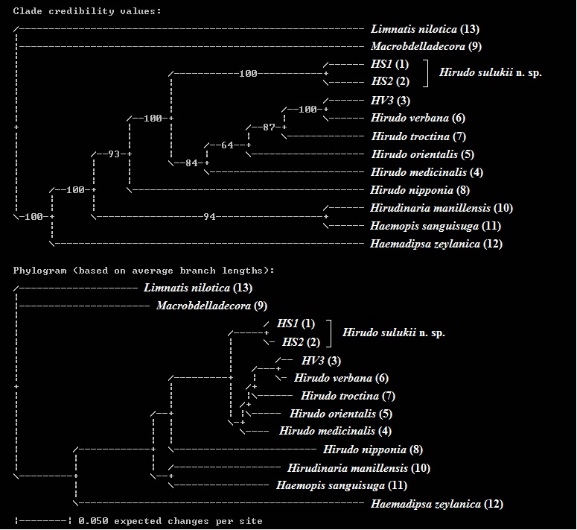
Figure 5. Leech relationships derived from 500,000 Bayesian trees based on a combined data set (morphological parameters, COI, 12S and 18S).

