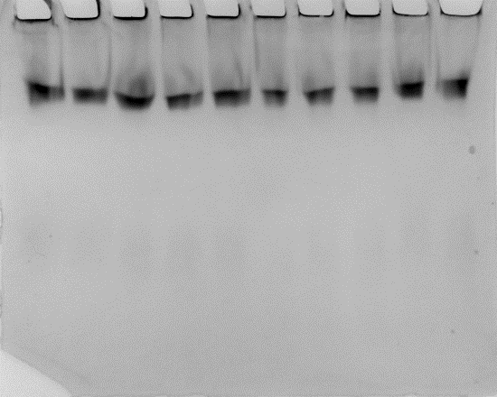
SI Figure 1: Electrophoresis to analyze the effect of aluminum on the proportions of soluble and membrane AChE. Upper band, membrane AChE; Lower band, soluble AChE. Control (left) and 25mg/L (right) exposure concentration gel (5 replicates/concentration).

