Supplementary Materials

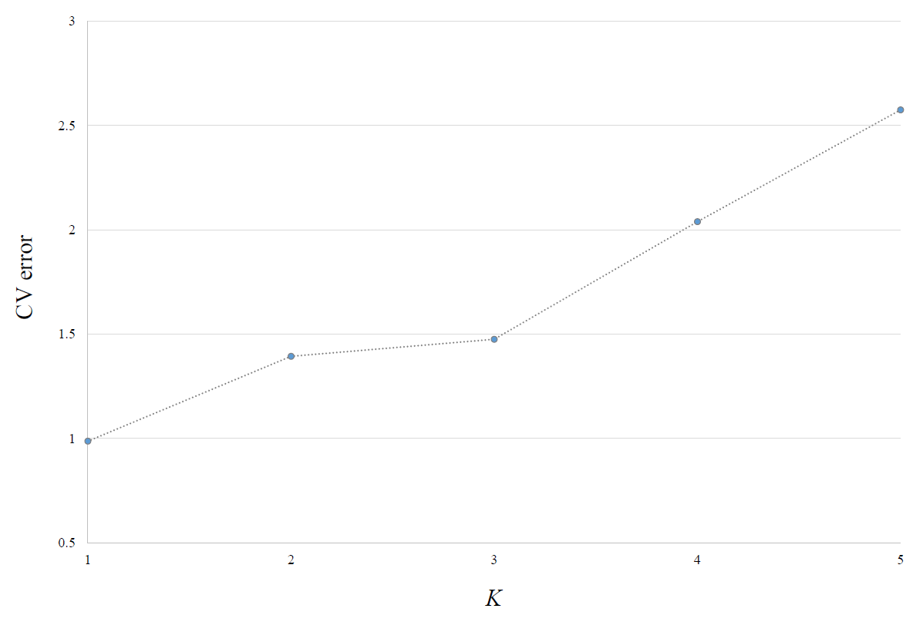
Figure S1. Cross validation (CV) error plot for ADMIXTURE analysis. Optimal K = 1.
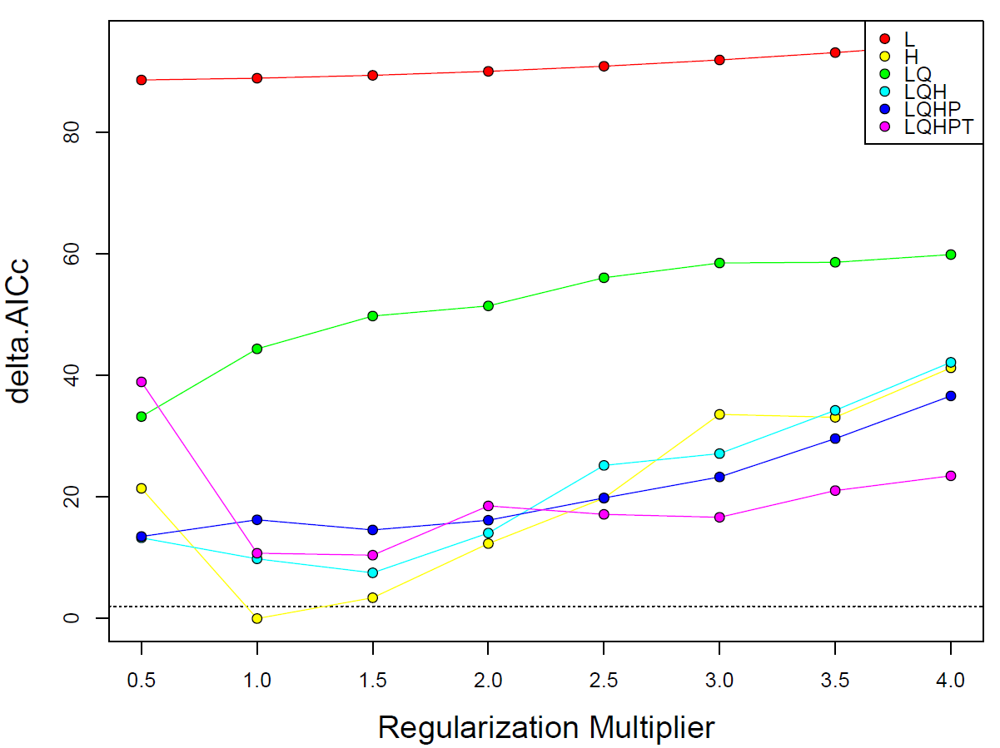
Figure S2. Delta AICc values of all models compared in ENMeval. Model H 1 was the best fit model.

