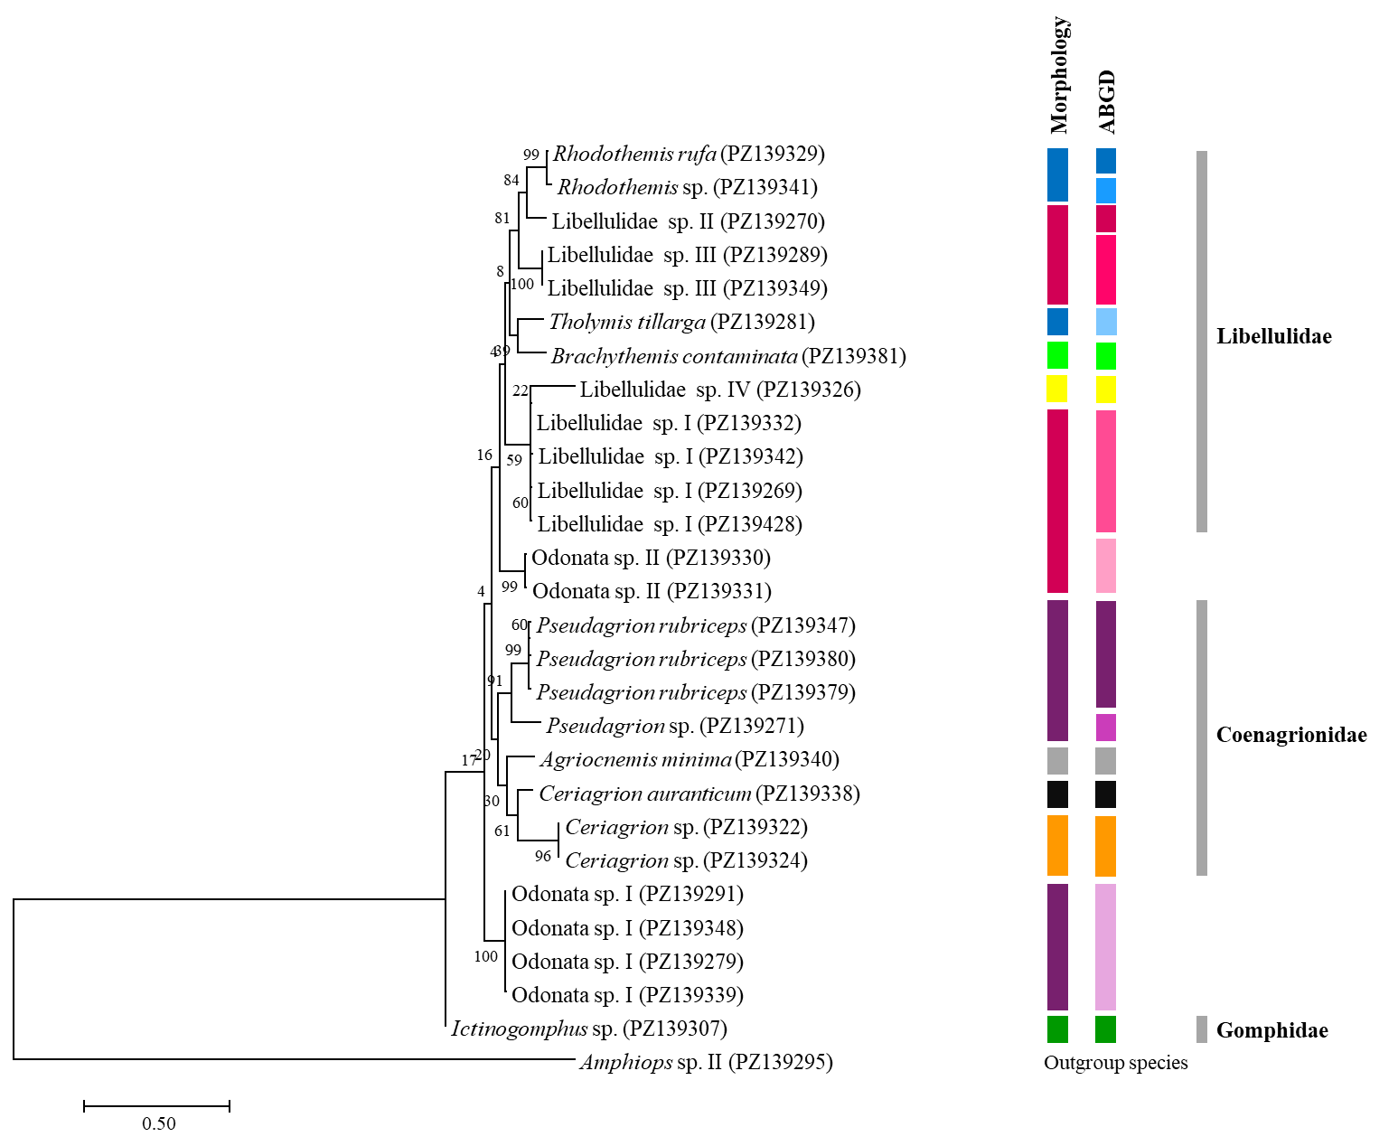

Fig. S7 Maximum likelihood phylogenetic tree inferred from partial mitochondrial cytochrome c oxidase subunit I sequences representing the order Odonata. Amphiops sp. II (order Coleoptera) was used as the outgroup. Morphological identifications were compared with species delimitation inferred using ABGD. Bootstrap support values (%) are shown at the nodes, and the scale bar represents the number of nucleotide substitutions per site.

