Additional File
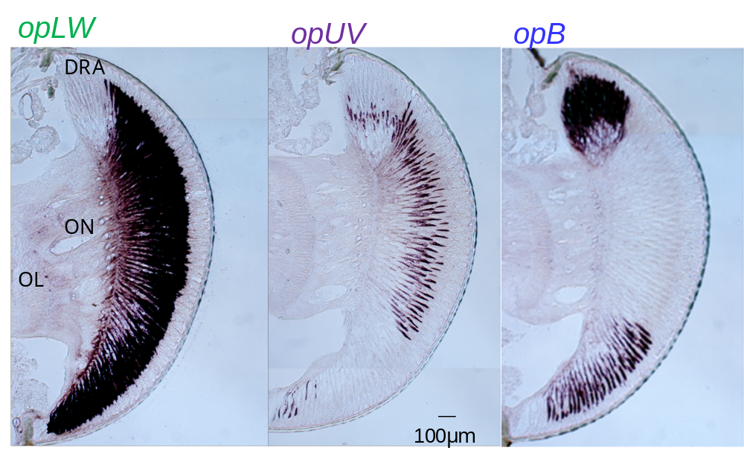

Figure S1. In situ hybridization of opLW, opUV and opB in the adult compound eye of the cricket Gryllus bimaculatus. Scale bar, 100 μm. DRA, dorsal rim area; ON, optic nerve; OL, optic lobe.

