Supplementary information
On the origin of vertebrate somites
Takayuki Onai, Toshihiro Aramaki, Hidehiko Inomata, Tamami Hirai and Shigeru Kuratani

Supplemental Figure S1. F-actin staining of adult amphioxus (Branchiostoma japonicum).
In amphioxus, myotomes extend to the rostral end. Anterior to the left. nt, notochord; m, myotome; bc, buccal cirri; df, dorsal fin; pm, pterygeal muscle.
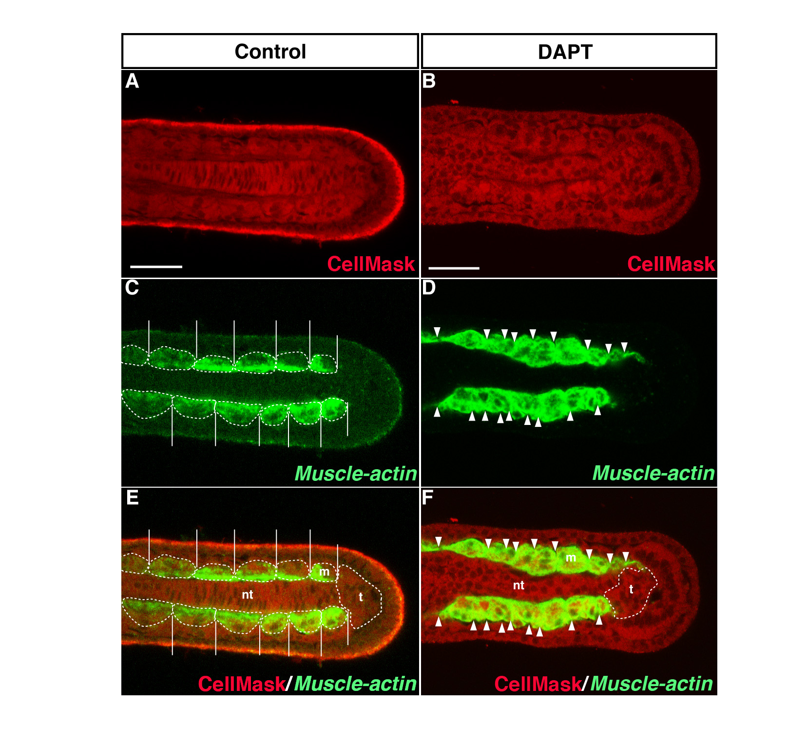
Supplemental Figure S2. Inhibition of Notch signalling and the effect on posterior myotomes at the early larva stage. (A, C, E) In the DMSO-treated control embryos, myotomes lay laterally to the notochord, and BfMuscle-actin was expressed in the myotomes (n = 5, 100%) (B, D, F) In the DAPT-treated embryos, BfMuscle-actin expression was detected in the myotomes (n = 5, 100%). The while line in (E) indicates the border of each myotome. The white dotted circle in (E) and (F) indicates a myotome or tail bud. The white arrowheads in (F) indicate a possible boundary between myotomes. m, myotome; nt, notochord; t, tail bud. Scale bars, 20 μm.

