Additional file 2. Ellipsometric parameter Ψ (A) and Δ (B) of the tunic of T. vagina (frozen and thawed specimens).

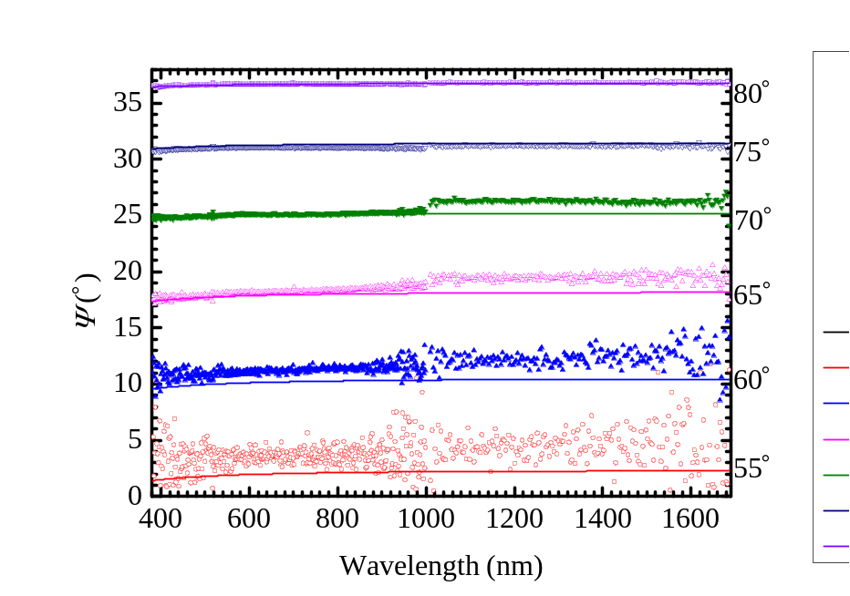
A
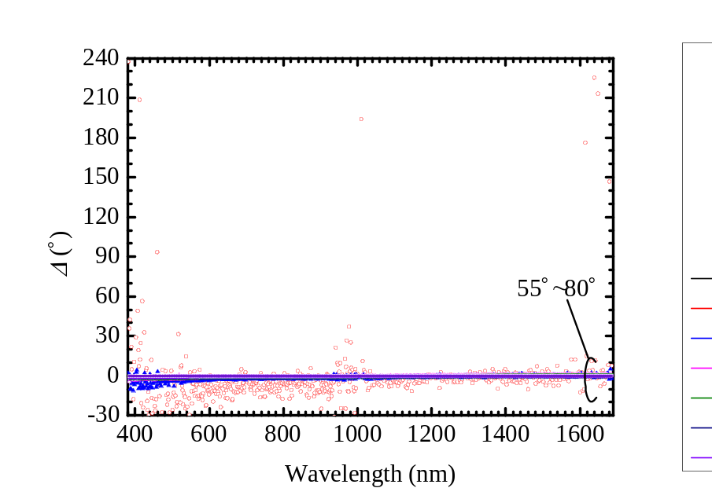
B

