Additional File 1

Structural and bio-functional assessment of the postaxillary gland in Nidirana pleuraden (Amphibia: Anura: Ranidae)

Yuzhou Gong, Yiwei Zeng, Puyang Zheng, Xun Liao, Feng Xie*
*Correspondence: xiefeng@cib.ac.cn

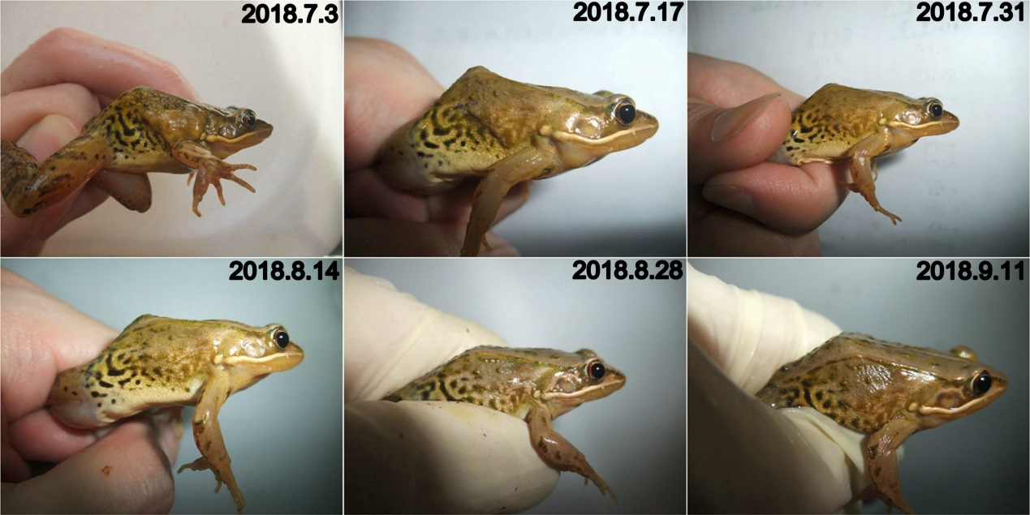
Fig. S1 Regression of the postaxillary gland in male N. pleuraden after the breeding season (June to July). The date of photographing is indicated in the upper right corner of each panel.

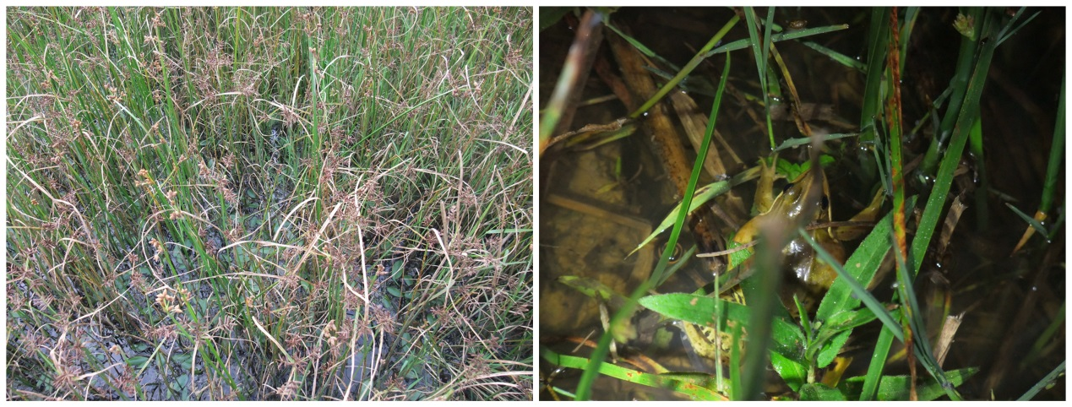
Fig. S2 Breeding sites of N. pleuraden are lush in hydrophytes and a male frog calls in such covert environment.

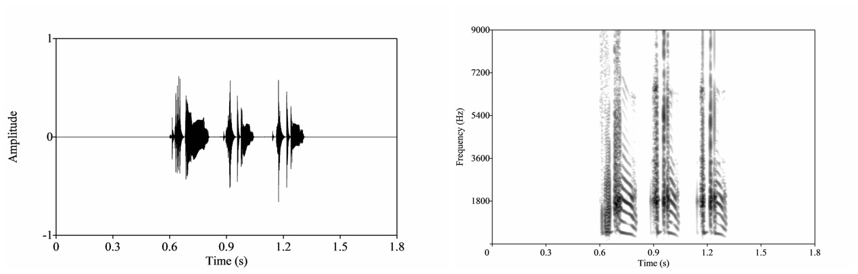
Fig. S3 Waveform (left) and spectrogram (right) of the male advertisement call used as auditory stimulus. The average call duration is 0.70 s, with the fundamental frequency and dominant frequency are 539.04 Hz and 1874.75 Hz, respectively.

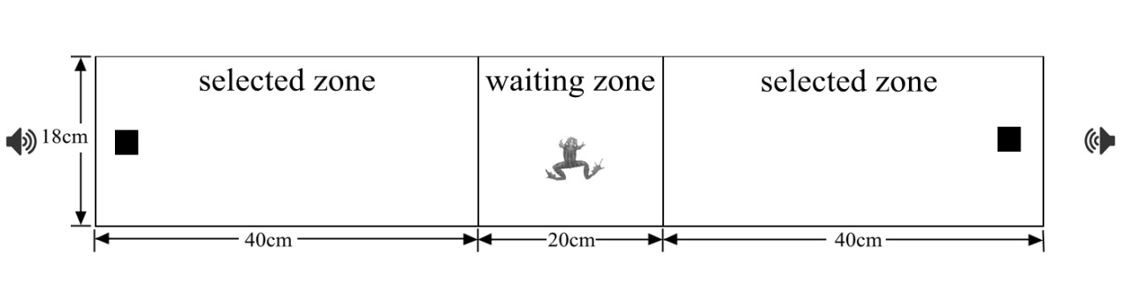
Fig. S4 Diagram of the setup of animal preference trials. Black boxes at the tank ends represent chemical stimuli, and speakers only work in trial series 4 with an intention to explore the interaction between chemosignal and sound.

