Additional file 2. Evolution of continents of destination (for selected destination countries) by regions of origin of African migrants
From East Africa (absolute numbers) | From East Africa (%)
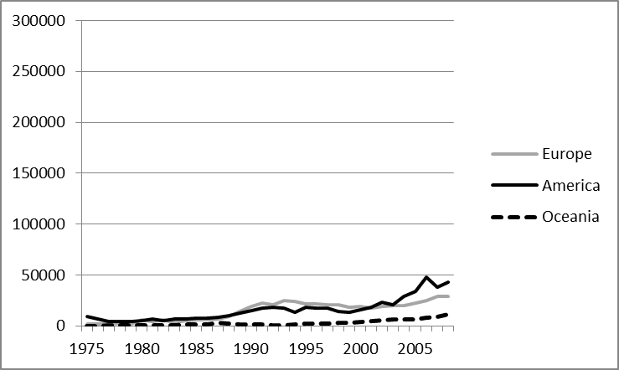 | 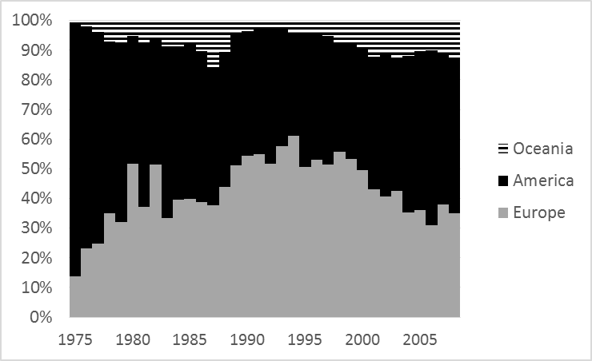
From Central Africa (absolute numbers) | From Central Africa (%)
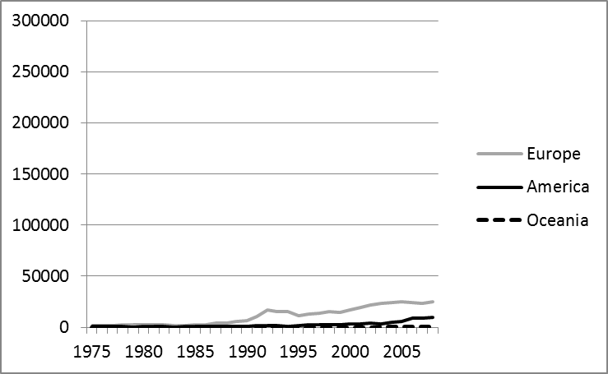 | 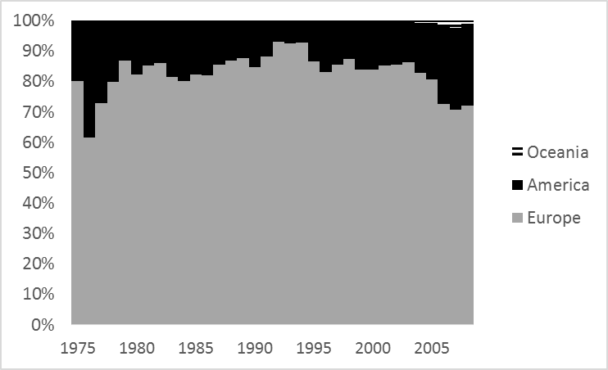
From North Africa (absolute numbers) | From North Africa (%)
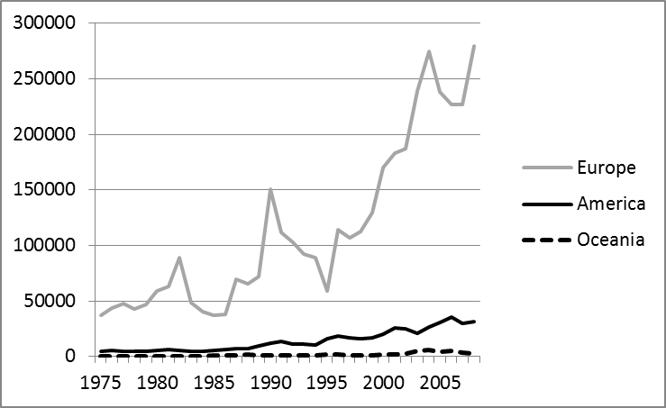 | 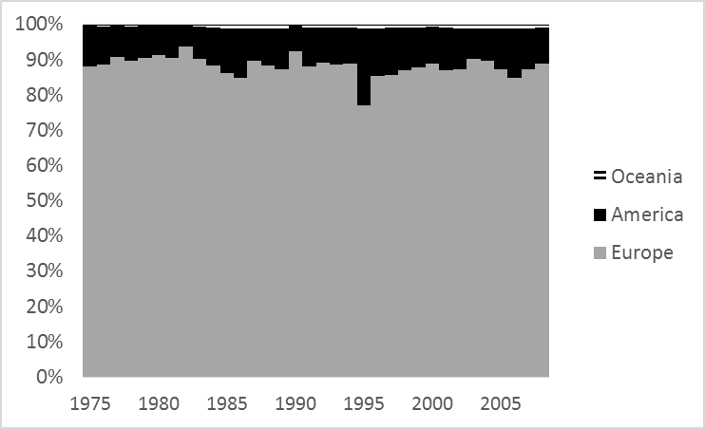
From Southern Africa (absolute numbers) | From Southern Africa (%)
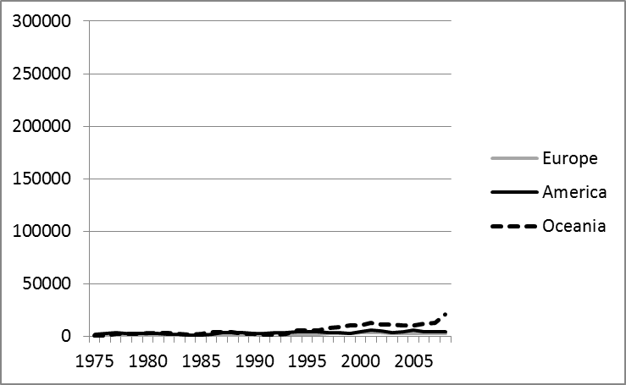 | 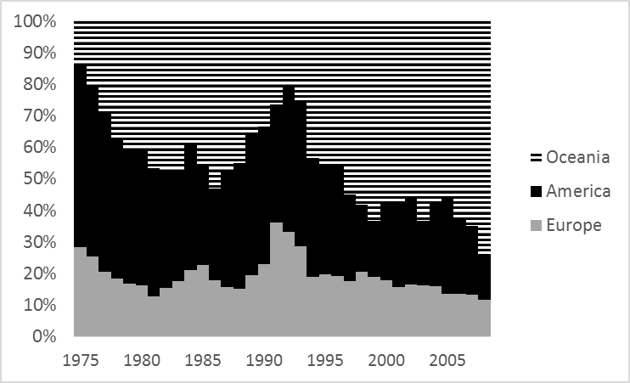
From West Africa (absolute numbers)  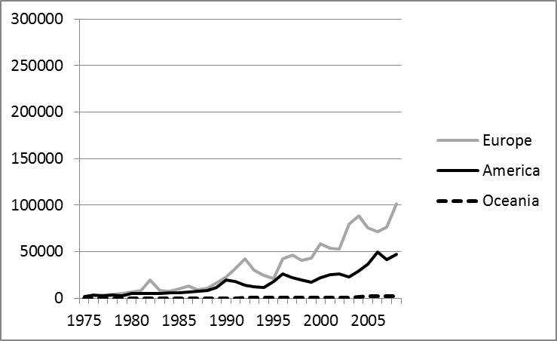 | From West Africa (%)  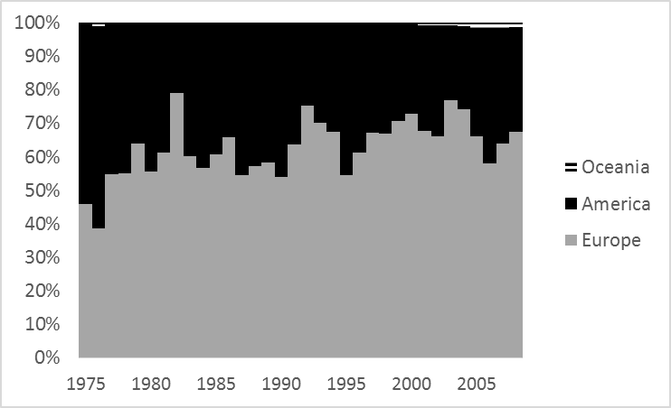
Source: DEMIG C2C database

