Business Migration between Labour and Trade. Evidence from Switzerland
Online Appendix

Mariana Alvarado, Paula Hoffmeyer-Zlotnik, Sandra Lavenex, Philipp Lutz
Table of Contents
List of abbreviations 3
Glossary 3
Data 5
Figures 8
Figure A1: Switzerland PTAs by year and mobility provisions 8
Figure A2: Annual number of third-country immigrant stays by reason for stay, 2011-2021 8
Figure A3: Annual distribution of third-country labour migrant stays (only posted workers) 9
Figure A4: Top 10 sending countries by status (posted/not posted) 9
Figure A5: Bilateral trade and short-stay business visas 10
Figure A6: Outward FDI and short-stay business visas 10
Figure A7: Swiss multinational staff and posted workers in Switzerland 11
Figure A8: Foreign multinational staff and posted workers in Switzerland 11
Figure A9: Swiss multinational presence and business visas 12
Figure A10: Foreign multinational presence and business visas 12
Figure A11: Swiss multinational staff and business visas 13
Figure A12: Foreign multinational staff and business visas 13
Figure A13: Posted stays and multinational jobs (by canton) 14
Figure A14: Incoming Chinese labour migrants (2011-2021) 14
Figure A15: Effect of PTAs on third-country posted worker flows 15
Figure A16: Effect of PTAs on volume of short-stay business visas 15
Tables 16
Table A1: Switzerland PTAs entering into force between 2012-2020 16
Table A2: Sample selection for PTA analyses with visa data 17

List of abbreviations
BV | Business visitor
ICT | Intra-corporate transferee
PTA | Preferential trade agreements
CSS | Contractual Service Supplier
MNC | Multi-national corporation
FDI | Foreign direct investment
WTO | World Trade Organization
GATS | General Agreement on Trade in Services
PTA | Preferential trade agreement

Glossary
Intra-corporate transferees (ICT) | Individuals who work for a multinational company outside the EU/EFTA, and who enter a different country to work in a sub-branch of this company.  Switzerland has signed GATS commitments for intra-corporate transferees referred to as “essential personnel” (WTO, 2003). ICTs are admitted for a duration of up to three years, which can be extended to 4 years. They need to have been employed by the sending company for at least a year preceding the stay in Switzerland. And they have to be managers, executives or specialists, defined as: “Executives and senior managers: Persons who primarily direct the enterprise or one of its departments and who receive only general supervision or direction from high-level executives, the board of directors or the stockholders of the enterprise. Executives and senior managers would not directly perform tasks related to the actual provision of services of the enterprise (…) Specialists: Highly qualified persons who, within an enterprise, are essential for the provision of a specific service by reason of their knowledge at an advanced level of expertise in the field of services, research equipment, techniques or management of the enterprise” (WTO 2003: 5).  In some preferential trade agreements, concluded bilaterally or through EFTA agreements, Switzerland grants further limited concessions: the length of stay is extended for ICTs to 5 years.  Data source for ICT stocks and flows: STATPOP.
Contractual service suppliers (CSS) | Individuals employed by a firm who come to a different country to deliver a specific service for a client on behalf of their employer.  Switzerland has signed GATS commitments for contractual service suppliers referred to as “other essential personnel”. They are allowed to stay for up to three months, and are only allowed in certain listed sectors. The pre-employment requirement applies here as well.  In some preferential trade agreements, concluded bilaterally or through EFTA agreements, Switzerland grants further limited concessions: in the bilateral agreements with China and Japan, for example, the list of sectors in which CSS are allowed is expanded.  Data source for CSS stocks and flows: visa statistics (C visa for business purposes) and STATPOP.
Business visitors (BV) | Individuals employed abroad who come to a different country to negotiate sales/service contracts and/or to prepare the establishment of a new sub-branch of their company.  Switzerland has signed GATS commitments for business visitors for sales or establishment. They are allowed to stay for up to three months. The pre-employment requirement applies here as well, except for BV for sales purposes.  Data source for BV flows: visa statistics (C visa for business purposes).
Posted workers | Term used in Swiss immigration statistics to identify workers coming to work in CH while keeping their foreign work contract (in German: “entsandte Arbeitnehmer”). As such, it can refer to ICTs or CSSs (BVs stay for shorter periods of time and are not captured by immigration statistics as they travel with short-term visas).
Regular labour migrants | Labour immigrants moving to a foreign country with a local employment contract.
Business migrants | High-skilled workers moving for temporary assignments while retaining their work contract in their home country. The transnational activity of firms is the main driver of this form of migration wherein labour moves as a corollary often without counting as foreign labour or immigration.  As such, it comprises ICTs, CSSs and BVs.  Business migrants captured by Swiss immigration statistics are referred to as posted workers.

Data
STATPOP
STATPOP data is available for both movements and stocks. The first records all individual movements that take place throughout the year, both physical (immigration and emigration across countries/cantons/communes) and legal (changes in civil status and nationality, births and deaths). The second records the information of all the individuals present in the country at the end of each calendar year, it also records the permission codes (immigration categories) used to identify posted vs non-posted or traditional workers. To identify posted workers, we focus on the following permission codes in the stocks database: 1385, 1386, 1398, 1420, 1425, 2012, 2013, 2025.
Using STATPOP movement data we constructed a database in which the unit of observation is the individual-stay. It thus records each stay in Switzerland made by adult third-country nationals between 2011 and 2021. We record for each stay not only the year of arrival and exit, but also the reason for the stay based on each individual’s permission code, resident permit, immigration reason and purpose of stay as recorded in STATPOP. Many individuals in the database have multiple temporary stays during the period of observation, with their reason for stay and permit often changing from one stay to the next. In addition to the above, the database also records age, gender, nationality and reporting canton for each individual-stay.
Figure 2 was constructed based on this data for the years 2011-2021. Reason for stay is coded based on the variable permission code, and when missing supplemented with information from the variables resident permit, immigration reason and purpose of stay. The diplomat category includes diplomats and international functionaries. The humanitarian category includes refugees, asylum seekers, provisionally admitted persons and hardship cases. The study category includes students and researchers. The work category includes all persons coming to work, posted and with a Swiss contract, independent professionals, artists and trainees. The family category includes all persons coming with others, either as family reunification of Swiss citizens or as spouses and children of people in any of the other categories. The ‘others’ category includes non-employed persons, pensioners, permits for important public interests, annual residents and residents employed abroad (who are not coming for work). The unknown category includes a small number of stays each year which cannot be categorized due to lack of information.
Figures differentiating between posted and not posted stays only include stays with work-related permission codes (for which posted/not-posted status can be determined): 404, 407, 1312, 1313, 1318, 1326, 1328, 1385, 1386, 1398, 1402, 1403, 1406, 1407, 1410, 1420, 1425, 1430, 2001, 2006, 2007, 2010, 2012, 2013, 2020, 2025, 2040, 2041, 2203, 2301, 2303, 3659, 3662. Stays with the following permission codes are coded as posted: 1385, 1386, 1398, 1420, 1425, 2012, 2013, 2025.
For the difference-in-differences estimations, we included only third country migrants with permission codes whose reason for coming (according to their permission code) is work. This means we exclude all those that don't have a permission code, either because they didn't stay until the end of the year, or for other reasons (e.g., because they have a settlement permit or they're diplomats or asylum seekers).

For the analysis looking at posted worker flows, we code as posted those whose permission codes describe them as "posted employees of companies based outside the EU/EFTA". We exclude those who are posted employees of a company based in an EU-28/EFTA state. The reason we exclude them is that even if they are nationals of a country with a PTA, they shouldn't be "affected" by it since they are coming via an EU/EFTA company.

The Migration-Mobility Survey
The Migration-Mobility Survey is conducted every two years since 2016 on the foreign population in Switzerland. To enhance comparability with our register data from STATPOP, we focus on the subset of respondents coming from non-EU/EFTA countries in the 2016, 2018 and 2020 waves. The MMS survey has a panel component complemented with refresh samples added in each wave. The analyses presented below pool all third-country respondents from the three waves mentioned in the text (2016, 2018, 2020). One of the questions in the survey allows us to identify ICTs —a major component of business mobility— by asking respondents whether they came to Switzerland as a transfer within their same company. Unfortunately, this question does not allow us to differentiate between those ICTs maintaining their contract in their home country —and thus counted as posted workers in the register data— and those coming with a new, Swiss contract. While there is a question about contract type in the survey, it is only asked in 2020 and responses indicate information levels are low, making it unreliable.
Other data
For analyses using visa data, to assess the effect of PTAs on the number of business visas issued, we replicated the staggered difference-in-differences analyses using STATPOP data. Table A3 presents all of the PTAs entering into force during our period of observation (2011-2019) and specifies which ones are included in our sample and why. Countries in the sample are coded as treated starting in the year in which their PTAs entered into force. All these PTAs have mobility provisions. Countries that had not signed PTAs up until 2020 (and do not have visa-free travel) make up the control group.

Data sources
Data | Source
CH immigration statistics | STATPOP
Bilateral trade | Harvard Growth Lab
Outward FDI | Eurostat
MNCs staff and establishments in CH | Swiss National Bank, Swiss Federal Statistics Office
Cantonal distribution of jobs in MNCs | Enterprise Group Statistics of the Swiss Federal Statistics Office
PTAs signed by CH | MITA dataset
Schengen business visas | SEM
Population in 2019 and GDP per capita PPP 2017 | World Development Indicators
Value of Inward Mode 4 Trade in Services | Trade in Services by Mode of Supply database (WTO)

Figures

Figure A1: Switzerland PTAs by year and mobility provisions
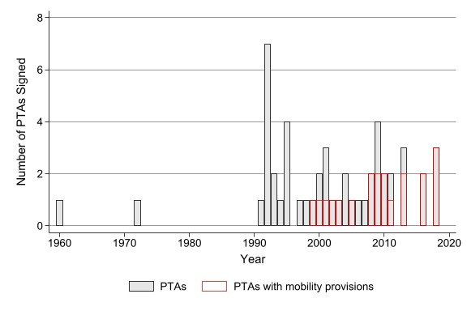
Note: PTAs signed between Switzerland/EFTA and third countries. Source: MITA.

Figure A2: Annual number of third-country immigrant stays by reason for stay, 2011-2021
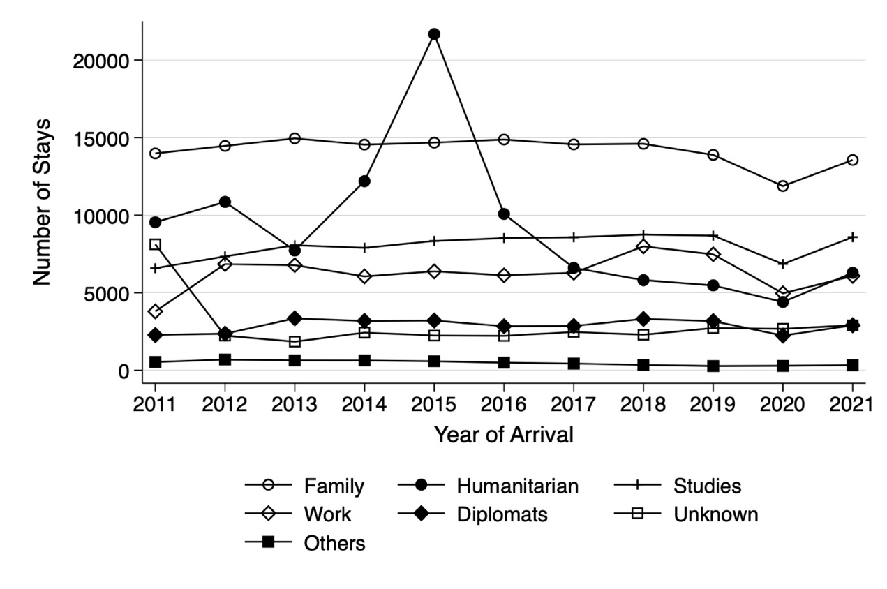

Figure A3: Annual distribution of third-country labour migrant stays (only posted workers)
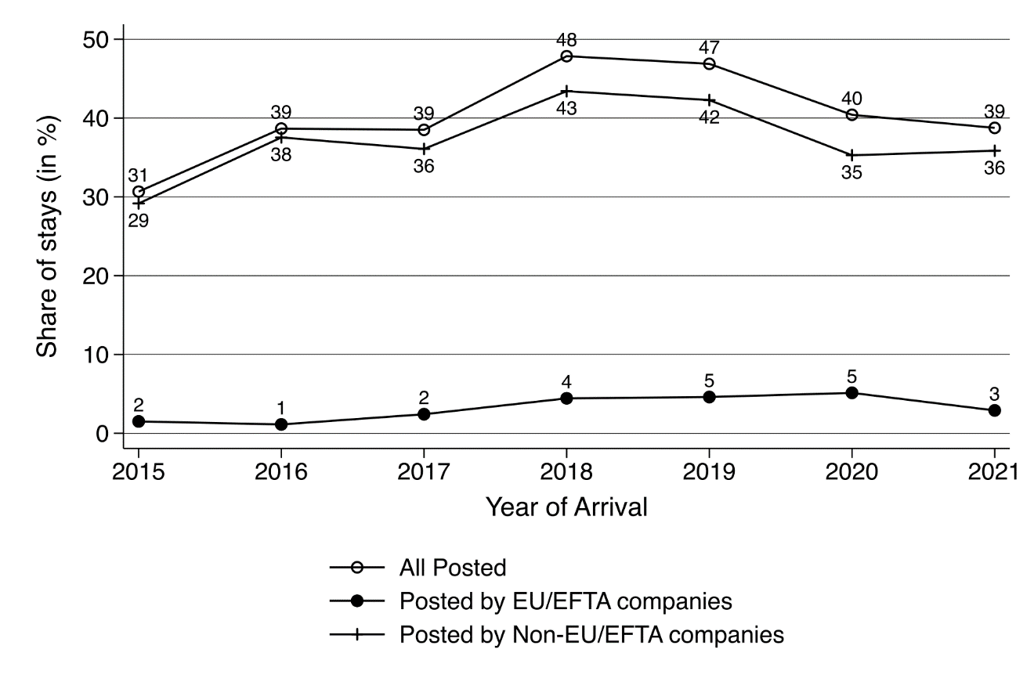
Source: STATPOP

Figure A4: Top 10 sending countries by status (posted/not posted)
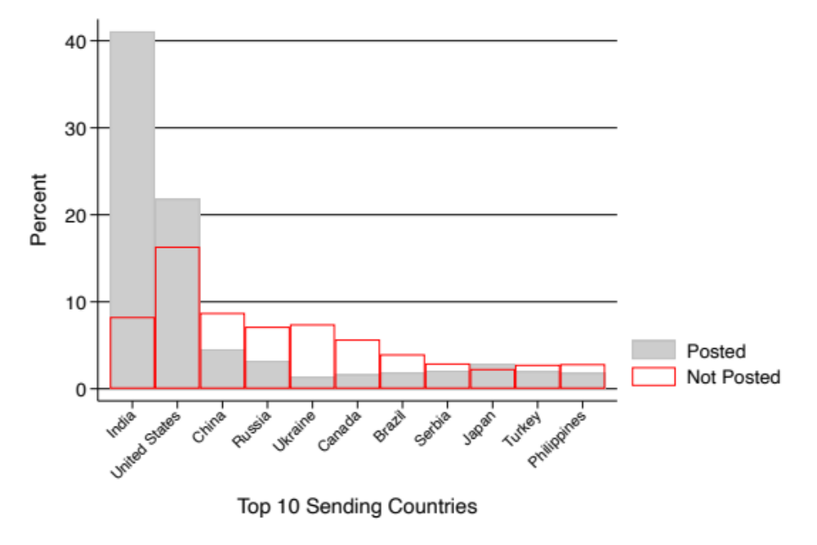
Source: STATPOP

Figure A5: Bilateral trade and short-stay business visas
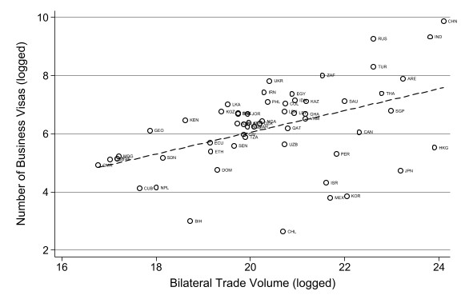
Note: Scatterplot of bilateral trade volume (total value of exports plus imports in US dollars) and number of business visas, log-transformed mean annual values for 2011-2019. Source: SEM and Harvard Growth Lab.

Figure A6: Outward FDI and short-stay business visas
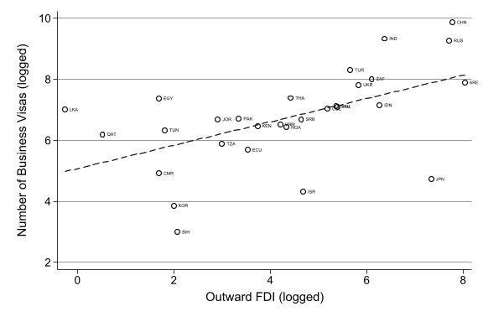
Note: Scatterplot of outward FDI (in US dollars) and number of business visas, log-transformed mean annual values for 2011-2019. Source: SEM and Eurostat.

Figure A7: Swiss multinational staff and posted workers in Switzerland
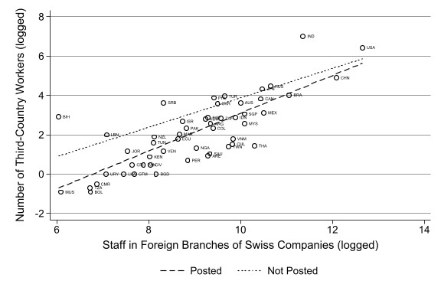
Note: Scatterplot of number of people employed in the foreign branches of companies headquartered in Switzerland in each sending country and number of posted workers from that country, mean (log-transformed) annual values for 2015-2019. Source: STATPOP and Swiss National Bank.

Figure A8: Foreign multinational staff and posted workers in Switzerland
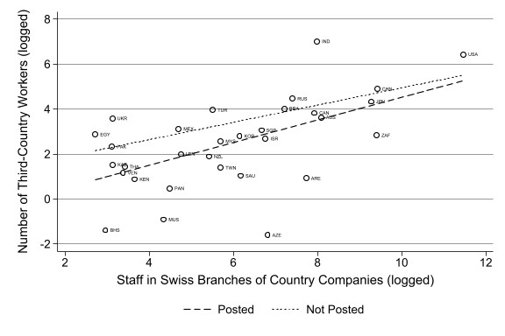
Note: Scatterplot of number of people employed in the Swiss branches of companies headquartered in each sending country and number of posted workers from that country, mean (log-transformed) annual values for 2015-2019. Source: STATPOP and Federal Statistics Office.

Figure A9: Swiss multinational presence and business visas
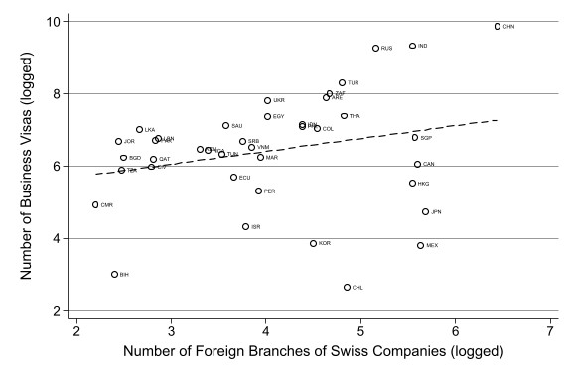
Note: Scatterplot of the number of branches of companies headquartered in Switzerland in each sending country and the number of business visas granted in that country, log-transformed mean annual values for 2011-2019. Source: SEM and Swiss National Bank.

Figure A10: Foreign multinational presence and business visas
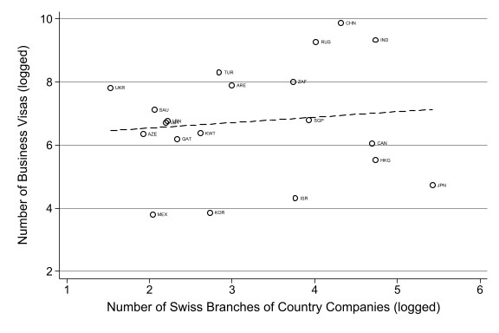
Note: Scatterplot of the number of Swiss branches of companies headquartered in each sending country and the number of business visas granted in that country, log-transformed mean annual values for 2011-2019. Source: SEM and Federal Statistics Office.

Figure A11: Swiss multinational staff and business visas
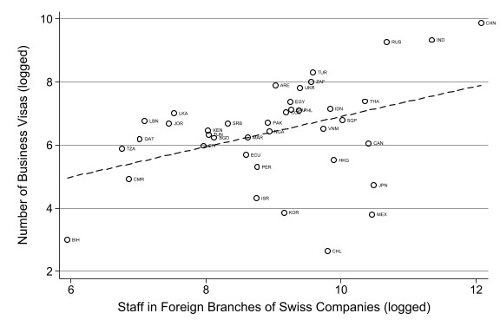
Note: Scatterplot of number of people employed in the foreign branches of companies headquartered in Switzerland in each sending country and number of business visas granted in that country, log-transformed mean annual values for 2011-2019. Source: SEM and Swiss National Bank.

Figure A12: Foreign multinational staff and business visas
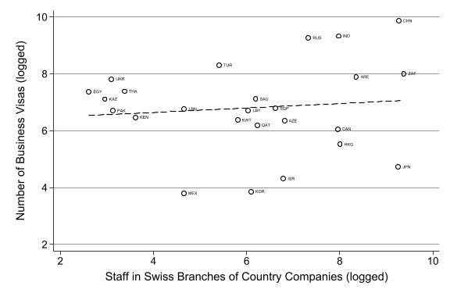
Note: Scatterplot of the number of people employed in the Swiss branches of companies headquartered in each sending country and the number of business visas granted in that country, log-transformed mean annual values for 2011-2019. Source: SEM and Federal Statistics Office.

Figure A13: Posted stays and multinational jobs (by canton)
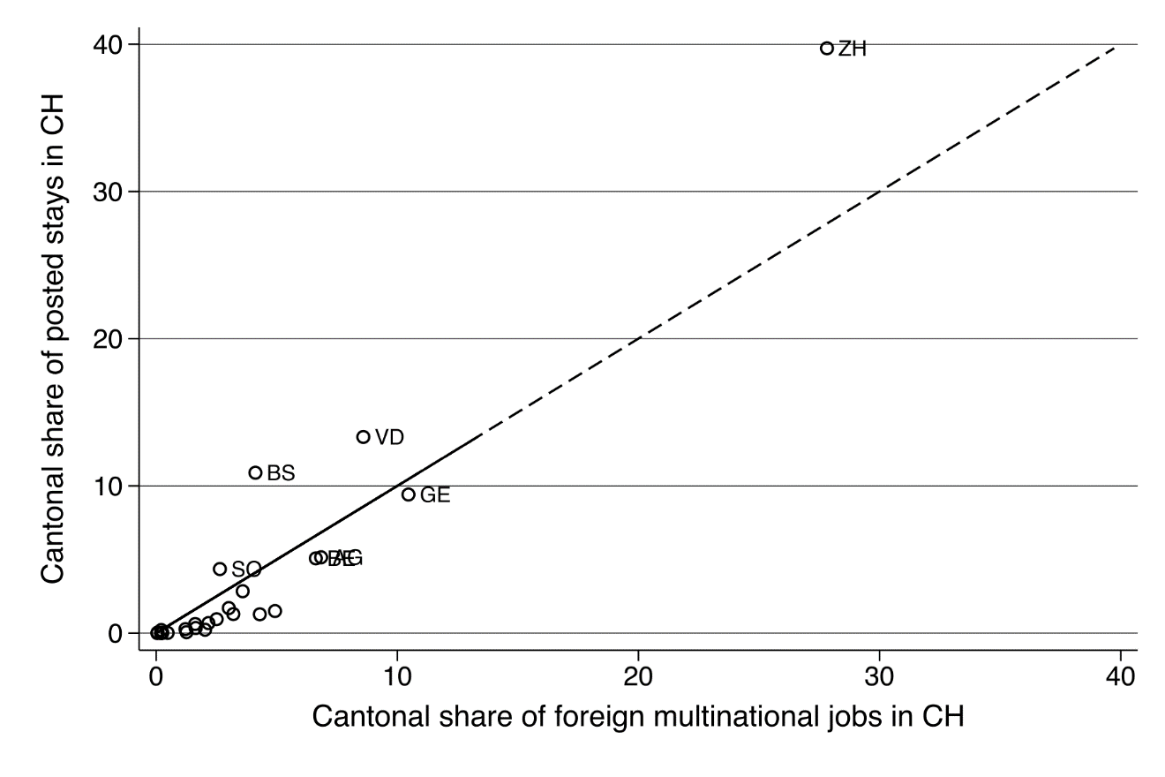
Note: Data on foreign multinational jobs is for 2016, data on posted stays are totals for 2015-2019 period. Source: STATPOP and STAGRE.

Figure A14: Incoming Chinese labour migrants (2011-2021)
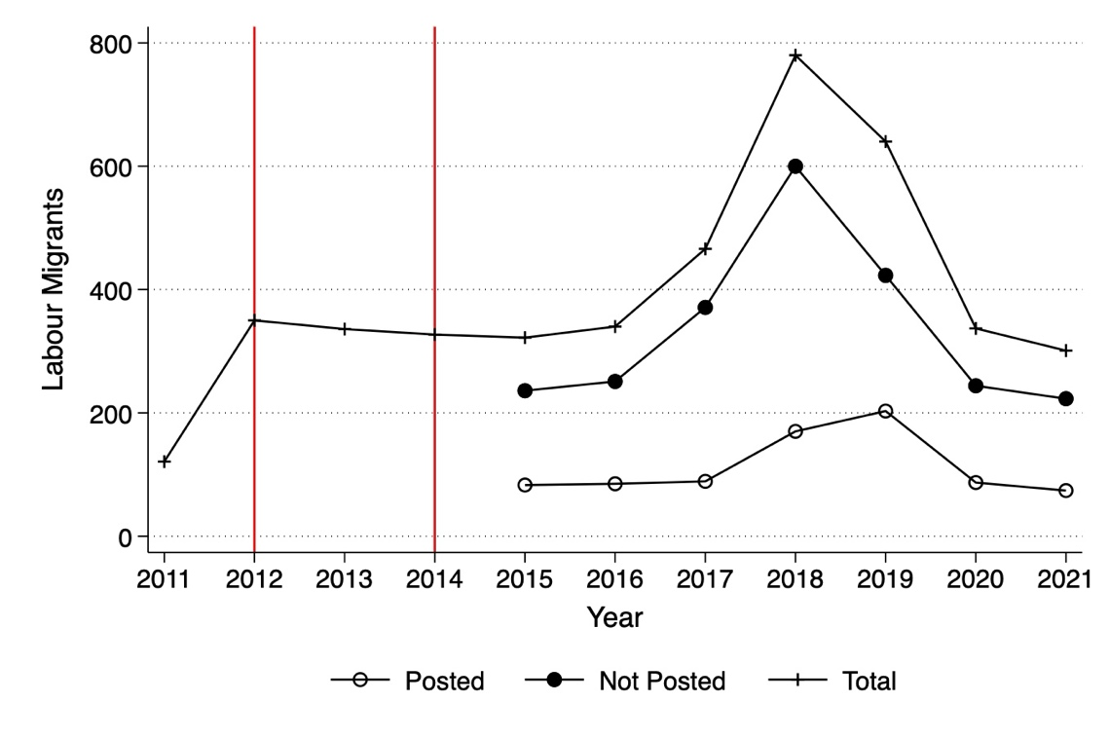
Note: Vertical lines indicate year of entry into force of PTA between EFTA and Hong Kong (2012) and between Switzerland and China (2014). Source: STATPOP and MITA.

Figure A15: Effect of PTAs on third-country posted worker flows
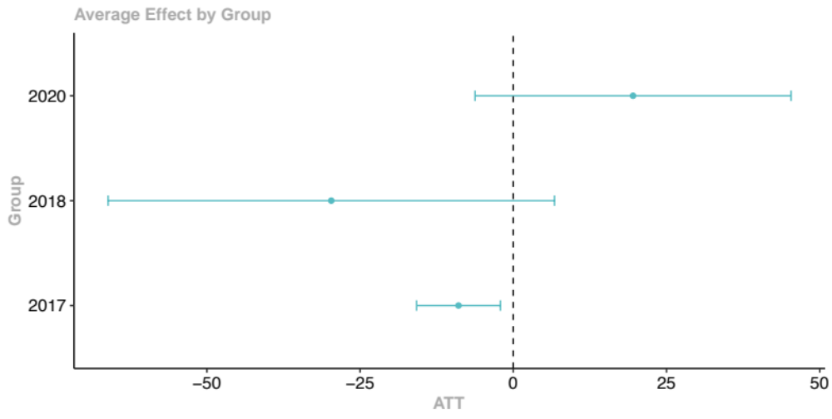
Note: Estimates from staggered difference-in-differences model. Average treatment effect (ATT) shown. Groups defined by year in which PTA entered into force: Georgia (2017), Philippines (2018), Ecuador (2020). Includes controls for population and GDP per capita PPP 2017 (both log-transformed). See estimation details in the appendix. Source: STATPOP and WDI.

Figure A16: Effect of PTAs on volume of short-stay business visas
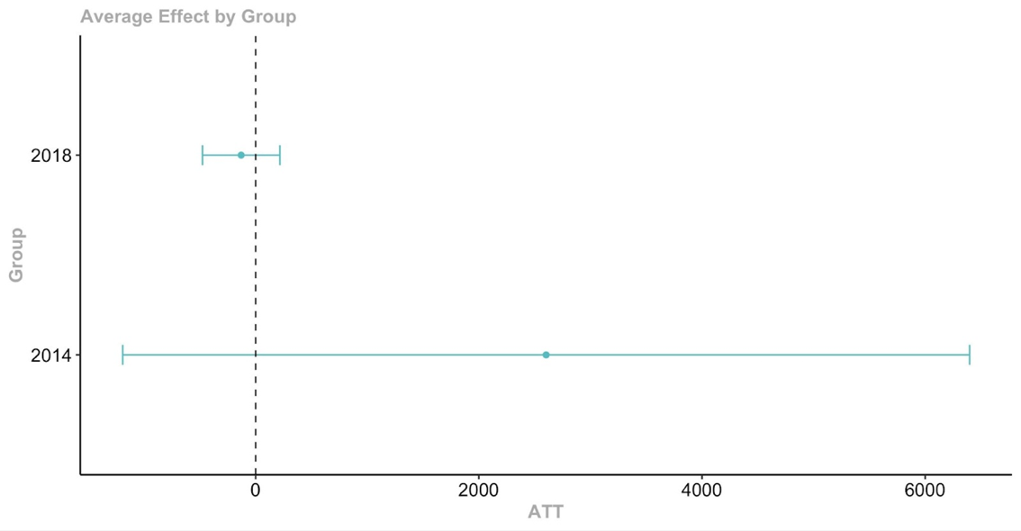
Note: Estimates from staggered difference-in-differences model. Average treatment effect (ATT) shown. Groups of countries defined by year in which PTA entered into force. Includes controls for population and GDP per capita PPP 2017 (both log-transformed). See table A3 for sample selection. Source: SEM and WDI.

Tables

Table A1: Switzerland PTAs entering into force between 2012-2020
Signatory | Entry force year
Ukraine | 2012
Montenegro* | 2012
Hong Kong | 2012
Gulf Cooperation Council  (Bahrain, Kuwait, Oman, Qatar, Saudi Arabia, United Arab Emirates) | 2014
China | 2014
Colombia | 2014
Central America (Costa Rica, Guatemala, Panama) | 2014
Bosnia and Herzegovina* | 2015
Georgia | 2017
Philippines | 2018
Ecuador | 2020
Note: PTAs signed between Switzerland/EFTA and third countries. Asterisks indicate PTAs without mobility provisions. Source: MITA database.

Table A2: Sample selection for PTA analyses with visa data
Signatory | Entry force year | In sample?
Peru | 2011 | No, no pre-treatment observations
Ukraine | 2012 | No, only 1 pre-treatment observation
Hong Kong | 2012 | No, only 1 pre-treatment observation
China | 2014 | Yes
Colombia | 2014 | Until 2016, when visa-free agreement enters into force
Kuwait | 2014 | Yes
Qatar | 2014 | Yes
Costa Rica | 2014 | No, does not require visa
Saudi Arabia | 2014 | Yes
United Arab Emirates | 2014 | No, visa free agreement starts in 2015
Bosnia and Herzegovina | 2015 | No, visa free agreement starts in 2011
Georgia | 2017 | No, visa free agreement starts in 2017
Philippines | 2018 | Yes
Note: PTAs signed between Switzerland/EFTA and third countries, 2011-2019. Panama, Guatemala, Montenegro, Bahrain and Oman are excluded because visa data was not made available due to the low number of visas issued. Source: MITA database and Eur-Lex for visa requirements.

See STATPOP variable list for code descriptions: https://www.bfs.admin.ch/bfs/en/home/statistics/population/surveys/statpop.assetdetail.7766422.html

