Annex 1: IDI Participants in Wolaita

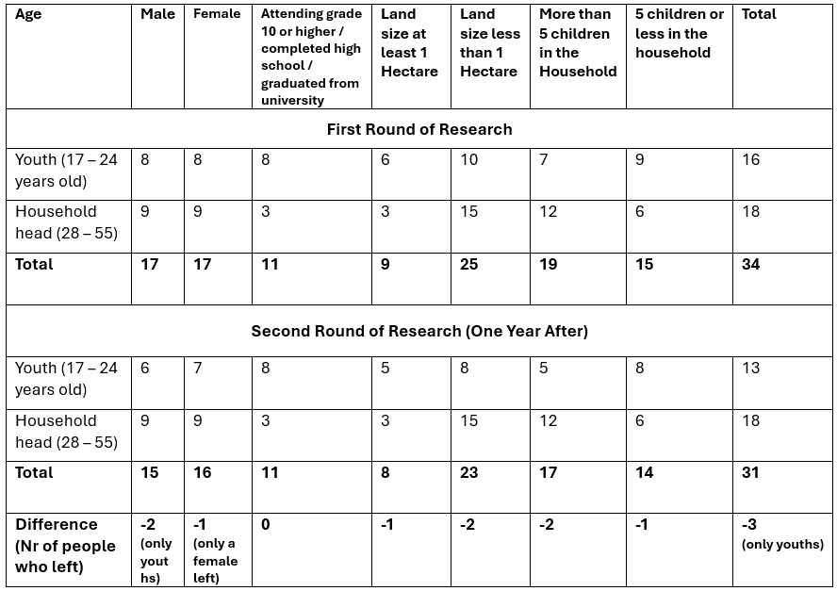

Annex 2: FGD Participants in Wolaita

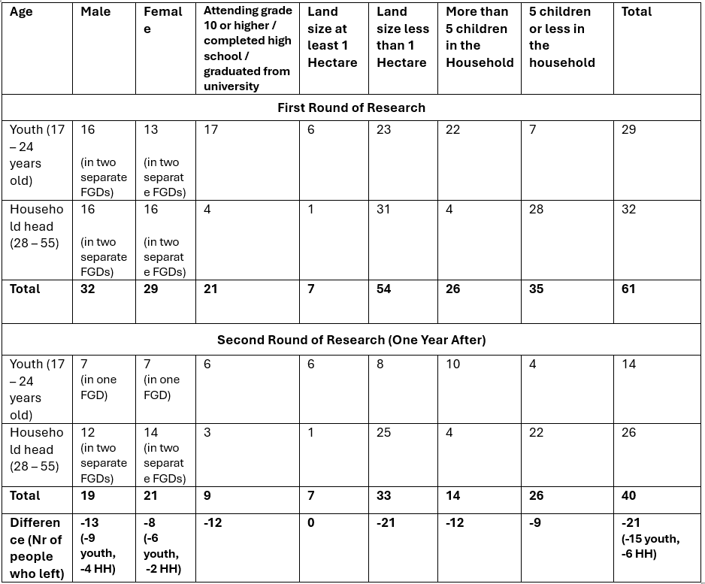

Annex 3: IDI Participants in Dasenech

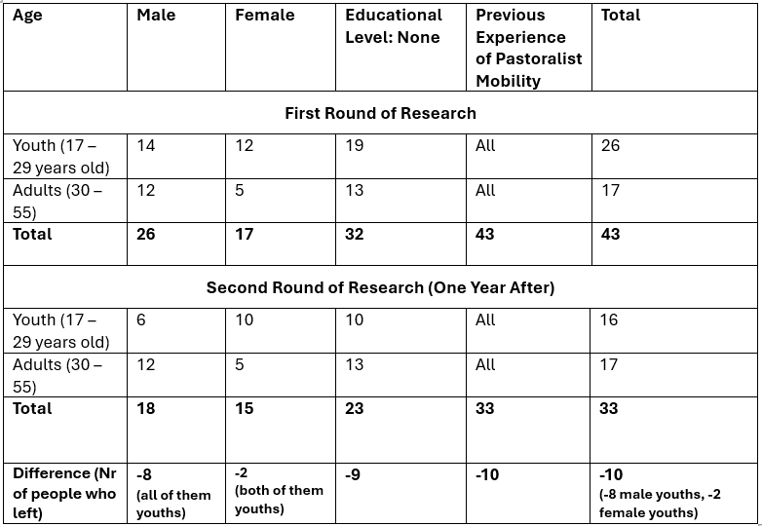

Annex 4: FGD Participants in Dasenech

