Additional Figure S1
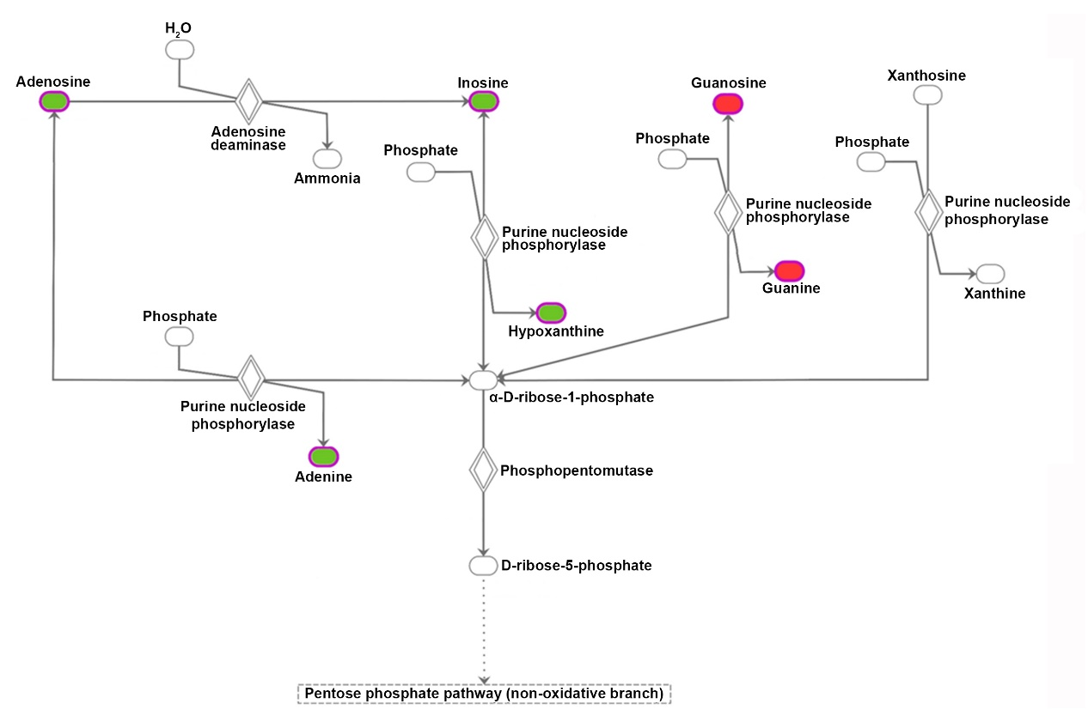
Additional Figure S1. Illustration of the ingenuity pathway analysis (IPA). The pentose phosphate pathway is shown as the highest ranked canonical pathway with significant changes in BaF3/ITD-R cells, as analyzed by the IPA. Molecules with red marker represent metabolites increased in BaF3/ITD-R. Molecules with green marker represent metabolites decreased in BaF3/ITD-R. Molecules with white marker represent metabolites with no change in BaF3/ITD-R cells.

Additional Figure S2

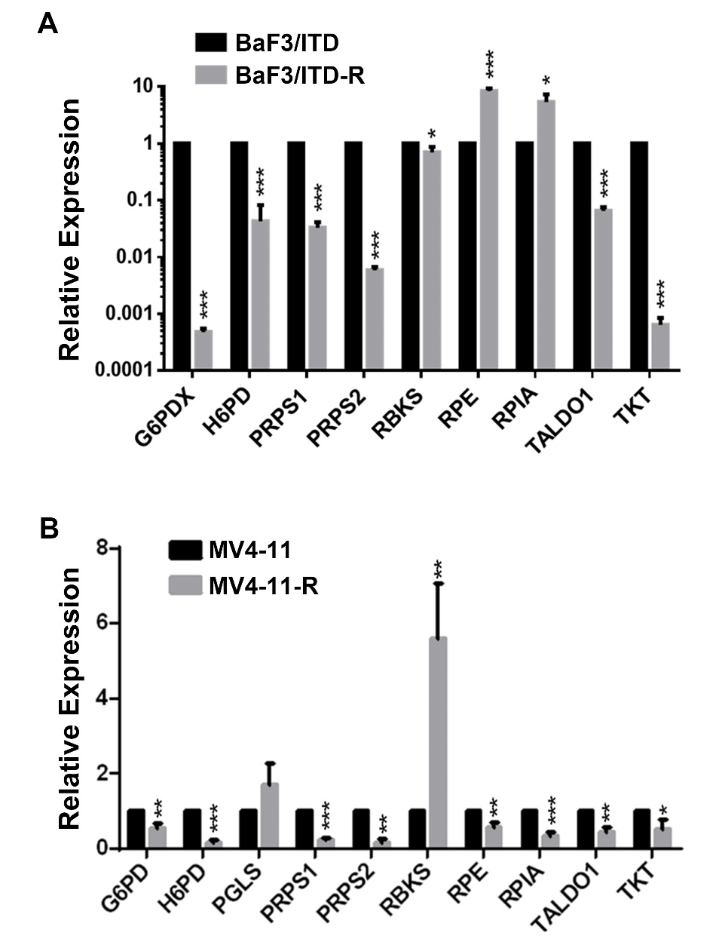

Additional Figure S2. Real-time PCR analysis of PPP enzymes in the sensitive and resistant cells. BaF3/ITD vs. BaF3/ITD-R (A) and MV4-11 vs. MV4-11-R (B): Bars, means ± SEM. * P < 0.05, ** P < 0.01, *** P < 0.001.
Abbreviations: PPP, pentose phosphate pathway; G6PDX, Glucose-6-phosphate 1-dehydrogenase X; H6PD, GDH/6PGL endoplasmic bifunctional protein; PRPS1, Ribose-phosphate pyrophosphokinase 1; PRPS2, Ribose-phosphate pyrophosphokinase 2; RBKS, Ribokinase; RPE，Ribulose-phosphate 3-epimerase; RPIA, Ribose-5-phosphate isomerase; TALDO1, Transaldolase；TKT, Transketolase; G6PD, Glucose-6-phosphate dehydrogenase; PGLS, 6-phosphogluconolactonase
Additional Figure S3
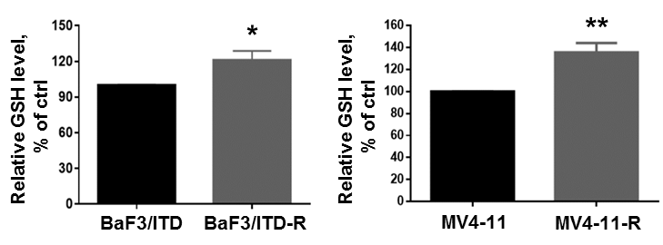
Additional Figure S3. GSH levels in the sensitive and resistant cells. BaF3/ITD vs. BaF3/ITD-R and MV4-11 vs. MV4-11-R. * P < 0.05, ** P < 0.01. Abbreviations: ctrl, control; GSH, glutathione

Additional Figure S4
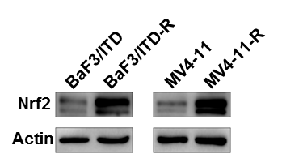

Additional Figure S4. Western blot analysis of Nrf2 in the sensitive and resistant cells. BaF3/ITD vs. BaF3/ITD-R and MV4-11 vs. MV4-11-R.

Additional Figure S5
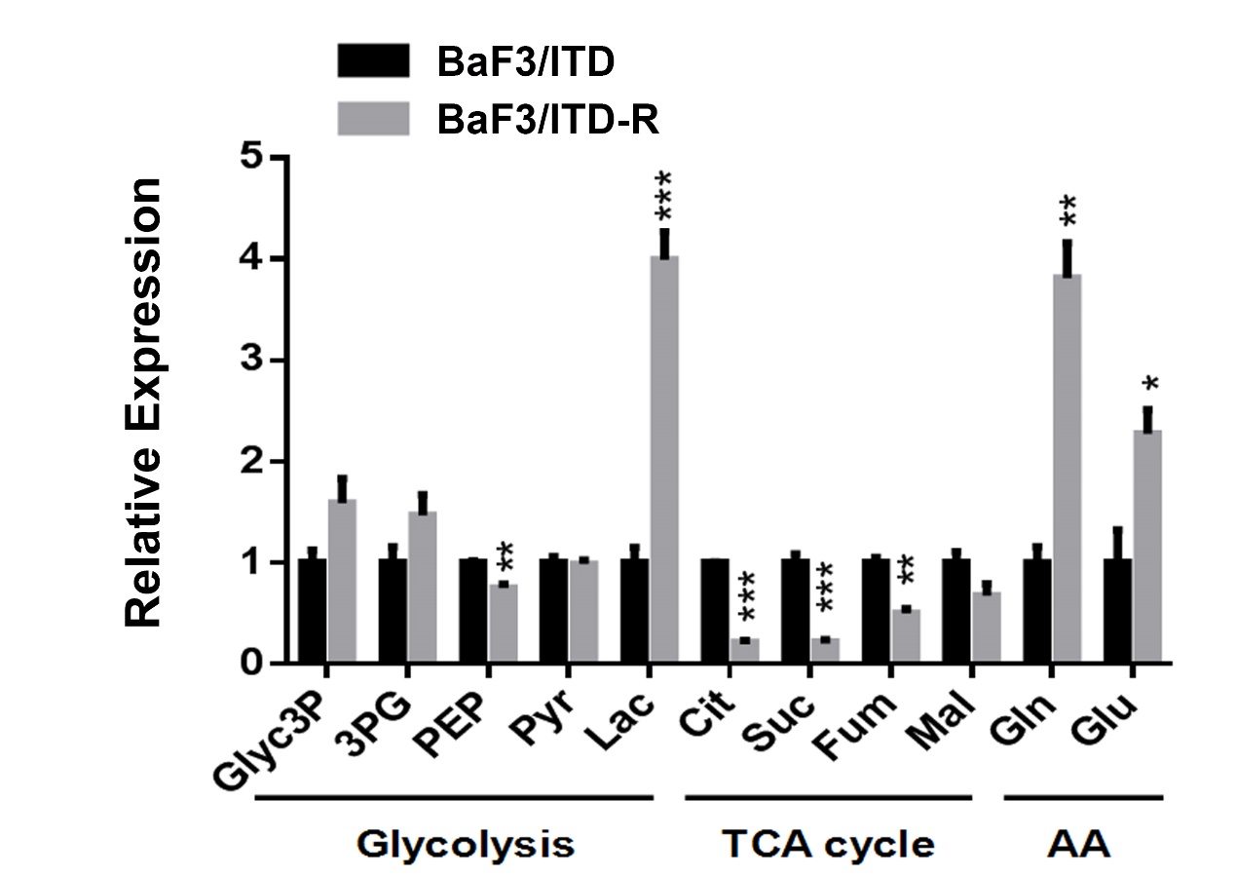

Additional Figure S5. Relative intracellular metabolite abundance of BaF3/ITD and BaF3/ITD-R cells. Metabolite extraction and GC-MS analysis was described in section “Method and materials”.
Abbreviation: Glyc3P, glyceraldehydes 3-phosphate; 3PG, 3-Phosphoglyceric acid; PEP, Phosphoenolpyruvate; Pyr, pyruvate; Lac, lactate; Cit, citrate; Suc, succinate; Fum, fumarate; Mal, malate; Gln, glutamine; Glu, glutamate; TCA cycle, tricarboxylic acid; AA, amino acid.

