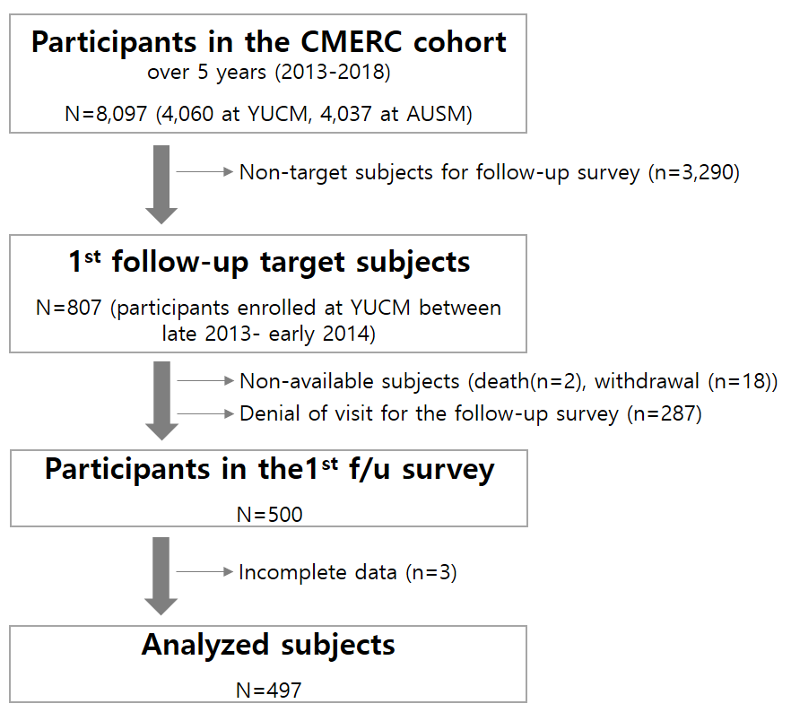

Supplementary Figure 1. Flow in the study subjects

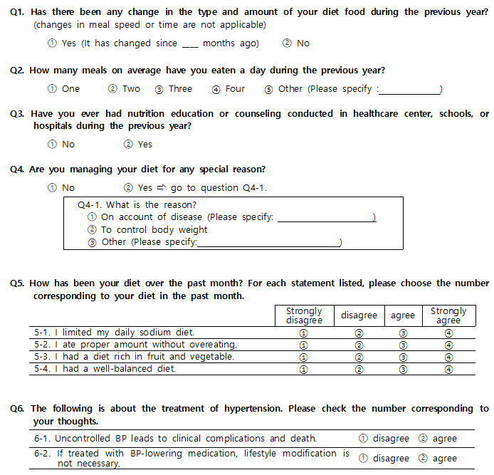 | 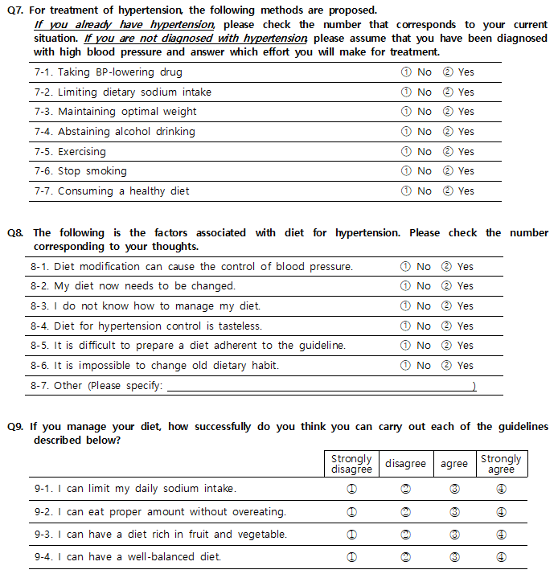

Supplementary Figure 2. Questionnaire on dietary adherence, management, benefits, barriers, self-efficacy of dietary therapy

