Supplementary File 3
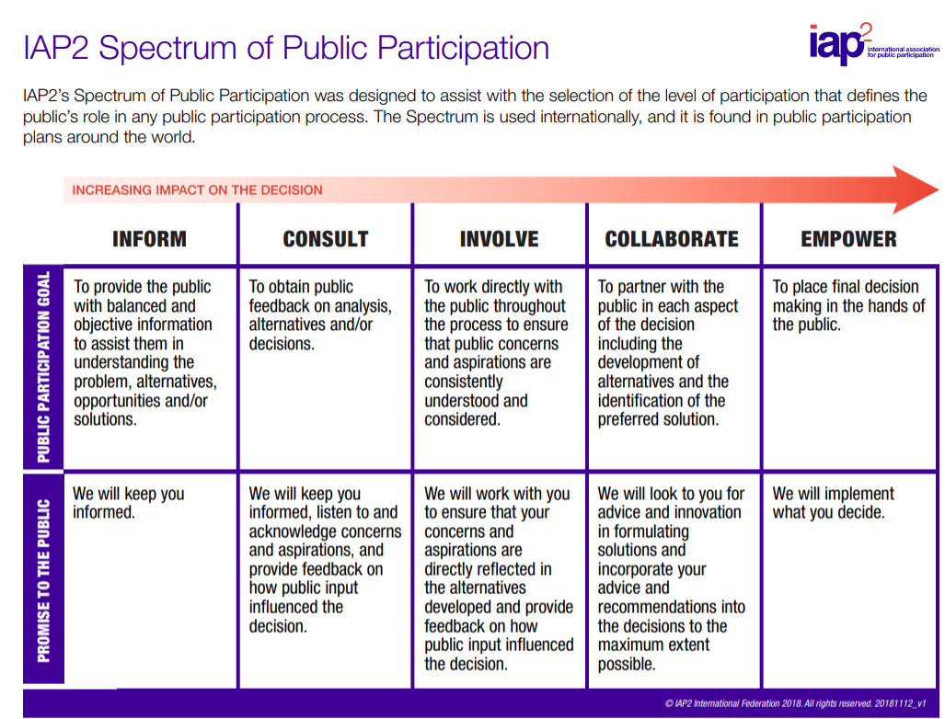
Reproduced with permission of IAP2 International Federation.

