Additional file 1
Questionnaire data on participant satisfaction with the workshops. WS = workshop.

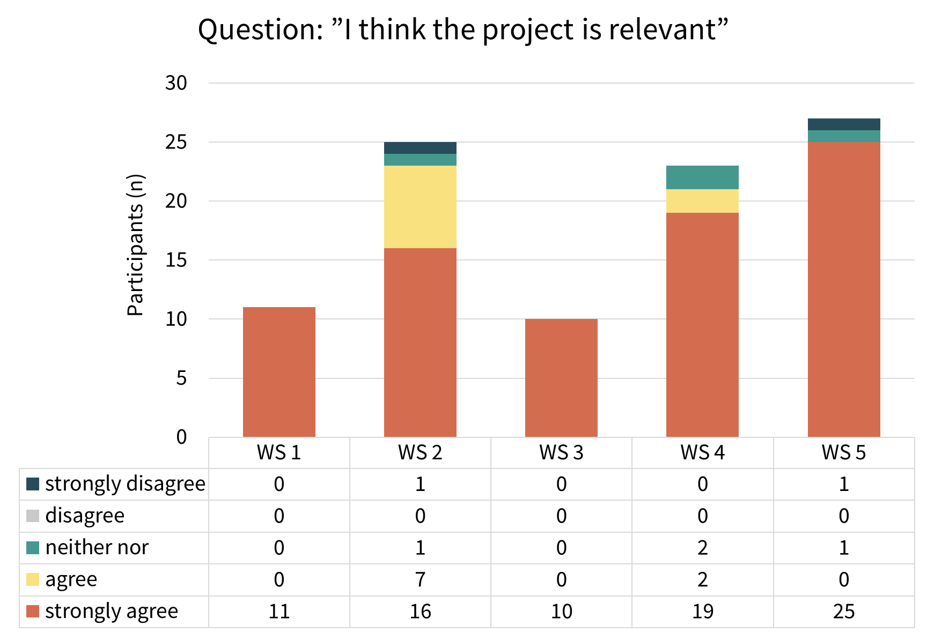

Figure 4a: Question: “I think the project is relevant”

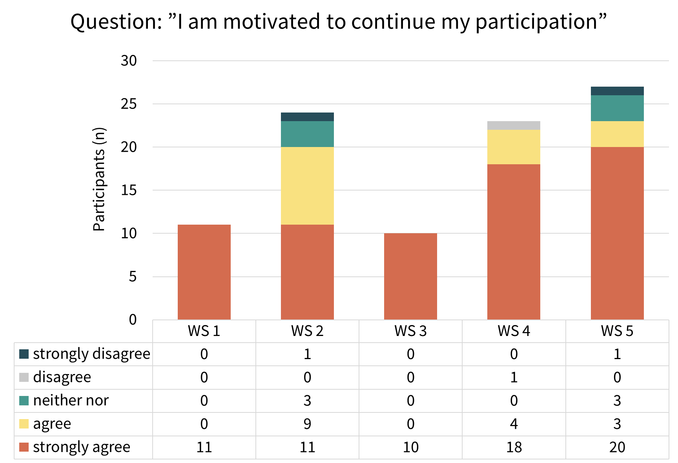

Figure 4b: Question: “I am motivated to continue my participation”

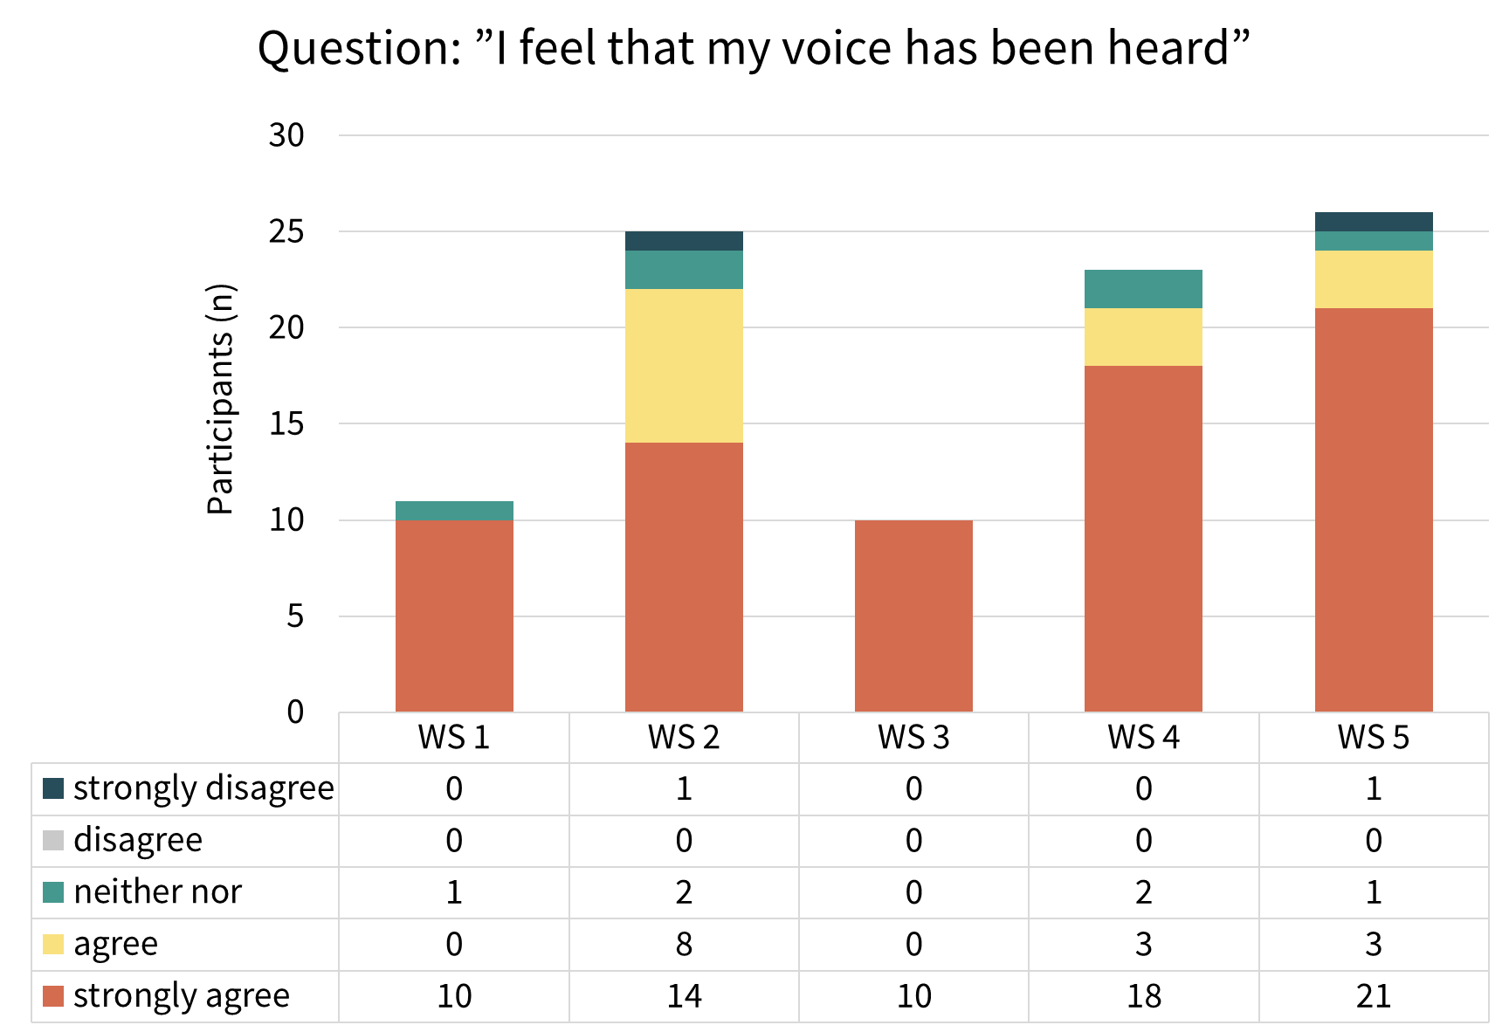

Figure 4c: Question: “I feel that my voice has been heard”

