Table of Contents | Page
Guidance for Reporting Involvement of Patients and the Public (GRIPP2) Checklist | 1
Mixed Methods Article Reporting Standards (MMARS) checklist. | 3
Journal Article Reporting Standards for Qualitative Research (JARS-Qual) checklist. | 4
CONSORT Reporting Checklist for Pilot Trials. | 7
Consent infographic prototypes. | 11
Final consent infographic (COVID-19). | 17
Summary of modifications to original CUE-R questionnaire. | 19
CUE-R 2 (patient/SDM questionnaire). | 20
Research Coordinator CRF. | 26
Table S1. Summary of patient/SDM and research coordinator suggestions for infographic design. | 30
Table S2. Summary of patient/SDM and research coordinator suggestions for infographic content. | 31
Table S1. Summary of Patient/SDM ratings of consent experience. | 32
Figure S1. Self-rated (patient/SDM) and Research Coordinator perceived satisfaction and confidence in consent decisions. | 33
Figure S2. Patient/SDM reported strengths of standard consent form. | 34
Figure S3. Patient/SDM reported strengths of infographic. | 35
Figure S4. Patient/SDM reported weaknesses of standard consent form. | 36
Figure S5. Patient/SDM reported weaknesses of infographic. | 37
Figure S6. Patient/SDM perception of the amount of information received. | 38

Guidance for Reporting Involvement of Patients and the Public (GRIPP2) Short Form Checklist

Section and topic | Item | Reported on page No
1: Aim | Report the aim of PPI in the study | Background, pgs 6-7
2: Methods | Provide a clear description of the methods used for PPI in the study | Protocol paper, co-design approach
3: Study results | Outcomes—Report the results of PPI in the study, including both positive and negative outcomes | Phase 1 results, pgs 13-16
4: Discussion and conclusions | Outcomes—Comment on the extent to which PPI influenced the study overall. Describe positive and negative effects | Discussion, pg 19
5: Reflections/critical perspective | Comment critically on the study, reflecting on the things that went well and those that did not, so others can learn from this experience | Discussion, pgs 19 and 23

Mixed Methods Article Reporting Standards (MMARS) checklist.
Item | Section, Page #
Title
Refrain from using words that are either qualitative (e.g., "explore," "understand") or quantitative (e.g., "determinants," "correlates"), because mixed methods stands in the middle between qualitative and quantitative research. Reference the mixed methods, qualitative methods, and quantitative methods used. | Cover page
Abstract
Indicate the mixed methods design, including types of participants or data sources, analytic strategy, main results/findings, and major implications/significance. | Abstract, pg. 4-5
Introduction
State three types of research objectives/aims/goals: qualitative, quantitative, and mixed methods. Order these goals to reflect the type of mixed methods design used. | Methods, pg. 9
Describe the ways approaches to inquiry were combined, as it illuminates the objectives and mixed methods rationale | Methods, pg. 9, Protocol pg. 3
Methods
Explain why mixed methods research is appropriate as a methodology given the paper’s goals. | Protocol pg. 3
Identify the type of mixed methods design used and define it. | Methods, pg. 9; Protocol pg. 3
Indicate the qualitative approach to inquiry and the quantitative design used within the mixed methods design type | Methods, pg. 9; Protocol pg. 3
If multiple approaches to inquiry were combined, describe how this was done and provide a rationale (e.g., descriptive, interpretive, feminist, psychoanalytic, postpositivist, critical, postmodern, constructivist, or pragmatic approaches), as it is illuminating for the mixed method in use. | N/A (did not use multiple approaches)
Provide a rationale or justification for the need to collect both qualitative and quantitative data and the added value of integrating the results (findings) from the two databases. | Protocol pg. 3
When data are collected from multiple sources, clearly identify the sources of qualitative and quantitative data (e.g., participants, text), their characteristics, and the relationship between the data sets, if there is one (e.g., an embedded design). | Phase 1 methods, pg. 10, Phase 2 methods, pg. 11; Protocol pg. 4 and pg. 6
State the data sources in the order of procedures used in the design type (e.g., qualitative sources first in an exploratory sequential design followed by quantitative sources), if a sequenced design is used in the mixed methods study. | We have reported accordingly.
Describe the qualitative and the quantitative sampling in separate sections. | Phase 1 methods, pg. 10, Phase 2 methods, pg. 11; Protocol pg. 4 and pg. 6
Discuss the recruitment strategy for qualitative and quantitative research separately. | Phase 1 methods, sampling + recruitment pg.10, Phase 2 methods, SWAT recruitment + sample size, pgs. 11-12; Protocol pg. 4 and pg. 6
Devote separate sections to the qualitative data analysis, the quantitative data analysis, and the mixed methods analysis. | Phase 1 data analysis, pg. 11, Phase 2 data analysis, pg. 13; Mixed methods integration, protocol pg. 9
Indicate methodological integrity, quantitative validity and reliability, and mixed methods validity or legitimacy. | Protocol, pgs. 9-10
Results
Indicate how the qualitative and quantitative results were “mixed” or integrated (e.g., discussion; tables of joint displays; graphs; data transformation in which one form of data is transformed to the other, such as qualitative text, codes, themes are transformed into quantitative counts or variables). | Results, integration, pg. 17

Journal Article Reporting Standards for Qualitative Research (JARS-Qual) checklist.
Item | Page #
Title
Identify key issues/topic under consideration. | Cover page
Acknowledge funding sources or contributors. | Declarations, pg. 26 (per journal)
Acknowledge conflicts of interest, if any. | Declarations, pg. 26 (per journal)
Abstract
State the problem/question/objectives under investigation. | Abstract, background, pg. 4
Indicate the study design, including types of participants or data sources, analytic strategy, main results/findings, and main implications/significance | Abstract, methods, pg. 4
Identify five keywords. | Abstract, pg. 5
Introduction
Frame the problem or question and its context. | Background, pgs. 6-7
Review, critique, and synthesize the applicable literature to identify key issues/debates/theoretical frameworks in the relevant literature to clarify barriers, knowledge gaps, or practical needs. | Background, pgs. 6-7
State the purpose(s)/goal(s)/aim(s) of the study. | Background, pgs. 8-9
State the target audience, if specific. | N/A
Provide the rationale for fit of design used to investigate this purpose/goal. | Protocol, pgs. 3-4
Describe the approach to inquiry if it illuminates the objectives and research rationale. | Protocol, pgs. 3-4
Methods
Summarize the research design, including data-collection strategies, data-analytic strategies, and, if illuminating, approaches to inquiry. | Phase 1 methods, pgs. 9-11; Protocol, phase 1 methods, pgs. 4-5
Provide the rationale for the design selected. | Protocol, pg. 3
Describe the researchers’ backgrounds in approaching the study, emphasizing their prior understandings of the phenomena under study | Protocol, pg. 3
Provide the numbers of participants/documents/events analyzed. | Phase 1 methods, sampling + recruitment, pg. 10
Describe the demographics/cultural information, perspectives of participants, or characteristics of data sources that might influence the data collected. | Did not collect
Describe existing data sources, if relevant. | N/A
Provide data repository information for openly shared data, if applicable. | N/A
Describe archival searches or process of locating data for analyses, if applicable. | N/A
Describe the relationships and interactions between researchers and participants relevant to the research process and any impact on the research process. | Protocol, pg. 2
Describe the recruitment process (e.g., face-to-face, telephone, mail, email) and any recruitment protocols. | Protocol, pg. 4
Describe any incentives or compensation, and provide assurance of relevant ethical processes of data collection and consent process as relevant. | Protocol, pg. 5
Describe the process by which the number of participants was determined in relation to the study design. | Protocol, pg. 4
Provide any changes in numbers through attrition and final number of participants/sources. | N/A
Describe the rationale for decision to halt data collection. | N/A
Describe the participants/data source selection process. | Phase 1 methods, pg. 10; Protocol, pg. 4
Provide the general context for the study. | Background, context, pg. 8; Protocol, pg. 2
If your participant selection is from an archived data set, describe the recruitment and selection process from that data set as well as any decisions in selecting sets of participants from that data set. | N/A
State the form of data collected. | Phase 1 methods, data collection, pgs. 10-11
Describe the origins or evolution of the data-collection protocol. | N/A
Describe any alterations of data-collection strategy in response to the evolving findings or the study rationale. | N/A
Describe the data-selection or data-collection process (e.g., were others present when data were collected, number of times data were collected, duration of collection, context). | Phase 1 methods, data collection, pgs. 10-11
Convey the extensiveness of engagement (e.g., depth of engagement, time intensiveness of data collection). | Phase 1 methods, data collection, pgs. 10-11, Protocol supplement
For interview and written studies, indicate the mean and range of the time duration in the data-collection process. | N/A
Describe the management or use of reflexivity in the data-collection process, as it illuminates the study. | N/A
Describe questions asked in data collection: content of central questions, form of questions. | Protocol supplement
Describe the methods and procedures used and for what purpose/goal. | Phase 1 methods, data analysis, pg. 11; Protocol pg. 5
Explicate in detail the process of analysis, including some discussion of the procedures (e.g., coding, thematic analysis) following a principle of transparency. | Phase 1 methods, data analysis, pg. 11; Protocol pg. 5
Describe coders or analysts and their training, if not already described in the researcher description section (e.g., coder selection, collaboration groups). | Protocol pg. 2
Identify whether coding categories emerged from the analyses or were developed a priori. | Protocol, pg. 5
Identify units of analysis (e.g., entire transcript, unit, text) and how units were formed, if applicable. | Protocol, pg. 5
Describe the process of arriving at an analytic scheme, if applicable. | N/A
Provide illustrations and descriptions of the analytic scheme development, if relevant. | N/A
Indicate software, if used. | N/A
Methodological integrity | Protocol, pg. 9
Results
Describe research findings (e.g., themes, categories, narratives) and the meaning and understandings that the researcher has derived from the data analysis. | Phase 1 results, pgs. 14-17
Demonstrate the analytic process of reaching findings (e.g., quotes, excerpts of data). | Phase 1 results, pgs. 14-17
Present research findings in a way that is compatible with the study design. | Phase 1 results, pgs. 14-17
Present synthesizing illustrations (e.g., diagrams, tables, models), if useful in organizing and conveying findings. Photographs or links to videos can be used. | N/A
Discussion | N/A (protocol)
Describe the central contributions and their significance in advancing disciplinary understandings. | Discussion, pgs. 19-20
Describe the types of contributions made by findings (e.g., challenging, elaborating on, and supporting prior research or theory in the literature describing the relevance) and how findings can be best utilized. | Discussion, pgs. 19-20
Identify similarities and differences from prior theories and research findings. | Discussion, pg. 20
Reflect on any alternative explanations of the findings. | N/A
Identify the study’s strengths and limitations (e.g., consider how the quality, source, or types of the data or the analytic processes might support or weaken its methodological integrity). | Discussion, pgs. 24-25
Describe the limits of the scope of transferability (e.g., what should readers bear in mind when using findings across contexts). | Discussion, pg. 25
Revisit any ethical dilemmas or challenges that were encountered, and provide related suggestions for future researchers. | N/A
Consider the implications for future research, policy, or practice. | Discussion, pgs. 19-25

CONSORT 2010 checklist of information to include when reporting a pilot or feasibility trial.

Section/Topic | Item No | Checklist item | Reported on page No
Title and abstract
 | 1a | Identification as a pilot or feasibility randomised trial in the title | Cover page
 | 1b | Structured summary of pilot trial design, methods, results, and conclusions (for specific guidance see CONSORT abstract extension for pilot trials) | Abstract, pgs. 4-5
Introduction
Background and objectives | 2a | Scientific background and explanation of rationale for future definitive trial, and reasons for randomised pilot trial | Background, pgs. 6-8
Background and objectives | 2b | Specific objectives or research questions for pilot trial | Background, objectives, pgs. 8-9
Methods
Trial design | 3a | Description of pilot trial design (such as parallel, factorial) including allocation ratio | Methods, pg. 9, Phase 2 methods pg. 11
Trial design | 3b | Important changes to methods after pilot trial commencement (such as eligibility criteria), with reasons | Deviations from published protocol, pg. 13
Participants | 4a | Eligibility criteria for participants | Phase 2 methods, pg. 11
Participants | 4b | Settings and locations where the data were collected | Phase 2 methods, pg. 11
 | 4c | How participants were identified and consented | Phase 2 methods, pgs. 11-12
Interventions | 5 | The interventions for each group with sufficient details to allow replication, including how and when they were actually administered | Phase 2 methods, pg. 12; Protocol pgs. 6-7
Outcomes | 6a | Completely defined prespecified assessments or measurements to address each pilot trial objective specified in 2b, including how and when they were assessed | Phase 2 methods, pgs. 12-13; Protocol pg. 7
Outcomes | 6b | Any changes to pilot trial assessments or measurements after the pilot trial commenced, with reasons | N/A
 | 6c | If applicable, prespecified criteria used to judge whether, or how, to proceed with future definitive trial | Phase 2 methods, pg. 12; Protocol pg. 8
Sample size | 7a | Rationale for numbers in the pilot trial | Protocol pg. 8
Sample size | 7b | When applicable, explanation of any interim analyses and stopping guidelines | N/A
Randomisation:
Sequence  generation | 8a | Method used to generate the random allocation sequence | N/A
Sequence  generation | 8b | Type of randomisation(s); details of any restriction (such as blocking and block size) | N/A
Allocation  concealment  mechanism | 9 | Mechanism used to implement the random allocation sequence (such as sequentially numbered containers), describing any steps taken to conceal the sequence until interventions were assigned | N/A
Implementation | 10 | Who generated the random allocation sequence, who enrolled participants, and who assigned participants to interventions | N/A
Blinding | 11a | If done, who was blinded after assignment to interventions (for example, participants, care providers, those assessing outcomes) and how | N/A
Blinding | 11b | If relevant, description of the similarity of interventions | N/A
Statistical methods | 12 | Methods used to address each pilot trial objective whether qualitative or quantitative | Phase 1 methods, pg. 13; Protocol pg. 8
Results
Participant flow (a diagram is strongly recommended) | 13a | For each group, the numbers of participants who were approached and/or assessed for eligibility, randomly assigned, received intended treatment, and were assessed for each objective | Figure 1
Participant flow (a diagram is strongly recommended) | 13b | For each group, losses and exclusions after randomisation, together with reasons | Figure 1
Recruitment | 14a | Dates defining the periods of recruitment and follow-up | Phase 2 results, pg. 17
Recruitment | 14b | Why the pilot trial ended or was stopped | N/A
Baseline data | 15 | A table showing baseline demographic and clinical characteristics for each group | Table 1
Numbers analysed | 16 | For each objective, number of participants (denominator) included in each analysis. If relevant, these numbers  should be by randomised group | Figure 1
Outcomes and estimation | 17 | For each objective, results including expressions of uncertainty (such as 95% confidence interval) for any  estimates. If relevant, these results should be by randomised group | N/A
Ancillary analyses | 18 | Results of any other analyses performed that could be used to inform the future definitive trial | N/A
Harms | 19 | All important harms or unintended effects in each group (for specific guidance see CONSORT for harms) | N/A
 | 19a | If relevant, other important unintended consequences | N/A
Discussion
Limitations | 20 | Pilot trial limitations, addressing sources of potential bias and remaining uncertainty about feasibility | Discussion, pgs. 24-25
Generalisability | 21 | Generalisability (applicability) of pilot trial methods and findings to future definitive trial and other studies | Discussion, pgs. 20-24
Interpretation | 22 | Interpretation consistent with pilot trial objectives and findings, balancing potential benefits and harms, and  considering other relevant evidence | Discussion, pg. 25
 | 22a | Implications for progression from pilot to future definitive trial, including any proposed amendments | Discussion, pg. 22
Other information
Registration | 23 | Registration number for pilot trial and name of trial registry | Abstract
Protocol | 24 | Where the pilot trial protocol can be accessed, if available | Methods, pg. 9
Funding | 25 | Sources of funding and other support (such as supply of drugs), role of funders | Declarations, pgs. 26-27
 | 26 | Ethical approval or approval by research review committee, confirmed with reference number | Declarations, pgs. 26-27

Citation: Eldridge SM, Chan CL, Campbell MJ, Bond CM, Hopewell S, Thabane L, et al. CONSORT 2010 statement: extension to randomised pilot and feasibility trials. BMJ. 2016;355.
Consent Infographic Prototype 1.

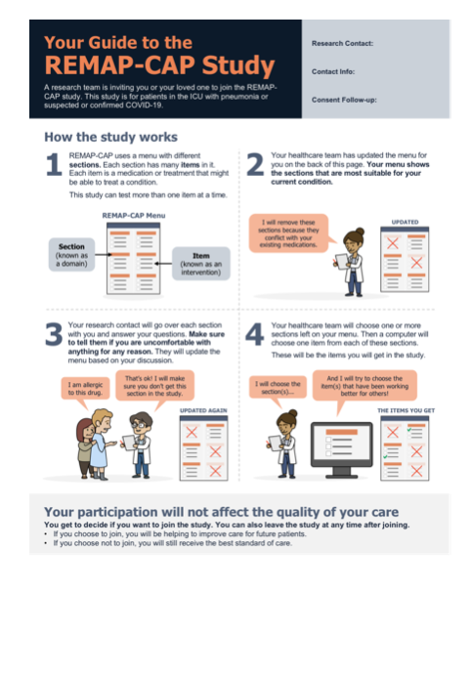
Consent Infographic Prototype 2.

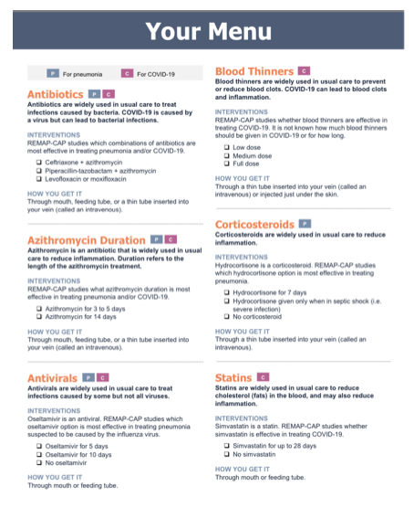
Consent Infographic Prototype 3.
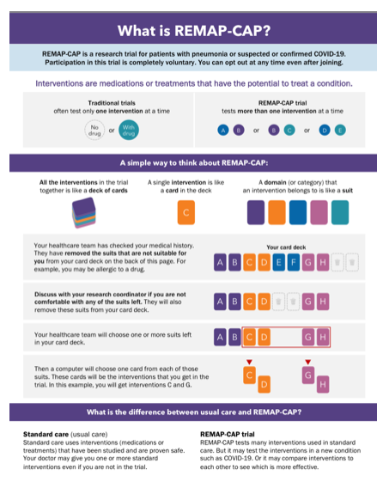
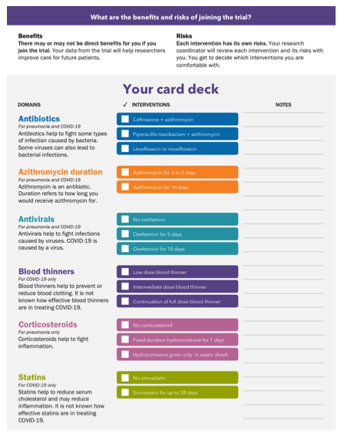
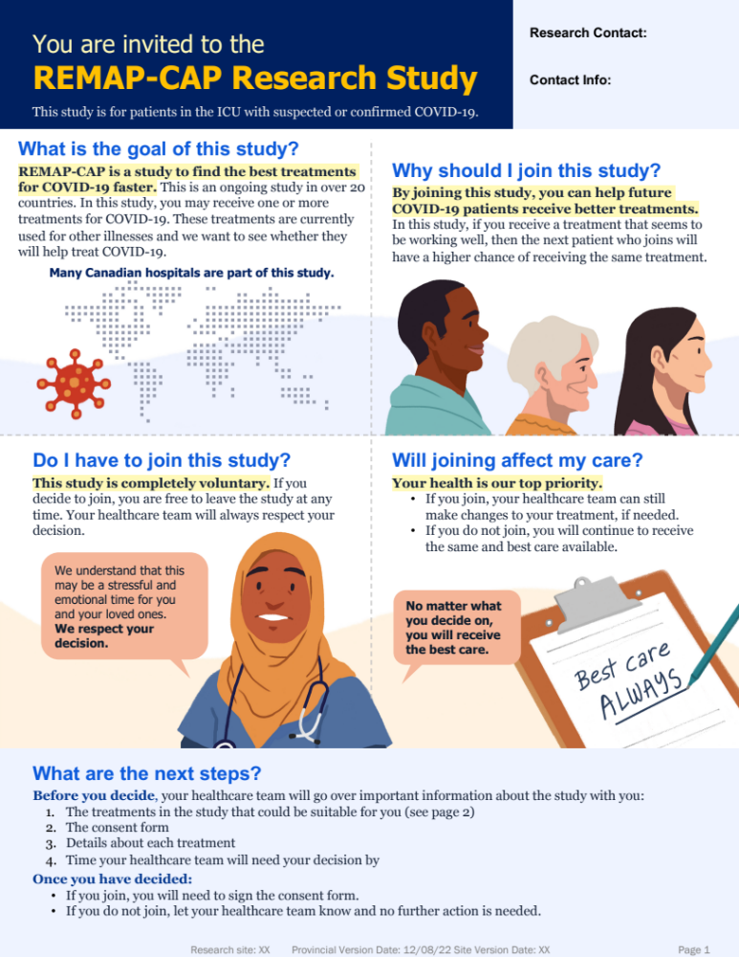
Consent Infographic (COVID-19)

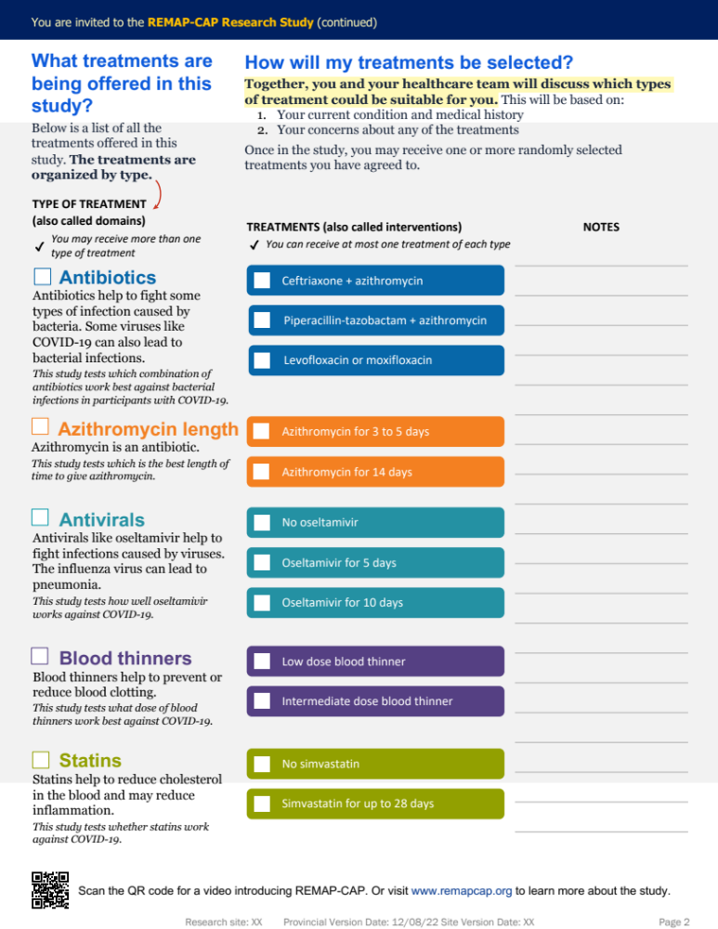

Summary of modifications to the Consent Understanding Evaluation-Revised tool (Taylor et al 2021).

General Formatting:
- Modified from telephone to self-administered questionnaire. Revised text accordingly.
- Added text to be inclusive of patient OR SDM.

Modified Questions:

Section A: Introduction:
- Dropped question A1
- Added question to understand who participated in the consent discussion

Section B/C: Study Knowledge
- Dropped questions B1-B5
- Modified questions B6 and B7 from open-ended to multiple choice.
- Dropped questions B8-B9
- Dropped question C1
- Modified question C2 to be specific to REMAP-CAP
- Modified question C3 to reflect response-adaptive randomization
- Dropped questions C4-C14

Section D: General Research Knowledge
- Dropped questions D1-D3

Section E: Consent Mode
- Dropped question E1 – all patients will receive all consent materials.

Section F: Consent Process
- Dropped questions F6-F7

Section G: Consent Form
- Dropped question G4

Section J: Video – Dropped whole section (not applicable)

Section K: Demographics
- Revised question K3 from open-ended to age groupings
- Dropped questions K6-K9

Cue-R 2 self-administered questionnaire.

REMAP-CAP Consent Feedback (V. 4.0)

Title: Pilot Testing an Infographic to Support Patients/Families through the REMAP-CAP Consent Process

Principal Investigators: Dr. John Marshall, Dr. Michelle Kho and Heather O’Grady, on behalf of the REMAP-CAP Coordinating Team and the CAPTIC Patient/Family Partners.

Electronic Preamble: Thank you for speaking with us about the REMAP-CAP study. The purpose of this questionnaire is to learn about your experiences during the REMAP-CAP consent process. We will use your feedback to try and improve the research consent experience for future patients and families as part of a small pilot research study.

We expect this questionnaire will take 10-15 minutes to complete; please answer as many questions as you are able. You may skip any questions that you do not wish to answer. We understand that participation in this survey may re-ignite or feelings of stress, anxiety and/or grief, which are typical of an ICU encounter, in which case you may choose to pause or stop participation in the survey. The study team is also available to discuss any concerns and/or to refer you to available resources (contact information below). Your participation is voluntary. If you choose to participate, your responses will be confidential and will not be shared with anyone outside of our research team. Your decision to complete this questionnaire will not impact quality of care for you or your loved one, nor will it impact your participation in REMAP-CAP. Should you choose to participate, your care team will not see your responses. You may choose to discontinue participation and stop the survey at any time; your responses will not be stored or used for analysis unless you hit “submit” on the final page of the survey. Results will be available to you after the pilot research study is complete, at your request.

Should you choose to participate in this research study, we ask that you kindly complete the questionnaire within one week of receiving our invitation email. If we have not received a completed questionnaire within one week, we will follow up with a reminder email. Your consent will be implied by your completion and submission of the electronic questionnaire. Your name will not appear anywhere, and your data will be grouped with survey participants. Direct quotes from your responses to survey questions may be used in reports or publications, but the quotes will not be attributed to you or contain any information that could be used to identify you. You may choose to withdraw your survey responses at any time by contacting the study investigators. In appreciation of your contributions, a member of our team will follow-up with you by email to provide you with a $5 e-gift card.

If you have questions regarding the survey or your rights as a research participant for the Research Board that reviewed the survey, contact the Unity Health Toronto Research Ethics Board at 416-864-6060 ext. 42557. If you have any other questions, please contact the Study Investigators at: [insert generic study email here]. You may also keep this letter for your records.

Hard-Copy Preamble: Thank you for speaking with us about the REMAP-CAP study. The purpose of this questionnaire is to learn about your experiences during the REMAP-CAP consent process. We will use your feedback to try and improve the research consent experience for future patients and families as part of a small pilot research study.

We expect this questionnaire will take 10-15 minutes to complete; please answer as many questions as you are able. You may skip any questions that you do not wish to answer. We understand that participation in this survey may re-ignite or feelings of stress, anxiety and/or grief, which are typical of an ICU encounter, in which case you may choose to pause or stop participation in the survey. The study team is also available to discuss any concerns and/or to refer you to available resources (contact information below). Your participation is voluntary. If you choose to participate, your responses will be confidential and will not be shared with anyone outside of our research team. Your decision to complete this questionnaire will not impact quality of care for you or your loved one, nor will it impact your participation in REMAP-CAP. Should you choose to participate, your care team will not see your responses. You may choose to discontinue participation and stop the survey at any time. Results will be available to you after the pilot research study is complete, at your request.

Should you choose to participate in this research study, we ask that you kindly complete the questionnaire within one week. Please return the completed questionnaire to the ICU research team in [insert office room # here]. Your consent will be implied by your completion and return of the questionnaire. Your name will not appear anywhere, and your data will be grouped with survey participants. Direct quotes from your responses to survey questions may be used in reports or publications, but the quotes will not be attributed to you or contain any information that could be used to identify you. You may choose to withdraw your survey responses at any time by contacting the study investigators. In appreciation of your contributions, a member of our team will follow-up with you to provide you with a $5 e-gift card.

If you have questions regarding the survey or your rights as a research participant for the Research Board that reviewed the survey, contact the Unity Health Toronto Research Ethics Board at 416-864-6060 ext. 42557. If you have any other questions, please contact the Study Investigators at: [insert generic study email here]. You may also keep this letter for your records.

A. 1. To begin, who was asked to provide consent to join the REMAP-CAP study?
Myself
My loved one
Not sure

A. 2. Did you or your loved-one join the REMAP-CAP study?
Yes
No
Not sure

A. 3. If you or your loved one did not want to participate in REMAP-CAP, could you have declined to sign the consent form?
Yes
No
Not sure

A. 4. Is it ok for you or your loved one to join REMAP-CAP and then choose to withdraw partway through the study?
Yes
No
Not sure

Now, we will ask you a few questions about the consent form for REMAP-CAP.

B. 1. On a scale of 1-5, how much did you read over the consent form you were given? For this question, 5 means you feel like you read every word, and 1 means you did not read it at all.
1 2 3 4 5

I did not read it at all I read every word

B. 2. On a scale of 1-5, how hard or easy did you think it was to understand the consent form given to you? For this question, 5 means it was very hard to understand, and 1 means it was really easy to understand.
1 2 3 4 5
Really easy to understand Very hard to understand

B. 3. On a scale of 1-5, how complicated did you think the consent form was? For this question, 5 means it was very complicated, and 1 means it was not complicated at all.
1 2 3 4 5

Not complicated at all Very complicated
Next, we will ask you some questions about the infographic used for REMAP-CAP.

C. 1. On a scale of 1-5, how much did you read over the infographic you were given? For this question, 5 means you feel like you read every word, and 1 means you did not read it at all.
1 2 3 4 5

I did not read it at all I read every word

C. 2. On a scale of 1-5, how hard or easy did you think it was to understand the infographic given to you? For this question, 5 means it was very hard to understand, and 1 means it was really easy to understand.
1 2 3 4 5
Really easy to understand Very hard to understand

C. 3. On a scale of 1-5, how complicated did you think the infographic was? For this question, 5 means it was very complicated, and 1 means it was not complicated at all.
1 2 3 4 5

Not complicated at all Very complicated

C. 4. On a scale of 1-5, how strongly would you recommend that researchers use an infographic to educate potential study participants and substitute decision makers about REMAP-CAP? For this question, 5 means you think they should always use an infographic, and 1 means they should never use an infographic.
1 2 3 4 5

Never use an infographic Always use an infographic

Next, we will ask you two questions about the REMAP-CAP study. Please choose the answer you think is best.

D. 1. Individuals who participate in REMAP-CAP:
Will not receive any intervention for their community acquired pneumonia
Will get a new intervention for their community acquired pneumonia
Will get multiple intervention for their community acquired pneumonia, potentially including new interventions
Not sure

D. 2. Individuals who participate in REMAP-CAP:
Are equally likely to receive interventions offered
Are more likely to receive interventions that are showing no impact
Are more likely to receive interventions that are performing best
Not sure

Next, we would like to get your general feedback on what you learned about REMAP-CAP and how you learned about the study.

E. 1. Overall, how satisfied or unsatisfied were you with the information you were given today about the study?
Very satisfied
Pretty satisfied
Pretty unsatisfied
Very unsatisfied
Don’t know

E. 2. What did you like most about the infographic and forms you received?

E. 3. What did you like least about the infographic and forms you received?

E. 4. In thinking about the amount of information you received about REMAP-CAP, do you feel like you got too little, the right amount or too much information about the study?
Too little
The right amount
Too much
Don’t know

E. 5. In thinking about the information you received about REMAP-CAP, would you say that you now have no questions, a couple of questions or lots of questions about the study?
No questions
A couple of questions
A lot of questions
Don’t know

E. 6. In thinking about the decision you made whether or not to participate in REMAP-CAP, how confident are you in the decision you made?
Very confident
Pretty confident
Pretty unconfident
Very unconfident
Don’t know
I have not decided whether or not to participate

Lastly, we have a few questions to get to know you better.

F. 1. Have you been asked to participate in a medical research study other than REMAP-CAP?
Yes
No
I don’t know

F. 2. What is your gender?
Male
Female
Other
Prefer not to answer

F. 3. What is your age?
18-24 years old
25-34 years old
35-44 years old
45-54 years old
55-64 years old
65-74 years old
75-84 years old
85 years or older
Prefer not to answer

F. 4. Which race category best describes you? Please check all that apply.
Black
East/Southeast Asian
Indigenous
Latino
Middle Eastern
South Asian
White
Other
Do not know
Prefer not to answer

F. 5. What is the highest level of education that you have completed?
No formal education
Less than high school diploma
High school diploma
College diploma
Bachelor’s degree
Master’s degree
Doctorate
Other
Prefer not to answer

F. 6. We are interested in improving the way study staff tell people about REMAP-CAP. Is there anything else you would like to tell us about the consent form, the infographic or the consent process?

Thank you for taking the time to answer these questions!


Research coordinator survey case report form.
Preamble:

IMPLIED CONSENT TO PARTICIPATE IN A RESEARCH STUDY

Dear [insert research coordinator name],

We are interested in improving the REMAP-CAP consent experience for patients, families and research coordinators. To do this, we are conducting a small pilot research study, titled “Pilot Testing an Infographic to Support Patients/Families through the REMAP-CAP Consent Process “. Our research study involves asking you to use an infographic to support your standard consent procedures. We will then ask you to complete an electronic case report form (CRF) after each consent encounter, which will take about 5-10 minutes to complete. The CRF will tell us about your experience implementing the infographic.

You do not have to participate in this study if you do not want to. Your participation is voluntary. This will not adversely affect your future relationship with staff nor will impact your employment or professional standing at St. Joseph’s Healthcare Hamilton. The information you provide will remain confidential. Your data will only be linked to you through a master list, which will be stored by the Research Coordinator at St. Joseph’s Healthcare Hamilton. Hard copies will be stored in a locked filing cabinet, in a locked office and electronic copies will be password-protected and stored on the hospital’s secure server. Your name will not appear anywhere, and your data will be grouped with other participants. Direct quotes from your responses to questionnaire questions may be used in reports or publications, but the quotes will not be attributed to you or contain any information that could be used to identify you. The data collected will be kept for a period of at least 10 years in a secure location and then destroyed. You may choose to withdraw your data at any time by contacting the research study investigators. Your data will be deleted from the database.

WHAT ARE THE RESPONSIBILITIES OF STUDY PARTICIPANTS?
Should you choose to participate, you will be completing the CRF using LimeSurvey, a web-based secure platform for survey administration. You can skip any question you wish. There are no correct or incorrect answers to this survey, and there are no additional requirements

There are common risks of using email to communicate:
- Information travels electronically and is not secure in the way a phone call or regular mail would be.
- If someone sees these emails, they may know that you are a participant in this research study.
- Emails may be read or saved by your internet or phone providers (i.e. Rogers, your workplace, “free internet” providers).
- Copies of an email may continue to exist, even after efforts to delete the email have been made.
- There is always a chance with any unencrypted email, however remote, that is could be intercepted or manipulated.

HOW WILL MY INFORMATION BE KEPT CONFIDENTIAL?
While your responses will be linked to your institutional data your identity is completely anonymous in LimeSurvey. By completing this survey, you are agreeing to participate in this study and agree to and understand the terms of the study. LimeSurvey’s servers are located in Hamburg, Germany but holds all data from this survey within Canada and complies with Canadian legal standards for data storage and privacy. We will not collect or use Internet Protocol (IP) addresses or any other information which could link your participation to your electronic device. Your name and email will be shared with the research team (jointly coordinated at McMaster University and St. Michael’s Hospital). A unique link will be sent to you by email after each consent encounter.

The investigators and study staff will keep the information they see or receive about you confidential, to the extent permitted by applicable laws. Even though the risk of identifying you from the study data is very small, it can never be completely eliminated.

Your decision to participate in this survey will not impact your role in REMAP-CAP. All RCs who choose to participate will receive a $50 gift card of their choice to recognize their time and expertise in implementing our study protocol. RCs will receive a gift card regardless of how many consent encounters they implement the infographic in.

This pilot study has been reviewed through Clinical Trials Ontario (CTO ID 3779). If you have questions for the Research Board that reviewed the survey, contact the Unity Health Toronto Research Ethics Board at 416-864-6060 ext. 2557.

Research Coordinator Survey Case Report Form (V. 3.0)

Date:

A. 1. Type of consent: In-person Remote Other:

A. 2. Who made the consent decision? Patient SDM

A. 3. Did the patient/SDM consent for REMAP-CAP? Yes No

A. 4. Approximately how long was the consent encounter? minutes

A. 5.1. Was the consent encounter eligible for use of the infographic? Yes No
A. 5.1a. If no, why?
Patient/SDM could not communicate in English
Not able to send study documents by email
Other:

A. 6.1. Did the patient/SDM receive the infographic? Yes No

A. 6.2. If no, why?
Internet/email difficulties
RC workload/capacity
Other:
Unknown

The following questions relate to your experience of the consent encounter. Please circle the best number for each question.

B. 1. How easy was it to use the infographic during this consent encounter?
1 2 3 4 5 6 7

Very Difficult Very Easy

B. 2. Approximately how many questions did the patient/SDM ask during the consent encounter?
0 1-5 6-10 11-15 16 or more

B. 3. How difficult were the questions asked by the patient/SDM?
1 2 3 4 5 6 7

Very Simple Very Difficult

B. 4. How satisfied were you with this consent encounter?
1 2 3 4 5 6 7

Very Unsatisfied Very Satisfied
The last questions relate to your perception of the consent encounter. Please circle the best number for each question.

C. 1. How well do you think the patient/SDM understood REMAP-CAP?
1 2 3 4 5 6 7

Very Poorly Very Well

C. 2. How satisfied do you think the patient/SDM was with the consent encounter?
1 2 3 4 5 6 7

Very Unsatisfied Very Satisfied

C. 3. How confident do you think the patient/SDM was with their consent decision?
1 2 3 4 5 6 7

Very Unconfident Very Confident

Table S1. Summary of patient/SDM and research coordinator suggestions for infographic design.
Theme | Sub-Theme | Quote(s)
Visual Presentation | Make text big where possible, highlighting key information that is easily read to another person. | “It’s not always the caregiver looking at the resource in the ICU. It might be someone more elderly, so it may be hard to read when the text is small”  “Because of meds, my vision was blurred, and so I needed someone to read stuff to me”  “I like bullet point form—it’s better for cognitive load”
Visual Presentation | Use imagery and colours to communicate information. | “People are graphic so adding images will help”  “I prefer brighter or bolder colours to prioritize importance”  “I found the use of colours more eye-catching”
Visual Presentation | Make the infographic modifiable. | “Seeing something crossed out makes it feel personal—that someone spent time to review your file and crossed it out”
Language | Use plain language, avoid jargon, and use an appropriate tone. | “[the infographic] wasn’t plain language for people whose language isn’t English. You need simpler terms throughout the whole document, which seemed like it was for scholars and not the everyday population”  “The whole document needs to be revisited by lay people to make it easier to understand”  “The language is cold and has no empathy. It didn’t draw me in”  “Language should be simpler. Words like ‘domain’ and ‘intervention’ should be omitted”
Language | Explain uncommon terms. | “Patients might not know what ‘standard of care’ means. I also don’t usually use ‘usual care’”  “I don’t know who is who, so I wouldn’t know the difference between the healthcare practitioners until I get to know people”  “Why are we talking about a research coordinator?”
Language | Ensure the focus is on the patient. | “Make sure you’re patient-focused, not solely research-focused”
Table S2. Summary of patient/SDM and research coordinator suggestions for infographic content.
Theme | Sub-Theme | Quote(s)
Study Details | What condition do I have? | “If I’m in crisis at the hospital, I have no interest in reading a lot of information about something I don’t have (e.g., COVID-19)”
Study Details | What is the purpose of this study? | “The main thing is I want to know what the purpose of the study is”  “Remind people of the end goal: if you participate, what we’re trying to achieve with no ambiguity”
Study Details | What is the consent process? | “You really have to tell people what to expect”
Study Details | What treatments will I receive? | “The resource must have what’s going into my body and why I am taking this”  “Maybe have a description of antibiotics, what they do, and then research goal underneath”
Study Details | How does the team decide which treatments to give me? | “It’s important to know that the healthcare team has already picked things suitable for you”
Study Details | Do I have a say in my treatment? | “There must be choice: the ability to turn down chosen interventions”
Participation | Why should I participate in this study? | “I like the idea of being informed that this study is going to help other patients. Being helpful is my tipping point to join.”  “There is a lot of explanation about what it’s all about, but I care about my loved one. What can I do for them? What’s in it for me?”
Participation | Do I have to continue participation in this study? | “It’s important to tell people that you can leave the study at any time.”
Participation | Will participation affect my care? | “It’s very important that the level of care remains the same or better regardless of whether you participate. This should be positioned at the beginning of the resource.”
Participation | Does the research team care more about me or the research results? | “State at the beginning that if a treatment in the study is not working well, there will be revisions made ASAP for the best outcomes”  “Stress that the healthcare team cares about you first before the research”

Table S3. Summary of Patient/SDM ratings of consent experience.
Question |  | Number of responses | Median rating (1st, 3rd quartiles) | Range
Overall rating for standard consent form-related questions. | 1 – Negative experience  5 – Positive experience | N/A | 4.0 (3.5, 4.5) | N/A
How much did you read over the consent form you were given? | 1 – I did not read it at all  5 – I read every word | 14 | 5.0 (1.75, 5.0) | 1-5
How easy or hard was it to understand the consent form given to you? | 1 – It was very hard to understand  5 – It was very easy to understand | 12 | 3.0 (1.75, 4.25) | 1-5
How complicated did you think the consent form was? | 1 – It was very complicated  5 – It was not complicated at all | 13 | 4.0 (2.0, 5.0) | 1-5
Overall rating for standard infographic-related questions. | 1 – Negative experience  5 – Positive experience | N/A | 5.0 (4.75, 5.0) | N/A
How much did you read over the infographic you were given? | 1 – I did not read it at all  5 – I read every word | 15 | 5.0 (4.0, 5.0) | 1-5
How easy or hard was it to understand the infographic given to you? | 1 – It was very hard to understand  5 – It was very easy to understand | 15 | 4.0 (2.5, 5.0) | 1-5
How complicated did you think the infographic was? | 1 – It was very complicated  5 – It was not complicated at all | 15 | 5.0 (3.5, 5.0) | 1-5
How strongly would you recommend that researchers use an infographic, compared to no infographic, to educate potential study participants and substitute decision makers about REMAP-CAP? | 1 – They should never use an infographic  5 – They should always use an infographic | 14 | 5.0 (4.0, 5.0) | 1-5
Legend: this table summarizes responses to questions B1-C4 from the CUE-R 2, related to patient/SDM experience with the standard REMAP-CAP consent documents and the infographic.

There was a total of 15 CUE-R 2 questionnaires completed. Patients/SDMs had the option to select “prefer not to answer”, which is why not all questions had 15 responses.

Figure S1. Self-rated (patient/SDM) and Research Coordinator perceived satisfaction and confidence in consent decisions.
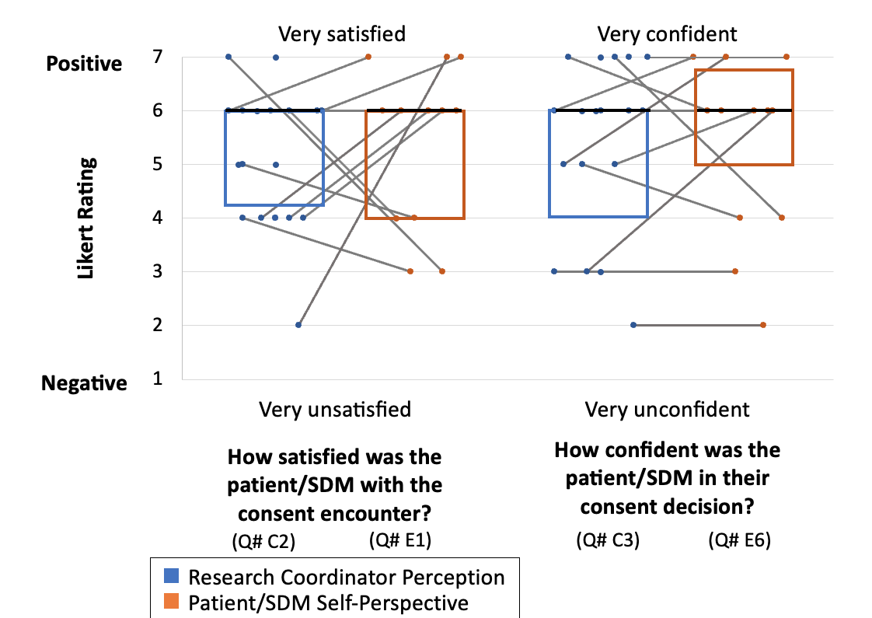
Legend: This figure summarizes questions that were asked to both patients/SDMs and RCs. Question numbers from data collection tools are denoted below each item, with RC questions on the left and patient/SDM on the right. Each circle represents an individual response. Blue circles represent RC responses about their perception, while orange represents the patient/SDM self-perspective. Box plots represent the median participant score and quartiles. The horizontal, black line within the box plot represents the median, while the bottom represents the 1st quartile, and the top side represents the 3rd quartile. Instances where the black bar is the top or bottom of the box represent instances when the median was the same as one of the quartiles. For example, the median response for RC perceived satisfaction was 6.0 (4.25, 6.0).

Figure S2. Strengths of the standard consent form identified by patients/SDMs.

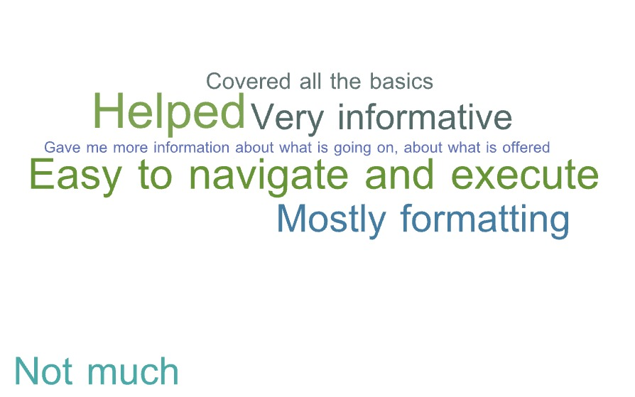

Figure S3. Strengths of the consent infographic identified by patients/SDMs.

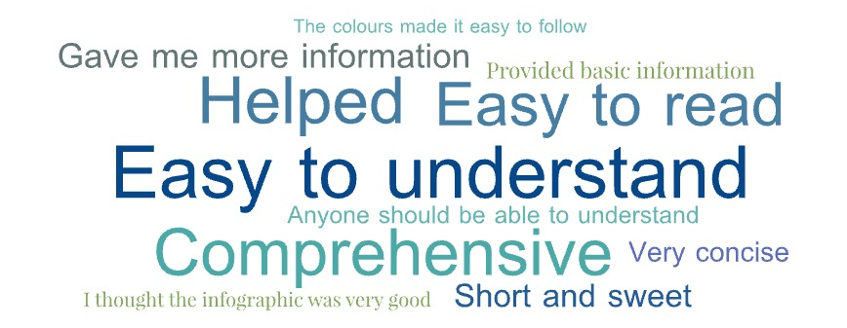

Figure S4. Weaknesses of the standard consent form identified by patients/SDMs.


Figure S5. Weaknesses of the infographic identified by patients/SDMs.

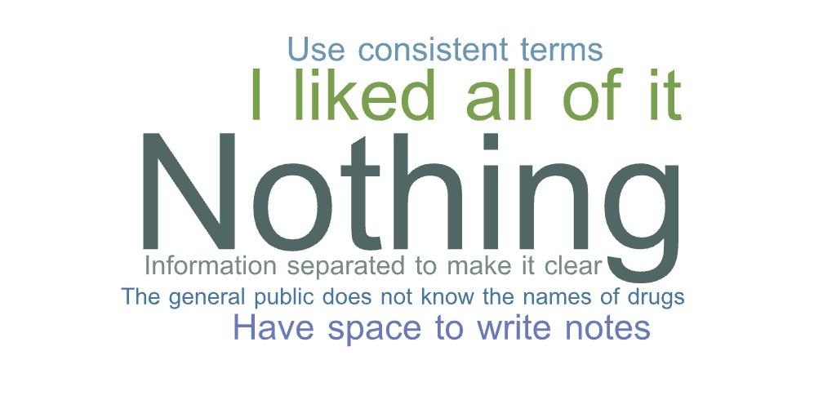
Figure S6. Patient/SDM perception of the amount of information received.

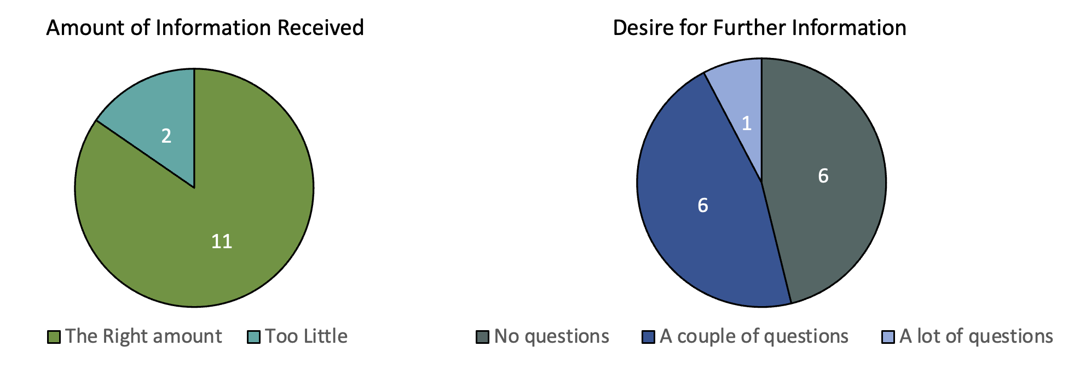

Legend: These pie charts summarize patient/SDM responses regarding the amount of information received and desire for further information. For further information, the question asked whether the patient/SDM still had any questions about the trial. Two people did not respond to these questions, thus n=13.

