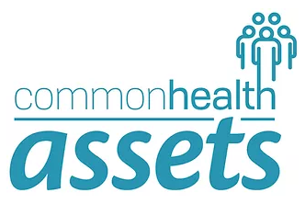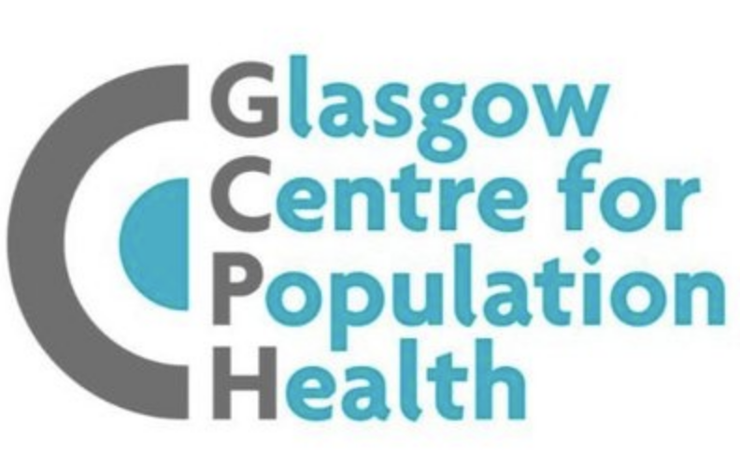

Final Lived Experience Panel Meeting Evaluation Questionnaire
Section 1. About you
These questions are being asked to explore which voices were represented in the Panel and if any voices were missed. Please leave blank if you would prefer not to say.

- How would you describe your gender?

- What is your age?

- How would you describe your ethnicity?

- Do you consider yourself to have a disability or long-term illness?

- What is your current employment status? (e.g., in employment, retired, studying, unemployed)

- What is your highest education level? (e.g., high school, college/further education, university, post-graduate)

- Would you consider yourself to live in an urban area or a rural area?

Section 2: Impact of Panel participation on individual Panel members
Please answer the following questions in as much detail as possible. If yes, give please give examples where possible. If no, what would you have liked to happen?
- Have you gained any new skills from taking in the Lived Experience Panel?

- Have you gained any new knowledge (for example, about research, health or community organisations etc.) from taking in the Lived Experience Panel?

- Has being a part of the Panel impacted you in any other way (e.g., made new friends, tried something new, travelled to new places, helped you do something)?

- Has taking part in the Panel impacted on your confidence or abilities in any way?

- Has taking part in the CommonHealth Assets project changed your attitude of, or interest in, health research?

Section 3: Experience of being a Lived Experience Panel member
Please answer the following questions in as much detail as possible. If yes, give please give examples where possible. If no, what would you have liked to happen?
- Do you feel that your opinions and contributions have been valued by the team in the CommonHealth Assets project? Please share an example if you can.

- Do you feel as though the Lived Experience Panel has had made an impact in shaping the CommonHealth Assets project as it developed? Why/why not?

- How connected have you felt to the wider research team and overall CommonHealth Assets project?

- Did the facilitation style used in Panel meetings by Mohasin suit your needs?

- How satisfied were you with the communication methods used throughout the Panel (i.e., frequency of meetings, communication in between meetings etc.)?

- Do you feel you received enough information from Mohasin and the researchers about the activities and progress of the CommonHealth Assets project over time?

- How inclusive do you feel the Panel has been regarding different perspectives, ideas and backgrounds?

- Did you feel adequately supported during your participation in the Panel (e.g., with accessibility needs, resources provided, contact with Mohasin)?

- Do you feel as though the Panel was adapted to meet the needs of participants, and that you had a say into the content and structure of Panel meetings?

- Do you feel you were adequately compensated for your sharing your expertise, expertise and participation?

- Did you enjoy the Panel moving to the different project locations? If yes, what did you enjoy?

- Did you take part in any other Panel learning opportunities (attending full team meetings, workshops, conferences)? If so, what was your experience with these?

- Was there any other learning opportunities you would like to have taken part in or that you would have liked to have been offered?

Section 4: Your overall experience
Please answer the following questions in as much detail as possible.
- Overall, how satisfied are you with your experience as a Panel member?

- What improvements would you suggest for future activities and Panels?

- Would you recommend taking part in a similar experience to others?

- Is there anything else you would like to share about your experience of taking part in the CommonHealth Assets project and LE Panel?

- Do you wish to be kept updated as to the findings and outputs from the project once published?

Thank you for sharing your experiences, views and suggestions

